GRADE VI
ELECTRICAL ENERGY

At the end of the module, you should be able to:

- Identify energy and their uses (electrical)



Try to Recall

Study the type of energy shown in each picture.
Identify whether it is light energy, chemical energy or mechanical energy.
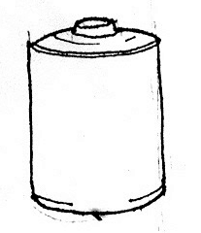
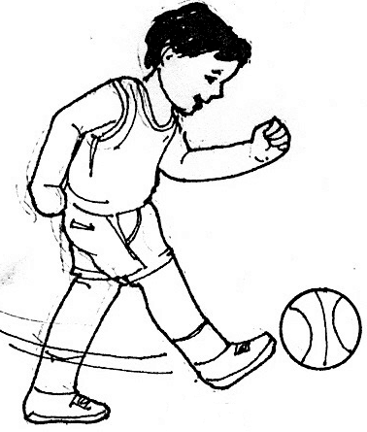
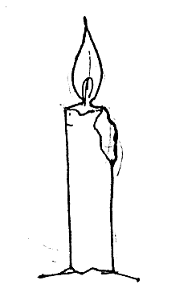

______________ ______________ ______________
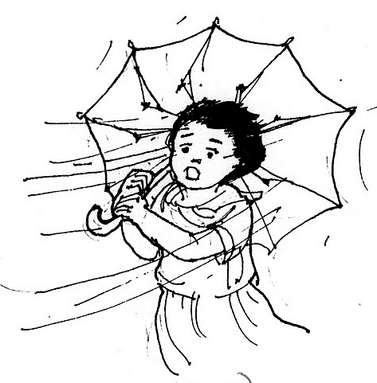
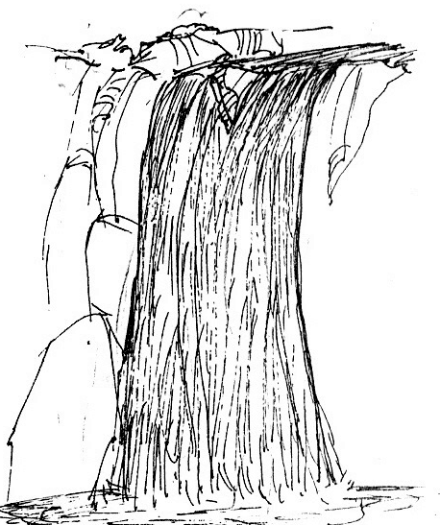
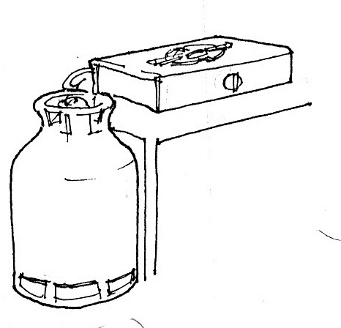

______________ ______________ ______________

Explore

In this lesson you will learn more about another form of energy - - - electrical energy.

Activity 1

What you need:

comb
tiny bits of paper

What to do:

- Place the tiny bits of paper (size of a dot) on the table.
- Comb you hair several times in one direction.
- Then put the comb about ½ cm above the head of your seatmate. Observe what happens.
- Repeat procedure 2. Then place the comb near the bits of paper. What happened?
- What do you think caused the comb and paper to attract each other?
- What is produced when you rub or comb your hair repeatedly?

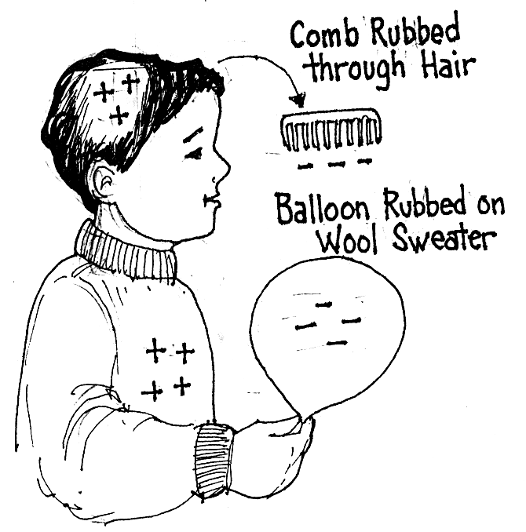
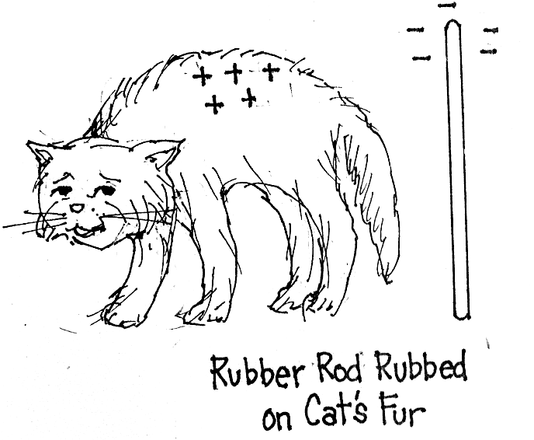

Did you know that…

- when you comb or rub your hair, the comb, gains electrons (negatively charged). The hair loses electrons (positively charged).
- as the negatively charged comb is placed near your seatmate hair or bits of paper the electrons in the hair or paper move away! The hair or paper is now positively charged.
- the rule says “Unlike poles attract”. That’s why the comb and the bits of paper attract each other.
- rubbing produced static electricity
- the electrons in the comb and the electrons flowing along the wires forms electricity that light our homes.

Activity 2

What you need:
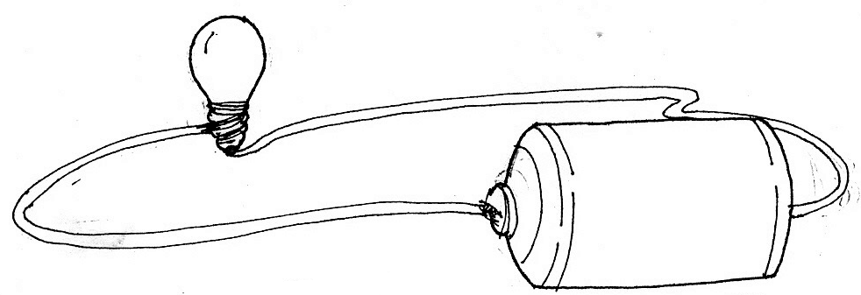
60 m wire
a battery
a flashlight bulb

What to do:

- Find ways of connecting the materials to make the bulb light. Draw as shown in the illustration above.

Answer these:
- Did the bulb light? Why
- What energy flow along the wire?
- Where did this energy come from?
- What are some uses of this energy?
- Can you tell how electrical energy is produced in a battery?
- Trace the energy changes in this energy.

____________energy ____________energy
battery movement of electrons

Did you know that…

when wire is connected to a battery just like the illustration of a simple circuit, chemical reaction takes place inside the battery. The substance chemically react to produce excess electrons. These electrons flow along the wires and is called electrical energy.

Activity 3

What to do:

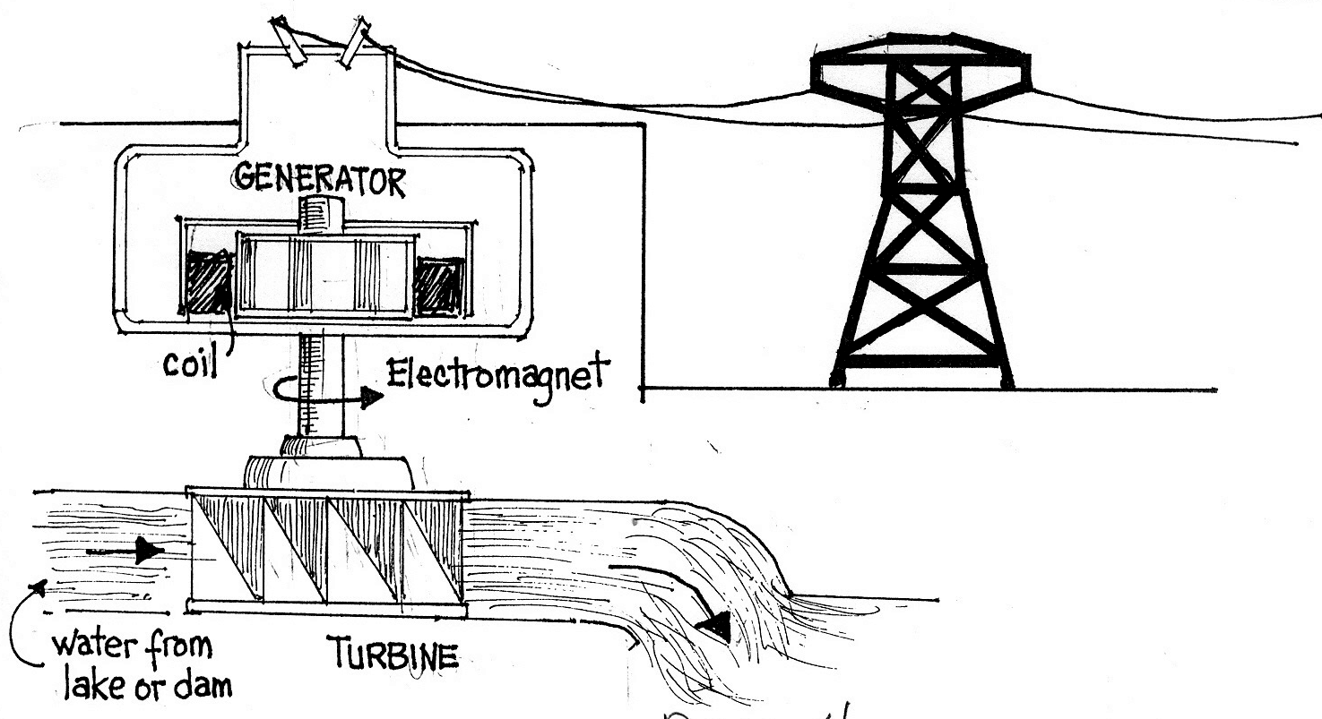

- Study the illustration.
  - What makes the turbine move? When the turbine move, the generator works.
  - What is the work of a generator?

- Study the illustration.

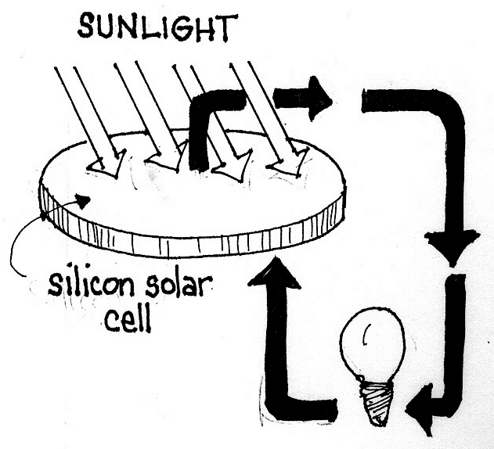

- What happens to sunlight n the solar cell?
- What changes happen to he sunlight?
- What form of energy is produced?
- What are the uses of this energy?
- Trace the energy changes

light energy ____________energy
sunlight light of bulbs

Activity 4

- Look around the classroom. Identify things that uses of show electricity.

- Study the illustration of a shopping mall below. Identify things which uses electrical energy and describe how it is used. Write your answers in your notebook.

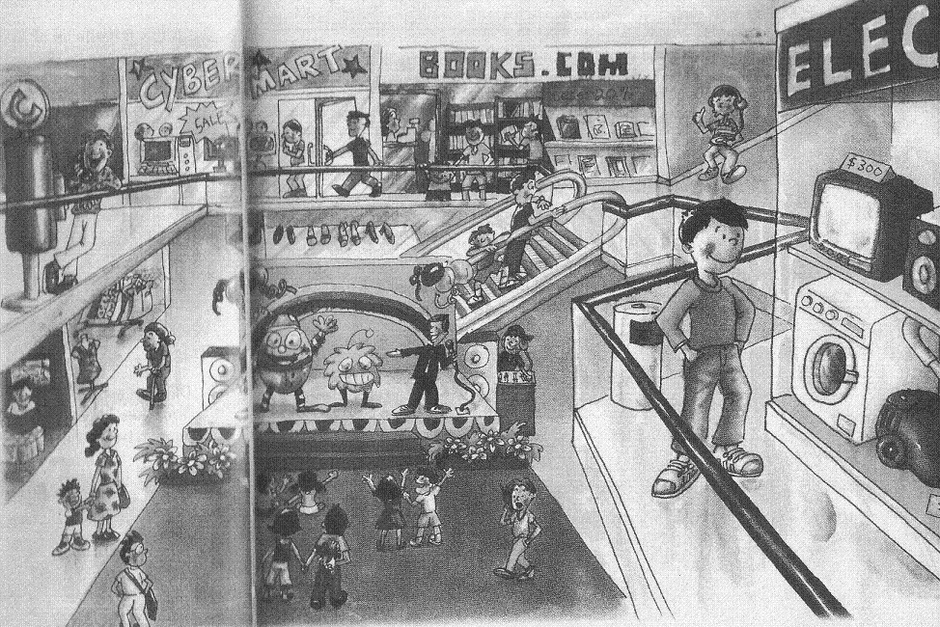

I LEARNED THAT:

- Electrical energy is formed from fast movements of electrons along wires
and other conductors.

- Electrical energy can be generated by the following: dry cell, generator, wind turbine, solar cells, hydroelectric plant, geothermal plant and others.

- Generator is a device that converts mechanical to electrical energy.

- Electrical energy has many uses.

- Enables electrical equipment to work.

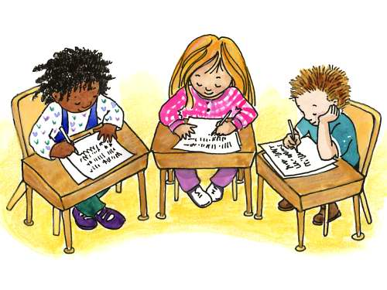

Apply It

You often see your mother wipe the electric bulb and fluorescent light. Why?



Test Yourself

*

- Choose and check the item that uses electrical energy

___ 1. floor polisher ___ 6. burning
___ 2. dancing girls ___ 7. car
___ 3. refrigerator ___ 8. wielding
___ 4. writing ___ 9. light bulb
___ 5. microscope ___10. television

B. Complete the graph. Choose the words from the box.

movement of electrons plant
moving water solar cells,
windmills hydroelectric plant
geothermal plant school

ELECTRICAL E NERGY
formed by
2.
3.
4.
5.
1.
uses

Key to Correction

Try to Recall

Exploration Time

Activity 1

Activity 2

Activity 3

Activity 4

Apply it

1.

2.

Test Yourself

- movement of electrons
2 - 6 in any order
(hydroelectric plant, solar cells, geothermal plant, windmills)

