GRADE VI
CHEMICAL CHANGE

At the end of the module, you should be able to:

- Show how chemical change take place in materials
- Observe that a new material is formed when chemical change takes place
- Observe that the product of chemical change cannot be brought back to its original form

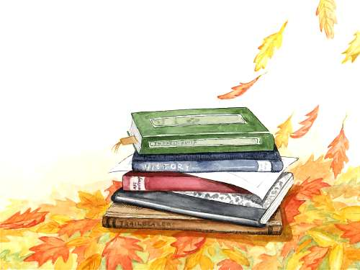

Try to Recall

Do you still remember what physical is change? Let us find it out. You may answer now the exercises below.

- Put a check mark (√) before each number if the situation shows physical change and a cross mark (x) if not. Write the answer in your notebook.

_____1. Cutting a piece of cloth
_____2. Freezing water to form ice
_____3. Melting gold nuggets to produce gold bars
_____4. Evaporating
_____5. Lighting a match stick water from uncovered container

Explore

What is your favorite fruit?

Do you know that ripening of fruits undergo a kind of change called chemical change?

Activity 1

What you need:
decayed wood or plant (Options: any rotten food, moldy bread)
rusty nail or any rusty object
scratch paper
matchstick
metal dust pan
small pot or pan
stove or candle
2 tablespoon sugar dissolve in 1 tablespoon water
tablespoon

What to do:

- Observe the decayed wood, rotten food, moldy bread and the rusty nail.
- Burn the paper in the metal dust pan.
- Put the dissolved sugar in the pot and heat on stove or candle. Taste it.

Questions:
- What made the food spoil?
- What happened to the paper after burning?
- What happened to the sugar after heating?
- What kind of changes happen?

Write your answer in a table like the one below:

Material | How it undergoes Chemical Change
nail | corrosion or
bread | fermentation
food | rotting or
paper | combustion or
sugar

Activity 2

What you need:

- plate
raw food like egg
pot half-filled with water
- nail
glass bottle with $\frac{1}{4}$ water -$\frac{1}{4}$ news paper page or scratch paper
- $\frac{1}{4}$ cup vinegar matchsticks
metal dust pan
- any unripe fruit like guava or banana
plastic bag

What to do:

1. Put a nail in the bottle with water and vinegar. Let it stay for a week. Take note of the changes
2. Let the raw food or any seafood stay on a plate for a week. Observe what happens.
3. Boil the egg in a pot. (Ask the help of your older sister or brother)
4. Burn the newspaper o a metal dust pan. (Ask the help of your older sister or brother)
5. Put an unripe fruit like guava in a plastic bag. Name it for then observe for 3 days.

Questions:

- What happened to the nail after soaking it in vinegar for a week?
- What happened to the egg after cooking?
- What happened to the paper after burning?
- What happened to the unripe fruit after 3 days?
- Did chemical change happen?
- What is chemical change?

Read and learn more.

Chemical change is a change in which substance becomes another substance having different properties
Chemical change takes place in rusting combustion decaying burning and cooking. Oxygen takes port is buring.

I LEARNED THAT:

- In chemical change, properties or characteristics of materials change.

- Materials that undergo chemical change cannot be brought back to their original form.

- Chemical change takes place through corrosion, fermentation, decomposition and cooking.

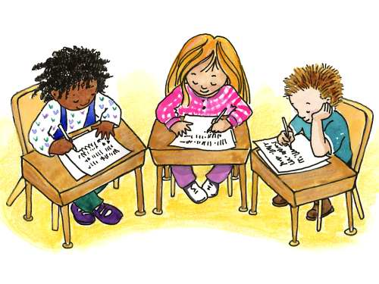

Apply It

- Write C if the situation shows chemical change and NC if the situation does not show chemical change. Write in your notebook.

1. moldy bread
2. vegetable salad
3. vinegar-making
4. wood furniture
5. hot charcoal
6. rusty doorknob

- Your window has grills. What would you suggest so they will not get rusty?

C. There is left-over food. What would you do so it will not spoil easily?

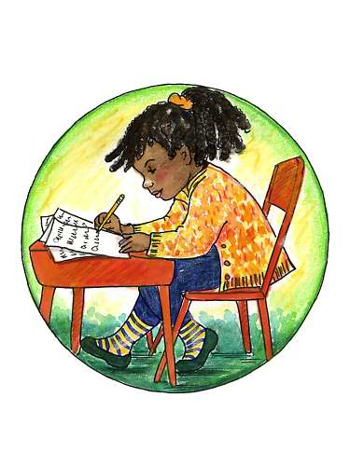

Test Yourself

*

- Copy the situation that tells a chemical change

1. spoiled menudo 5. decayed wood
2. corroded steel 6. ground pork
3. burned meat 7. ripened mango
4. cooked pancit 8. decomposing rat

- Make a table like the one below. Complete the information needed

Original Material | How it undergoes  chemical change | Product
1. pork | Cooking | adobo or sinigang
2. steel | r _ s ting | _ _ _ _
3. wood | _ _ r - ing | _ _ _
4. melon | yeast + _____ oxygen | spoiled food
5. grapes | _____ + ____ oxygen | wine
6. chicken | c_ o_ ing

