GRADE 1V
THE SKELETAL SYSTEM AND ITS FUNCTIONS

At the end of this module, you will be able to:

- Explain how the skeletal system gives the body form, shape, and support.

Try to Recall
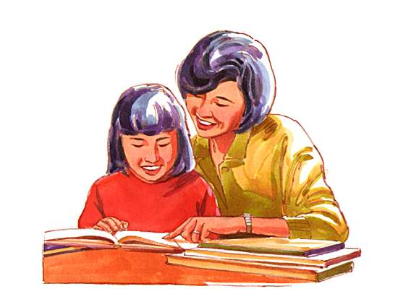

You have learned about some bones that make up the skeletal system. Try to remember them as you do the activity below.

Activity 1

Rearrange the jumbled letters in the box to form the word or words described by the group of words on the right. Write the word or words in your notebook.

1. H B O N S E I P - located just below the waist

2. S P I L A N C O M N L U – consists of 26 vertebrae

3. R B I G A C E – consists of 12 ribs on each side of the body

4. K U L S L – located at the top of the spine

Activity 2

Identify each numbered part below. Write the name of the body part in your notebook.

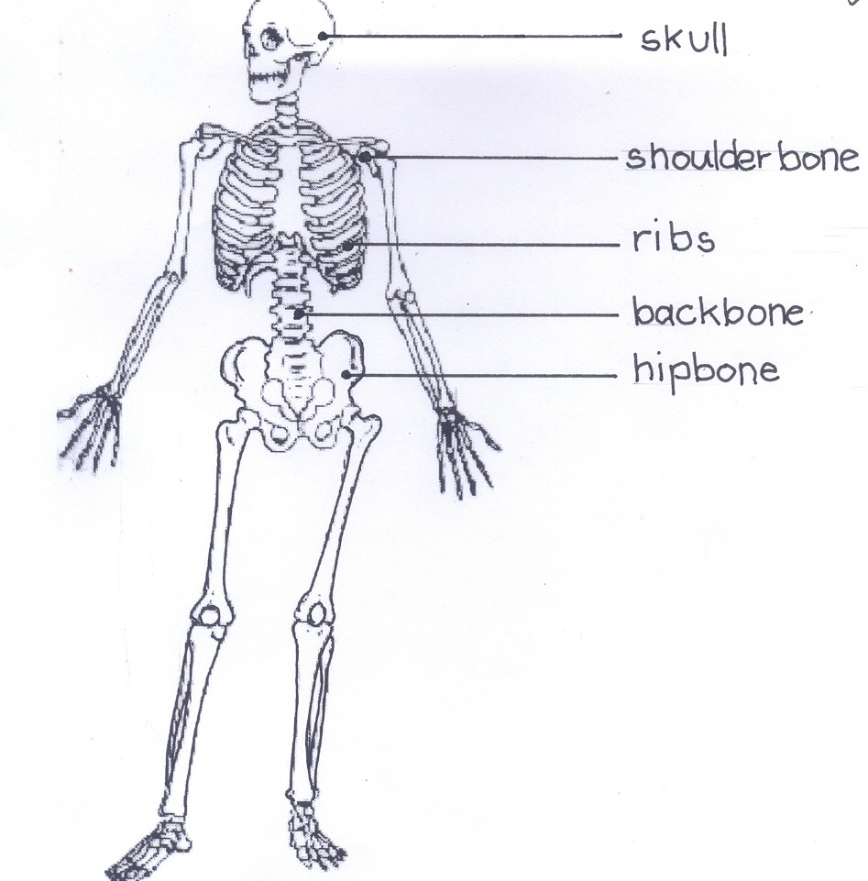
1

2

3

4

5

Explore

A.  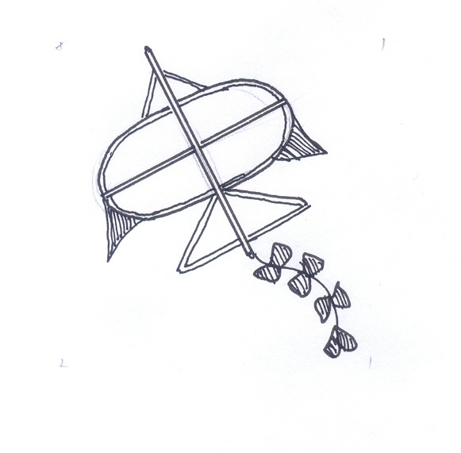 | Have you ever made a kite in a certain shape? What did you use for its frame? Where did you paste the paper to complete the kite? When the kite was finished, what shape did it have?
B.  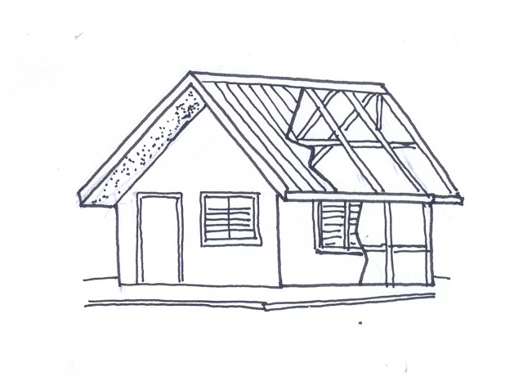 | Have you ever seen a house being built? What do you think the carpenters built first? What does it do for the house ? Does it give a definite form to the house?
C. Look at your classmates or other people around you.. You may also look at yourself in a mirror. What shape does your head resemble? your arms and legs?

Read: Framework for Shape
The skeletal system is the framework of your body. This framework is made up of rigid and strong materials called bones. The skeletal system gives shape to your body. Without it, your body will look like a paper kite without a rigid frame.

- Stand, sit, then lie down.

Did the different parts of your body in change their “ location” in your body after
you performed each movement above.?

Read: Framework For Support and Anchorage

Aside from giving shape to your body, the skeletal system also supports your body weight. Without your bones, you cannot stand, sit erect, or lie down.

Even as you move, the muscles in your arms remain in your arms. Your heart and lungs remain in your chest. This is possible because your bones provide an anchorage on which the different soft parts of your bodies remain in place.

Read and Learn More

In the human body, the skeletal system forms a strong framework for body support. The chart below lists some bones and the support they provide.

BONES | SUPPORT
Breastbone | Provides anchorage for ribs in front
Femur | Bears weight of upper body
Pelvic girdle | Supports spinal column and legs
Spinal column | Makes body straight; supports head
Shoulder girdle | Supports arms

I learned that:

- The framework of your body is made up of rigid and strong materials called bones.
- The skeletal system gives your body a form, shape, and support.

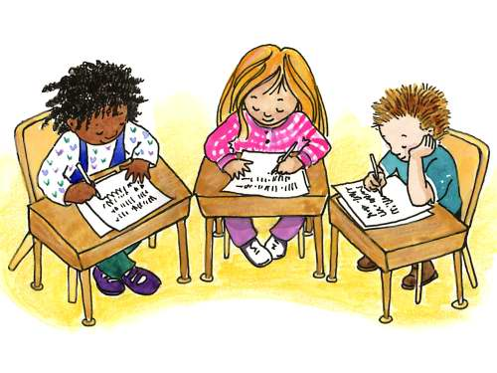

Apply It

Read each situation below. Then answer the questions briefly. Write the answer in your notebook.

1. Allan met a vehicular accident. The bone in his left arm was hit. Which bone in his body will now support his left arm?

2. Janina wrapped herself with a blanket. What shape will the blanket take? Why?

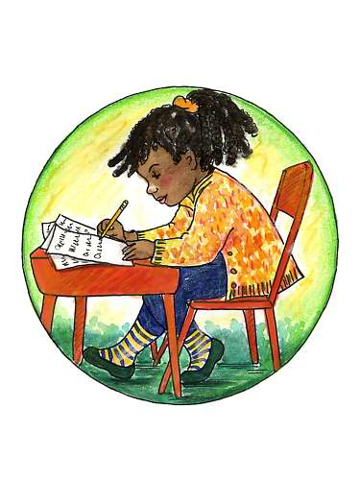

Test Yourself

A. Read each statement below. Write True in your notebook if the statement is correct. Write False if it is incorrect.

1. The skeletal system provides support to the body.
2. Without your bones, you cannot stand or sit erect.
3. Not every part of the body has shape.
4. The skeletal system does not support your body weight.
5. The skeletal system gives shape to the body.

B. Match the bone in column A with the support it provides in column B. Write only the letter of the answer in your notebook.

A | B
1. breastbone | a. anchorage for the ribs in front
2. pelvic girdle | b. bears weight of upper body
3. femur | c. makes body straight; supports head
4. shoulder girdle | d. supports spinal column and legs
5. spinal column | e. supports arms

