GRADE V
PHOTOSYNTHESIS

At the end of the module, you should be able to:

- Determine what plants need to make food
- Explain the process of photosynthesis.



Try to Recall

- Match the plant part in column A with its function in column B. Write only the letter of the answer in your notebook.

A  a. holds the plant in the ground | B
b. produces seeds

c. comes from the flowers

d. makes food for the plant

e. supports the leaves

Explore

Find out what plants need to make their food.

Activity 1

- Prepare the following

four potted plants of the same kind

1

transparent plastic
carbon paperz
cardboard or any thick paper
water

- Label the plants 1,2,3,4.

- Expose Plant under the sun and water it for a week.

- Put Plant under the sun but do not water it for a week.

- Placed Plant 3 in a dark corner. Cover one of the leaves with carbon paper or cardboard for a week.

carbon
paper/
cardboard

- Wrap one branch (with its leaves) of Plant 4 with transparent plastic. Place the plant under the sun and water it for a week.

b. Describe what happens to each plant by completing the table below. Number 1 has been done for you.

Plant | Conditions | Observations
1 | With enough water, sunlight, and air | The plant is healthy.
2
3
4

Answer the following questions based on your experiment.

1. What did Plant 1 have that allowed it to grow?
2. What was not given to Plant 2?
3. Plant 3, what did it receive? Not receive? What did you observe?
4. Is air in Plant 4 absent? What do you think will happen?
5. What pot has all the factors needed for a plant to grow?

Activity 2

- Prepare the following

Plant 3 from the activity 1
iodine (to be provided by the teacher)
alcohol in a can placed in a pan of water
dropper
scissors

- Get one leaf from the wrapped branch of the plant.
- Cut the leaf.
- Heat the leaf in the can of alcohol. Observe what happens. Observe the green coloring that is produced.
- Take out the leaf and let it dry.
- Put a drop of iodine on the leaf. Observe what happens.

Answer the following questions.
- What do plants need?
- In which part of the plant is air and water combined?
- When air and water combine, what is formed in a leaf?
- If the leaf turned bluish in color, did photosynthesis take place in the plant? Why?

Read and learn more.

- This equation shows photosynthesis:

CO₂ + H₂O + chlorophyll C₆H₁₂O₆ (sugar) O2 H₂O
sunlight starch oxygen water

Photosynthesis is the process of making food in plants it happens with the help of sunlight, water (H₂O), and carbon dioxide (CO₂). Light energy from the sun is absorbed by the green coloring in leaves called chlorophyll. Light energy is used to combine carbon dioxide and water to make sugar. Sugar provides plants with the energy to stay alive. Plants usually make more sugar than they need.
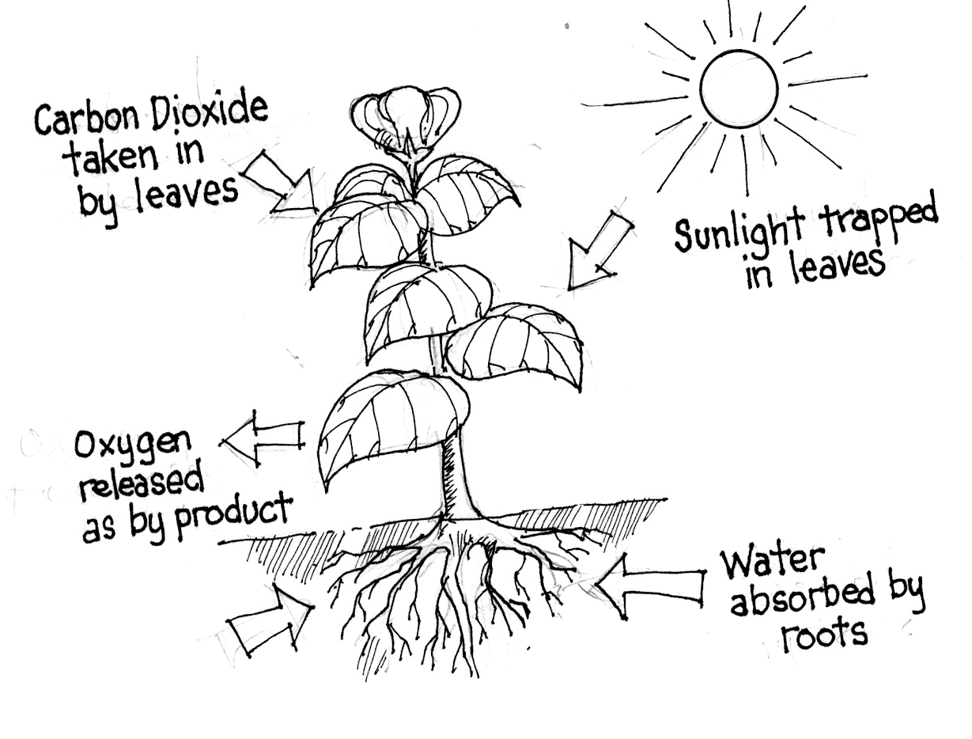
Carbon dioxide taken in by leaves

Sunlight trapped in leaves

Oxygen released as by product

The excess sugar is changed mostly into starch and stored in different parts of the plants. When we eat fruits or vegetables, we are taking in the plants’ stored energy. So plants not only make food for themselves, but they also provide food for other living things. Oxygen and moisture are by-products of photosynthesis. As long as photosynthesis takes place there will always be oxygen for all living things.

I LEARNED THAT:

Photosynthesis is the process of making food in plants. Sunlight and water is very important to manufactured food as long as Photosynthesis takes place, supply of oxygen to people and animals will be sustained.



Apply It

- Your family will leave for a week’s vacation. No one will be left behind to care for your indoor plants. What will you do?

- Explain the process of photosynthesis by writing the different steps of the process below the diagram.



Test Yourself

*

A. Fill in the blanks to explain the process of photosynthesis. Choose your answer from the rectangle.

Water enters the _____ that travels to the leaf. Meanwhile, _____ and _____ enter the leaves. With chlorophyll, these three factors form _____, the life-giving gas, together with water is produced in the process. _____ is the process of food-making in plants.
water minerals roots

oxygen photosynthesis

B. Fill in the missing letters to complete the word.
w
1. enters the roots
u
h
2. is absorbed by the leaves
i

c
r
d
x
3. goes through the leaves

h
l
o
4. makes the leaves green

s
e
5. is the process of food-making in plants

