GRADE VI
ALIMENTS OF THE CIRCULATORY SYSTEM

At the end of the module, you should be able to:

- Identify common ailments of the circulatory system(cardiovascular diseases) and their symptoms
- Practice health habits to prevent ailments of the circulatory system



Try to Recall

Complete the two blood circuits below.

- Pulmonary Circuit

Blood from (1)___________ atrium goes to the (2) __________ventricle from here

Blood flows through pulmonary (3) ___________ to the right and left (4) _________

Passing through pulmonary (5) ___________ blood centers the __________ atrium

- Systemic Circuit

Blood from (1)___________ atrium is pushed to the (2) ________ventricle, which pumps (3) ____________different parts of the body. (4) blood with entering the ________ atrium through the interior and posterior vein cava.

Explore

In the past lessons, you have learned about the parts of the circulatory system: the blood, the blood vessels and the heart including their functions. You also traced the flow of blood in a pulmonary circulation as well as in a systemic circulation.

Activity 1

Let us study the dialogue between Vonn and Dr. Gail Mendoza, a cardiologist. She is a doctor specializing in the heart and its ailments.

Vonn : Good morning, Doctor Gail.
Doctor Gail : Good morning, Vonn. What can I do for you?
Vonn : I want to know more about some ailments of the circulatory system. Will you help me please?
Doctor Gail : Sure! That’s no problem. Here are some pamphlets on cardiovascular diseases. It will help you understand your lesson.

After the visit and talk to the cardiologist, Vonn made a summary of his interview.

Here are some common heart ailments affecting the circulatory system.

High Blood Pressure or Hypertension

This is characterized by an abnormally high pressure in the arteries and increases the risk of problems such as stroke, heart failure, heart attack and kidney damage. If the blood pressure is too high, it can rupture a blood vessel and can cause bleeding in the brain or other complications.

Heart Attack or Myocardial Infarction

A heart attack occurs when blood flow to a section of heart muscle becomes blocked. If the flow of blood is not restored quickly, the section of the heart muscle becomes damaged from lack of oxygen and begins to die. This heart damage may not be obvious or it may cause severe or long-lasting problems. Severe problems linked with heart attack can include heart failure.
The most common heart attack signs and symptoms are:
- chest discomfort or pain,
- upper body discomfort in one or both arms, the back, neck, jaw or stomach,
- shortness of breath may occur with or before chest discomfort,
- other signs include nausea, vomiting, lightheadedness or fainting, or breaking out in cold sweat.

Acting fast at the first sign of heart attack symptoms can save life and limit damage to the heart.

Heart Failure (congestive heart failure)

This is a serious condition in which the amount of blood pumped by the heart each minute is insufficient to meet the body’s normal requirements for oxygen and nutrients.

Arteriosclerosis

This is general term for several diseases in which the wall of the artery becomes thicker and less elastic.
Example:

- Atherosclerosis is a condition wherein a fatty material or cholesterol accumulate under the inner lining of the arterial wall.
b) Coronary Artery Disease (CAD) happens when fat deposits accumulate in the walls of coronary artery causing a decrease of blood flowing through it, to a reduced blood, thus depriving the heart muscle with oxygen.

Congenital Heart Disease

This is aliment which result from an malformation of the muscles of the heart and major blood vessels that produces abnormality in the flow of blood. Congenital means present at birth. This develops while the baby is still in the mother’s womb.
A baby with congenital heart disease is sometimes called “blue baby”. This is because the baby has a bluish color around the lips and at the tips of the fingers and toes when he/she cries.
The following are often the causes of the disease:

a) abnormalities in the genetic material of the developing embryo
- infection of the pregnant mother through exposure to illnesses such as German measles
- smoking and drinking alcoholic beverages by pregnant mothers
d) intake of certain drugs by pregnant mothers

Rheumatic Heart Disease or Rheumatic Fever

Aliment is caused by (arthritis) and the ( carditis heart enlargement) resulting from a streptococcal infection usually of the throat.

Sore throat or strep throat is an infection caused by streptococcus bacteria which leads to rheumatic fever. When the fever is not attended, it can develop into rheumatic heart disease.

A person with rheumatic fever has swollen joints which become red and painful. There is also the swelling of face and legs; chest pains and shortness of breath.

- Anemia is a conditions in which the number of red blood cells or amount of hemoglobin in them is below normal. It is also called iron poor blood because the most common cause is not having enough iron. If one has anemia, your blood does not carry enough oxygen to the rest of the body. A person will becomes weak, cold, dizzy, and irritable.
- Hemophilia is a rare inherited disorder in which the blood does not clot normally. People who have it may bleed for a long time after an injury or accident. The main treatment is injecting the missing clotting factor in the bloodstream.

Disorders of the Blood

- Leukemia is cancer of the blood cells. It starts in the tissue that forms blood. The bone marrow makes abnormal white blood cells called leukemia cells. Leukemia cells don’t die when they should. They may crowd out normal white blood cells, red blood cells and platelets. This makes it hard for normal blood cells to do their work.

Do these in your notebook.

1. List some of the ailments or disorders belonging to the heart, blood and blood vessels.
- Complete the given table below with the needed information.

AILMENTS OR DISORDERS OF
HEART | BLOOD | BLOOD VESSEL

Activity 2

- Spot the difference on each set of pictures.

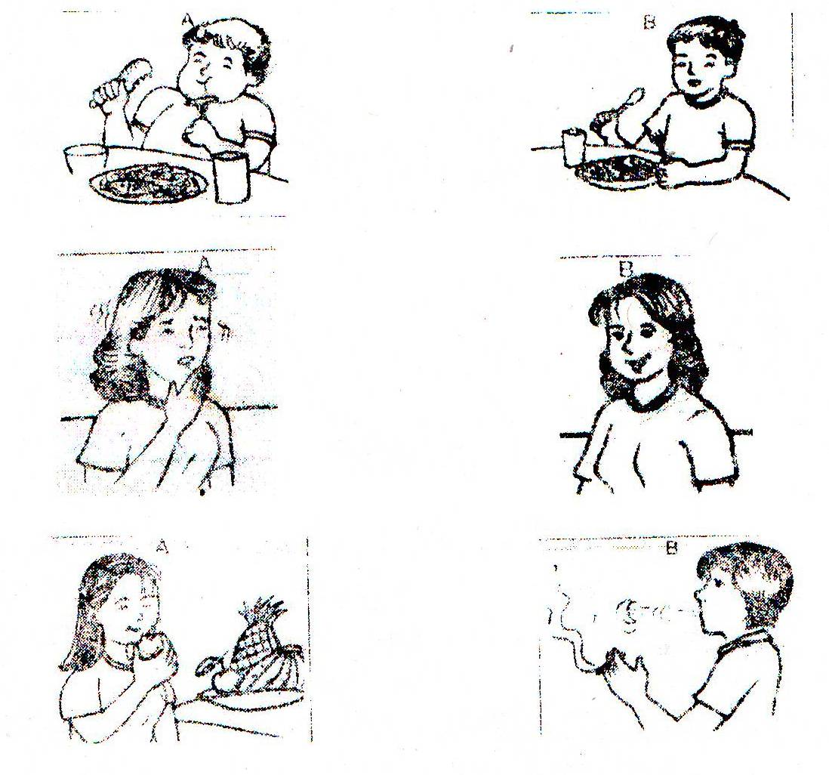
- Answer these:

- Enumerate which pictures show the proper care of the circulatory system?
2. Some of the proper ways to keep your circulatory system healthy.

Read and learn more.

Keeping the Circulatory System Healthy

Knowing about the different disorders of the circulatory and their symptoms, it is only important to keep the circulatory system healthy. How?

Here are some suggestions:

A. For Your Heart

1. Minimize your salt (sodium) intake. Too much salt may cause the development of heart disease for people already suffering from hypertension. | 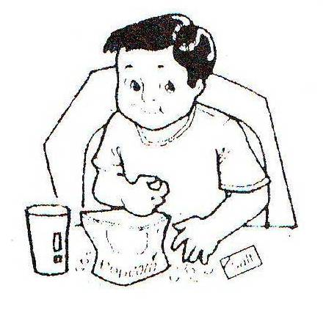
2. Get enough rest, sleep, and proper exercise.

3. Avoid activities that lead to extreme anger, too much joy, too much excitement, and unnecessary fears. All these lead to severe circulatory disorders. | 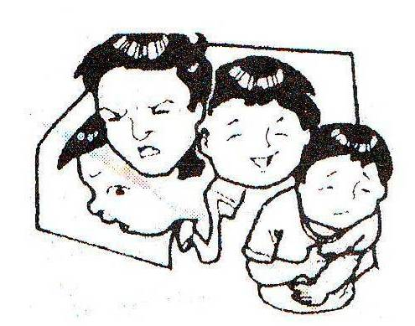

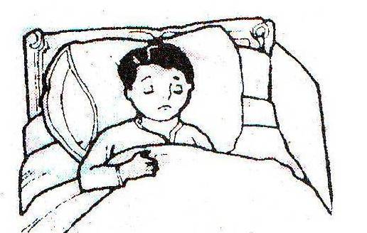

B. For Your Blood

1. Eat a balanced diet. A variety of food in your daily meals will supply the necessary nutrients your body needs to be strong. | 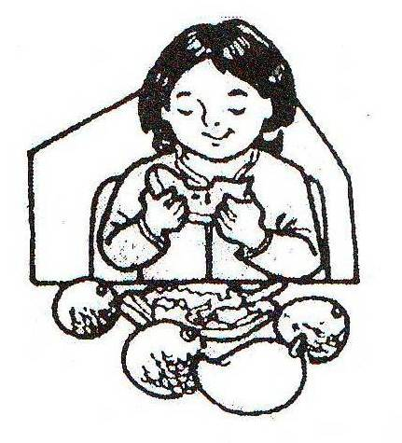
2. Avoid fatty foods. Fatty foods contain bad cholesterol. Some fats form cholesterol deposits in the blood vessels. | 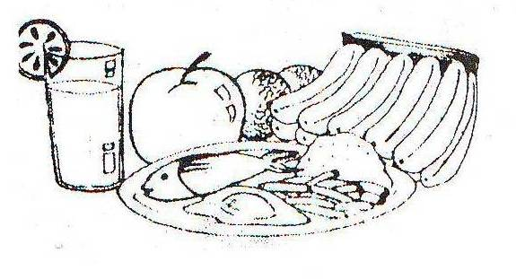
3. Avoid harmful drugs, cigarettes, and alcohol. Alcohol intake can increase blood pressure and react with blood pressure medications. People who smoke and have high blood pressure may suffer from other diseases due to complications. | 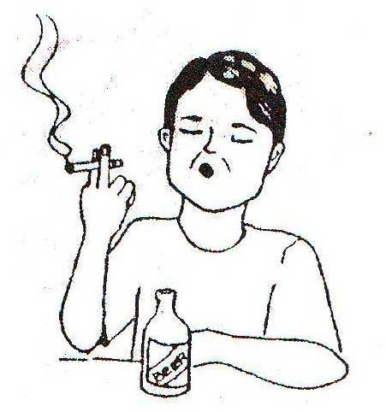
4. Avoid crowded places to prevent catching cold or flu. Take plenty of fluids, eat a balanced diet and vitamin C-rich fruits. This will increase body resistance. | 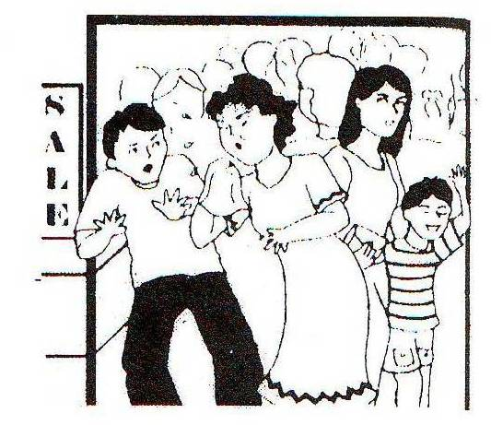

C. For Your Blood Vessels

1. Avoid standing or sitting for  long periods without stretching  or moving around. | 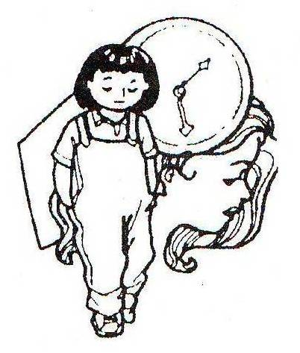
2. To avoid any infection, treat cuts and other breaks on the skin at once. | 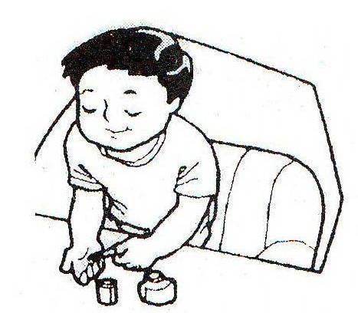
3. Wear loose clothes to avoid restriction of blood circulation. | 
4. Have a regular medical check-up. Consult a physician when you are ill. Never take unprescribed medicine.

These are all practices which should be done regularly to maintain a healthy circulatory system.



Apply It

Record your answers in your notebook.

1. Your mother is not feeling well. Her doctor says that she is suffering from coronary artery disease. What could be the symptoms of this disease?

2. Knowing the ailments of blood, what will you do so that the different blood cells (red blood cells, white blood cells) will be in the normal level or amount?

3. Conduct a survey to determine which disease or ailment is common among the children or the adults in your community or barangay.

Name of Barangay: _________________ Name of Province: ________
Name of Town or City: _______________

Put a check mark on the appropriate column.

Name of the Disorder or Disease | Common in Children | Common in Adults
A. Heart and Blood Vessels
1.Enlargement of heart
2.Congestive Heart failure
3.Congenital heart disease
4.Rheumatic heart disease
5.Hypertension
6.Arterisclerosis
B. Blood
1.Anemia
2.Hemoglobin
3.Leukemia



Test Yourself

*

- Match column A with column B. Choose the letter only.

Column A Column B

- Heart failure a. caused by a deficiency in
one of the blood clotting factors

- Anemia b. lack of red blood cells

- Leukemia c. abnormally high pressure in the
arteries

- Hypertension d. cancer of the blood; characterized by high
white blood cells count

- Hemophilia e. a serious condition in which the quantity
of blood pumped by the heart each minute
is insufficient to the needs of the body

f. inflammation of the heart and the joints

- List down three health practices that would help prevent ailments of the circulatory system.

Key to Correction

Test Yourself
A.
- right atrium
- right ventricle
- pulmonary artery
- lungs
- pulmonary vein
- left atrium
B.
- left atrium
- left ventricle
- aorta
4. right atrium

Exploration Time

Activity 1

AILMENTS OR DISORDERS OF
HEART | BLOOD | BLOOD VESSELS
hearthattack | Anemia | high blood pressure
congenital heart disease | Leukemia | arteriosclerosis
heart failure | Hemophilia
rheumatic heart disease

Activity 2
1.
- B
- B
- A

2.
- Eating a balanced diet
- Visit the dentist when the gums or the teeth are inflamed.
- Eat variety of fruits.

Apply It

- Coronary artery disease results when fats are stocked in the walls of coronary artery thus blocks the normal flow of the blood. This cause leads to a lesser flow of the blood carrying oxygen to the heart.

- I need to eat balanced diet and avoid fatty foods. I not take harmful drugs like cigarettes and alcohol. I will eat fruits and vegetables.

3.
Name of the Disorder or Disease | Common in Children | Common in Adults
A. Heart and Blood Vessels
1. High Blood Pressure or Hypertension
2. Heart attack or Myocardial Infarction
3. Arteriosderosis
4. Heart Failure (congestive heart Disease)
5. Congenital Heart Disease
6. Rheumatic Heart Disease
B. Blood
1. Anemia
2. Hemophilia
3. Leukemia

Test Yourself

- E
- B
- D
- C
- A

