TAKE A DEEP BREATH
GRADE V
TAKE A DEEP BREATH

At the end of the module, you should be able to:

- Demonstrate the mechanics of breathing using the lung-chest model



Try to Recall

Study the illustration below then identify the numbered parts of the respiratory system. Use words or phrases in the box. Write the parts in your notebook.

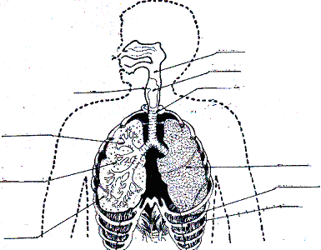

3
4
1
5

2.

7
6
}10

9
______________ 8
nasal cavity trachea lungs
epigllotis bronchi diaphragm
pharynx bronchial tube air sacs or alveoli
ribs

Were you able to label the illustration correctly? Let us see if your work is correct.

The parts of the respiratory system are:

1 – nasal cavity 4 - trachea 7 - lungs
2 - epigllotis 5 - bronchi 8 - diaphragm
3 – pharynx 6 - bronchial tube 9 - air sacs alveoli
10 - ribs

If your answers are correct you may go now to the EXPLORATION TIME page to learn a new lesson. If not, review again the parts then go directly to EXPLORATON TIME page. Good luck kid!

Explore

Making a Lung-Chest Model

Activity 1

Take a deep breath. What do you think happens to your lungs when you inhale and exhale? Find out by doing the activity below.
In the activity, you will make a lung-chest model to demonstrate what takes place as you breathe.

- Prepare the following materials:

modeling clay deflated balloon plastic bottle

scissors screw driver rubber band

tube masking tape

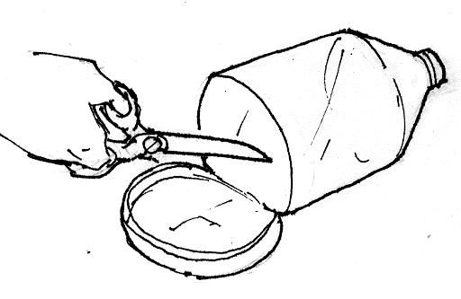
2. Cut off the bottom of the plastic bottle with a scissor. Ask an adult to assist you. Observe proper precautions.

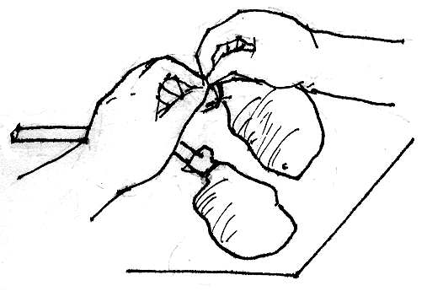
3. Cut each of the ice bags to about 2.5 centimeters in length. Using rubber bands, tie bag to end of the Y-tube.

4. Carefully insert the Y-tube through mouth of the plastic bottle. Use modeling clay to hold it in place and prevent air from entering or leaving.
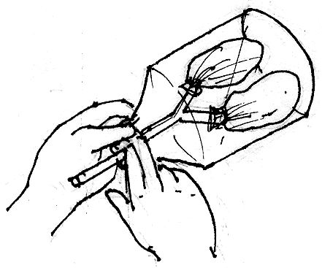

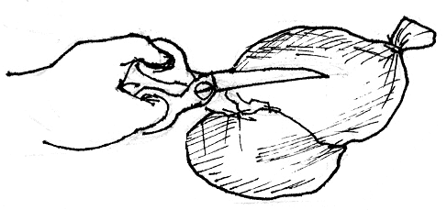
5. Cut the plastic bag or a balloon (if available), big enough to cover the open bottom part of plastic bottle.

6. Stretch the balloon sheet or the plastic sheet under the open bottom of the bottle. Use thick rubber bands to hold it in place. Tie a string at the middle of the stretched balloon sheet. or stick 2 pieces of masking tape to serve as handle.
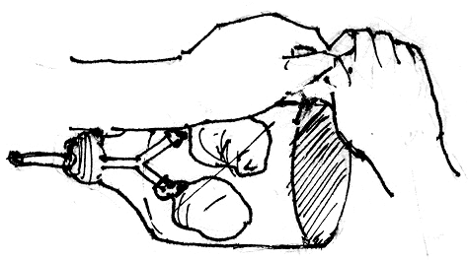

Look at the illustration. This is how your lung-chest model should look like.
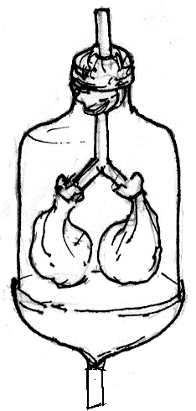

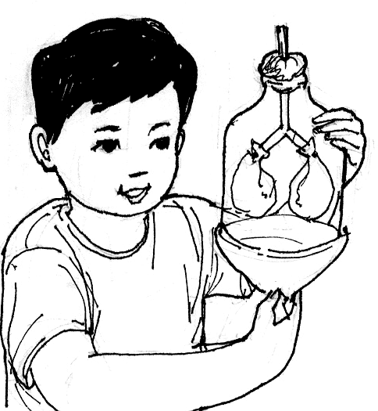
7. Pull the plastic sheet or balloon sheet downward before push it upward. Do the push-pull movement several times. Observe how the plastic bags attached to the Y-tube change in shape.

Answer the following questions.
Write your answers in your notebook.

- Study the lung-chest model. Which part represents the lungs?
- What happens to the lungs when you push the plastic sheet or balloon upward?
- What happens to the lungs when you pull the plastic sheet downward?
- In respiration, what do these movements represent?

In Activity 1, Read the paragraphs below to verify if your answers to the questions are correct.

Read and Learn More.
The lung-chest model represents the major parts of the respiratory system. The lungs are represented by the ice candy plastic bags.

When you push the plastic sheet upward, you will notice that the ice candy bags contract. This means that when you exhale, Your lungs deflate or contract and your diaphragm curves upward. This movement represents exhalation.

Once you pull the plastic sheet downward, the ice candy bags expand. This explains that whenever you inhale, diaphragm flattens. This movement represents inhalation.

You inhale a mixture of gases found in the atmosphere. This include nitrogen, oxygen, carbon dioxide and other gases in small amounts. Your body uses only oxygen. The air we inhale has more oxygen than the air we exhale. This decrease of oxygen in inhaled air shows that your body uses oxygen.

The air we exhale has more carbon dioxide showing that our body produces carbon dioxide during cellular respiration
There is no difference in the amount of nitrogen in both inhaled and exhaled air shows that our body do not use this gas neither can it produce nitrogen.

I LEARNED THAT:
√
air is drawn in and pushed out by the movement of the ribs in the chest and the muscular diaphragm.

the changes in the size of the chest cavity cause the movement of air in and out of the body.
√

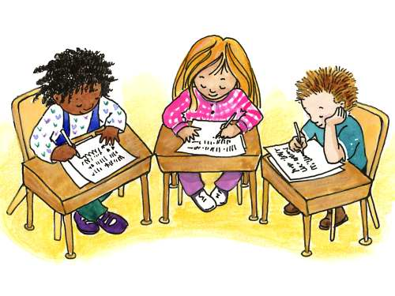

Apply It

- Label the parts of the lung-chest model to represent the major parts of the human respiratory system. Write your answer in the individual number in your notebook.

B. Answer the following questions. Write in your notebook.

- Why do you think there are more people suffering from respiratory illness the urban areas than in rural area?

- What can you do in order to avoid having respiratory illnesses?

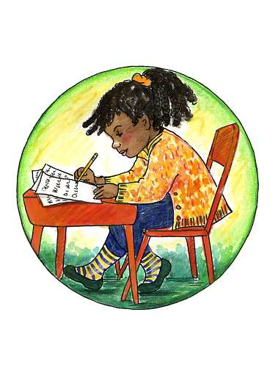

Test Yourself

- Read each sentence below. If it is correct, write true in your notebook. If it is incorrect, write false.

  - The muscular diaphragm moves when you breathe in and out.
  - The changes in the size of the chest cavity cause the movement of air in and out of the body.
  - When you breathe out, your chest muscles and diaphragm relax.
  - The size of the chest cavity does not change when you inhale and exhale.
  - The composition of the air that you breathe in remains the same even when you breathe the air out.

- Find a partner. Demonstrate to him/her the breathing process using the lung-chest model. Make sure to explain the process clearly.

