** Our Teeth**

 The doctor examined the children’s teeth in a class. He found out that more than one half of the children in the class have decayed teeth. You know that decayed teeth may prevent you from eating your food well. If you do not eat well, you may not grow healthy and strong. Try to see your dentist once a year.

Questions:

1. Why did the doctor visit the children?
2. To see if they eat well.
3. To examine their teeth.
4. To talk about their teeth.
5. Why do you think children with decayed teeth could not eat well?
6. They could not chew their food well.
7. They could not see their food.
8. They do not like food.
9. What good does visiting a dentist once a year do for you?
10. He will cure your sickness.
11. He will tell you what’s wrong with your teeth.
12. He will brush your teeth.

**Marita’s Trip To The City**

 Marita was raised in a far away barrio. There she saw no vehicles but carts drawn by carabaos. One day, her aunt took her to the city. They rode in a bus. At first, Marita was enjoying the ride. Then her head reeled, and she cried out loudly. “Oh! My head! Please stop the bus.”

Questions:

1. What do you think the people in the bus did?
2. They were angry.
3. They laughed.
4. They asked the driver to stop the bus.
5. What do you think Marita felt?
6. She felt dizzy.
7. She felt happy.
8. She felt sorry.
9. Why do you think Marita felt that way?
10. She enjoyed the ride.
11. She liked to ride in a bus.
12. It was her first ride in a bus.

It’s Monday morning and we begin with a flag ceremony in school. The pupils and the teachers are in a happy mood.

 Suddenly, a group of fifteen pupils come up the stage. They are all walking with covered noses. Everyone is wondering about what they are to do. “Will there be a play?” they asked.

The principal stands up and tells everyone to listen. Then he says, “Do you know why their noses are covered? It is because they want to show us to take care of our noses especially in dusty places. When we travel to school we should cover our noses so dust won’t enter our nose. Also avoid being near a person sneezing. Pupils, cover your noses, will you?”

 “Yes, sir, yes, sir,” shouted the children.

** Peter’s Pet**

Bibo is Peter’s pet dog. He is a wise dog. Bibo followed Peter to school yesterday. They stopped at the bakery. Peter looked at the cakes. Bibo barked at the baker. He wanted a piece of cake too. The baker placed two pieces of bread in a paper bag.

The baker said, “This bread is for Bibo.” Bibo wag his tail happily.

Bibo is an obedient dog. He can do many things. He can understand and follow what Peter tells him.

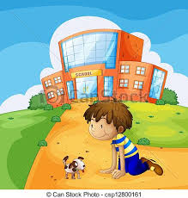

**The Funny Chick**

Red hen has ten young chicks. One of them looks funny. It has a wide bill. Her other chicks have small, narrow bills. It does not walk like a chick. It waddles. It walks like a duck. It likes to play in the water.

Red Hen feels sad when she looks at her funny chick. When she calls out her chicks, funny chick is always the last one to come.

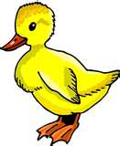 Who do you think the funny chick is?

Questions:

1. How many chicks does Red Hen have?
2. Why does one of its chicks look funny?
3. What kind of bill does funny chick have?
4. Who do you think her funny chick is?

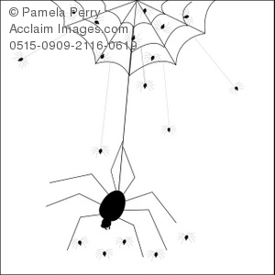**Baby Spiders and their Mother**

A spider is looking for a place to lay her eggs. She says, “I’m a big and fat spider now. I’ll be a mother spider soon. This is a good place to put my eggs.”

She puts her eggs in a little round envelope. It is a silk envelope. Then she closes envelope and hangs it under the green leaf.

The eggs are white and shiny. Baby spiders come out from the small eggs.

There are many baby spiders. Some are big and some are very small.

The baby spiders grow fast. They make their homes. Their homes are called spider webs. Some spider webs are found in the ceilings of our homes.

Some spiders grow big and fat. They become mother spiders too.

Questions:

1. Where does the spider put her eggs? Describe it.
2. What words describe the mother spider?
3. Describe the eggs.
4. Describe the baby spiders.

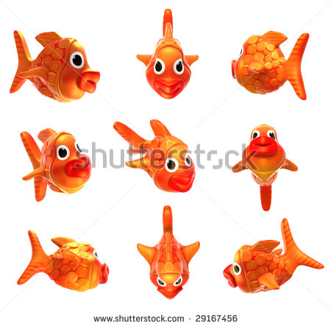 **The Little Fishes**

 Arnold and Ben went fishing one day near a lake. It was a lucky day for them. They caught many silver fishes and soon their baskets became almost full. They always throw back into the water the very little fishes which were caught in their lines. They could hardly carry their baskets as they went back home.

Questions:

1. Who went fishing one day?
2. Why do you think they return the little fishes back into the water?
3. What do you think Arnold and Ben practiced?







**Plants**

Plants are living things. Most plants are green. They have many uses. They give us food, wood and lumber, shade and shelter. Plants beautify the surroundings. Plants have different sizes. Some plants are big and tall. Others are small and short. Plants differ in shape. Some plants climb. They are called vines. Other plants are called bushes. They do not climb.

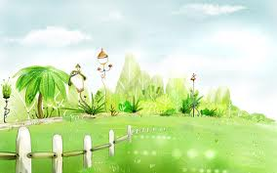 Plants have different parts. Plants have roots, trunk/ stem, leaves fruits, and flowers. Plants need water, soil, sunlight and air in order to live and grow. We can take care of plants by watering.

Questions:

1. What are the uses of plants?
2. What is the color of most plants?
3. What do you call the plants that climb? Those that do not climb?
4. What are the different parts of plants?
5. How should we take care of plants?



**The Sampaguita Girl**

Sam is a good girl. She sells sampaguita garlands during weekends. She makes her parents happy by helping them earn money. She also takes care of her baby sister when her mother is doing something. She loves watering the plants in their garden. She enjoys looking at the flowers of different colors. But she likes the sampaguita, our national flower best of all.

**Flowers**

 Some plants bear flowers, but some do not. Some plants have flowers so they can make seeds. Flowers differ in size and smell. Some are big, others are small. Some flowers have a sweet smell. Some have a strong smell. Some are odourless. Flowers are used to decorate our homes and offices. They are also offered to the Blessed Virgin Mary to show our love for her. Flowers remind us of the beauty of God’s creation and the greatness of His love.

*Questions:*

1. Why do plants have flowers?
2. Do all plants bear flowers?
3. What are the differences among flowers?
4. How do we use flowers?
5. What do flowers remind us?



I am Matt Vedan. My parents are Mr. Noel Vedan

and Mrs. Anna May Vedan. The family lives

at 1 Zond Street, Barangay Moonwalk.

I have three siblings.

Kuya Mike is the oldest. Ate Darlyn is older

than I for a year. Angel May is six years old.

We are a happy family. We do work together.

We enjoy free time together, too. God is the

center of our lives.



Questions:

1. Whose family is described?
2. Who are the members of the family?
3. Where does the family live?
4. 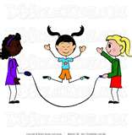What kind of family is the Vedans?



**Mang Doroy, the Carpenter**

 Mang Doroy is a carpenter. He goes to work at six o’clock in the morning. At noontime, he eats his packed lunch inside the furniture store where he works. He stops working at five o’clock in the afternoon. He reaches home at seven o’clock in the evening when the traffic is heavy.

Questions:

1. What is the work of Mang Doroy?
2. At what time does he goes to work?
3. Where does he eat his lunch?
4. When does he stop working?
5. At what time does he reaches home?
6. Does Mang Doroy work hard every day?



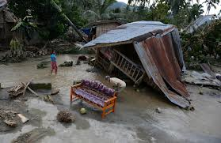**The Typhoon**

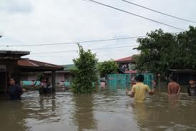Typhoon Lakay raged the last night. I could hear the wind blowing against the pine tree along our street. I could hear galvanized roofs being ripped off and blown away. Branches of trees were being blown down, too. The rain came pouring in through an old window. Everybody at home could not sleep because of the strong wind.

Questions:

1. 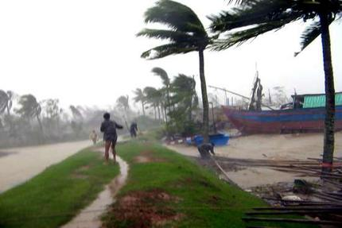What’s the name of the storm?
2. How strong was the storm?
3. Why could not the people sleep at night before?
4. What do you think was the street scene the next day?

**My Dog Bruce**

My dog Bruce loves to go to the river. Every Saturday morning I take Bruce to the park by the river to play. The first thing that Bruce does when we get there is to run down the water.

Bruce likes to take a drink and splash around. The cold water doesn’t bother him at all. When he gets out of the water, he shakes and giggles. I stand back and stay away from him so the water doesn’t get on me. Then he looks for a place under the sun to rest and take a nap. He sleeps there until I call him that it is time to go home.

I think our Saturday trips to the river are something that Bruce looks forward to all week. I, myself, look forward to doing that with him. Bruce is my best friend.

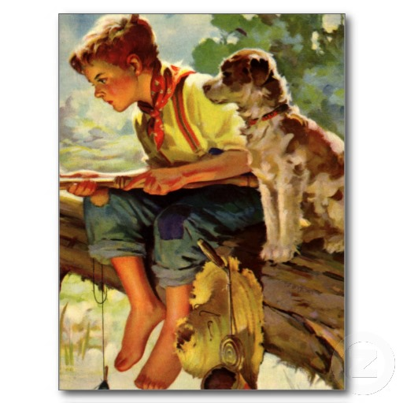

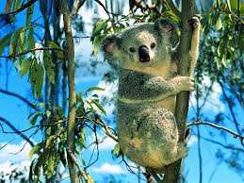

**The Koala**

 Have you seen a koala? Koalas live in Australia. They eat leaves from a eucalyptus tree all day long. They may eat more than three pounds of leaves in one day! Many people think that koalas are bears but they are not. Koalas are marsupials. Marsupials are a special kind of mammal. Marsupials have a pouch on them where their babies go to stay warm and safe. You might be able to see a koala in the zoo.

Questions:

1. Where do koalas live?
2. What do they eat?
3. What are marsupials?
4. Where we can find or see koalas?



**The Forest**

In the other side of the mountain, there was a forest. Five baby lions tromped by. “ Let’s play,” they screamed. So into the forest they went.

Four wild birds came swinging by. “let’s play,” they shouted. So into the forest they went.

Three small tigers hopped by. “Let’s play,” they wailed. So into the forest they went.

Two little squirrels wiggled by. “ Let’s play,” they said. So into the forest they went.

One big crocodile appeared. “I’m hungry,” he howled. So into the forest he went.

 Then, out of the forest came out one big crocodile! Two little squirrels, three small tigers, four wild birds, and five baby lions weren’t able to play no more!



**Kathy My Kitty**

I have a cat for a pet. Her name is Kathy. She is so little. Her mom can’t take of her, so I do. I use a baby bottle to feed her warm milk. She sleeps in my room on a soft clean blanket.

I named my pet Kathy because she is so cute and friendly. I keep her clean by giving her a bath with soap and warm water every day. She cries when her face and ears are washed.

We go out for a walk when the sun is shining. Kathy loves to run in the fields. She runs after me every time. We have so much fun running and playing around.

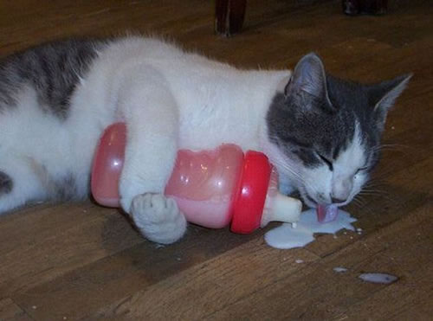 When we get tired of playing, we lie on the grass and enjoy each other. I love Kathy very much. I know she loves me too

**The Dog and the Bone**

There was a dog that found a fine bone and carried it home for his dinner. On his way, he had to walk across a thick wooden board or plank over a stream.

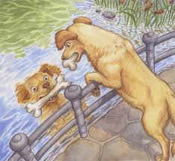 As he walks across the plank, he looked down and saw another dog in the water. He did not know that it was only his reflection in the water.

He thought that it was another dog with another fine bone, too. He wanted to have that bone, too; so he could have two bones instead of one. But when he tried to reach out for the other dog’s bone, his own bone fell into the water and was lost forever.

**Kaarawan ni Boyet**

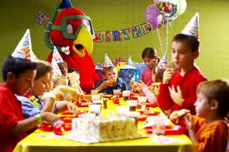 Noong Linggo ay kaarawan ni Boyet. Maaga siyang nagsimba at nagpasalamat sa Diyos. Sa hapon ay nagkaroon ng kaunting salusalo sa kanilang bahay. Maraming bisita ang pumunta. Dumating ang kanyang Lolo at Lola gayundin ang iba pa nilang kamag-anak at kanyang mga kamag-aaral.

Nagluto ng spaghetti ang kanyang ina. Nag ihaw ng hotdog at barbecue ang kanyang tatay. Ang kanyang ate naman ay bumili ng ice cream. Siyempre, hindi nawala ang kanyang paboritong pritong manok na niluto ng kanyang ninang.

 Napakaraming lobo ang binili ng lolo niya. Mayroon pa siyang payaso at pabitin. Naglaro silang lahat ng mga bisita niya. Nagsayawan at nagkantahan sila buong maghapon. Masayang-masaya talaga ang kaarawan ni Boyet.

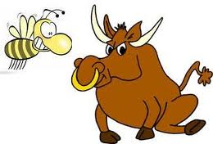

**The Bee and the Bull**

A Bull was sleeping peacefully when a bee passing by decided to sting it. Enraged at this, the bull went mad and charged toward bee hives knocked all down for revenge.

The bees were alarmed and swarmed towards the bull, the bull got badly stung. Later it said to itself, “it would have been wiser to let one injury pass than to receive so many.”

Moral Lesson: *Revenge always gives more problems*.

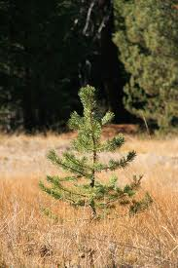

**The Little Pine Tree**

One day, the little pine tree wished its needles be changed to gold leaves and its wish was granted. After a while, a man got interested to the gold leaves and plucked all the leaves. Angry of being robbed wished for leaves of glass but soon came a storm which broken all grass leaves to pieces. Disappointed with what had happened wished for pretty green leaves. The wish was granted again but a hungry goat came and ate it all.

Feeling very disappointed realized that needles is the best and pleaded “Please bring back my needles again.”

Moral Lesson: Be contented with what you are

Being just a creature of God

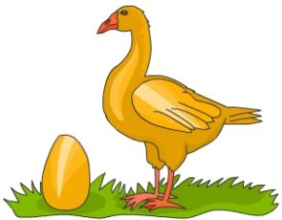

**The Golden Goose**

One day, a fairy rewarded a woman to her hard work.

The woman received a golden goose. Each day, the goose would lay a golden egg. The woman would sell the egg and buy the things she wanted.

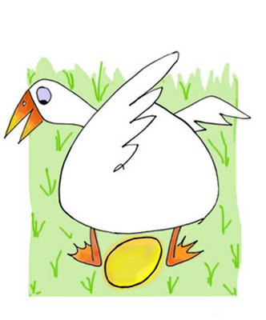 But soon the woman got greedy and wanted all the treasure at once. She cut the goose to get the entire eggs only to find that there were none inside.

Moral Lesson: In pursuit to grab everything in the end got nothing.

**The Boot in the Jungle**

One day in the jungle the bear and the wolf had an argument regarding the thing they had found.

There came a parrot pointing to the long laces commenting it’s a plant.

Listening to their argument, the monkey said it was a boot who said that it seen a man wearing such things on their feet.

 The other animals laughed at the monkey, saying “we have seen no such thing and so we can’t believe you.”

**Moral lesson**: We could not see all the things in this world. We believe in some things without even seeing it.

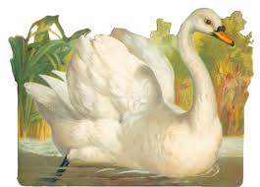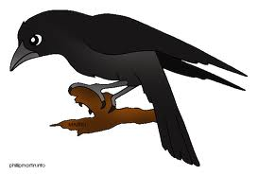

**The Raven and the Swan**

Once, a raven envied as swan its whiteness.

Every day, it saw the swan’s snow white body its desire to be as white and as beautiful as the swan grew. But it did not know how to make itself white. Then one day, an idea flashed across its mind, it thought, “The swan keeps bathing itself again and again. Maybe that’s why it is so white. Yes, I’ll also bathe myself continuously till I become as white as the swan. It did exactly that. It went on rubbing and scrubbing itself day after day, till it got tired.

Unfortunately, all it got was cold and discontentment.

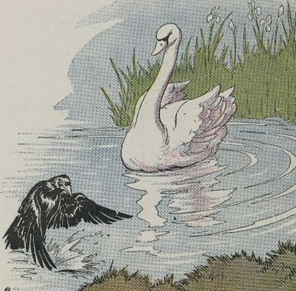**Moral Lesson**: Be contented on what you are.

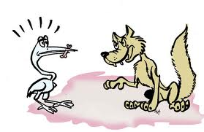

**A Wolf and a Crane**

A greedy wolf ate in a great hurry and got a bone stuck in its throat. It pleaded with a crane to remove it, promising it a reward. The crane willingly helped the wolf and then demanded its reward. But the cunning, ungrateful wolf did not keep its promise. It said that sparing the crane’s head was reward enough.

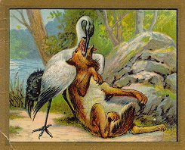**Moral Lesson**: Think well first before plunging into great decision.

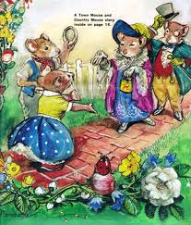

**A Country Mouse and a Town Mouse**

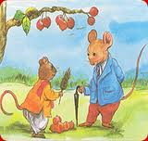Once there were two mice. One lived in the country and the other in the town. The country mouse invited the town mouse for dinner and served him the best food. But the town mouse said that the food was tasteless and invited the country mouse to his house.

At the town mouse’s house, the food was very tasty.

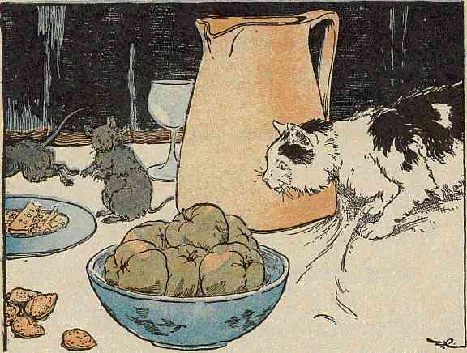But all the time, while eating, the town mouse was on the look-out for human beings and the cats trying to kill mice.

“What a miserable life you lead!” exclaimed the country mouse.” Back, in the country, at least I can eat my meals in peace. Thanks for your hospitality but I think I would like to go back home”.

**Moral Lesson**: It is easier to lead a simple life.



**A Stag and its Antlers**

A young stag was drinking at a pool. It looked at its reflection and remarked, “I have such glorious antlers; but my legs are so thin!”

Just then, the stag heard some hunters come towards the pool. It fled in terror. Its slender legs carried it swiftly away from danger.

Once inside the thick forest, it thought that it was safe. But antlers, which it valued so much, proved to be its enemy. They got entangled in the branches and no matter how hard it struggled, it could not get free. And very soon the hunters traced it there and trapped it.

**Moral Lesson**: Foolish pride is dangerous.

**A Bear and some Bees**

On a hot afternoon a bear was sleeping peacefully in the shade of a leafy mango tree. A bee that was passing by envied the bear its sleep and decided to sting it.

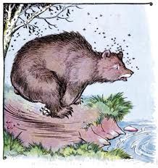Just as it was stung the bear woke up. It was so angry that it decided to knock down all the beehives in revenge.

The bees could not bear this insult and swarmed towards the bear to teach t a lesson. The beat got badly stung.

It said to itself, “It would have been wiser for me to let one injury pass than to receive so many.”

**Moral Lesson**: Often time’s revenge aggravates the problem.

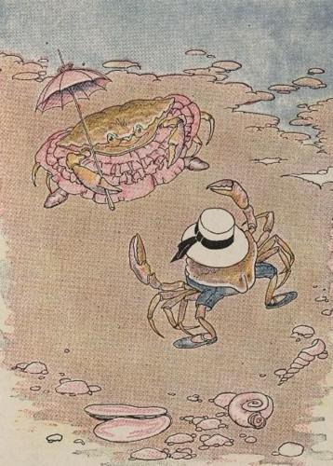

**A Young Crab and her Mother**

A mother crab, quite particular about her daughter’s grooming, was very concerned at her crooked gait. But no matter how hard she tried, the daughter was not successful in walking straight.

One day, tired and disappointed, the young crab said, “Mother, I’ve tried and tried, but with no success. Please, why don’t you show me how to walk straight?”

“Sure, this is how to do it,” said the mother, as she walked a short stretch, in a crooked line!

**Moral Lesson**: Teach a child through an example.

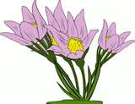

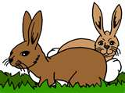

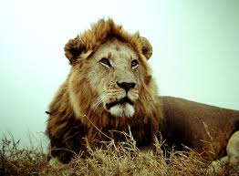

**An Old Lion**

Once there lived a lion that was cruel in the days of his youth. When he became old and weak, the entire beast in the forest treated him badly.

Some insulted him; others laughed at him still others took revenge.

He was a miserable creature towards the end of his days. But nothing has been hurting him more deeply in this time of sorrow and shame than to find himself battered by the heel of an ass.

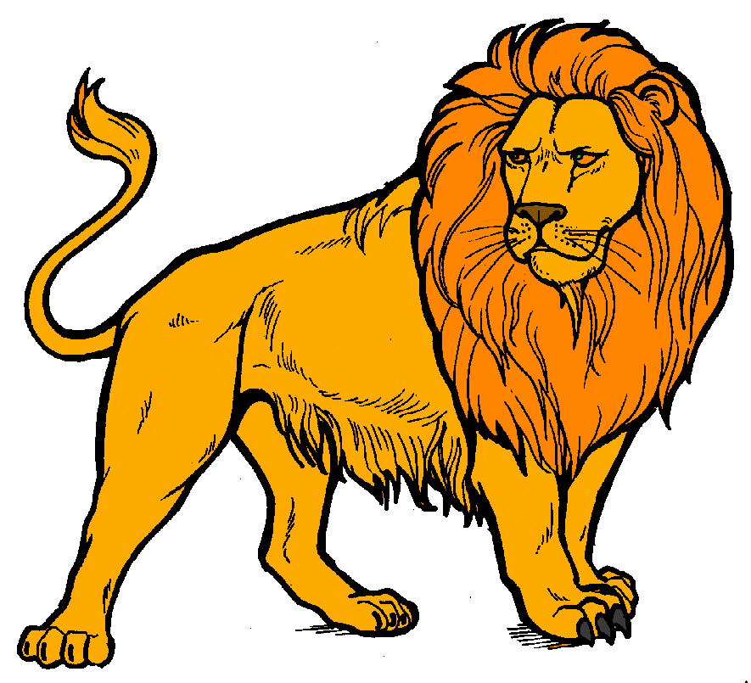**Moral Lesson**: Do not do unto others what you don’t want them to do to you.

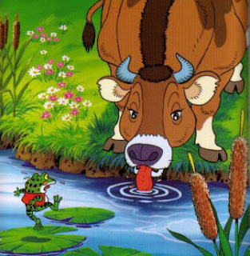

**The Ox and the Frog**

**`**

A young frog lived very contentedly till the day it stepped out of its pool. It saw a huge ox in the meadow nearby. It started envying the ox’s looked majestic because of its size.

In an attempt to become as huge as the ox, the frog took in lots of air to puff itself up. It then compared its size to that of the ox. There was still a large different.

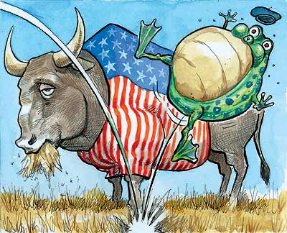 Getting annoyed at the slow progress, it breathed deeper and faster, till it puffed itself up so much that it finally burst.

Moral Lesson: Foolish pride is dangerous.

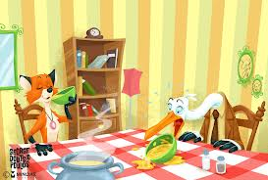

**A Fox and a Stork**

Once a fox invited a stork for dinner and served it some soup in a flat dish. Though it knew very well that some stork, with its long beak, could not feed from flat dish, it said, I hope you’re enjoying the tasty meal I prepared.”

The stork merely looked on helplessly and so the ox lapped up its share too. After a few days, the stork invited the fox to dinner and serves it food in a jug with a long and narrow neck.

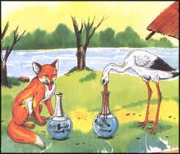 The fox realized that it was being repaid for its behaviour with the stork.

**Moral Lesson**: Do not do unto others what you don’t want others do unto you.

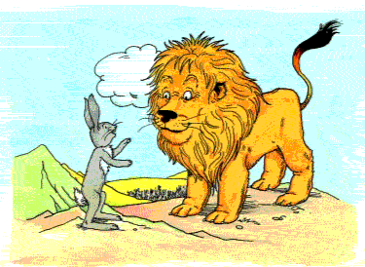**A Lion and a Rabbit**

A lion said to the animals in the forest that if one out of them came to him as his meal for the day, he would not kill anyone else among them. The animals agreed to this.

One day, it was a rabbit’s turn and it took very long reaching the lion. It said that it was stopped by another lion who claimed to be the king of that jungle. “And he wants to meet you, your lordship.” “So do I!” said the furious lion.

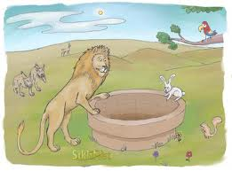 The rabbit took the lion to a well and showed it its reflection. The lion jumped into the well to chase its opponent and got drowned.

Moral Lesson: A furious mind could not think well

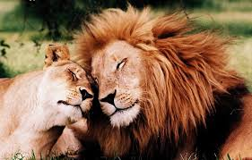

**A Lion in Love**

A lion fell in love with a country maid and asked her father if he could marry her. Though the father was frightened he kept cool. He said that his daughter was a foolish girl and that she was very afraid of the lion’s sharp teeth and claws and that she was prepared to marry the lion if he had his claws and teeth removed. The lion agreed. He went to the dentist and had his teeth pulled out and his claws removed. The next moment, the father killed the lion with a cudgel.

Moral Lesson: Love God next is you than anybody else.

**The legend of the Sun**

In the beginning, the Earth was so dark because there was nothing in the sky that gives light. The early people had to make fire using primitive way and keep bonfire day in and day out to keep them warm and to have light. But bonfire was not enough to drive away the darkness. The people called on their gods and goddesses for help.

The god of fire came down from above and created a very big ball of fire that was enough to warm and light up the surrounding. But the ball of fire was so big and so hot that everybody had to stay inside the caves to avoid being burned.

Seeing this, the god of fire threw the ball of fire up, up and away until it reached the sky.

**The Legend of the Salty Egg**

A long time ago in a town called Palanyag, house robberies were rampant. Robbers took everything of value, even a pot of rice.

One day, a farmer and his wife went to the city to visit their son who was studying there. They buried a dozen eggs in their yard so that robbers could not take it while they were away. They put a lot of salts in the pit so the eggs would not decay.

When they came back after four days, they took the eggs from the pit. The eggs were stinking and they thought the eggs were no longer fit for human consumption. But when the wife opened one of the eggs and tasted it, she found out that it tasted good. Since then, they started making salted eggs and later, painted it red to differentiate it from the fresh eggs.

**The Legend of a Lizard**

Once upon a time, there were a lovers who were very much in-love with each other. One day, the girl dared the man to prove his love to her. “Get your mother’s heart and dedicate it to me. . .” the girl ordered. Because of extreme love, he obeyed the order.

When he arrived, her mother was praying. He silently went his mother. He mercilessly stabled her mother. He got his mother’s heart and offered it to his love.

Because he was rushing, he slipped and the heart fell into the crack.

Suddenly, a voice was heard from the heart,” Why did you do this to me son?” “Why did you obey the evil intention of your girlfriend?” said the heart.

After hearing those questions, then immediately he turned into a lizard.

He became the first lizard and he never returned from being a human.

**The Pied Piper of Hamelin**

It was a bright, sunny day when a poor musician reached the town of Hamelin. He was known as the Pied Piper.

Hamelin is a town in Germany. It is famous because it is prosperous. Pied Piper went to the plaza. He sat in a stone bench and started playing his pipe. The children who were playing in the plaza gathered around Pied Piper. They wanted to listen to his music. The proud parents got angry. They don’t want their children to hang out with a poor musician. Pied Piper was hurt. All he ever wanted is to make children happy with his music.

Pied Piper went away but continued playing with his pipe. Children started to follow him. The parents called their children. Instead of obeying their parents, the children followed Pied Piper. The parents went panicky. They did not know what to do. “Stop him!” a mother begged another parent. “Stop playing with your pipe!” they begged Pied Piper. Pied Piper stopped playing. Pied Piper gave them a stern warning. “Don’t ever underestimate a person because he is poor.” “The next time you do it, you might lose your children,” he said. The people of Hamelin became kind-hearted from then on.

Questions:

1. Who is the main character in the story?

2. Who reached the town of Hamelin?

3. Where is Hamelin located?

4. Why is Hamelin famous?

5. Where did the Pied Piper sit and play his pipe?

6. Who gathered to listen to Pied Piper?

7. Why were the parents angry?

8. Who followed Pied Piper as he went away?

9. What did the panicking parents do?

10. Why did Pied Piper stop playing his pipe?

11. What lesson did the people of Hamelin learn?

**Why the Moon Shines at Night?**

One day, the moon, a small round body of rocks orbiting the Earth, noticed that the sun was lonely. She approached the sun and asked him the reason for his lack of vigor. The sun told her that he was going to the other side of the earth because the people there also needed his heat and light. He didn’t want to leave the other side without light.

The moon asked the sun if she could be of help. The sun told her that he would give her a part of his light so she could shine in this part while the sun was at the other side. “But I am so small,” replied the moon. “I can’t give them enough light.”

The sun told her it was better that way than to have no light at all. So every time the sun was at the other side, the moon would shine and give a little light.

**Why do we cook the Food we Eat?**

In the early times, people did not cook food. They eat everything raw- meat, fish, fruits and vegetables.

One night, a group of aborigines were chasing a wild boar in the forest. The boar was so strong that it ran so fast. The boar reached a cleaning that bounded on the river. The aborigines scattered themselves to prevent the boar from going back to the forest. But as they were approaching the boar, a strong lightning hit the boar.

The boar died instantly. The aborigines inspected the boar. They wanted to see if they could still take it for food. But alas, the burned boar smelled so good. They tasted it and found out it tasted so very good and delicious so they took it home. Since then, the people started cooking their food.



**The legend of Sampaguita**

Guita was a beautiful princess who fell in love with a slave named Sampa. When the cruel king learned of the affair, he was furious. He ordered Guita to stop seeing Sampa. To avoid the wrath of the king, Sampa and Guita eloped and went to the forest to hide. The king ordered his soldiers to arrest the two and killed them.

The soldiers found Sampa and Guita in the forest and killed them. They buried the lovers on the spot where they were killed. After several days, the king went to the tomb of the lovers and saw a healthy shrub with white little flowers that smelled so good. He was full of remorse because of the death of his daughter whom he himself ordered.

He called the flowers Sampaguita, in memory of Sampa and Guita.

.

**Why Firefly Have Light in their Tails?**

A long time ago, fireflies did not have light in their tails. And they went out at night only when the moon was shining. They were afraid of fruit bats. Fireflies were the favorite food of the bats. However, when the moon was bright, fireflies could freely fly around because the fruit bats could not see when it was bright.

One day, the fireflies held a meeting to solve the problem with the fruit bats once and for all. An intelligent young firefly suggested that they would carry a small torch in their tail so the fruit bats could not come near them. And so they did and the fruit bats could no longer come near them.

Since then, they always carried a light in their tails.

**The Legend of Guava**

Once there lived a young boy whose name was Bayabas. He was very kind and helpful especially to the needy. There were several fruit trees in their backyards. He would always give fruits to anyone who asked for something to eat.

One day, a hungry old woman passed by their house and asked him for something to eat. But there was not any fruit in the trees in the backyards.

There was one tree in the backyard that had so many ripe fruits. However, he could not give the fruits to the old woman because they were believed to be poisonous. Concerned with the old woman, he silently wished that those fruits could be eaten. The fairy of the forest heard his wish and granted it because of his kind heart. He then gave the old woman a basketful of ripe fruits and since then, the fruits were called Bayabas, in honor of the young boy.

**Why Do Chickens Have Crown**?

The enemies of a faraway kingdom, Batalla, were planning a surprise attack to conquer the territory. The king of Batalla called on everybody’s help to save the kingdom, the soldiers, the men, women and children and even all the animals. Preparations to counter the attack were made. However, on the night that the enemies would attack, everybody in the kingdom was fast asleep because it was a very cold night.

The enemies came at dawn but all the chickens in the kingdom crowned simultaneously, waking up the soldiers and the people. The attack was successfully repelled. In gratitude, the king put a crown on every chicken’s head.



**The Legend of the Butterfly**

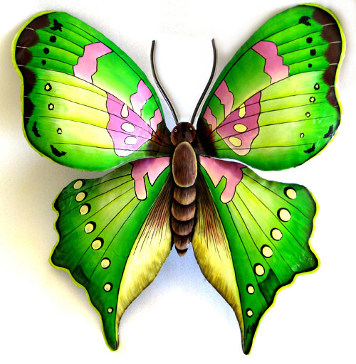A woman had a beautiful daughter she dearly loved. She worked hard to be able to give her every good thing in life. She never let her work. All that the daughter wanted was to have fun, attending parties and going out with friends.

One day, the woman got sick because of hard work. She could barely move but she got no help or concern from her daughter.

Her daughter decided to leave her but a kind-hearted fairy blocked her way and, in a sleight of her wand, changed the daughter into a colourful butterfly. When the mother looked for her daughter, she saw a butterfly fluttering among the flowers, just like her daughter who wanted nothing but fun.





** Why the Cats and Dogs are Enemies?**

Before, cats and dogs were good friends. They slept together, ate and played together. One day, the cat saw a piece of meat in a flail hanging in a clothesline. She wanted to get it but could not reach it because the flail was so high. She went to her dog friend and told him about the meat. She made him promise that once he got the meat, they would divide it between themselves. The dog agreed since it was the cat that saw the meat.

They went together to get the meat. Since the dog was big, he easily got the meat from the flail. But instead of dividing the meat between the two of them, the dog ran away and hid himself in a bush to have the meat all for itself. The angry cat sine then considered the dogs as her enemies.

**The Legend of the Mushroom**

A long time ago, some of the smaller insects like moths and mosquitoes went to a kind-hearted fairy of the forest to seek help. They complained that they didn’t have a food place to stay and sleep during the night. If they would sleep under the leaves of a tree, they were afraid to be eaten by some bigger animals that that were also sleeping n the tree, like the birds, fruit bats, and even the spiders that wove their sticky nests in the branches of the tree.

The fairy considered their situation and took pity on them. She thought of creating a new plant, a small one, so small that the birds, the fruit bats and other bigger animals would not even think of sleeping there. Thus, the mushroom came to be, a small umbrella-like plant that grew on the ground. The smaller insects rejoiced and thanked the fairy for having a good place to stay and sleep when the night fall.

**Why the Sea is Salty?**

Once there was a small village near a lake whose residents lived on making salt. Every day, the people would harvest their salts and keep them on a big warehouse. Some traders would go to the village twice a month to trade their products with salt. One day, the residents of the village heard the news that a group of bandits would come to take control of the village.

The frightened villagers decided to leave the place riding a very big boat. They took with them several sacks of salt. But a heavy rain caught up with them when they were in the middle of the sea. They had to lessen their load so that the boat would not sink so they threw all the salt into the water. They were saved but since then, the water became salty.

**Why the Lion is King in the Forest?**

One day, all the animals in the forest were having some fun. They were eating and playing. After the fun, they decided to sit down and elect among themselves who would be their leaders. Several animals were nominated to be the king but before the election was held, a strong earthquake occurred. Several trees fell down. Big rocks came rolling down from the mountains killing several animals.

When the earthquake stopped, the animals found the eldest among them trapped under a big body of rock. Everyone took turn in rescuing the old animal but to no avail. It was only the lion that was able to free the old animal unharmed using its strength and wit. When the old animal recovered, it declared the lion to be their king and all the animals agreed.

**How Malakas got his Name?**

When the first man and woman came out from the bamboo shoots, all the animals gathered around them asking their names. They could not answer because they did not know how to call themselves.

When they were conversing and while the animals were thinking of a good name to call each of them, they heard a loud and pitiful moan coming from a nearby brook. They all went to the brook and saw a lion trapped under a big rock. All the animals took turn in freeing the lion but all their efforts were wasted. The man lifted the rock very easily and threw it away and the lion was freed. Admiring his strength, the animals called him Malakas.

**How Maganda Got her Name?**

While all the animals were praising Malakas for his strength after he freed the lion from a big rock, a bird with a beautiful flower in its mouth perched on the shoulder of the woman who was created along with Malakas. The bird put the flower on the woman’s head. The woman smiled sweetly.

All the animals turned their gaze on the woman and admired her magnificent beauty which was further enhanced by the beautiful flower in her head. Malakas, too, looked at her admiringly. “You are very beautiful (maganda),” he exclaimed. Since then, the woman was called Maganda.

**The Legend of Gagamba (Spider)**

Gamba was the best weaver in the village. Everyone in the village would come to her and ask her to weave for them fabrics with intricate and colourful designs.

One day, while Gamba was away, her mother took a needle and thread from her things to sew the pants of her brother. When she returned and found out what her mother did, she was furious. She confronted her mother and showed no respect for her gray hair.

In a fit of anger, her mother cursed Gamba, saying that if weaving was the only thing important to her, then just weaves and weave and weave and forget about her mother, brother, and sister. Gamba soon disappeared and a small inset was seen in her room weaving and weaving nets. The insect was later on called Gagamba, in memory of Gamba.

**The Legend of the Lanzones**

Before, the fruits of the lanzones were thought to be poisonous. They looked delicious but nobody wanted to eat them. Several deaths in the village had been linked to eating its fruits. One day, a hungry old woman came to the village begging for food. The villagers gladly gave the old woman food, water and clothes to wear.

The old woman was awed by the kindness of the villagers. When she learned about the lanzones fruits that could not be eaten because they were poisonous, she taught the villagers the proper way to pick, peel and eat the fruits of the lanzones tree. The villagers discovered that the fruits were very edible and delicious and were not really poisonous. Since then, the villagers started planting more lanzones trees and it had become a very lucrative source of income for everyone.

**Ang Magkaibigan**

Dalawang magkaibigan ang namamasyal sa isang gubat, sina Taba at si Payat.

Sila’y nalibang habang sila ay nasa kakahuyan. Habang nasa kakahuyan sila, bigla na lang silang tinugis ng isang oso, mabilis na tumakbo ang dalawa. Agad na umakyat sa puno si Payat, samantalang naiwan pa si Taba sa ibaba ng puno. Hirap na hirap naman sa pag akyat si Taba, dahil nga sa katabaan. “Tulungan mo ako Payat! Iakyat mo ako!” ang pakiusap ni Taba sa kaibigan. Nagpilit pa rin umakyat si Taba subalit talagang nahihirapan sya. Hanggang sa naabutan na sya ng oso.

Nagkumwari siyang patay na, dahil may nagsabi sa kanya noon na hindi pinapansin ng oso ang patay na. Inamoy amoy ng oso si Taba sa mukha at sa tainga. Hindi naman halos humihinga si Taba upang magmukha na syang patay. Di pa nagtagal at umalis na ang oso. Agad bumaba si Payat. “Mabuti na lamang at hindi ka pinatay ng oso.” Ang wika nito. Bumangon na rin si Taba at tumingin kay Payat. “Parang may binubulong sa iyo ang oso, ano ang sabi niya?” ang tanong ni Payat. “Sinabi sa akin ng oso na huwag daw akong sumama sa taong pababayaan ako sa oras ng kagipitan! Kaya dyan ka na!” at umalis na si Taba pagkasabi nito.

Naiwan si Payat na malungkot dahil nawalan siya ng kaibigan. Sabi nga, tunay na kaibigan, sa kagipitan makikilala.

**Ang Alamat ng Butiki**

Noong unang panahon, may magkasintahang may wagas na pagmamahalan. Isang araw, snubukan ng dalaga na patunayan ng binata ang pagmamahal niya sa kanya. “Kunin mo ang puso ng iyong ina at ialay mo sa akin.” Utos ng dalaga sa binata.

Dahil sa matinding pag ibig, sinunod niya ang kasintahan. Nadatnan nya ang kanyang ina na nagdadasal. Dahan-dahan niyang nilapitan ito. Walang awing tinarak ng binata ang punyal sa kanyang ina. Kinuha niya ang puso ng ina upang ialay niya sa kanyang kasintahan.

Sa kanyang pagmamadali, nadulas ang binata. Nahulog ang puso sa bitak. Biglang nagsalita ang puso, “Bakit mo ako ginanito anak?” “Bakit mo sinunod ang maitim na hangarin ng iyong kasintahan?” wika ng puso.

Pagkatapos marinig ng binata ang mga katanungan ay bigla siyang naging butiki. Kaya ang binata ang unang butiki. Hindi na siya bumalik sa pagiging tao.