GRADE VI
CARING FOR THE NERVOUS SYSTEM

At the end of the module, you should be able to:

- Describe common ailments that affect the nervous system
- Practice health habits and proper care of the nervous system



Try to Recall

Answer the following in your notebook.
- What are the three main parts of the nervous system?
- What are the parts of the brain and their functions? Complete the diagram below.

Functions

B
R
A
I
N
Cerebrum

Functions

Functions

Brain ______

Explore

Activity 1

1. Read the readings thoroughly about the ailments/disorders of the nervous system.
2. Fill in the table with the needed information.

Injuries and Diseases That Affect the Nervous System

Concussion

A sudden blow on the head may cause the nervous system to temporarily lose its function. This injury is called concussion. Concussions do not cause permanent damage. To ensure fast recovery, the victim is advised to rest.

Contusion

When hard blow causes the brain or the nerves to be bruised, the injury is called contusion. A contusion may cause the victim to be unconscious for days. A contusion may also result in a blood clot in the brain. Surgery is needed to remove the blood clot.

Encephalitis

Encephalitis is a disease caused by the bite of a common mosquito which carries a virus. This virus destroys the gray matter in the brain. The disease is also called “sleeping sickness” because it causes the person to fall into a coma. A coma is a prolonged unconsciousness.

Getting rid of the breeding place of mosquitoes can help lessen the occurrence of this disease.

Meningitis

Meningitis is caused by a kind of bacteria which infect the meninges the protective layer of the brain and the spinal cord.

The symptoms of this disease are severe headache, fever and chills followed by back pains and stiffness of the neck.

Meningitis is common among children. Antibiotics are effective in fighting the bacteria that cause meningitis.

Rabies

Do you know of anybody who was bitten by a mad dog? A mad dog has the virus called rabies. When a person is bitten by a dog with rabies and the virus reached the nervous system the person will die. The symptom that person is infected by rabies is fear of water.

Rabies is very dangerous even if treatment is given to the victim he may not survive.

Epilepsy

Epilepsy is a disorder of the nervous system. An attack of epilepsy is characterized by a violent shaking of the body which lasts from 2 to 5 minutes. The muscles become tense. After the shaking, the epileptic person feels a headache and becomes sleepy.

In some children with epilepsy, an attack of epilepsy may not be characterized by violent shaking. Instead they stare blankly into space for a few seconds. Some attacks are accompanied by unusual behavior such as smacking the lips, chewing or angry outburst.

Epilepsy is believed to be caused by brain injury at birth, or by a high fever in a child, or a brain tumor.

Poliomyelitis

Poliomyelitis or polio is caused by a virus which attacks the motor nerve cells near the spinal cord. The infection causes the muscles to become paralyzed. To prevent polio, children should be vaccinated.

Cerebral palsy

Cerebral palsy is caused by a damage to the central nervous system. Sometimes it occurs before or during birth when the oxygen supply to the baby’s brain is cut off.

People affected by cerebral palsy have spastic muscles. These are muscles that are tensed and contracted. This disease can cause difficulty in walking and speaking in a person.

Exercises, special trainings, and braces all help to make cerebral palsy victims lead a normal life.

Parkinson’s Disease

This disease occurs in older person. It affects the nervous system causing the arms and legs to shake. Walking and speaking become difficult because the muscles are stiff.

Answer these question in your notebook.

- What are some injuries/ailments that may affect the nervous system?
- How can you tell that a person is having an epileptic attack?
- Why should you protect your head from being hit by a hard object?

Copy the table and fill up with needed information.

Ailments/Disorders | Body Parts Affected | Signs/Symptoms/Descriptions
1. Polio | spinal cord, legs, feet | cannot walk

You have learned about the diseases that affect the nervous system. Accidents may also affect the brain and spinal cord. Some diseases and injuries may be prevented if you observe safety precautions when playing, riding bicycles, and getting on and off any vehicle.

Activity 2

- Study each illustration then answer the questions that follow.
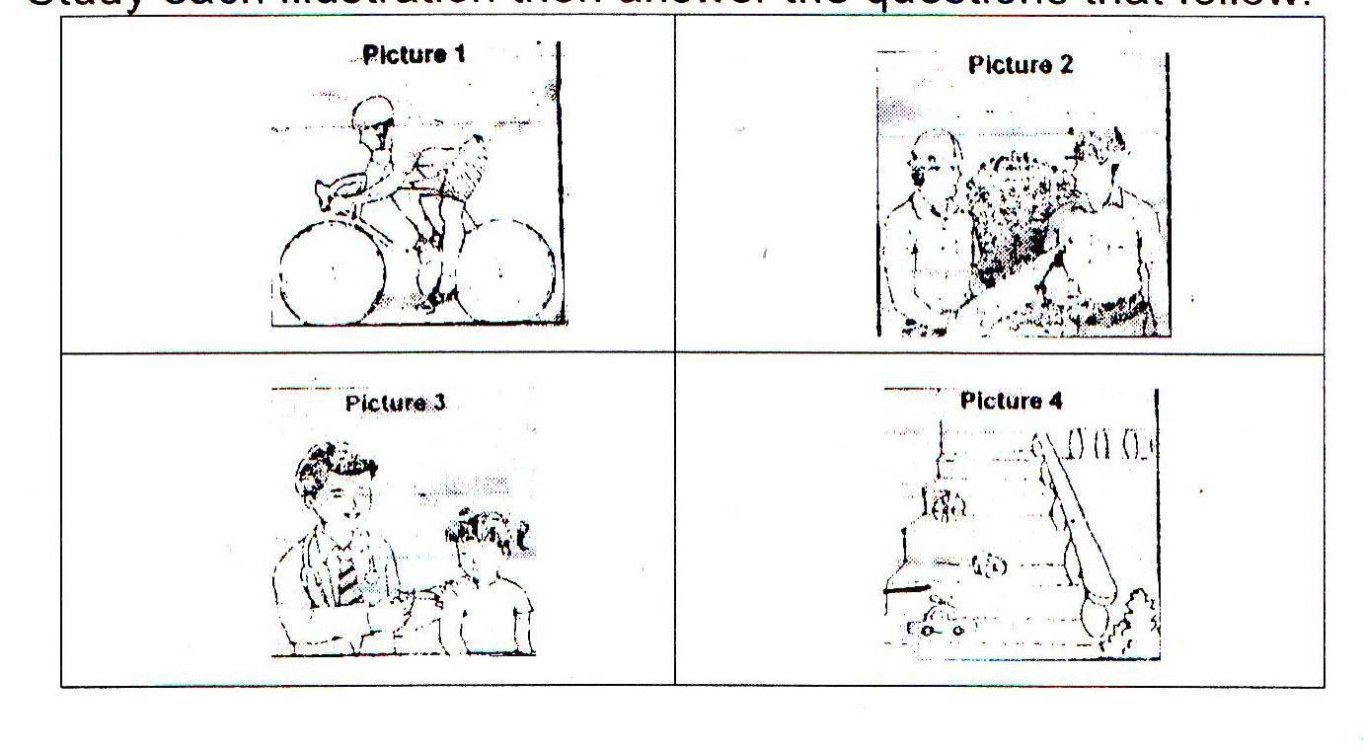

Answer these:

- What does each picture show?
picture #1 _________________________________________
picture #2 _________________________________________
picture #3 _________________________________________
picture #4 _________________________________________
- Which pictures show the proper ways of keeping the nervous system healthy? Why? _________________________________________
______________________________________________________.
3. Which pictures do not show the proper ways of keeping the nervous system? _______________________________________________
______________________________________________________.

Activity 3

Read the short selection carefully then answer the question after it in your notebook.

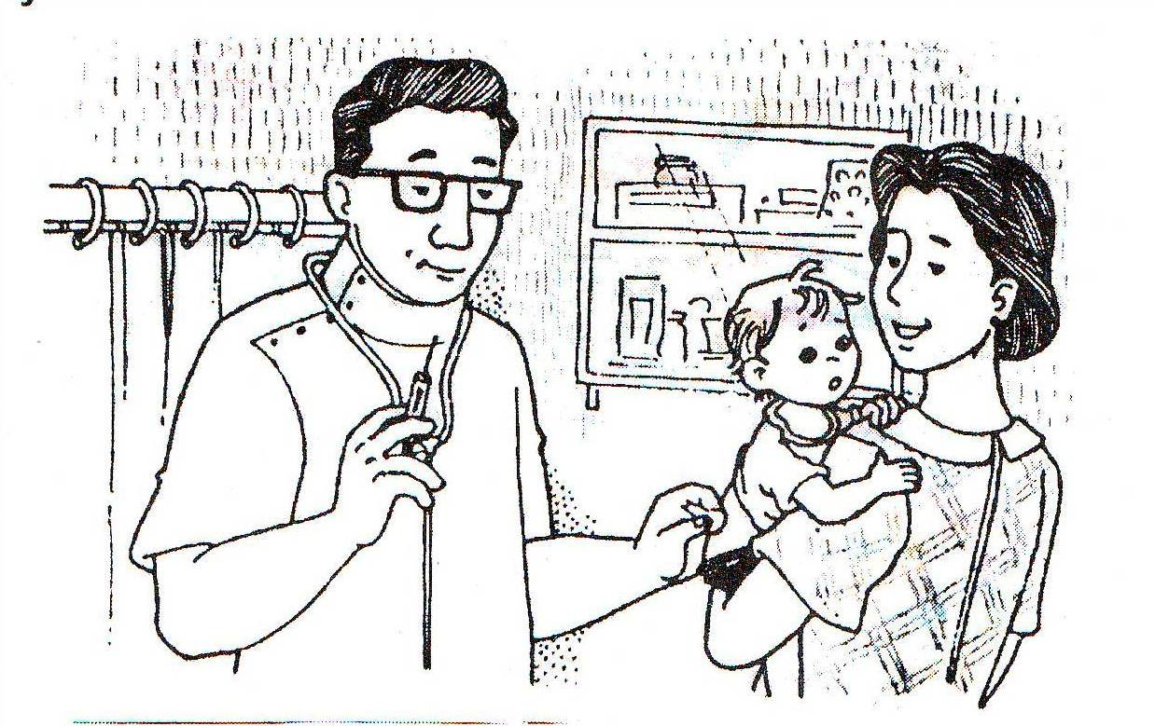

VACCINATION

Infection of the nervous system can cause lifetime damage to a person. It is therefore important that the body should be strong enough to fight infections.
Vaccination is one way to keep the body ready to fight diseases caused by infection. Children should be given anti-polio vaccines so that they will not be infected with polio. Vaccines are weakened disease-causing microorganisms. They are introduced to the body either by injection or by droplets to be taken through the mouth. Your body then generates an antibody for the polio virus. This antibody will protect you from future infections that can lead to polio.
Ask your mother if you were given vaccinations when you were still a baby or before you started going to school. What vaccinations were given to you? Was anti-polio vaccine among them.

- What causes infection of the nervous system?
- What is a vaccine? Why is it important?
- Why should babies be vaccinated?

Activity 4
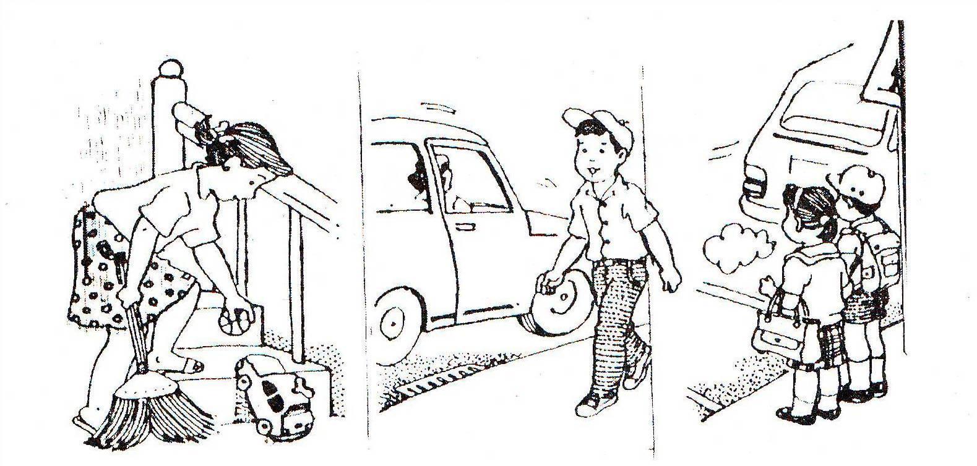

KEEPING SAFE FROM ACCIDENTS

Accidents can happen right in your own home. For example, you may fall from the stairs or slip in the bathroom. You can keep your home safe from most accidents.

Remember:
1. Keep the stairs free from things which can cause you to fall. Slippery doormats and toys should be kept away from the stairs.
2. Keep the bathroom soap in a soap tray; never leave even a small piece of soap on the bathroom floor.
- Do not put too much wax to make the floor shine.
- Keep furniture out of the way especially in places where much walking is done.

Some accidents also happen on the way to and from school. Here are a few reminders to avoid accidents on the street.

- Walk/Stay on the sidewalks, not on the street. Cross only on pedestrian lanes. Be sure vehicles are at a stop before you cross the street.
- When riding a bicycle, stay on the safe side of the street. Do not race with moving vehicles.
- Exercise care when getting on or off a bus or a jeepney. Never get off while the vehicle is still moving.

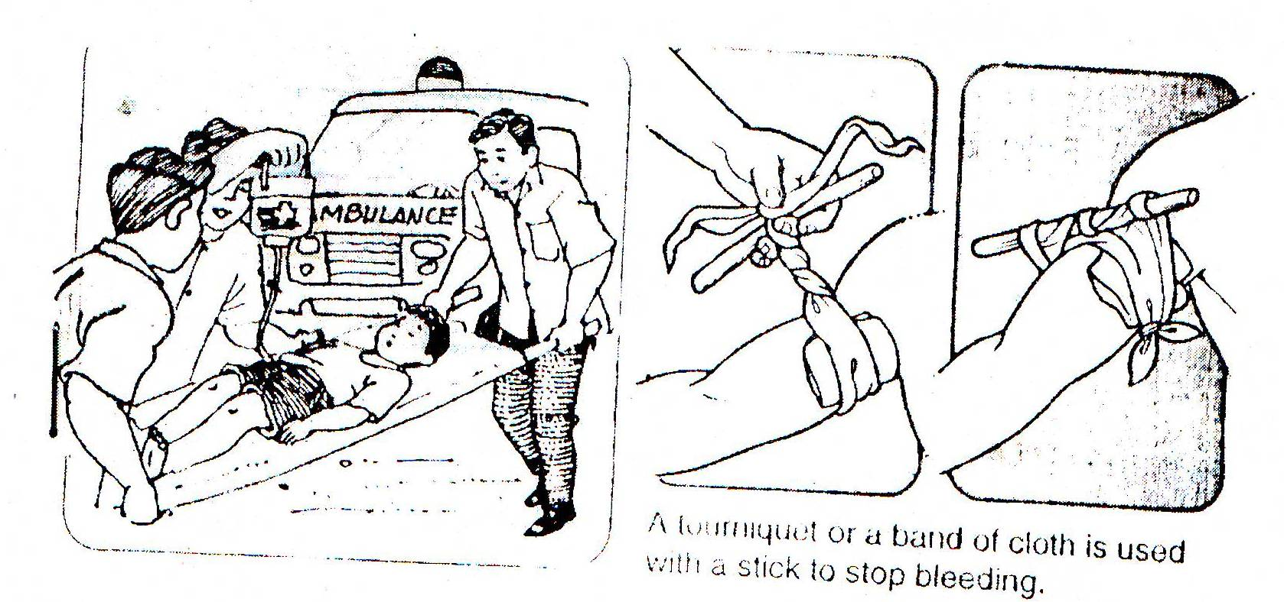

FIRST AID

Accidents may cause injuries that require first aid before a doctor arrives.

Here are some things to remember in case an accident occurs, for example, to your friend or classmate:

- Stay calm. Do not shout but try to talk or call for assistance in a normal voice.
- Never leave the victim alone. When somebody can stay with the victim, you may leave to find help.
- When there is too much bleeding, try to stop it by a using a tourniquet. (Look at the diagrams above.) Be sure the tourniquet is loosened from time to time to allow blood to flow to the rest of the body. A responsible adult should do this.
- If it is necessary to move the victim, keep the injured part still.
- If it is the neck or back that is badly injured, call for an ambulance.

Injuries that harm any part of the nervous system should be attended to immediately by a doctor to prevent further damage.

Answer these in your notebook.

- What may happen if any part of the nervous system is injured?
- How can you keep yourself safe from the accidents?

Read and learn more.
To protect ourselves from the ailments of the nervous system, we must practice the following health habits.

- Eat a balance/healthy diet. Eat foods that are rich in protein and vitamin B like beans, peas, mongo and vegetables.
- Protect your brain and spinal cord from physical damage or accidents. Observe safety measures to avoid falls and accidents.
- Maintain good hygiene to avoid bacterial or viral infections.
- Avoid drugs, alcohol, coffee and tobacco.
- Take medicines and drugs only upon the doctor’s advice.
- Learn to manage stress and tension.
- Vaccinations protects us from future infections. It is introduced to the body either by injections or by droplets.

The common ailments of the nervous system are:

- Cerebral palsy – is caused by damage in the brain of the newborn baby during birth.
- Infantile paralysis – is a disease affecting the gray matter of the spinal cord.
- Cerebral thrombosis – is the clotting of blood in a blood vessels of the brain.
- Amnesia – is the temporary loss of memory.
- Stroke – happens when the blood supply to the brain is cut off.
- Encephalitis - is the inflammation of the brain.
- Meningitis – is an inflammation of the membrane covering the brain and spinal cord.
- Epilepsy – a person experiences seizures, muscular convulsion and black outs or loss of consciousness.
- Multiple sclorosis – happens when axons cannot conduct nerve impulses or information properly.
- Alzheimer’s disease – the victim experiences memory loss,
disorientation, and difficulty with abstract thinking.
- Polio – is caused by a viral infection which destroys the motor
nerves in the spinal cord.

I LEARNED THAT:
- The common ailments of the nervous system are concussion, contusion, encephalitis, meningitis, rabies, epilepsy, polio, cerebral palsy, and parkinson’s disease

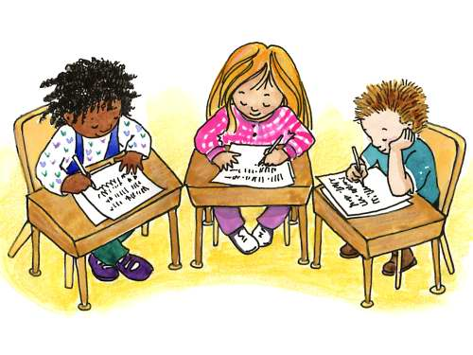

Apply It

- Alanna and her friends were playing near the street. When she was trying to get the ball back when it was thrown towards the street, a fast moving car hit her and she was thrown on the ground, her head hitting the pavement.

Predict what would happen? Then write what precaution to take in this situation.

- Jeco rides in his motorcycle in going to his work.

What does he need to wear while riding? Why must he wear it

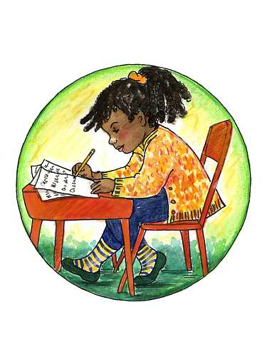

Test Yourself

*

A. Match the ailments in column A with the descriptions in column B. Write the letter of the correct answer. Write the answer on your paper/notebook.

A B

- Encephalitis A. This is temporary loss of memory.

- Meningitis B. It is caused by a virus transmitted by this
disease is also called “sleeping sickness”.

- Parkinson’s Disease C. It is caused by a kind of bacteria that
infect the meninges- the protective layer of
the brain and the spinal cord.

- Amnesia D. It is caused by a virus which attacks the
motor nerve cells near the spinal cord. It
causes the muscle to become
paralyzed.

- Polio E. It is characterized by seisures, muscular convulsions, and black-outs.

F. This disease occurs in older people. It affects the nervous system causing the arms and legs to shake.

B. Create a slogan or make a poster on health habits that will help you avoid ailments/disorders of the nervous system.

Key to Correction

Test Yourself

A.
- B
- C
- F
- A
- D

