GRADE VI
THE HUMAN NERVOUS SYSTEM

At the end of the module, you should be able to:

- Identify the main parts of the nervous system (brain)
- Describe the function of each part



Try to Recall

A. Copy this chart in your note and fill up the needed information.

Circulatory System

parts
Blood
(1) ____________
Blood Vessels

It carries (2)______ and (3)______ to the cells of the body.
It pumps blood to all parts of the body.
It serves as pathways of (4)________________.

Explore

Activity 1
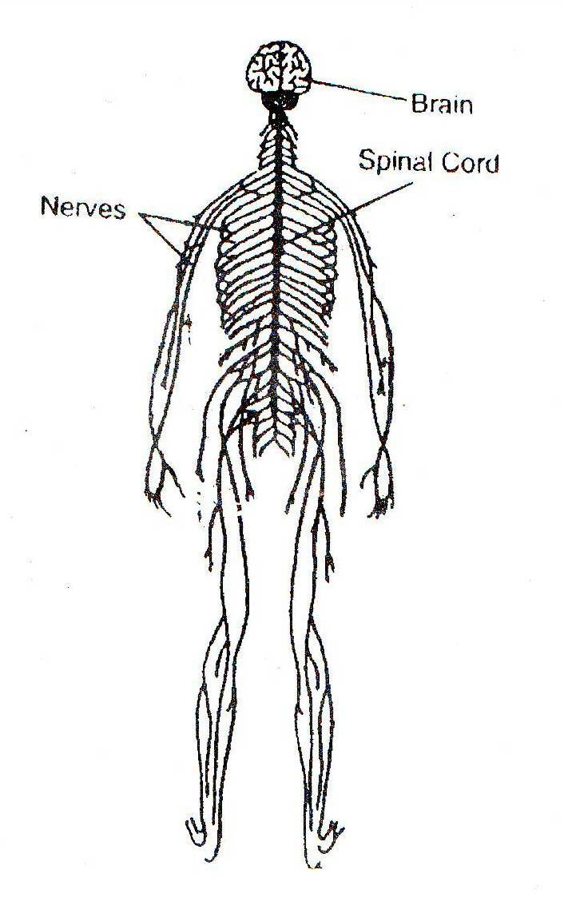
- Study the diagram of the nervous system
- Answer this in your notebook
What are the parts of nervous system?

b)
c)

- Read this information about the nervous system.

The nervous system known as the mesten control, is the communications network of the body. It controls everything we do. It is made up of the brain. Spinal cord and nerves.

The brain serves as the command center. It receives information by then, interprets it and send messages back to the part of the body that has received the stimulus (a factor capable of producing activity in an organism).

The spinal cord is the main nerve of the nervous system that extends down the back. It is enclosed in the vertebual column (a serves of small bones), or spine the spinal cords is the main pathway for messages that are received and sent by the brain.

Bundles of nerves fibers are called nerves. Nerves are the carrier of message inside the body. They carry messages from the brain to other parts of the body.

- Copy this mp and fill it up with needed information

Nervous Sytem

parts

function

Activity 2

- Study the illustration and read the notes below.
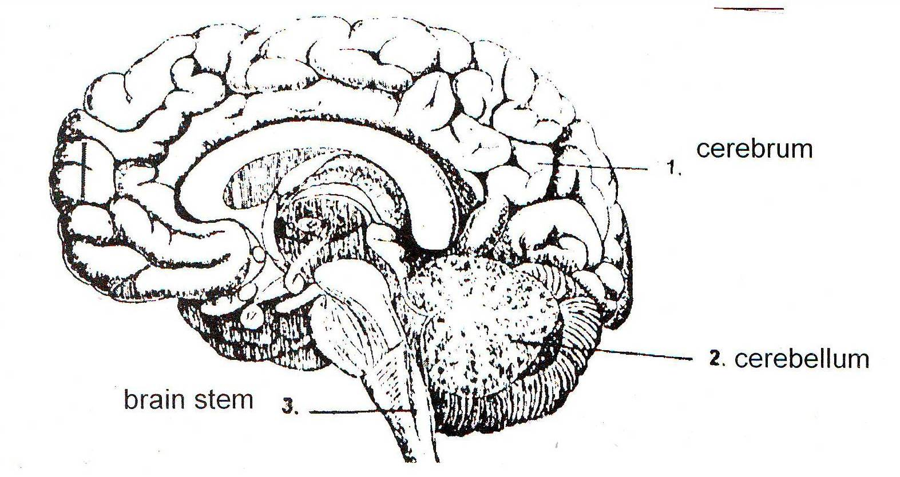

The brain has three main parts: cerebrum, cerebellum, and the brain stem. The cerebrum is responsible for controlling speech, memory and intelligence. The cerebellum controls movements and balance. The brain stem connects the brain to the spinal cord. It maintains vital automatic functions that include circulations and breathing.

1. Cerebrum
The part that receives sensory messages. It acts as the center of emotions, consciousness, learning and voluntary movement. It is also the largest part of the brain. It is divided into the right hemisphere and the left hemisphere.The right hemisphere controls the left side of the body. The cerebrum controls mental process such as thinking, memorizing and decision making. All nerve impulses must reach the cerebrum to be analyzed.

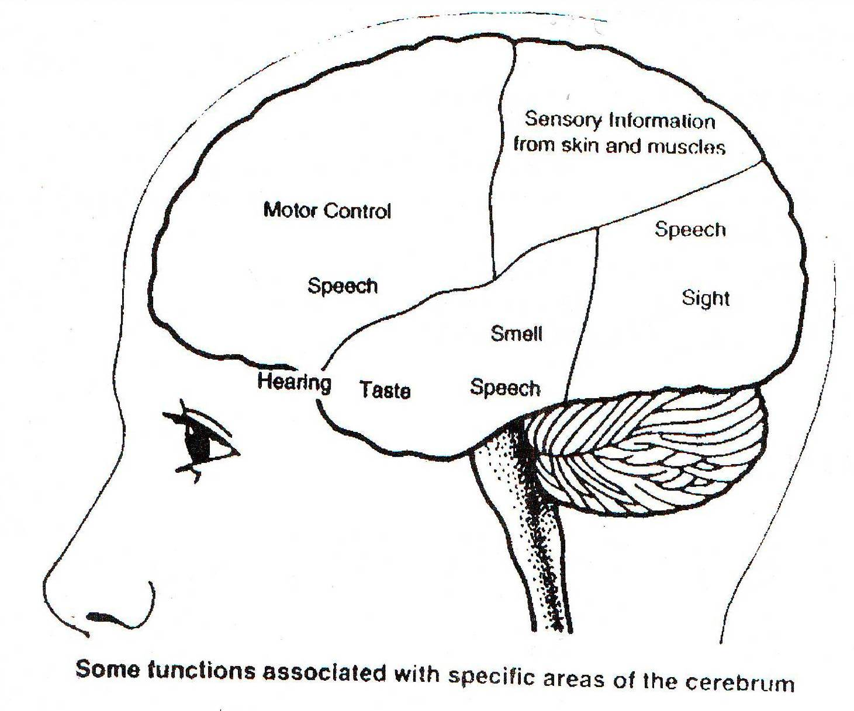

2. Cerebellum
Muscle movement is coordinated by cerebellum which means “little brain”. The cerebellum is located beneath the cerebrum. It is smaller than the cerebrum. It coordinates involuntary and muscular actions. These are necessary in many activities, including sports and athletics. The cerebellum is responsible for man’s ability to learn habits and develop skills. It also helps maintain one’s sense of balance.

3. Brain stem
The brain stem of the central nervous system contains vital centers for autonomic functions. The brain stem is the elongated area at the base of the brain. The lower part of the brain stem is called medulla oblongata. It is responsible for the control of several vital functions of the heart, stomach, diaphragm and esophagus.

Answer these in your notebook.

- What are the parts of the brain?
- What is the largest part? the second largest part of the brain?
- Which is found at the base of the brain?
- Which part of the brain enables you to memorize, reason out and make decisions?
- Which is called the “little brain”?
- What are the functions of the cerebellum?
- Which controls vital functions of the body?

Activity 3

1. Identify the part of the brain that is responsible for doing the following actions. Refer to the diagram in answering the questions.

Vision/sight Smell Taste Touch Hearing

Emotions Movement Planning Speech Heart Rate

Breathing Thinking Balance Digestion Drinking

Blood Sleep Problem Reading Eating
circulation coordination solving

2. Complete the diagram about the functions of each part of the brain.

Memory

1. Cerebrum

Coordination

2. Cerebellum

Blood circulation

3. Brain Stem

Read and learn more.
The Brain
- Brain is the control center of the body.
- Brain is a soft spongy material that is found inside the skull. It is the main mass of nerves. It receives and sends messages to all parts of the body.
- The brain has three parts: the cerebrum, cerebellum and the brainstem or medulla oblongata.
- The cerebrum is the largest part of the brain and is divided into right and left hemispheres. It is responsible for controlling speech, memory and intelligence.
- The cerebellum is located beneath the cerebrum. It is smaller than the cerebrum and is known as the “little brain”. It controls the body movement and balance.
- The brainstem or medulla oblongata is the elongated area at the base of the brain. It controls body functions such as breathing, digesting, blood flow and body temperature.

Did you know that…

- Your brain is about 80% water.
- A message can travel along nerve cells at the rate of about 100 meters per second.
- The brain of people is smarter than a computer. A computer is very fast but it cannot think of new idea by itself. It can do only what people program it to do. If the computer is out of order, it cannot do anything anymore. However, if a person has prepared a program for computation of large numbers, a computer can solve a mathematical problem very much faster than a person can.
- Your nervous system is involved in every action that you do from blinking your eyes to solving very difficult problems.
- Your senses make you aware of the things around you. You have five senses – sight, hearing, touch, smell and taste. You are able to see something because of your brain. For example, a beautiful flower stimulates the nerves of your eyes. Nerve impulses from the eyes travel to the brain. In the brain, the impulses are interpreted as pleasing or beautiful. Then you are pleased with the flower you see.
- The cerebrum is divided into two halves called cerebral hemispheres. Its surface, the cerebral cortex, is made of gray matter like that in the spine and arranged into walnut-like folds. The electrical signals of the nerve cells or neurons in the cerebral cortex can be measured and recorded by an electroencephalograph (EEG). The wave patterns produced are different when the brain is at rest and when it is thinking.

I LEARNED THAT:

- the nervous system is made up of brain, spinal cord, and nerves.
- The brain is made up of the cerebellum and the brain stem.

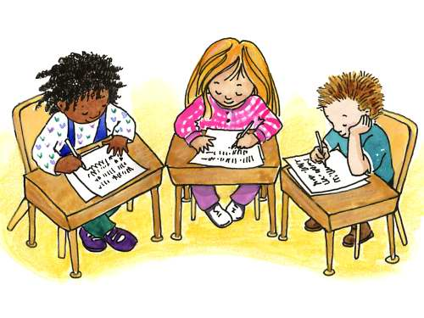

Apply It

Read the selection below and answer the questions that follow in your notebook.

The Grade Six class of La Paz Elementary School is camping at Mt. Makiling at Los Baños, Laguna. One of their tasks is to collect all kinds of rocks. While collecting rocks, one pupil accidentally slipped and fell on a big rock. By then this boy has suffered temporary loss of memory.

- What part of the boy’s brain is damaged by the accident? Why do you say so?
- Why is the brain called the control center of the body?



Test Yourself

*

A. Copy the drawing in your notebook and label the parts indented.
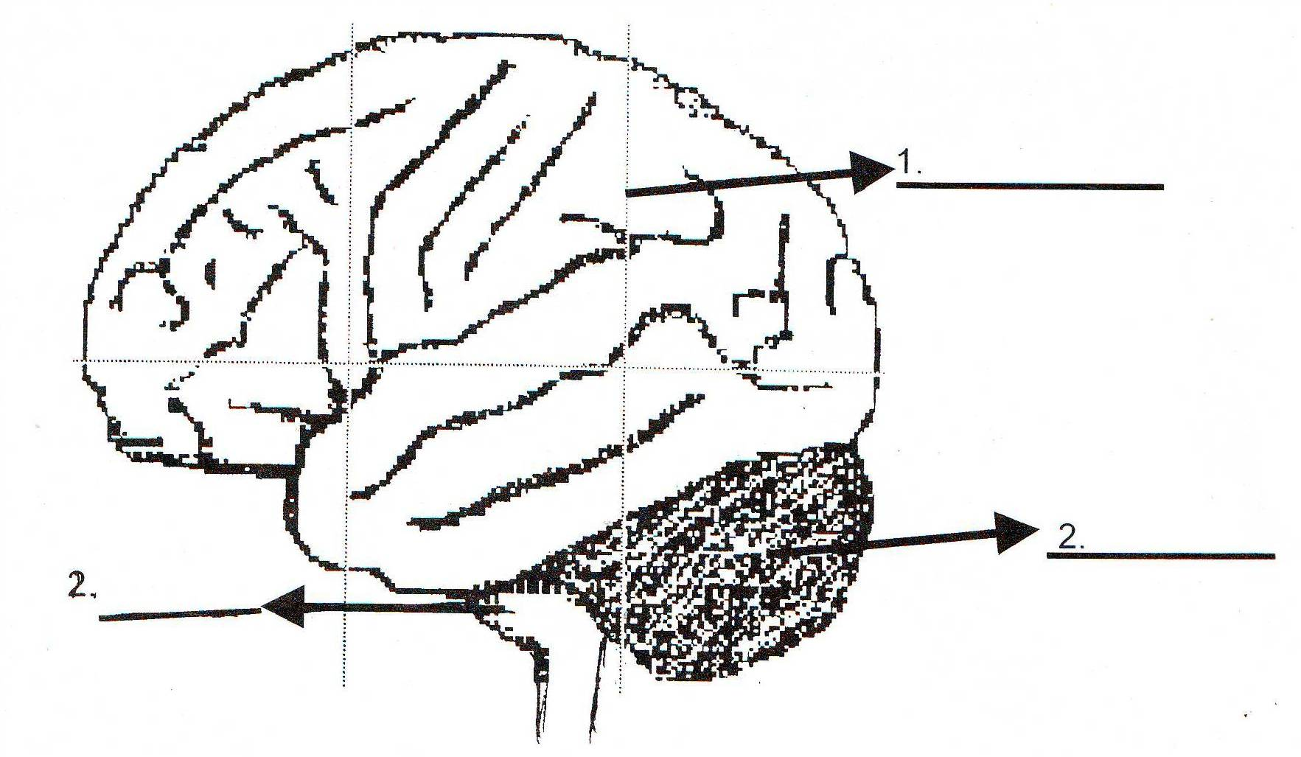

3.

- Fill in the blank with the appropriate words. Select your answers inside the box.

- The___________ is a soft spongy material that is found inside the skull. It also 2. __________ and sends messages to all parts of the body.
It has three main parts the 3. ______________, 4. _________________ and 5. ____________. Its largest part is the cerebrum which enables us to 6. __________________. 7. ______________ that coordinates our muscle 8. __________. It is also called the 9. “______________”. The third part of the brain is the brainstem or medulla. Which controls our basic 10. _____ ______.
life functions cerebellum “little brain”

cerebrum brainstem think

receives Brain memorize

movement blood heart

Key to Correction

Test Yourself

A.

- cerebrum
- brainstem/medulla
- cerebellum

B.

- Brain
- receives
- cerebrum
- cerebellum could be interchanged
- brainstem
- think
- memorize
- movement
- little brain
- life function

