GRADE V
MIXING SOLIDS WITH LIQUIDS

At the end of the module, you should be able to

- describe what happens when liquids are mixed with solids.

Have you tried mixing water and sugar? What happened to the sugar? What do you call this process? Do all solids dissolve water? Go check agreement in number.

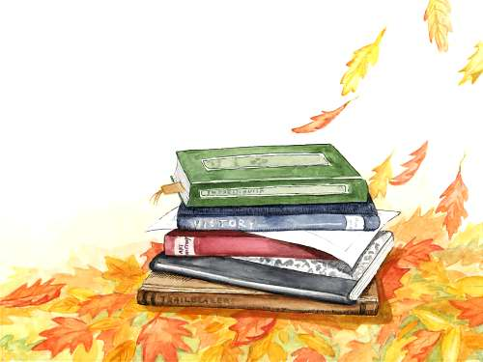

Try to Recall

- Mix each set of liquids below. Describe what happens when they are mixed.

alcohol

+

water
1.

soy sauce

vinegar

+
2.

oil

water

+
3.

- Decode each set of numbers below to come up with a word. Write the word in the notebook. Beside the word, write S or L to indicate if the word refers to a solid (S) or liquid (L).

Example:

19 1 12 20 : __S_A_L_T, S______________

- 6 12 15 21 18 : __________________________

- 23 1 20 5 18 : __________________________

- 1 12 3 15 8 15 12 : __________________________

- 22 9 14 5 7 1 18 : __________________________

- 1 3 5 20 15 14 5 : __________________________

1 = A 4 = D 7 = G 10 = J 13 = M 16 = P 19 = S 22 = V 25 = Y 2 = B 5 = E 8 = H 11 = K 14 = N 17 = Q 20 = T 23 = W 26 = Z
3 = C 6 = F 9 = I 12 = L 15 = O 18 = R 21 = U 24 = X

Explore

Activity 1

- Get samples of sugar, coffee, powdered milk, creamer, chocolate powder, powdered juice, and detergent soap.
- Prepare a spoon, 8 drinking glasses, and water. Label the glass 1 to 8. 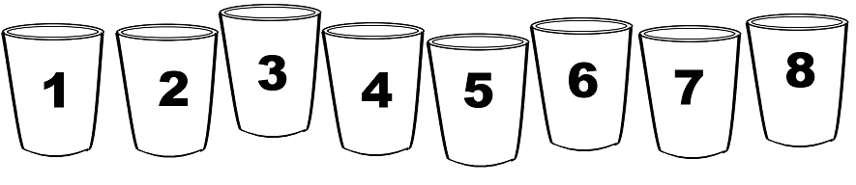
3. Fill half each glass with water.
4. Into glass 1, pour the sugar sample. Into glass 2, pour the coffee sample. Do this with the rest of the samples and glasses.
5. Mix the sample and water in each glass.
6. Describe what happen to the sample.

Activity 2

1. Prepare a glass.
2. Fill the glass with half filled water.
3. Add a spoonful of flour into the glass of each then stir.
4. Observe and describe what happens.

Activity 3

1. Prepare a glass half filled with water.
2. Add a spoonful of sand into the glass then stir.
3. Observe and describe what happens.

Activity 4

1. Prepare three solids other than flour and sand.
2. Prepare three glasses half filled with water.
3. Add a spoonful of each solid into each glass, then stir.
4. Identify how the solids reacted with the water.

Read and Learn More.

When sugar is mixed with water, the sugar seems to disappear into the water. In a process called dissolution. But sugar did not really disappear; the sugar molecules actually settled into the water molecules that it can no longer be seen, the same happens with salt. You know that sugar and salt is still there because you can taste it, even though you can not see it. The salt and sugar particles dissolve completely into the water. This clear mixture is called solution.
Other solids like detergent soap, powdered juice, powdered milk, chocolate powder and other also dissolve in water but we know it has mixed with the water because of the resulting color of the mixture. Solids that dissolve in water are called soluble materials. Solids that do not dissolve in water are called insoluble materials. For example, sand is insoluble in water. The particles of sand do not mix with the water. Instead the sand settles at the bottom of the water forming a sediment. Some insoluble solids such as flour seem to make the water appear cloudy. When the insoluble solid is spread throughout the liquid, making it cloudy, it is called a suspension.

I LEARNED THAT:

- solids that dissolve in a liquid are soluble substance.
- a solution is a kind of mixture in which the solids are completely dissolved throughout the water.
- solids that do not dissolve in liquid are insoluble substance.
- a suspension is a kind of mixture in which the solid is spread throughout the liquid, making it cloudy.
- some solids do not dissolve in a solvent and settle at the bottom of the water.

Answer the following questions.

- Marta learned that detergent bars dissolve in water, What would she do so that it would not melt?
- Rosa wants to form a clear solution that is clear. What materials should she you use? Why?
- Why do you think medicine suspensions need to be shaken before they can be taken orally?

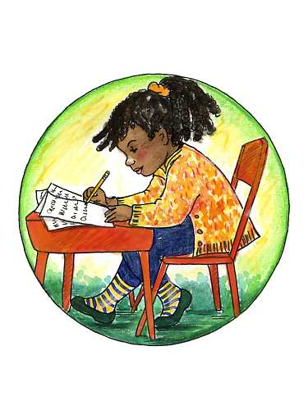

Test Yourself

- Match the word in column A with the description in column B.

A | B
a. Sediment | 1. Solids that dissolve in a liquid are to that liquid
b. Suspension | 2. Insoluble particles that settle at the bottom of a solvent
c. Solution | 3. A solution wherein no more solute can dissolve
d. d. Soluble | 4. Insoluble particles dispersed in a liquid
e. Insoluble | 5. Formed when a solid dissolves completely in liquid

B

- Given the following susbstances

chocolate powder | detergent powder | salt
pepper | Soil | flour
face powder | Polboron | powdered chalk

- Write them under the correct column in the table below, keeping in mind their reaction when mixed with hot water.

SPREAD EVENLY IN THE HOT WATER | MAKE THE WATER CLOUDY | SETTLE AT THE BOTTOM OF THE WATER

