List of Stories

1. At the beach
2. Having a Picnic
3. Jessica can cook well
4. My Family
5. Bestfriends
6. My house
7. Bob the Frog
8. A Big Cake
9. A Great Big Fox
10. Underground Town
11. Picnic Time
12. Little blue Bird
13. Halloween Fun
14. My Camping Trip
15. Bedtime
16. A Hike with Spike
17. I Can Zip
18. Jack Loves Adventure
19. Painting
20. Eva and Pat
21. Going to School
22. Whitney and Whistler
23. Here Comes the Band
24. Marita’s trip in the City
25. Our Teeth
26. The Funny Chick
27. The Little Fishes
28. Flowers
29. Mang Doroy The Carpenter
30. The Koala

# At the Beach

Jane went on vacation to the beach. She likes to play in the sand. Her brother likes to jump over waves. Her favorite thing to do is find sea shells.

**Questions:**

1. Where did Jane go on vacation?
   1. to the mountains
   2. to the beach

1. What does her brother like to do?
   1. jump over waves
   2. play in the sand

1. What is Jane’s favorite thing to do?

# Having a Picnic

Franklin went on a picnic with his family. They packed lots of food to eat. They sat on a blanket. It was a nice day. Franklin had a great time.

**Questions:**

1. What did Franklin do with his family?
   1. have a picnic
   2. write a letter

1. What did they bring?
   1. toys
   2. food
2. What did they sit on?
   1. blanket
   2. chairs

# Jessica can cook well



Jessica can cook well. Every Sunday she makes breakfast for everyone. She cooks eggs, bacon, and pancakes. Everyone in her family thinks she makes the best pancakes.

**Questions:**

1. On what day does she make breakfast for everyone?
   1. Sunday
   2. Monday
   3. Saturday
2. What does she cook for breakfast?
   1. Bacon
   2. Pancakes
   3. All of the above
3. What does she make really well?
   1. Bacon b. pancakes c. egg

# My Family

I love my family. There are five people in mmy family. I have one brother and one sister. My brother is seven and my sister is two. My mom and dad make the rules for my family. My little sister gets in trouble sometimes. Our favorite thing to do as a family is to play games together.

**Questions:**

1. How many people are in the family?
2. How old is the sister?
3. Who gets in trouble sometimes?
4. Who makes the rules?
5. What does the family like to do best?

# BESTFRIENDS

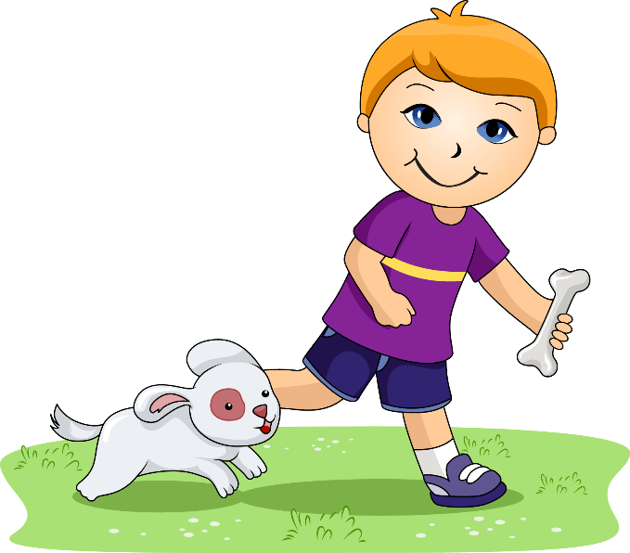

Jack is a seven year old boy who loves adventure. He likes to climb trees and find interesting bugs and leaves in his backyard. He also likes to play with his dog, Daisy. Daisy is a two year old yellow lab mix. Jack and Daisy are best friends.

**Questions:**

1. How old is Jack. He is _________________.
2. What does Jack loves to do in his backyard? He likes to ________________________________________.
3. What kind of dog is Daisy? She is a _____________________

# My House

My house is where my family lives. It is blue. There are four bedrooms. We have a kitchen and three bathrooms. Our family room is where we like to watch television together. When people come over, we eat in the dining room. We have a playroom in the basement. We have a swing in the backyard. I love my house.

**Questions:**

1. What is the color of the house?
2. Who lives in the house?
3. How many bedrooms are there in the house?
4. What is in the backyard?
5. What happens in the family room?

BOB THE FROG



Bob is a frog. He hops on a log. Hop, hop. The log is hot! Bob hops off the log. He plops in the pond. Plop, plop. Bob flops back on the log. Flop!

**Questions:**

1. Who is Bob?
   1. Dog
   2. Fox
   3. Frog
2. Where did Bob hop?
   1. Pond
   2. Fog
   3. Box
3. Where did Bob flops back?
   1. Bug
   2. Log
   3. Tad

# A BIG CAKE

My house is where my family lives. It is blue. There are four bedrooms. We have a kitchen and three bathrooms. Our family room is where we like to watch television together. When people come over, we eat in the dining room. We have a playroom in the basement. We have a swing in the backyard. I love my house.

**Questions:**

1. What is the color of the house?
2. Who lives in the house?
3. How many bedrooms are there in the house?
4. What is in the backyard?
5. What happens in the family room?

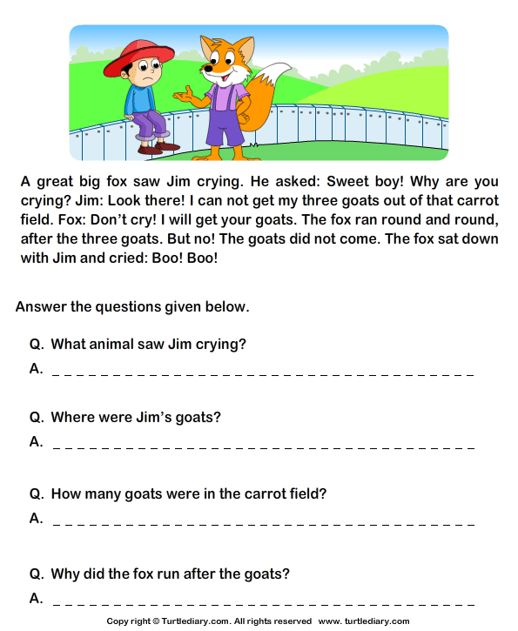A GREAT BIG FOX

Bob is a frog. He hops on a log. Hop, hop. The log is hot! Bob hops off the log. He plops in the pond. Plop, plop. Bob flops back on the log. Flop!

**Questions:**

1. Who is Bob?
   1. Dog
   2. Fox
   3. Frog
2. Where did Bob hop?
   1. Pond
   2. Fog
   3. Box
3. Where did Bob flops back?
   1. Bug
   2. Log
   3. Tad

# UNDERGROUND TOWN

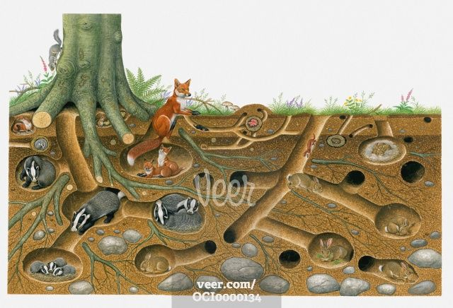Have you ever seen a prairie dog town? That is where prairie dogs live. But this town has no buildings or houses. Prairie dogs live underground. They dig deep into the earth to make tunnels. Along the tunnels are rooms for sleeping or storing food. One room is lined with grass for the babies.

**Questions:**

1. What is a prairie dog town?
   1. Underground town
   2. Bee hive
2. What did they do to make a prairie dog town?
   1. Build b. Dig
3. What can you see along the tunnels?
   1. Rooms b. classrooms

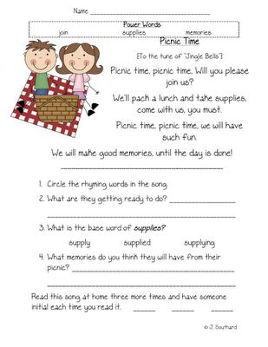**PICNIC TIME**

Picnic time, picnic time will you please join us?

We’ll pack a lunch and take supplies

Come with us you must.

Picnic time, picnic time

We will have such fun

We will make good memories

until the day is done.

1. Circle the rhyming words in the song.
2. What are they getting ready to do? ___________________________________
3. What is the base word of supplies? Supply supplied supplying
4. What memories do you think they will have from their picnic? ____________________________________
5. Read each song at home three more times and have someone initial each time you read it. _______ _______ _______

**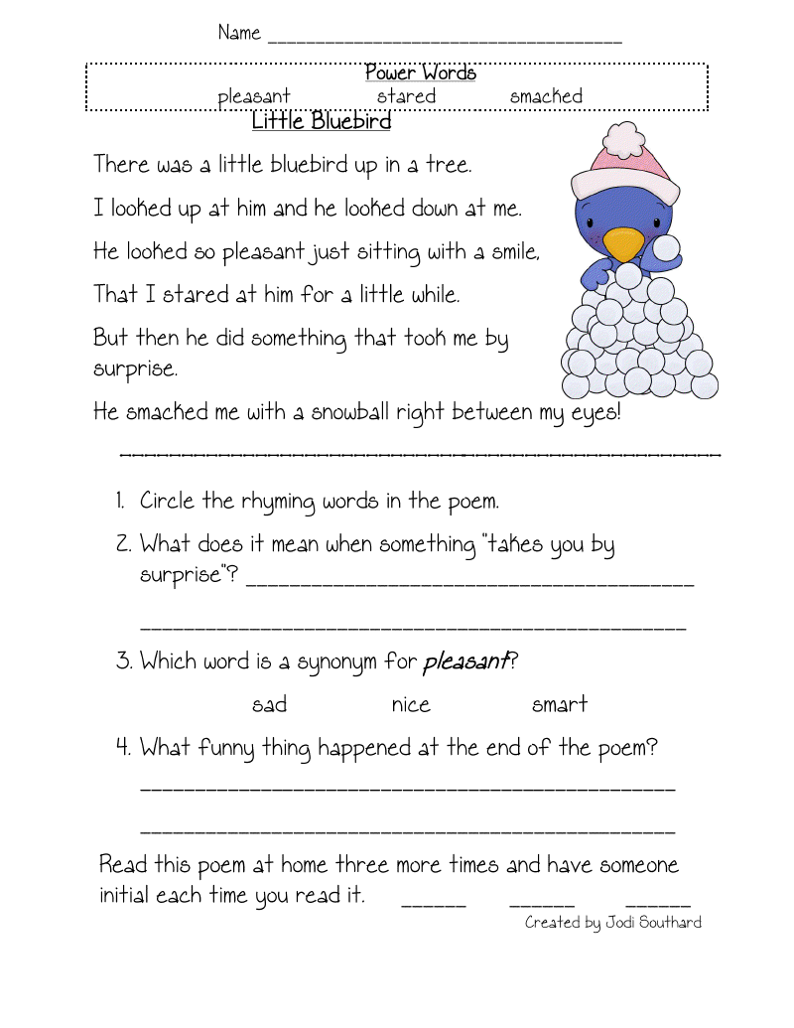****LITTLE BLUE BIRD**

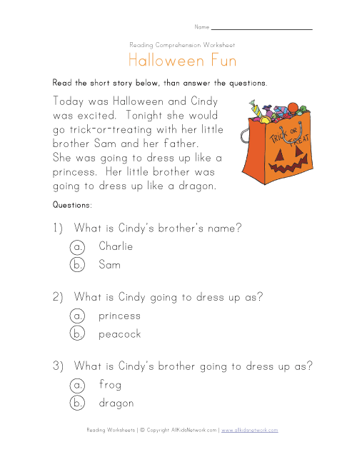**HALLOWEEN FUN**

Today was Halloween and Cindy was excited. Tonight she will go trick-or-treating with her little brother Sam and her Father. She was going to dress up like a princess. Her little brother was going to dress up like a dragon.

**Questions:**

1. What is Cindy’s brother’s name?
   1. Charlie
   2. Sam
2. What is Cindy going to dress up as?
   1. Princess
   2. Peacock
3. What is Cindy’s brother going to dress up as?
   1. Frog
   2. dragon

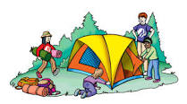**MY CAMPING TRIP**

I am going to camp with my family. We are going to sleep in a tent. We will swim in the lake. I can’t wait!

1. Where am I going? _________________________
2. Where will I sleep? _________________________
3. What will we do? ________________________

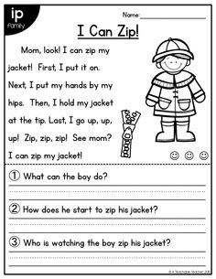

**BEDTIME**

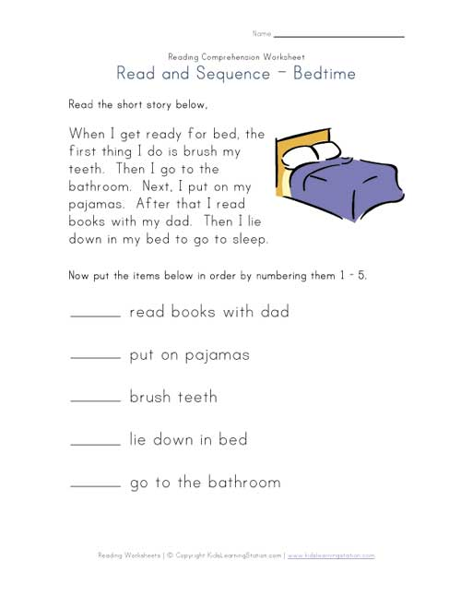When I get ready for bed, the first thing I do is brush my teeth. Then I go to the bathroom. Next, I put on my pajamas. After that I read books with my dad. Then I lie down in my bed to go to sleep.

Put the items below in order by numbering them 1-5

_____ read books with dad

_____ put on pajamas

_____ brush teeth

_____ lie down in bed

_____ go to the bathroom

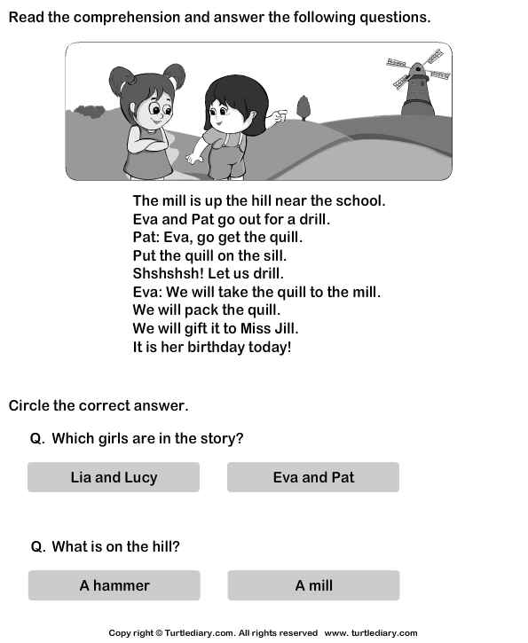

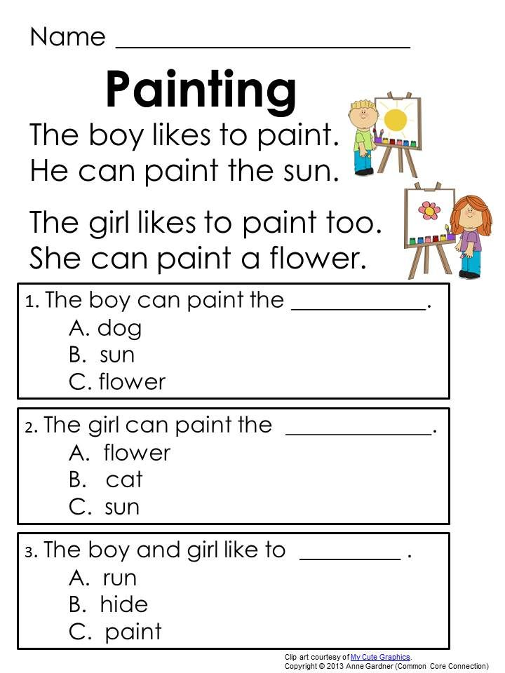

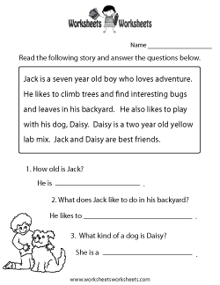

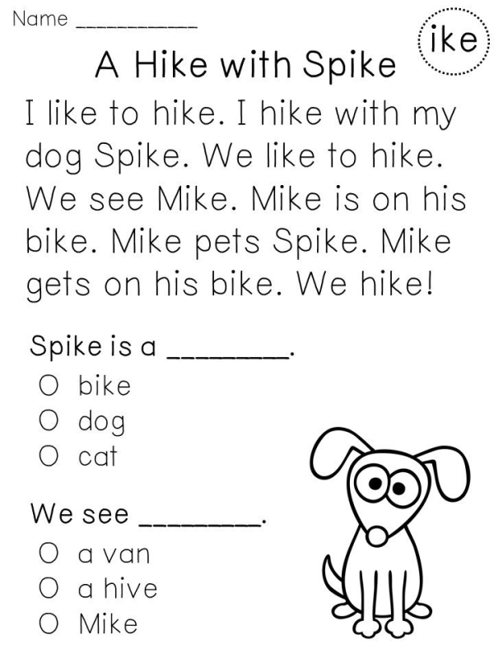



# **Going to School**

The very first thing I do on school days is wake up. Then I need to eat a good breakfast to give me energy. Next I get dressed. Then I put my backpack on to take to school. After that I wait for the school bus to come to take me to school.

Now put the items below in order by numbering them 1 – 5.

_______ get dressed

_______ wait for school bus

_______ wake up

_______ put backpack on

_______ eat breakfast

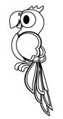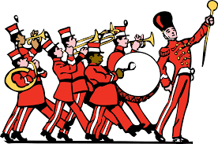**HERE COMES THE BAND**

# **Whitney and Whistler**

Whitney rode a bike everywhere.

She liked to visit whales at the zoo.

She liked to see wheat fields.

Her Wheels could take her anywhere

Whistler was a white parrot.

He could say a whole lot of words!

He asked, “who,” “why,” “when,” and “where.”

He didn’t know how to say,

“whatever.”

Questions:

1. Whistler was a _____parrot
   1. Green c. Orange
   2. Yellow d. White
2. What did Whitney ride?
   1. Bike c. Tricycle
   2. Unicycle d. Skateboard
3. Which of these things does Whitney go see?
   1. Whales c. penguins
   2. Bears d. Cats
4. Can Whitney’s wheel take her anywhere
   1. Yes b. No
5. Can Whistler say whatever?
   1. Yes b. No

Here comes the band! Should we call Mommy and Fanny to see it?

Let us stand still and hear the men play as they pass.

I hope they will stop here and play for us.

See the large man in front of the band with his big hat? What’s he holding in his hand? How fine he looks!

Look too at the man on that fine horse.

If the men do not stop, let us follow them and see where they go.

**Answer the Questions:**

1. Who should we call to see the band?
2. What is the man in front wearing?
3. What is the other man riding?
4. What will we do if the band does not stop?

**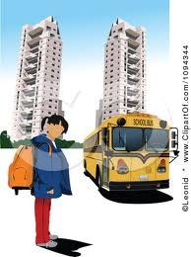****Marita’s Trip To The City**

Marita was raised in a far away barrio. There she saw no vehicles but carts drawn by carabaos. One day, her aunt took her to the city. They rode in a bus. At first, Marita was enjoying the ride. Then her head reeled, and she cried out loudly. “Oh! My head! Please stop the bus.”

Questions:

1. What do you think the people in the bus did?
2. They were angry.
3. They laughed.
4. They asked the driver to stop the bus.
5. 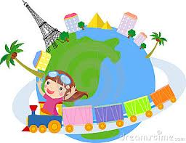What do you think Marita felt?
6. She felt dizzy.
7. She felt happy.
8. She felt sorry.
9. Why do you think Marita felt that way?
10. She enjoyed the ride.
11. She liked to ride in a bus.
12. It was her first ride in a bus.

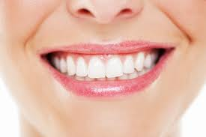 **Our Teeth**

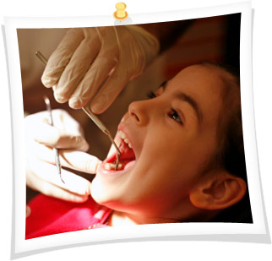 The doctor examined the children’s teeth in a class. He found out that more than one half of the children in the class have decayed teeth. You know that decayed teeth may prevent you from eating your food well. If you do not eat well, you may not grow healthy and strong. Try to see your dentist once a year.

Questions:

1. Why did the doctor visit the children?
2. To see if they eat well.
3. To examine their teeth.
4. To talk about their teeth.
5. Why do you think children with decayed teeth could not eat well?
6. They could not chew their food well.
7. They could not see their food.
8. They do not like food.
9. What good does visiting a dentist once a year do for you?
10. He will cure your sickness.
11. He will tell you what’s wrong with your teeth.
12. He will brush your teeth.

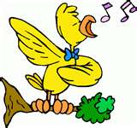**The Funny Chick**

Red hen has ten young chicks. One of them looks funny. It has a wide bill. Her other chicks have small, narrow bills. It does not walk like a chick. It waddles. It walks like a duck. It likes to play in the water.

Red Hen feels sad when she looks at her funny chick. When she calls out her chicks, funny chick is always the last one to come.

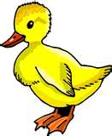 Who do you think the funny chick is?

Questions:

1. How many chicks does Red Hen have?
2. Why does one of its chicks look funny?
3. What kind of bill does funny chick have?
4. Who do you think her funny chick is?



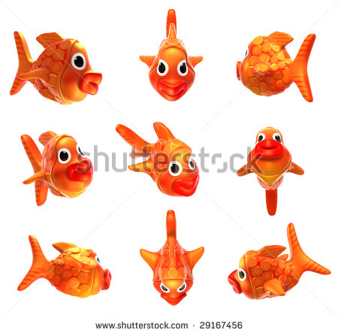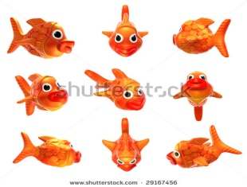 **The Little Fishes**

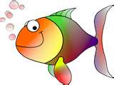 Arnold and Ben went fishing one day near a lake. It was a lucky day for them. They caught many silver fishes and soon their baskets became almost full. They always throw back into the water the very little fishes which were caught in their lines. They could hardly carry their baskets as they went back home.

Questions:

1. Who went fishing one day?
2. Why do you think they return the little fishes back into the water?
3. What do you think Arnold and Ben practiced?

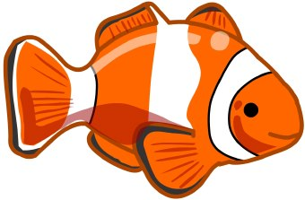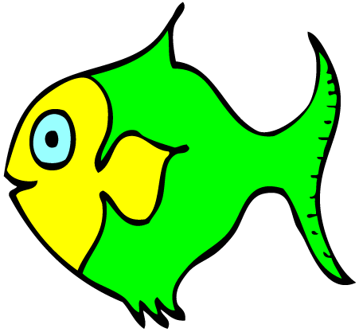





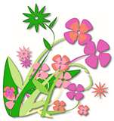**Flowers**

 Some plants bear flowers, but some do not. Some plants have flowers so they can make seeds. Flowers differ in size and smell. Some are big, others are small. Some flowers have a sweet smell. Some have a strong smell. Some are odourless. Flowers are used to decorate our homes and offices. They are also offered to the Blessed Virgin Mary to show our love for her. Flowers remind us of the beauty of God’s creation and the greatness of His love.

*Questions:*

1. Why do plants have flowers?
2. Do all plants bear flowers?
3. What are the differences among flowers?
4. How do we use flowers?
5. What do flowers remind us?

**Mang Doroy, the Carpenter**

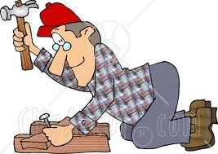 Mang Doroy is a carpenter. He goes to work at six o’clock in the morning. At noontime, he eats his packed lunch inside the furniture store where he works. He stops working at five o’clock in the afternoon. He reaches home at seven o’clock in the evening when the traffic is heavy.

Questions:

1. What is the work of Mang Doroy?
2. At what time does he goes to work?
3. Where does he eat his lunch?
4. When does he stop working?
5. At what time does he reaches home?
6. Does Mang Doroy work hard every day?

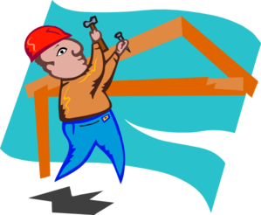

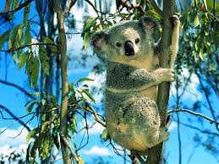

**The Koala**

 Have you seen a koala? Koalas live in Australia. They eat leaves from a eucalyptus tree all day long. They may eat more than three pounds of leaves in one day! Many people think that koalas are bears but they are not. Koalas are marsupials. Marsupials are a special kind of mammal. Marsupials have a pouch on them where their babies go to stay warm and safe. You might be able to see a koala in the zoo.

Questions:

1. Where do koalas live?
2. What do they eat?
3. What are marsupials?
4. Where we can find or see koalas?