GRADE 1V
FIRST AID TREATMENT FOR SPRAINS

At the end of this lesson, you will be able to:

- demonstrate first aid treatment for bone injuries

Try to Recall


Do you still remember the injuries that affect our bones and muscles? Find it out by answering the exercises below.

DIRECTION: Arrange the scrambled letters in each sentence to complete the statements on bone and muscle injuries. Write the correct word in your notebook.

Example: Accidents may cause JRNIUY to.

- Muscle RMCPA is a prolonged contraction of a muscle which causes pain.
- A RCTUFAER is a broken bone.
- A PSNRIA is a painful trusting of a joint which affects the ligament.
- TSAIRN is a soreness in the muscle caused by a prolonged activity.
- SIDOLACIOTN is a condition where the bone gets out of joint.

Explore

After knowing/learning the different injuries of the bones and muscles, this time you will discover and experience how to apply first aid treatment for sprains.

Perform the following activities with a partner as your patient. Your partner can be your sister, brother, a friend , mother or father.

A. First Aid Treatment For a Sprain

Procedure:

- Find a partner for this activity.
- Prepare the following materials:

a. an old clean triangular piece of cloth

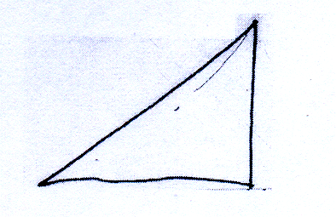

b. an old clean cotton t-shirt or sando

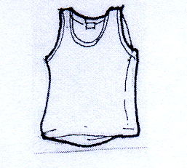
- mortar and pestle
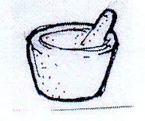

d. herbs or medicinal plants

ginger garlic kakawati
ikmo mayana

- Cut the old clean cotton t-shirt or sando into strips 3-5 centimeters wide.
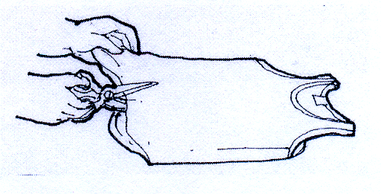

4. Choose one kind of herbal leaves that you can find in your backyard. Pound the leaves in a mortar and pestle.
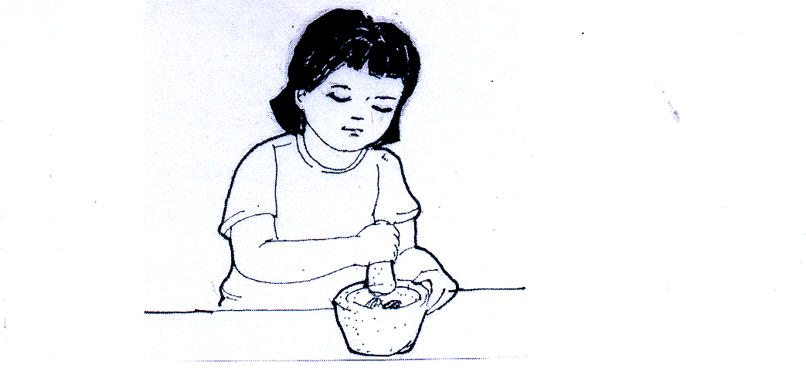

5. Apply the pounded medicinal plants on the elbow of you patient.

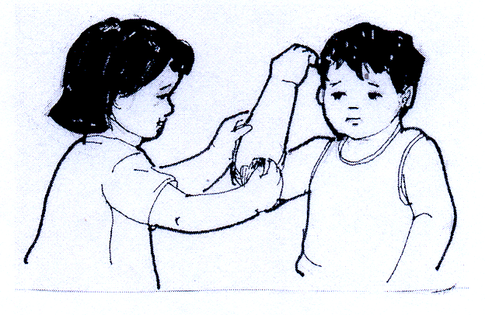

- Wrap the stripped t-shirt or sando to the elbow to hold the pounded medicinal plants.
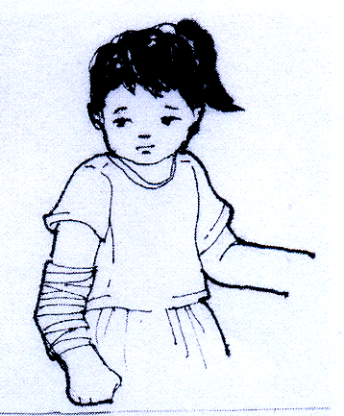

7. Since the sprain is on the elbow, use the triangular piece of cloth as sling.
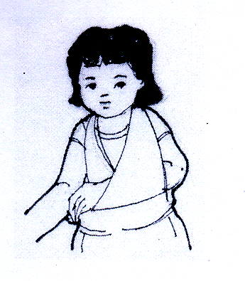

Answer the questions based on the activity that you performed. Write the answers in your notebook.

- Who act as your patient in the activity?

Answer: _____________________________________________

- What part of the body of your patient is affected by sprain?

Answer: _____________________________________________

- What medicinal plants did you apply in the sprained elbow of your patient?

Answer: _____________________________________________

- What material did you use as bandage? Why do you think it is needed?

Answer: _____________________________________________

- If you learned somebody who has sprained, can you apply the same first aid treatment?

Answer: _____________________________________________

- Why do you think its important to know the first aid treatment for sprain?

Answer: _____________________________________________

- Why is there a need to bring the patient to a doctor after applying first aid treatment?
Answer: _____________________________________________

READ AND LEARN MORE

A sprain is an injury that affects the bone. This needs an immediate treatment or first aid treatment to prevent greater damage. Before the doctor arrives, first aid should be given to an injured person. A trained individual on first aid can treat an injured person.

If there is no available first aider, the following procedures can be applied.

1. Keep the victim from using the sprained part. If an ankle or knee is sprained, carry the victim by making him sit in the arms of two children. | 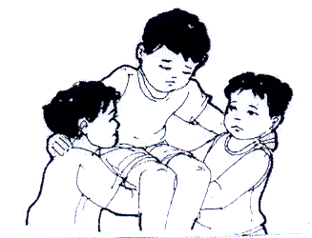
- Apply a cold compress or pounded herbal plants on the sprained part to reduce pain and swelling. | 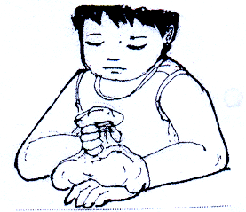
- Apply a bandage to the sprained part using an elastic bandage. The bandage helps avoid movement of the bones, but it should not be too tight nor too lose. A tight bandage disturbs the flow of blood. | 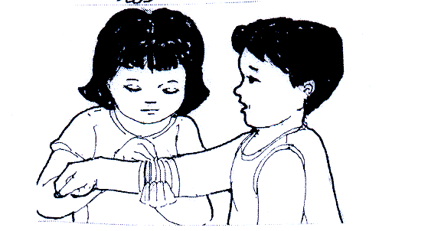
- If the wrist or elbow is injured, put a sling to give the arm some rest. | 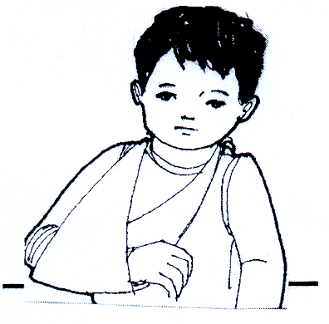
- If there is no more swelling, a hot compress may be applied on the injured part to improve the flow of blood or blood circulation.  - The juice of some herbs or medicinal plants like ginger, garlic, ikmo, mayana and kakawati may also be applied to the sprained area. | 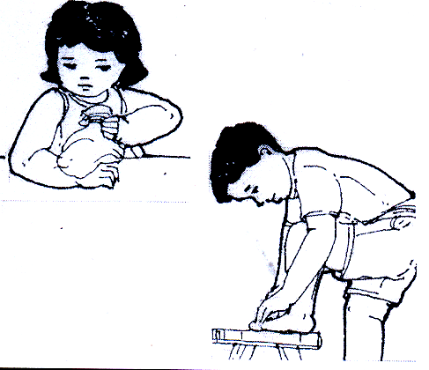


I learned that:

- A sprain needs immediate treatment to prevent greater damage
- A cold compress or pounded herbal medicines applied on a swelling sprain in the ankle, wrist, elbow or waist will help lessen the pain.
- A bandage around the affected area of a sprain will provide support and help lessen the pain.
- Herbs or medicinal plants like ikmo, ginger, garlic, mayana and kakawati can be used to reduce pain and swelling of a sprain

Apply It
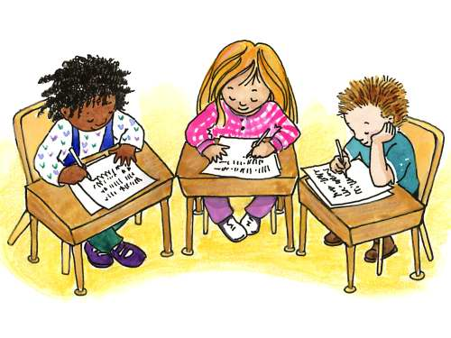

A. Select the statements that explain first aid treatment for a person with sprain. Write the letter of the correct answer on your notebook.

- A hot compress on the swelling of a simple sprain in the ankle or wrist will help lessen the pain.

- The injured person must not keep from moving.

- Pounded herbs or medicinal plants like ikmo can be applied to a swelling sprain.

- A triangular piece of cloth can be used as a sling for a sprain of the elbow.

- Pounded medicinal plants can be substituted for cold compress.

- A person with an injured ankle can be carried by making him sit on the arms of two persons.

- Read each situation and answer the questions in your notebook.

1. A boy living near your house twisted his foot while running. After a few minutes, he felt a pain and saw that his foot was beginning to swell. Since you have learned the first aid treatment for a sprain, what will you do?

2. In a basketball competition, there is always a first aider. What do you think is the importance of having a first aider in one game?

3. If you have goats, horses or carabaos that have sprain, do you think you can apply the first aid treatment that you have learned? Why?
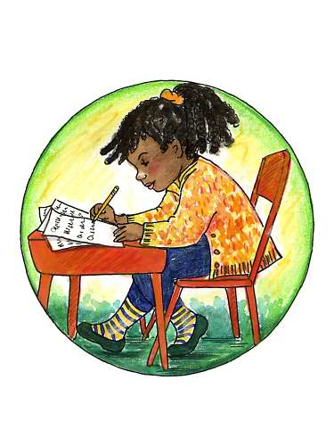

Test Yourself

- Select the drawings that show first aid treatment to a person with sprain.

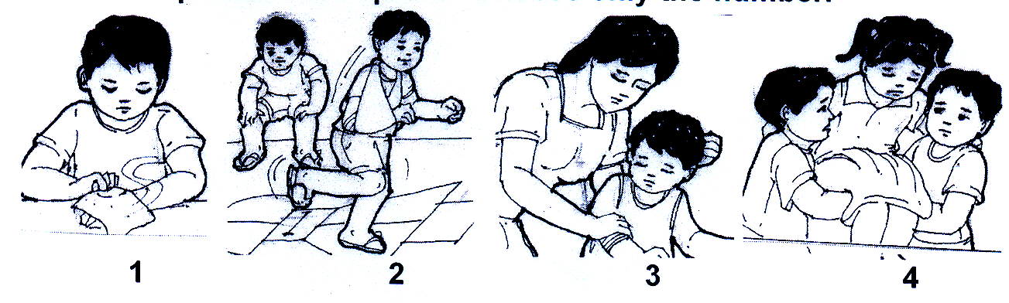

- Read each item carefully. Write the letter of the best answer in your notebook.

1. What is done to reduce pain and swelling of a sprain?

  - Apply hot compress
  - Wash the injured area
  - Apply cold compress or pounded medicinal plants

2. What should be placed in the injured area to avoid movement of the bones?

a. A sling
b. A bandage
  - A splint

3. Why should the bandage be not too loose and not too tight?

a. To allow free movement
b. To avoid the discomfort of the victim
c. To allow circulation of blood

