GRADE VI
LIGHT ENERGY

At the end of the module, you should be able to:

- Identify energy and its uses (light)

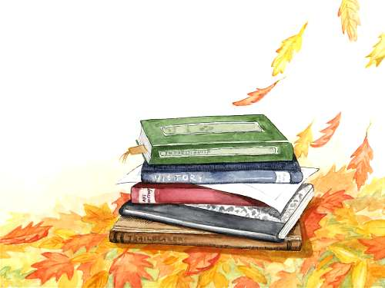

Try to Recall

Study the pictures. Identify if the illustration shows mechanical or chemical energy.
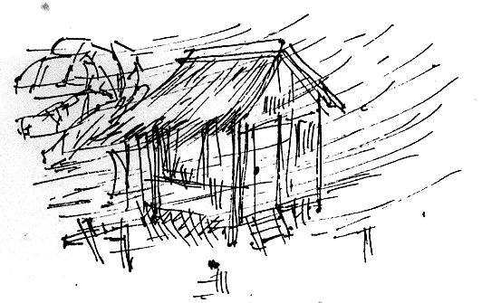

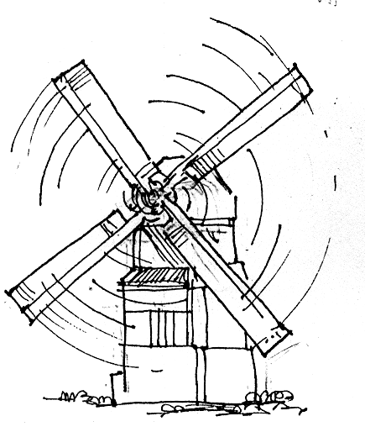
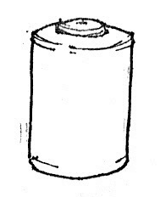

________________

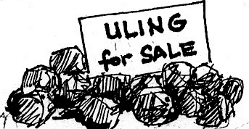

________________ ________________

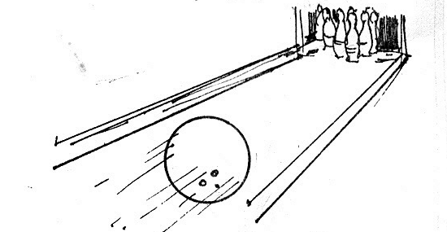
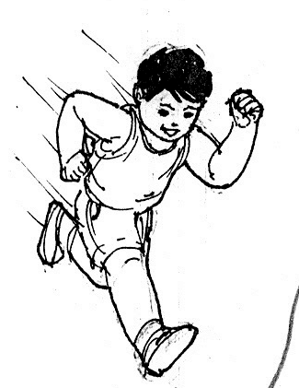

________________

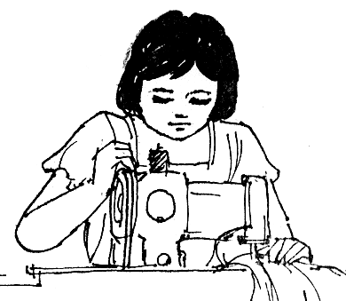

________________ _______________

________________

Explore

In this lesson, you will learn about light which is another form of energy.

Activity 1

What you need:

a room with different things

What to do:

- Go into the darkened room. Close the door and look around.
- Can you see any things? Why?

- Open the door a little to allow only little light to enter.
- What do you see? Why?

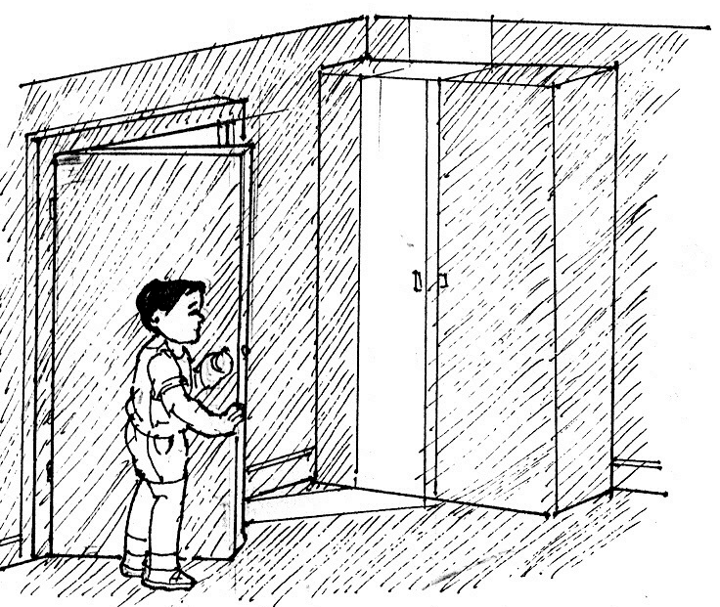

- Open wide the door to allow more light.
- Can you see all the things in the room? Why?

- What are some uses of light energy?
- What is the main source of light?
- What are the other sources of light?

Activity 2

What you need:

a piece of strong cardboard
a small, square or rectangular mirror
scissors
flashlight or torch
darkened room

What to do:

- Fold the piece of cardboard as shown in the picture. Then cut 3 slits along one side.
- In the darkened room, switch on the flashlight or light the torch, and place it behind the slits.
- Place the mirror at the opposite end of the folded cardboard, as shown in the picture.

- What happens when the rays of the light strike the mirror?
- How does each ray of light bounce back or reflect?

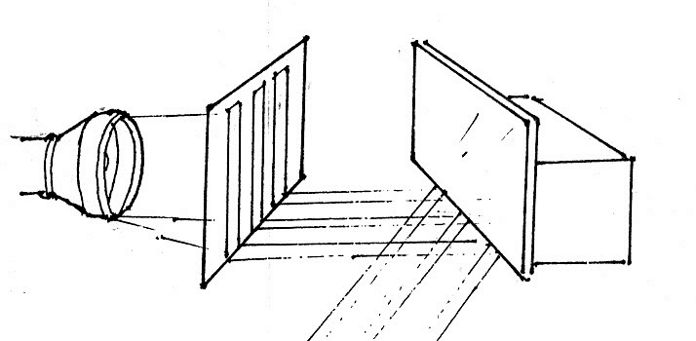

Did you know that…

when light bounces back it is called reflection.

4. What characteristic of light is shown in this activity?

Activity 3. Does light bend when it strikes another medium?

What you need:

a transparent container with flat sides
water
a small quantity of milk
a torch or flashlight
a piece of black card
scissors
sticky tape
a book
a darkened room

What to do:

- Fill the container with water and a few drops of milk. (to make rays of light easier to see)

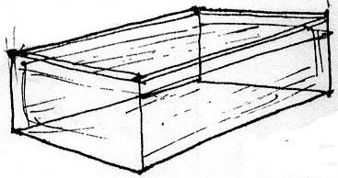

- Pierce a hole in the middle of the black card. Then fasten this around the lens of the flashlight with the sticky tape.

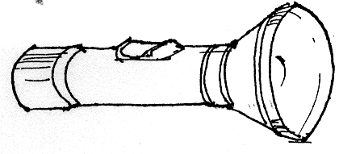

- In the darkened room, switch on the flashlight and shine it as you see in the picture, so that the beam of light falls on the surface of the water. (Place the container on a book)

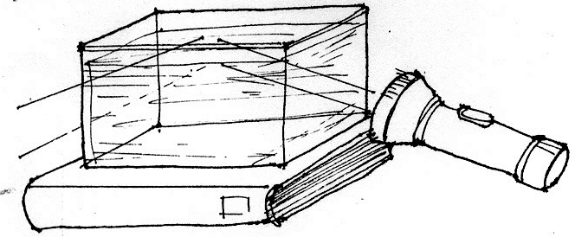

- What happens when the light of the flashlight, strikes the surface of the water?
- What caused the light to bend and go out of the container from the opposite side?

Did you know that…

- the surface of the water acts as mirror, that reflects the light.

- the reflection changes the path of light, in order to stay straight.

- refraction is the change of direction of light.

- Observe the picture.
- What happens when the beam of light enters the water?

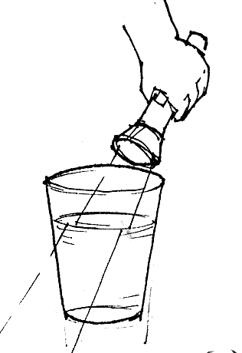

- Why does the straw seems to be broken at the point where it enters the water?
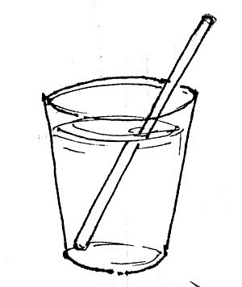

Did you know that…

when light passes from air to water it changes speed, which in turn, causes a change in direction.

5. What characteristic of light is shown in the activity?

Activity 4

What you need:

a round glass jar
a paper with drawings on it
a drinking straw
a water

What to do:
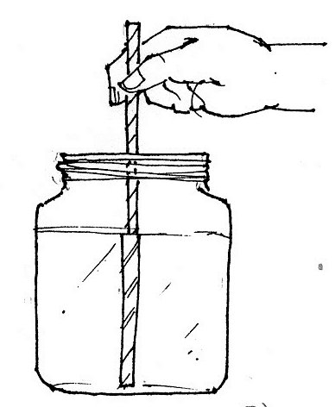

1. Fill the jar with water. Put the straw, in it keeping it up straight. Look carefully at the top of the water.
- What seems to happen to the straw in water?

2. Take out the straw. Place the paper with drawing behind the jar. Look carefully at the top of the water.
- What seems to happen to the drawing at the back of the jar?

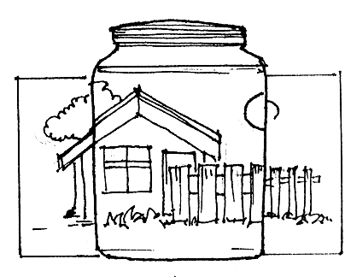

- What do you think caused the straw to look larger? The drawing seems to appear enlarged?

Did you know that…

when the rays of light pass from water to air, light is refracted (changes direction). If the surface of separation is a curved glass or jar, the refraction makes the object look bigger than it actually is.

- What characteristic of light is shown in this activity?

Activity 5

What you need:

a shoebox water
a glass a flashlight
a ruler a pencil
scissors a darkened room

What to do:

1. In a short side of the shoebox, draw and cut three slits or cuts 1 cm apart.

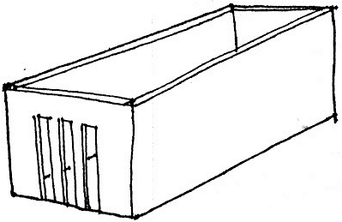

2. Fill the glass with water and place this in the center of the box, in line with the slits.

3. In the darkened room, switch on the flashlight and shine it on the slits. Observed carefully the rays of light.

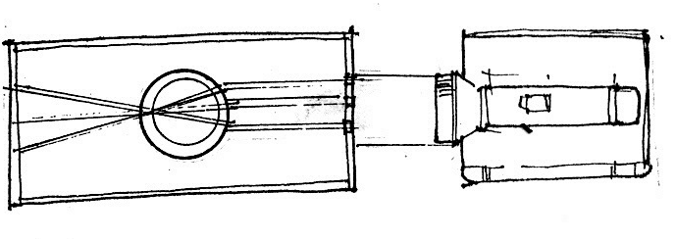

Describe the path of light…

- before it touches the glass from the source
- while passing through the glass
- after passing through the glass

- What do you think caused the light to meet together and then cross over?

Did you know that…

the curved surface of the glass and water causes refraction of the rays of light, making them meet together and then cross over.

- What does this activity show?

Activity 6

What you need:

prism or transparent uneven casing of a ball pen
direct sunlight

What to do:

1. Get a prism or transparent uneven casing of a ball pen.
2. Place a prism in the path of a strong beam of light as indicated in the diagram. Or use the ball pen casing as shown.

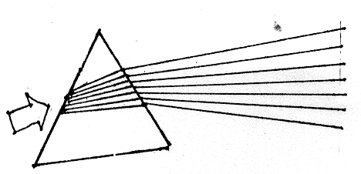
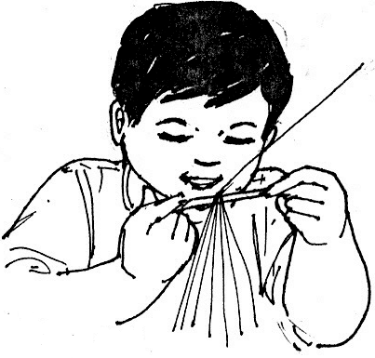

- What happens to the light rays when they pass through the prism?
- What color do you see?
- Which color seems to have bent the most?
- Which color seems to have bent the least?
- What is white light made of?
3. Study these illustrations of how a prism works. Look at your partner using A B side of the prism.

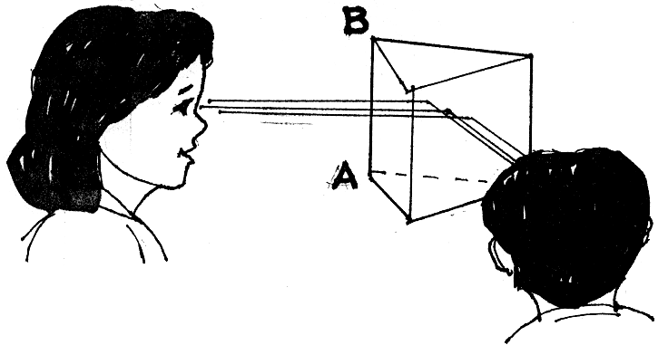

- Why is it possible to see your partner without looking directly at him or her?
- What happens to the light entering the prism that makes it possible for you to see your partner?
- What does the prism do to the light rays?

- Find out why prisms or mirrors are used in periscope.
Study the illustration.
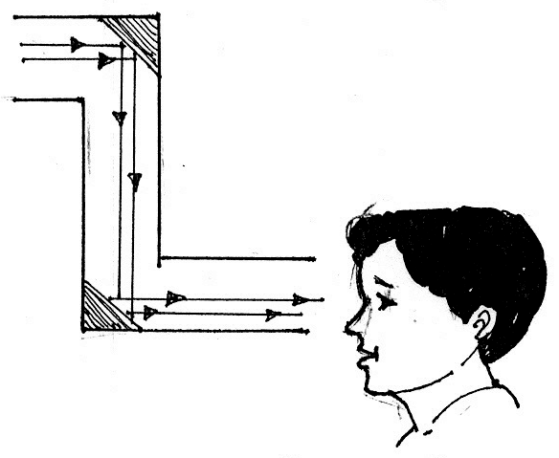

- What do prism or mirror do to light rays?

5. What characteristic of light is shown in this activity?

I LEARNED THAT:

- Things are seen only by reflecting light or when the light is sent back to our eyes.

- The mirror reflects the light in the ordinary way, with the same angle of reflection with which the ray strikes the mirror (angle of incidence).

- The mirror or prism inside the periscope makes us see a reflected image of something without being seen just like in submarine.

- Reflection is bouncing back of light.

- When light passes from one medium to another at an angle, the direction of light changes. This change is called refraction.

- White light is made of several colors, namely red, orange, yellow, green, blue, indigo and violet.

- Rays that pass through concave lens spread out from each other.

- Rays that pass through convex lens become closer to one another. When rays of light pass through curved objects like glass with water (somewhat convex) it causes the rays to meet together.

- Light energy is the form of energy that enables us to see.

- The sun is the main source of light on Earth. Besides the sun, lamps, candles, lanterns and torches are also sources of light energy.

- Besides helping us to see, light energy is used in cameras to “capture” images on films. Film projectors, overhead transparency projectors and visualizers also make use of light energy to project images into screens.

- Light energy is also used to communicate or send messages. For example, traffic light help to control the flow of traffic.

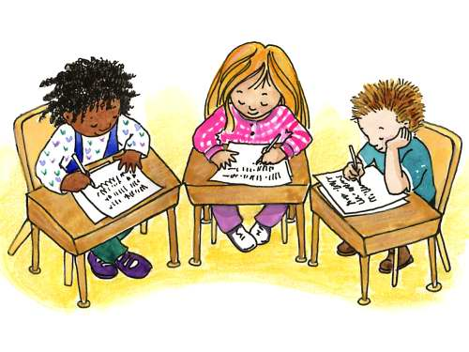

Apply It

- Answer the following.

1. Why can you see yourself in a mirror?
- Why can’t you see yourself in a paper?
3. Why can some bottoms of bottles with transparent convex surface cause fire when placed in dry leaves?

- Think and describe how lights on runway help airplanes.

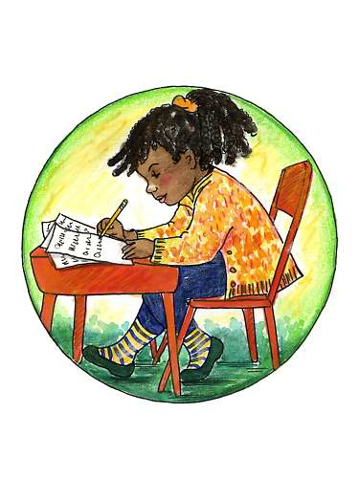

Test Yourself

*

- Some descriptions about light is found in column A. Write the letter of the correct answer.

A B

___ 1. bending of light a. reflection
___ 2. separates white light into 7 colors b. convex
___ 3. bouncing of light c. refraction
___ 4. bring rays closer to one another d. prism
___ 5. enables us to see things e. light

- Aside from enabling us to see things, describe another possible use of light energy.

Key to Correction

Try to Recall

Exploration Time

Activity 1

Activity 2

Activity 3

Activity 4

Activity 5

Activity 6

Apply it

1.
2.
3.

Test Yourself

- C
- D
- A
- B
- E

