COMMON CONSTELLATIONS
GRADE VI
COMMON CONSTELLATION

At the end of the module, you should be able to:

- Identify the common constellations in the sky
- Describe how constellations are useful to people



Try to Recall

Color the following stars according to their temperature.

coolest
cool

very hot

warm

hot

Explore

When you look at a cloudless night sky, what do you see? How do they appear? How do you describe them? Can you name some things that resemble their shape, form or pattern?

In this lesson, you will learn about common constellations in the sky.

Activity 1

- You will need 5 sheets of paper and a pencil

- Copy the arrangements of dots in separate sheets and connect the dots following the number to form a pattern.

2 . 4 .

1 . 3 .

. 5
2
1 .
.
.
3 .
4
5 .

6 .

. 7
1. 2.

7 .

6 .

5 .
.
4 . 1 . . 3 2

6 .

1 2 3 4
. . . .

.
5
3. 4.

1 .

2 .
. 5 .
. .
3 . 6 7 .
4 . . . . . 8 .

10 . .
9
5.

Answer the question in your notebook.

- What are the patterns or shapes that are formed?

Activity 2

Have you seen the star patterns which look like water dippers?

See the illustration at the right side.
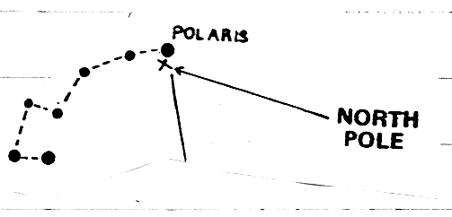

The star at the end of the Little Dipper’s handle is called the Pole Star or Polaris. It is also called North Star because it always seen in the north. This star does not seem to move much. All the stars in our sky seem to move around Polaris because the earth rotates in a west-to-east direction.

At night, people may use the North Star in finding directions. It also helps us determine the latitude of a place. If you are nearer the north pole, Polaris is almost overhead. If you are nearer the equator, Polaris is seen at the horizon. If you are south of the equator, you will not see Polaris. You will see a different set of constellations.

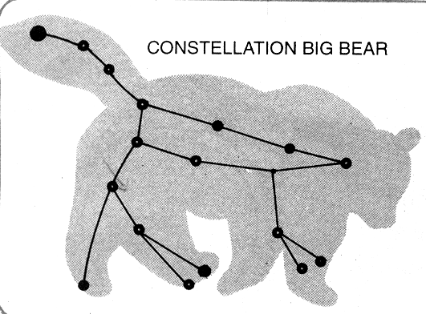

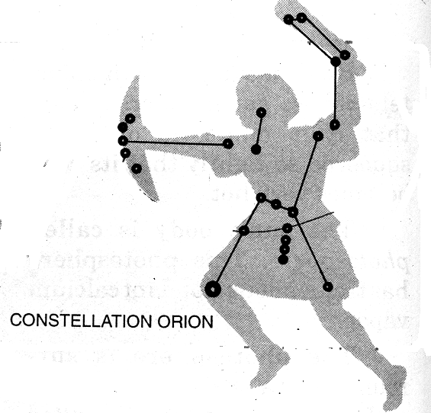

What to do:

1. On a clear night, find Polaris. Is it a bright star? Compare its brightness with that of the other stars.
2. Point to the four directions with Polaris at the north. Check your directions by using a compass.

Read and learn more.
Constellation is a group of star that forms a pattern in the sky.
The stars in a constellation are very far apart. Some are nearer the earth, while others are farther away. But seen from the earth, they form a pattern. There are more than 88 constellations.

Stars seem to move across the sky because of the earth’s movement.

The stars that we see depend upon two things:
the position of the earth in relation to the sun, and
our location on earth

Man uses the North Star to find directions and to determine the
latitude of the place where it is.

People of long ago thought that group of stars look like some famous constellation are Ursa mayn (Big ben), Ursa minn (small ben), orian (the great hunter), cassio pin (the gwen), and Cygnus (the crucifix)

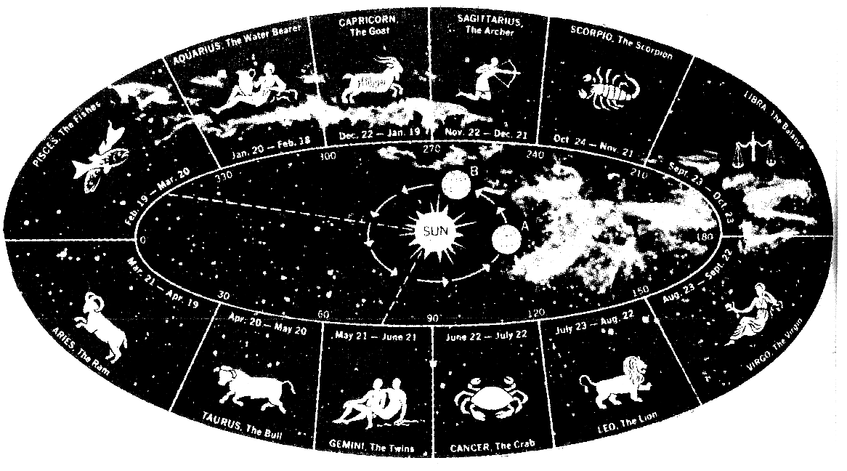 Zodiac Constellations
There are 12 constellations found at 30٥ longitude. They form the background stars of the sun as it passes in its annual motion. The group of stars bear the name of zodiac constellations.
The zodiac constellations are as follows:

Aries - the Ram Capricorn – the goat
Taurus - the Bull Aquarius – the Water Carrier
Gemini - the Twin Pisces – the fishes
Cancer - the Crab
Leo - the Lion
Virgo - the Virgin
Libra - the Balance
Scorpio - the Scorpion
Sagittarius - the Archer
Capricorn - the Goat
Aquarius - the Water Carrier
Pisces - the Fishes

I LEARNED THAT:

- There are many constellation and some of them are by bean, small bean, crucifix, orion
- Constellations are group of stars with definite patterns
- Constellations are useful to man because it helps us



Apply It

A. Write the name of the constellations below.
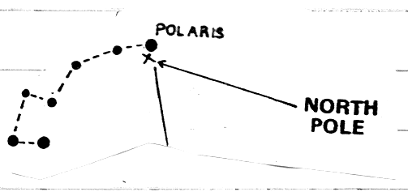  1. ___________________ | 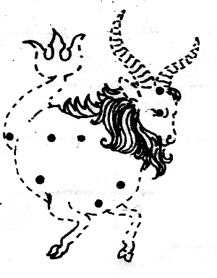  4. ___________________
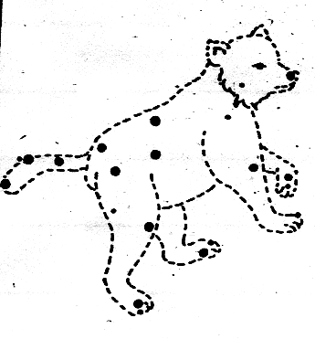  2. ___________________ | 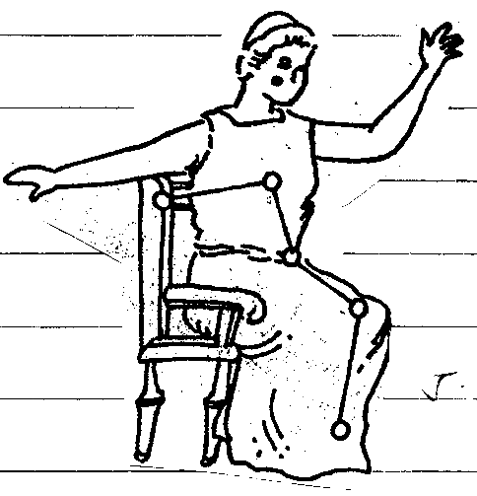  5. ___________________
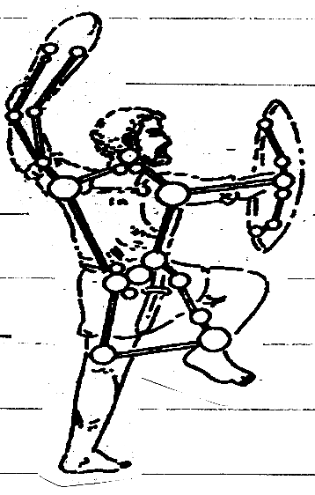

3. ___________________

- Pretend that you are in a camping and your group is assigned to get sample of rocks. Hours passed by and it is almost seven in the evening. You lost your compass and didn’t know your location. How will you come back to the camp site? What will you do?

C. make your own constellation pattern.

- Look for this needed materials:

pin, barbecue stick, styrofoam
coupon bond, and black art paper

What to do:

- Choose 1 constellation in the star map.
- Draw the pattern on the coupon bond.
- Place the pattern on top of the art paper and styrofoam using the pen.
- Pinch the dots on the pattern using the barbecue stick.
- View your work under the light or heat of the sun.
(See the sample pattern below)

Sample Pattern
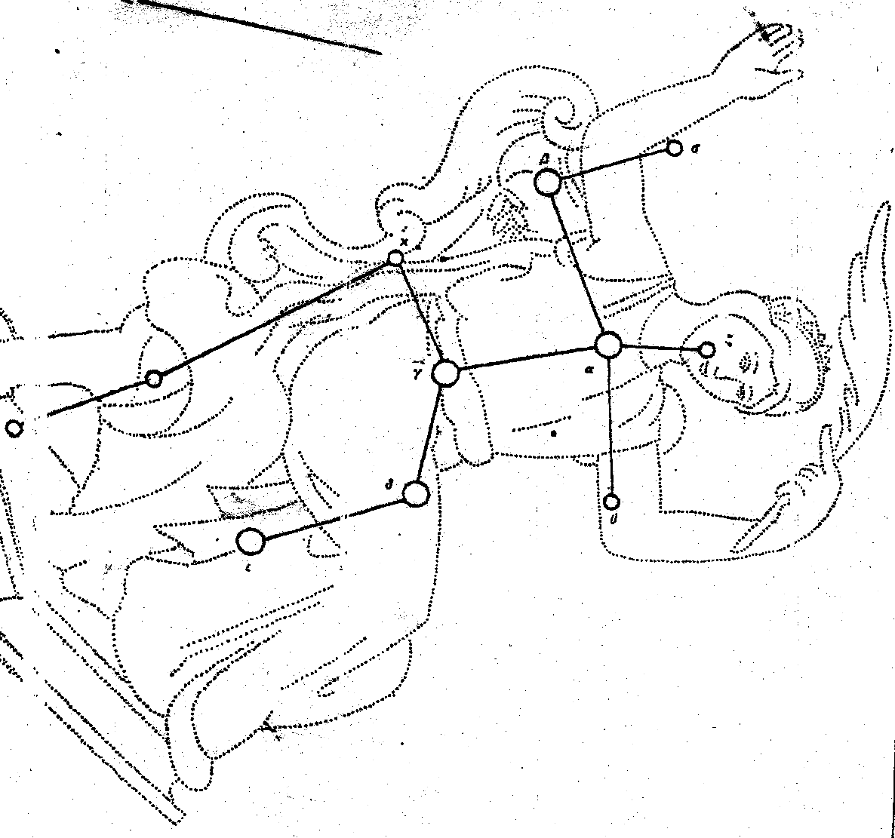



Test Yourself

*

Star Map

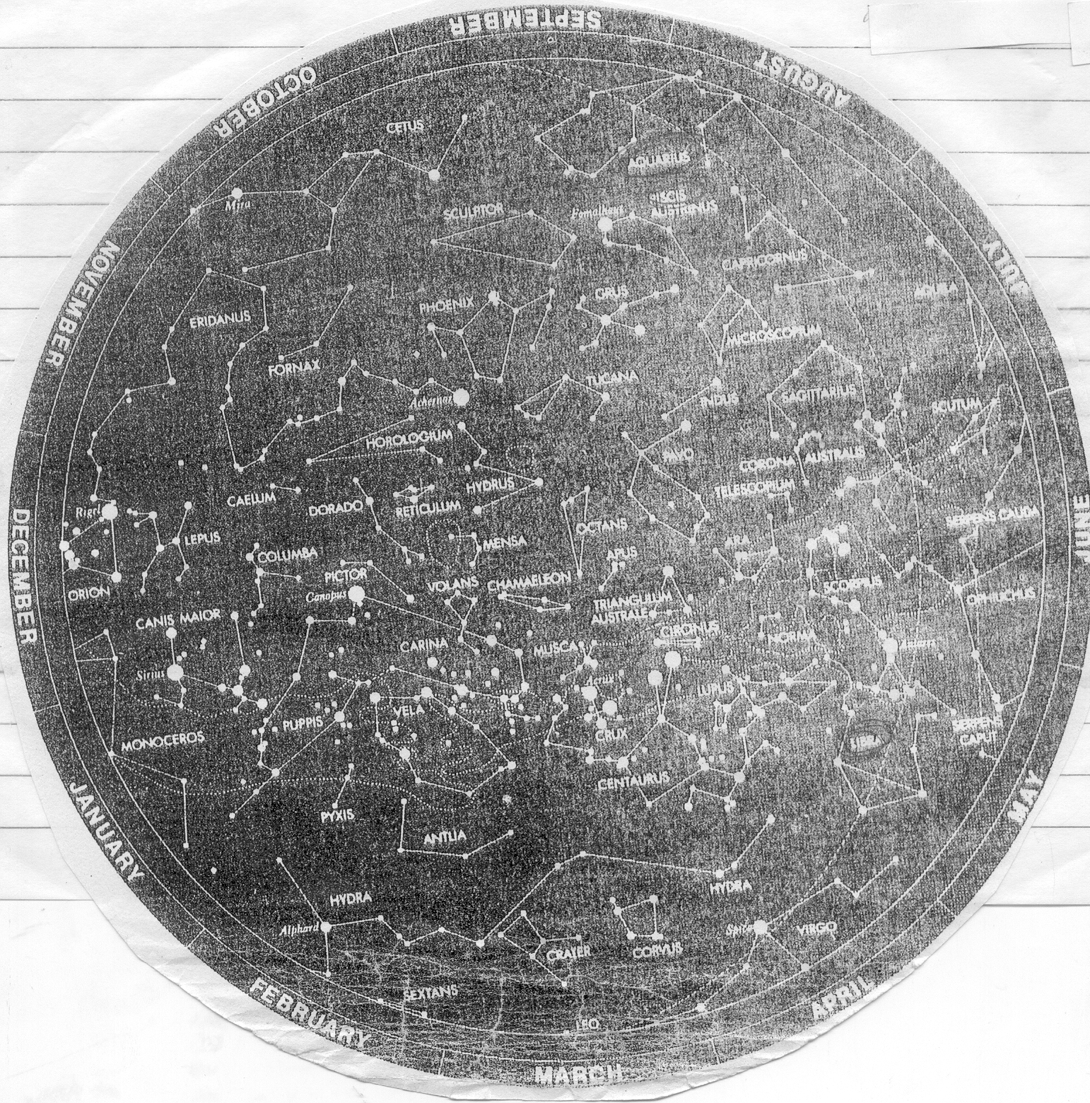

Identify the constellation in the star map as numbered

________________ ________________
________________ ________________
________________ ________________
________________ ________________
________________ ________________

B. Fill in the blanks with the correct answer.

1. _________ are star pattern in the sky.
2. _________ is also called Big Bear.
3. We can see _________ at the tail of Ursa Minor or Small Bear.
- We use the North Star to find _________ and to determine the
5. ______ of the place.

Key to Correction

Try t o Recall

Exploration Time

Activity 1
Answer these

Activity 2

Apply it

A

B

C.

Test Yourself

A.

B. 1. constellation
2. Ursa Major
3. North Star /Polaris
4. direction
5. latitude

