PRESERVING THE ENVIRONMENT
GRADE VI
PRESERVING THE ENVIRONMENT

At the end of the module, you should be able to:

- Demonstrate commitment and concern in preserving/conserving the balance of life in the ecosystem



Try to Recall

- Match column A with the description on column B. Write the letter of the correct answer in your notebook.

1. Muro Ami a. big and small fishes are killed when
chemicals are used

2. Dynamite fishing b. clearing and burning of ground cover to be
planted with crops

3. Illegal logging c. young trees are cut without replacing them

4. Improper waste disposal d. coral reefs are destroyed just to catch fish

5. Kaingin system e. homes of plants and animals are destroyed
and may cause flash floods

6. Deforestation f. dumping of garbages in land and bodies of
water

- List down three natural calamities that hit our country.

Explore

In this lesson you will learn how you can preserve and conserve the environment.

Activity 1

- The items listed in the chart are telling some problems that caused imbalance of life in the ecosystem.
- Can you suggest ways to solve these problems?

Problem | Ways of controlling/preventing
- burning garbage
2. using pesticides and herbicide
3. cutting of trees
4. kaingin
5. Muro-Ami Fishing

Activity 2

- The following can help protect our environment. How does each help protect our environment?

- Recycling garbage
- Clean and green project
- Save the Earth movement
- Providing Sanctuaries
- Reusing water
- Sagip Ilog
- River clean Up Drive

  - Look at your community. What is the environmental problem happening at this time? Make a simple plan on how you can solve this environmental problem in your community.

  - Follow the PROJECT PLAN below.

PROJECT PLAN

I. Title:

II. Objective: (the reasons why you want to do this project)

III. Where is the project location:

IV. When will you do it:

V. Who can help you:

VI. What will you do:

Read and learn more.

- To prevent global warming (the rise in global temperature), we should reduce the burning of fossil fuels and ensure that we have lots of trees. A growing tree can process about 20 kilograms of carbon dioxide a year.
- The restoration and maintenance of the balance of life in an ecosystem will help ensure the survival of future generation.
- The DEPARTMENT OF ENVIRONMENT and NATURAL RESOURCES (DENR) is responsible in addressing the environmental issues and problems. They enforce the following programs:

1. Sanctuaries - places where hunting and fishing are not allowed (prohibited)
- areas where endangered plants, animals
and marine life are taken care of.

- Clean and Green - encourages people to plant trees and
practice proper waste disposal.

3. Sagip Pasig - a campaign to help clean the Pasig River.

- Save the Earth Movement - aim to take good care of the
forest and endangered species.

- Recycling Garbage Project - encourages people to re use
Like paper, bottles cans,
wrapper, plastics and other recyclable materials.

I LEARNED THAT:

- Conservation is the wise use of resources available.
- You should involve yourself in the preservation and conservation of our environment. To sustain economy balance and ensure the survival of future generations.

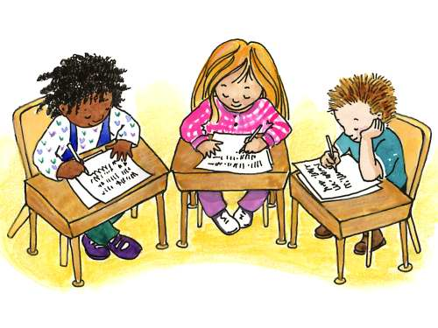

Apply It

1. Interview your barangay captain on the programs initiated in preserving and or managing the following:

  - forest
2. rivers
3. garbage disposal

2. If you could join an environmental group campaign which program would you like to join? Why?



Test Yourself

*

What will you in the following situations?

- You observes that your classroom is clean. You can’t find any trash can, what will you do to maintain the cleanliness?

- You often see your friend throwing their garbage into the river. What can you do to stop that practice?

3. Your friends are catching birds, butterflies, and other small animals. What will you tell them?

