GRADE V
PLANT ADAPTATION

At the end of the module, you should be able to

- Identify specific structures for adaptation
- Describe changes in environmental conditions that cause plant adaptation
- Practice ways of caring for and conserving plants



Try to Recall

- Where are these plants found? Identify the habitat each plants below.
Write the answers in your notebook.

Plant
1. cactus
2. seaweed
3. water lily
4. orchid growing on a tree

B. Unscramble each set of the jumbled letters below the things plants need. Refer to the clues given. Write the number in your notebook.

1. ULSNIHGT
2. RTAEW
3. LSIO
4. RIA

Clues:
1. It is the source of heat and light energy.
2. It is absorbed by the roots of plants.
3. It is where land plants grow and live.
4. It contains carbon dioxide and other gases.

Explore

Plants have structure/characteristics that protect themselves from humans and other animals. Plants pulled themselves to adopt to the place and in order to survive. This is what you call adaptation which means the process in which a specie becomes better suited to survive in an environment.

Activity 1

Plants living in a specific habitat like a pond and a forest have certain ways on how they can cope with the materials that they lack. Each plant part is specially made to do a specific job to make available those materials found in very limited amount. Plants have a special way of adapting themselves in a specific habitat in order for them to survive and grow.

What to do:

1. Visit a pond near your house or near the school.
2. List all the plants you see growing on that area.
3. Observe closely the different parts of the plants.
4. Make a table of your description on the structure of each plant part (leaves, stem, roots) as to size, shape of leaves, texture of stem, arrangement of roots, etc.

A. Plants Found in Water

Name of Plant | Plant Part
Name of Plant | Leaves | Stem | Roots

B. Plants Found on the Bank of the Pond

Name of Plant | Plant Part
Name of Plant | Leaves | Stem | Roots

C. Plants Found in the Forest

Name of Plant | Plant Part
Name of Plant | Leaves | Stem | Roots

Activity 2

Mrs. Cruz class went to a botanical garden. The entrance shows a pond.

Jan: | Hey, look! What are those plants floating in the pond?  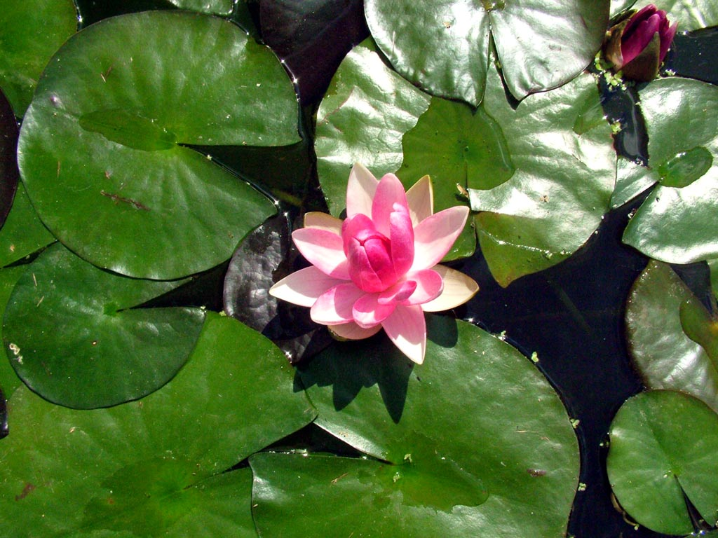
Mrs. Cruz: | Those are water lilies. They are called hydrophytes or water plants. They have hollow stems so they are able to make food.
Jan : | What are those trees with visible roots beside the shore?
Mrs. Cruz: | Those are mangrove trees. Their roots grow  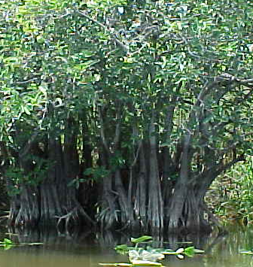  from the lower branches down into the soil.  Their exposed roots catch things that build  up soil so other plants can grow on it.
The class now approaches the sea mural showing where plants grow.

Mario : | What are those plants growing  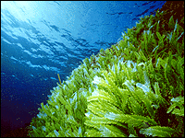  under the sea?
Mrs. Cruz: | They are seaweeds. Did you know that green plants under the sea can be found not deeper than 60 meters? Why do you think so?
Fina : | Sunlight can only reach certain level.
Mrs. Cruz: | That’s right! Now, let’s proceed to  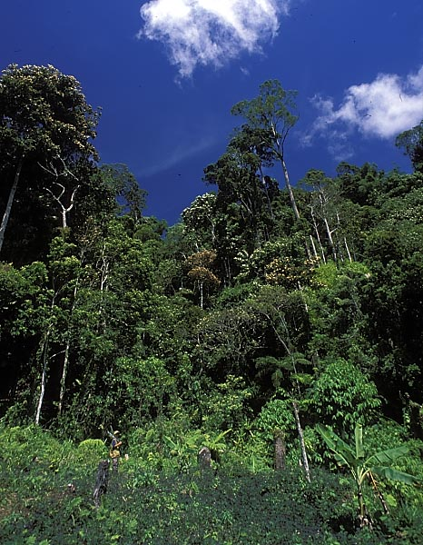  the FOREST Area. Look at the tall  trees. Do you notice how they  grow?Their leaves grow in a spiral  direction so that the other leaves  below them will not be blocked of  sunlight.  There are orchids, moss and ferns  growing on the trunks of trees. Their  roots are suspended to absorb  moisture from the atmosphere. They  can live on shady areas.

Let’s go to the next place.

Miko : | Wow, a sunflower! I know they like  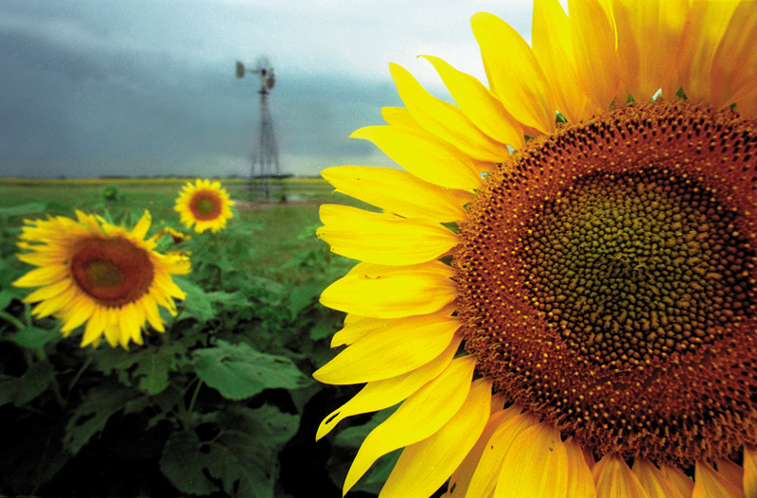  sunlight.
Mrs. Cruz: | Yes, like legumes, Indian grass, lettuce and radish.  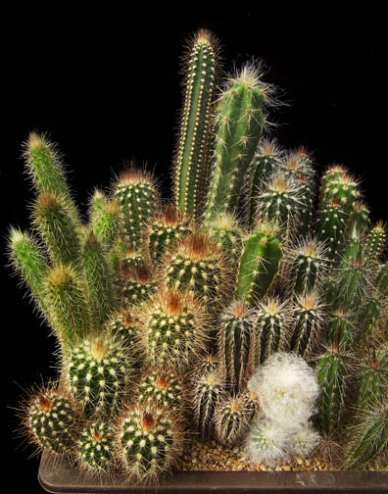
Martin : | We are now in the desert. Look, a cactus!
Mrs. Cruz: | They store water in their stems to reduce transpiration (loss of water from a plant by evaporation through the stomata)

These are ways of plant adaptation in their environment

Answer the questions based on the conversation:

1. What does water lily have that helps it to survive?

2. What does a mangrove tree have to help it adapt or survive?

3. How do the stems of the seaweed grow?

4. How do the tall trees survived in the forest?

5. What do ferns have that helped them survive?

6. What does cactus have that help them survive in the desert? What condition helped them adjust?

Complete the needed information on the table.

Plant | Structure for Adaptation | Condition for Plant Adaptation
1. water lily
2. mangrove
3. seaweed
4. trees
5. orchid
6. cactus

Find out how you can conserve and care for plants by doing this activity.

Activity 3

Andoy will transfer to the province for good. He gave his friend Jamie a potted plant. After a month, Andoy received a letter from Jamie.

Dear Andoy,

How are you? I hope you have made friends in your province. I miss our time playing together. Good thing, you gave me a plant. Here are pictures of how
I have been taking care of the plant – your remembrance to me.
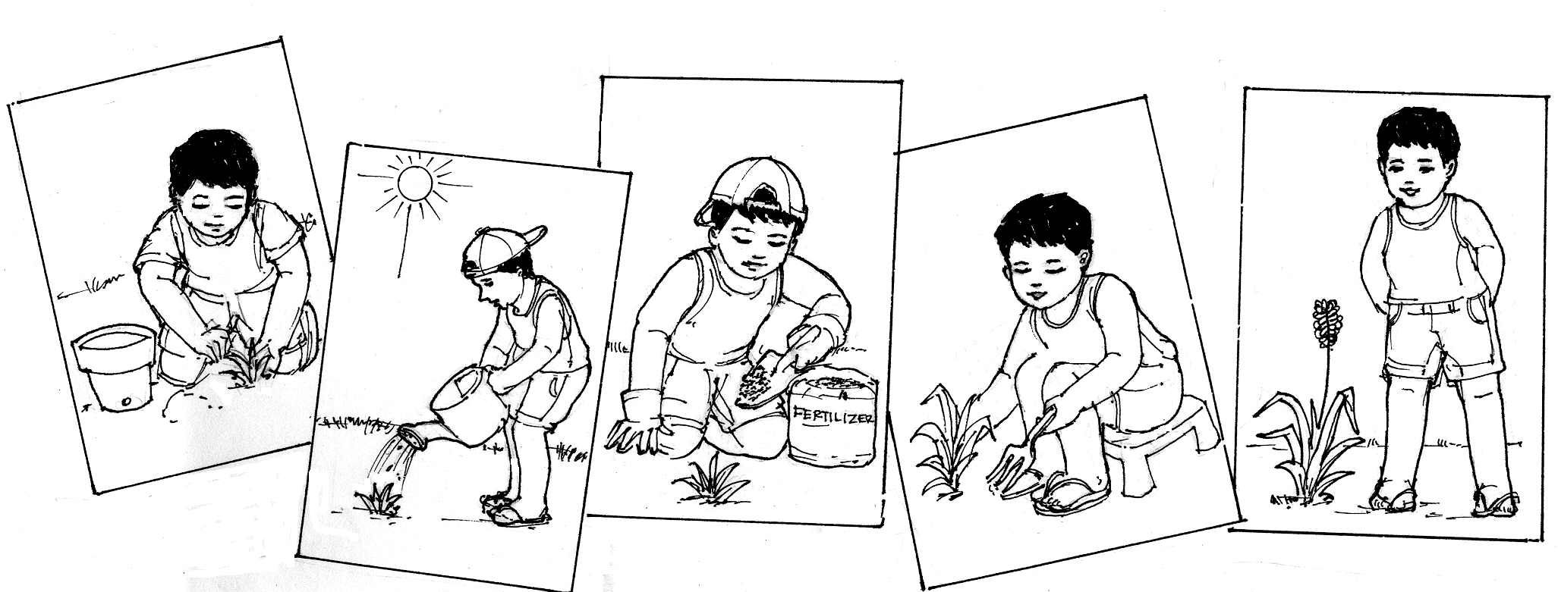

I have learned from Miss Santos, our Science teacher on how to take care
of plants. She also added that we should leave the plants in their natural habitat. I am sure you have learned a lot, too.

Write to me soon. I would love to hear from you.

Your friend,

Jamie

List down ways of caring for plants below.

Caring for Plants
Read and learn more.

- Plants compete with other plants for light, air, soil and water. People and animals may eat them or make their environment unfit to live in.
- Plants need light for photosynthesis, water absorption, and flower formation. Temperature should be 1 °C – 43 °C for a plant to grow well. Humidity, rain and soil moisture is needed. Soil is important to the growth of land plants.
- In the forest, sunlight may never reach the ground so plants that grow on other plants (epiphytes) have suspended roots to absorb moisture from the atmosphere and grow on upper limbs of trees and poles.
- Sunflowers, legumes and Indian grass are photophiles because they favor strong sunlight. They are covered with waxy coat or tiny hairs. Photophobes are better adapted to shady areas so they have thin, broad leaves with small opening on both surfaces. Ex.: mosses, liverworts
- Pine needle loses water slower than plants with broad leaves so pines are often found in mountain areas where wind is strong.
- HYDROPHYTES or water plants have hollow stems that connect directly with the stomata. Mangrove roots catch debris in their exposed roots that build up soil so other plants can grow on it.
- XEROPHYTES or dry plants are water-conserving plants. Examples: cactus, aloe - The stems can hold a large quantity of water and reduces transpiration.

I LEARNED THAT:

- Plants have special stems, roots, leaves to adapt to their environment.
- Changes in environmental conditions include too much or too little sunlight, too much or too little water, or humidity too hot or cold temperature, wind, and kind of soil, wind.



Apply It

A. Copy the organizer below in your notebook. Complete it by feeling in the boxes with appropriate words from the leaves below.

PLANTS

condition
structure
care

Hollow stem
e.g. water lily
1.
too much

Propped roots
e.g. mangrove
2.
too little

Suspended roots
e.g. fern
Broad leaves
e.g. pine
too little
3.

too much
4.

Special Stem
e.g. cactus
too little
5.

Water the plant.
Give fertilizer.
Leave the plant in its habitat.
Cultivate the plant.
Expose the plant to air and sunlight.
Expose to air and sun

water, wind
soil
sunlight

B. You have a garden. How will you care for the plants in your garden?


Test Yourself

*

A. Look at the picture of the plant. Write the structure that helps it adapt.

1. aloe vera | 4. mangrove
2. lotus | 5. sunflower
3. orchid | 6. moss

B. Give the condition that can cause the following plant adaptation. Answer in your notebook.

1. special stem
2. propped roots
3. hollow stem
4. broad leaves
5. suspended roots

C. Draw a tree. Write the ways to care for it.

D. On a piece of paper, write a slogan on caring for and conserve plants.

Example:

Care for a tree
And a bright future is ahead
For you and me

