GRADE VI
THE BLOOD VESSELS

At the end of the module, you should be able to:

- Identify the different kinds of blood vessels
- Describe the Function



Try to Recall

Fill up the map with correct answer.

Blood

has

SOLID PARTS
LIQUID PART

are of 3 kinds is called

Functions
Functions
Functions
Functions

Explore

Look at your wrist. What do you see? Can you see a green line?

On what other body parts can you see green lines? These lines are your blood vessels.

Activity 1
Directions: Write your answers in your notebook.

1. Where do you pass when you go to school? Make a sketch of your route from home to school. Label the streets you pass by.

2. Where do buses, jeepneys and cars pass?

Your blood vessels are like the roads where your bus, jeepneys, and cars pass. It is through these blood vessels where blood flows throughout your body.

Activity 2

Read this.

There are 3 types of blood vessels namely: arteries, capillaries and veins. Get to know more about these blood vessels by reading the descriptions and functions of each part.

Arteries are thick-walled and elastic. They carry reddish blood with nutrients and oxygen away from the heart. The thick walls withstand the force of blood flowing away from the heart. They are buried deep inside the body to keep them safe from injury. They branch off into even smaller arteries that lead to capillaries.
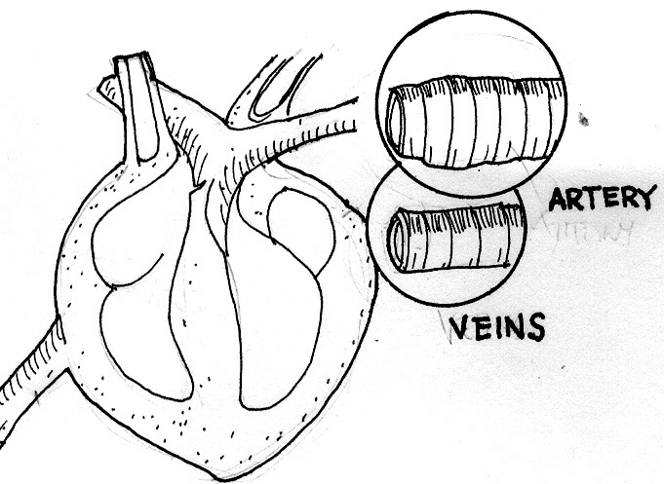

Capillaries are the smallest blood vessels and can be seen only with the microscope. Blood conpuscles-pass through the capillaries in single file. You find them near the skin. Oxygen and food in the blood pass through the capillary to the cells. Exchange of water, gases, nutrients and waste materials occurs between the blood and the tissues in the capillaries. Capillaries lead into another kind of blood vessels called veins.
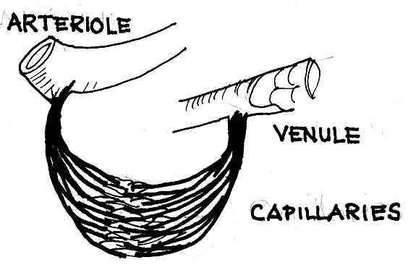

Veins carry bluish blood with more carbon dioxide and other wastes back to the heart out into the lungs. The walls are thin and contain less muscle tissue than the arteries. Many larger vains have cuplike values that keep blood from flowing backwards.
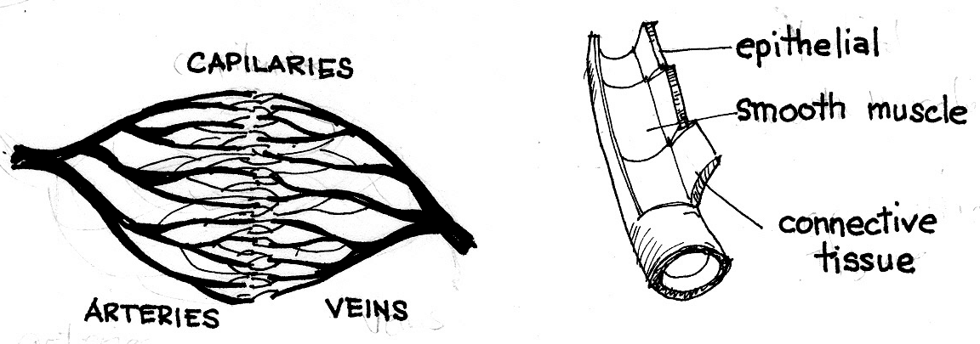

Activity 3

1. Fill up the table below using the information from your readings from the previous activity.

Kind of Blood Vessels | Characteristics | Functions

I LEARNED THAT:

- The blood vessels are the passage ways of blood.
- There are three kinds of blood vessels: arteries, veins, and capillaries
- Arteries are the largest and carry blood with oxygen (oxygenated blood) away from the heart.
- Capillaries are very thin and have tiny openings in their walls where oxygen and food pass to the cells.
- Veins carry blood (unoxygenated) back to the heart.

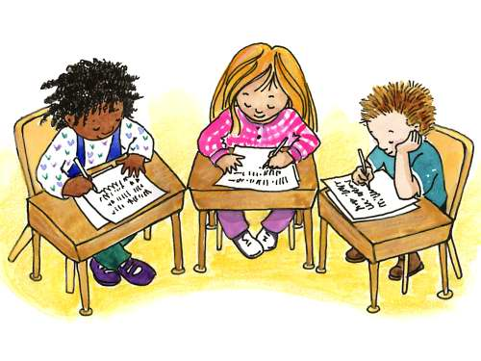

Apply It

Write your answers in your notebook.

- What will happen if the blood vessels will not work?
- Sometimes you prick your finger and no blood flows out. Explain why?
- Sometimes a prick can cause blood to flow out. Explain why?

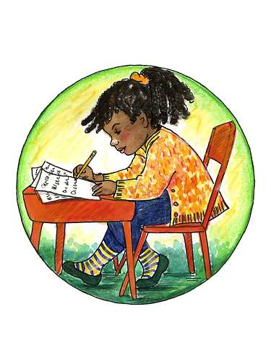

Test Yourself

*

Copy the table below and complete it using words in the box below it.

1.
4.
3.
2.
6.
5.
BLOOD VESSELS
KINDS
WORK
WORK
WORK

Artery
Capillary
Vein
Carries blood with oxygen and nutrients away from the heart
Carries blood with wastes like carbon dioxide back to the heart
The part where the exchange of gases, nutrients and wastes between
the blood and body cells occur.

Key to Correction

Try to Recall

Blood

SOLID PARTS
LIQUID PART

RED BLOOD CELLS
WHITE BLOOD CELLS

PLATELETS

PLASMA

Functions:
- contain hemoglobin which carries oxygen from the lungs and deliver it to body tissues
-bring oxygen to the cells and carry away carbon dioxide from the cells.
Functions:
- protect the body against infections by changing their shapes as they surround foreign bodies
- produce antibodies to protect the body against diseases
Functions:
- help seal blood vessel and stops bleeding
- produces blood clot
Functions:
- carries hormones, electrolytes, sugars, fats, minerals, vitamins to body tissues.
- carries antibodies that fight disease - causing germs

Activity 2

Kind of Blood Vessels | Characteristics | Functions
1. Arteries | - Thick-walled and elastic but are smaller in diameter than veins | Carry blood containing fresh oxygen and food nutrients away from the heart to the body cells.
2. Capillaries | - smallest | The part where the exchange of gases, food nutrients and waste materials between the blood and body tissues occur.
3. Veins | - Walls are thin but larger in diameter than arteries | Carry blood containing carbon dioxide and other wastes from the cells back to the heart.

Key to Correction

Test Yourself

carries blood with oxygen and nutrients away from the heart

BLOOD VESSELS

Artery

Capillary

Vein
the part where the exchange of gases, nutrients and wastes between blood and body cells occurs

carries blood with wastes like carbon dioxide back to the heart
KINDS
WORK
WORK
WORK

