THE WEATHER SYSTEMS
GRADE V
WEATHER SYSTEM: (southwest monsoon, north east monsoon)

(Southwest Monsoon, Northeast Monsoon)

At the end of the module, you should be able to:

- Describe how certain weather systems affect the Philippines



Try to Recall

Identify the weather for each day.
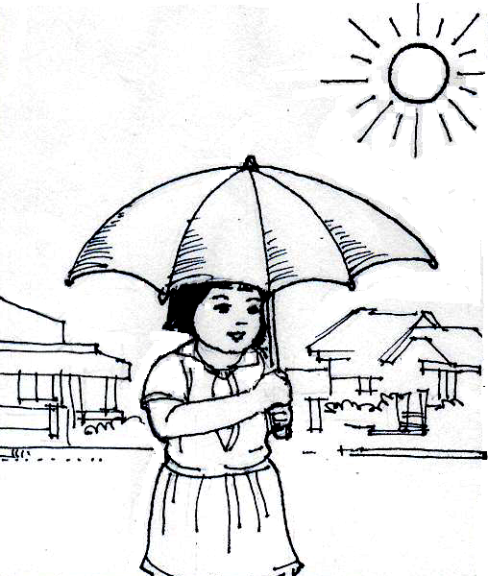
Monday

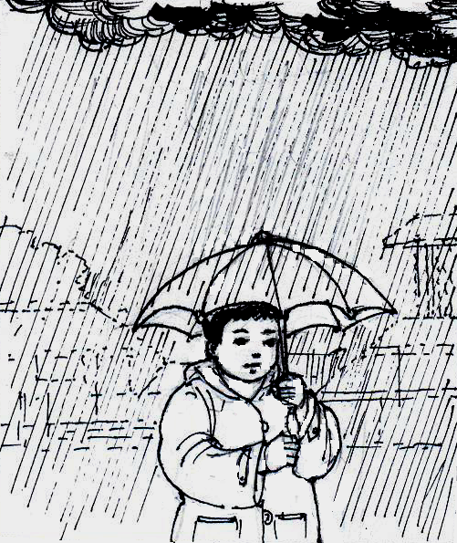
Wednesday
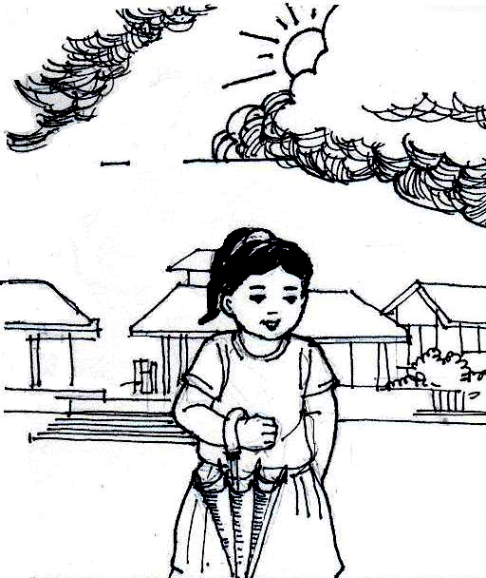
Tuesday

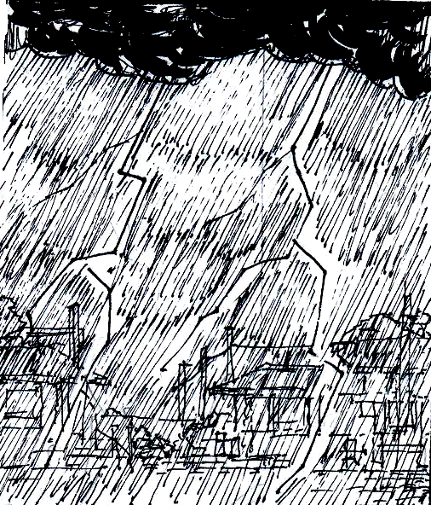
Friday
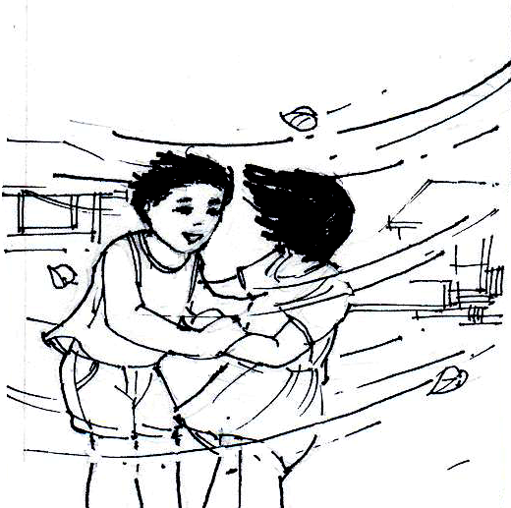
Thursday

Complete the table below. Do it in your notebook.

Days | Types of Weather
1. Monday
2. Tuesday
3. Wednesday
4. Thursday
5. Friday

Explore

When it is raining in your place, do you think it is also raining days in the other parts of our country? Can you tell why?
When it is dry season in your place, is it also dry season in other places? Find out more in this lesson.

Activity 1

N

E
W
S
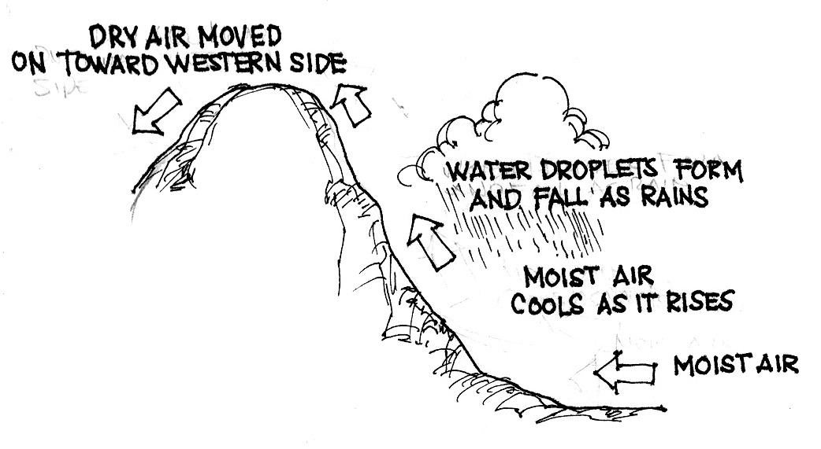
dry air moves toward western side

water droplets form and fall as rain

moist air cools as it rises

moist air

- How would you describe the weather at the eastern side of the mountain?
- What do you think causes the difference in weather between the two sides of the mountain?
- Do you agree that mountains affect the weather? How?

Activity 2

Study the illustration as you read the following paragraph then answer the questions below.
From June to October, a wind called the southwest monsoon (habagat) blows toward the Philippines. from Australia, where it is winter time.
As the wind travels from Australia over oceans, it gathers more and more moisture. Upon crossing the equator, it becomes warm. When it reaches the Philippines, it has become warmer with a great amount of water vapor. It brings rain to the western side of the Philippines.
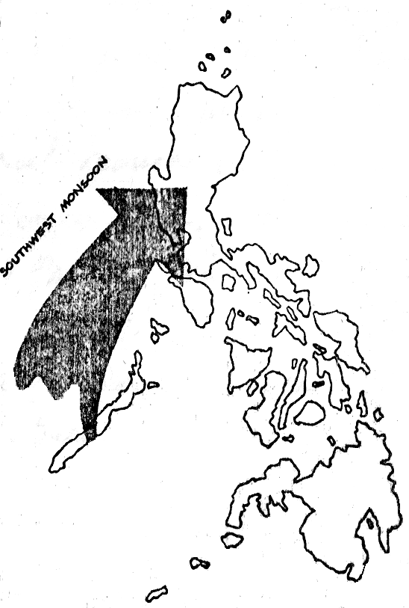

- What does the arrow represent?

- During what months does the southwest monsoon reach the Philippines?

- How would you describe the wind coming from Australia?

- What happens as this wind travels over oceans and crosses the equator?

- What kind of climate does this wind bring to the western side of the Philippines? The Eastern side?

- What can you conclude about how the habagat affects the weather systems in the Philippines?

Activity 3

Study the illustration as you read the following paragraph. Then answer the questions below.
From November to February, a wind blows toward the Philippines from the Northeast called the Northeast Monsoon (Amihan). This wind comes from Siberia where it is winter during this months. As the cold wind from Siberia passes over the oceans, it gathers moisture.
This moisture fall as rain in the eastern part of the Philippines. The cold wind continues to move to the western part of the country.
The Northeast Monsoon causes the coldest temperature during the year in the Philippines. It is cold and rainy in the east part, but cold and dry in the west.
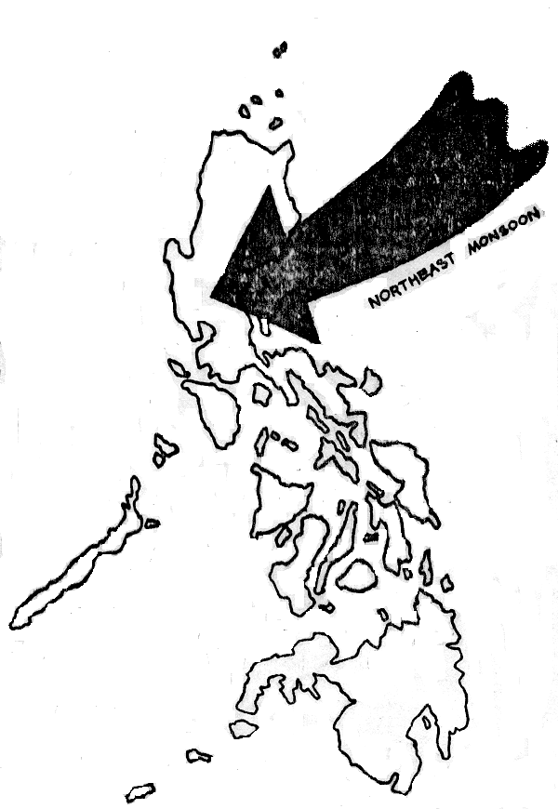

- What does the arrow represent?

- During which months does this wind reach the Philippines?

- What kind of wind comes from Siberia?

- What kind of climate does the northeast monsoon bring to the eastern side of the Philippines? The western side?

- What can you conclude about how Amihan affects the weather systems of the Philippines.

Activity 4

Study the illustration as you read the information about trade winds in the following paragraph. Then answer the questions below.
From March to early May, the trade winds reach the Philippines from the Northeast or east. Trade winds are warm and moist because they start near the equator. They bring heavy rains only to the eastern side of the Philippines. When they flow across to the western side, they cause arise in temperature and bring a small amount of rain with them.
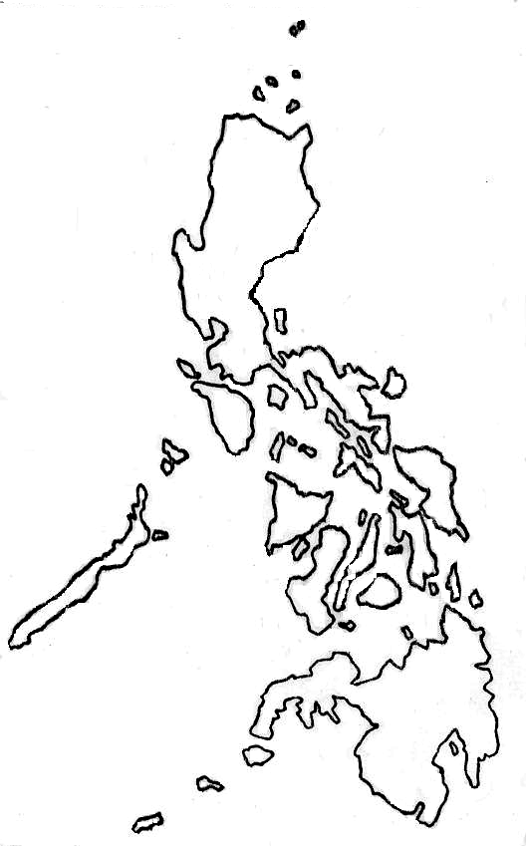

trade winds

- What does the arrow represent?

- Why are the trade winds warm and moist?

- What months do these winds reach the Philippines?

- What kind of climate do the trade winds bring to the eastern side of the Philippines? To the western?

- What causes the difference in climate between the eastern and western side of the Philippines?

6. What can you conclude about how the trade winds affect the weather systems of the Philippines?

I LEARNED THAT:

- Different factors affect the weather systems in the Philippines.

- The northeast monsoon or (Amihan) brings rain to the eastern side of the Philippines and dry but cool winds to the western side. It blows from the northeast from November to February.

- The southeast monsoon or (habagat) brings rain to the western side of the Philippines. It reaches the country from June to October.

- From March to early May, the trade winds bring heavy rain to the eastern side and hot temperature to the western side of the Philippines.

- High mountains found throughout the Philippines cause the difference in climate between the country’s eastern and western sides.



Apply It

- If you were a farmer in the Philippines, where would you want to live: in the eastern side or western side of the country? Why?



Test Yourself

Copy the diagram below in your notebook. Then complete it by writing descriptive phrases about monsoon winds in the spaces provided. Choose the phrases from the box.

rains the eastern side
cool but dry winds to the western side
rains to the western side
warm air the western side

Weather System: The monsoon Winds Systems
1.
2.
brings
Northeast monsoon

3.
brings
Southwest monsoon

4.
5.
bring
Trade winds

Key to Correction

Test Yourself

- rain to the eastern side
- cool but dry winds to the western side
- rain to the western side
- rain to the eastern side
5. warm air to the western side

