GRADE VI
EFFECTS EARTHQUAKE

At the end of the module, you should be able to:

- Describe the effects of an earthquake (e.g. landslide, tsunami, destruction of property, lost of lives, etc.)



Try to Recall

Unscramble each group of letters from the correct word. Use the clue below.

- s e p a l t - _________

2. e a e a h r q u k – _________

3. f l a u t – _________

4. p s u h – _________

5. l u p l – _________

Clue

- These are bedrocks in the crust. It may be in ocean or in the continents.
- The trembling or shaking of the earth’s crust.
- Crack on the earth’s crust.
- When the plates move toward each other. It _____ one another.
- It ______ one another, when the plates move away from each other.

Explore

Activity 1

You need the following

4 empty match boxes, rubber band
sand, and a box
broomstick (walis tingting)
sticks, rubber bands

What to do:

1. Fill two boxes with sand.
2. Tie the two boxes with a rubber band (side by side) or one on top of each other.
3. Do the same with the two box that are empty.
4. Let the boxes stand on a book.
(Note: The boundary of the two boxes represents the fault.)
5. Shake the book to simulate an earthquake.
6. Observe what happen to the houses.

Answer these:

1. What happens to the houses?
2. What causes the empty boxes to fire?

Activity 2

- Get the following

box, sand, water, soil

2. Fill the box with soil.
3. Make a steep mountain out of wet sand and place it at the center. (Inside the box).
4. Construct a small mound of wet sand (not as steep as the first one), beside the steep mountain you made.
5. Shake the box and observe.

Answer these:

1. What happens to the mountain and to the mound?
2. What does the shaking of the box represent?
3. What is this effect of earthquake?

Activity 3

- Prepare

rectangular container, water, pencil

2. Fill the rectangular container with at least ½ water.
3. Tap one end of the container with a pencil.
4. Observe.

(Note: The water in the rectangular container represents the ocean.)

Answer these:

1. What happened to the water in the container after tapping was done?
- What did the tapping on the container represent?
3. What do you call the movement of water?
4. What are these waves generated in the water/ocean?
5. If the tapping on the container represents the earthquake, what do you call the destructive wave produced?

Activity 4

- Get

drinking glass, half filled with water

2. Shake the drinking glass.
3. Observe the movement of water.
4. Repeat the shaking. Make it stronger this time.
5. Observe.

(Note: The drinking glass half-filled with water represent the lake.)

Answer these:

1. What happened to the water in the glass after shaking?
2. What does the shaking represent?
3. What do you call water movement in the lake during an earthquake?
4. What is the difference between the waves that originate in the ocean floor and the waves that come in the lake because of an earthquake? Which is harmful? Why?

Read and learn more.

Effects of Earthquake

- Earthquakes can destroy lives and properties.
- It can change land features.
- Cracks in the ground may result from an earthquake.
- Sand blows, small mound with craters are formed.
- A tsunami, a Japanese word meaning a big wave, is formed originating from the ocean floor due to an earthquake.
- A tsunami has the power to wipe out structures and living organisms near the shore.
A seiche is a word meaning a big wave or a lake usually around 3 meters high that can flood the surrounding areas, cover them with debris from the lake (e.g. lilies).

How to Survive Tsunamis

1. Be observant of the tide conditions around your coastal area. An unusual lowering of the sea level is a sign that a tsunami is approaching. Move to high ground immediately. If you are in a ship, immediately steer it for deep water.
2. Immediately move to high areas away from the shore when an earthquake occurs in your area. This is a warning that a natural tsunami is on the way. There may not be enough time for official warnings.
3. A tsunami is a series of waves. Stay out of danger until the last waves have passed.
4. Listen to tsunami warnings which help protect you. The tsunami may be generated by a local event or by an earthquake very far away.
5. Never watch tsunamis on shore. You may be too near to escape the event.
6. A tsunami may be quite small in one area but very large in another site, many kilometers away. Remember, the effect of waves can be changed by the structure of land under the sea.

(From: Philippine Institute of Volcanology and Seismology)

Precautionary Measures During and After Earthquake

- Stay calm, don’t panic.
- Avoid fly-over/overpass.
- Stay under sturdy/strong furnitures.
- Stay away from electric post.
- Go to an open field.
- Be prepared.

I LEAREND THAT:

- Earthquakes have harmful effects
- Earthquakes has often effects such as landslide, tsunami.
- There are precautionary measures to be observed before, during and after an earthquake.

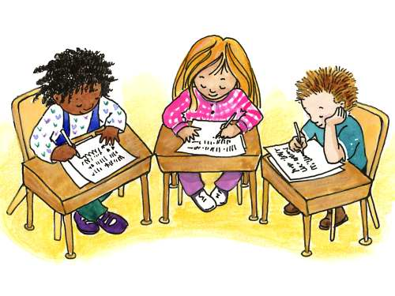

Apply It

A. Study the pictures below. Put a check (√) on the ones which shows the right thing to do during and after an earthquake.

1. | 4.
2. | 5.
3. | 6.

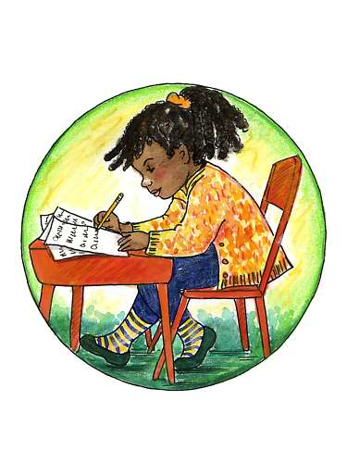

Test Yourself

*

A. Complete the table below.

EFFECTS OF EARTHQUAKE

people
water bodies

buildings/bridges
land forms

Tsunami

- Describe the effects of earthquake shown in the pictures below.

1. | __________________________  __________________________  __________________________  __________________________
2. | __________________________  __________________________  __________________________  __________________________
3. | __________________________  __________________________  __________________________  __________________________
4. | __________________________  __________________________  __________________________  __________________________
5. | __________________________  __________________________  __________________________  __________________________

