GRADE V

**ANIMALS WITH BACKBONES: THE VERTEBRATES**

(Intertropical Convergence Zone, Typhoons)

At the end of the module, you should be able to:

* *Describe how fronts, ITCZs, typhoon affect the weather systems in the Philippines*

## **Try to Recall**



Explain how the following affects weather system in the Philippine in two to three sentences. Write your answer in your notebook.

1. Northeast monsoon
2. Southeast monsoon

## **Explore**



Have you ever experienced a typhoon? Share your experiences with a friend

then discover more information about your lesson as you perform the following activities.

**Activity 1**

Read the following information. This will help you know facts about ITCZs and typhoon

**FRONTS**

The characteristics of air slightly vary from one another due to difference in temperature of the earth’s surface

When air masses of different characteristics meet, they do not readily mix. The surface contact between the two masses with different temperature forms a slope or boundary known as **front**. This boundary between them although wavy is definite. The colder air mass is denser and therefore tends to push under the warm air mass and lift.



When a cold air mass advances towards a warm air mass. The cold air mass being denser moves closer, rapidly to the ground and pushes the warm air mass upward.

The boundary between them is what we call cold front.

Another kind of front is the warm front. **Warm front** is formed when a

warm air mass advances over the edge of a mass of cold air mass. The

boundary known as warm front is has a very gentle slope extending as

much as 1.6 km. Ahead of the base of the front.



**Intertropical Convergence Zone** or simple (ITCZ) is a simple weather system formed when trade winds from both northern and southern hemisphere meet forming a big mass of cloud which is moving from east to west. Its horizontal extent is several thousands of kilometers. At the convergence area (point where the winds meet) the air moves upward carrying water vapor and in the process forming lines of clouds.

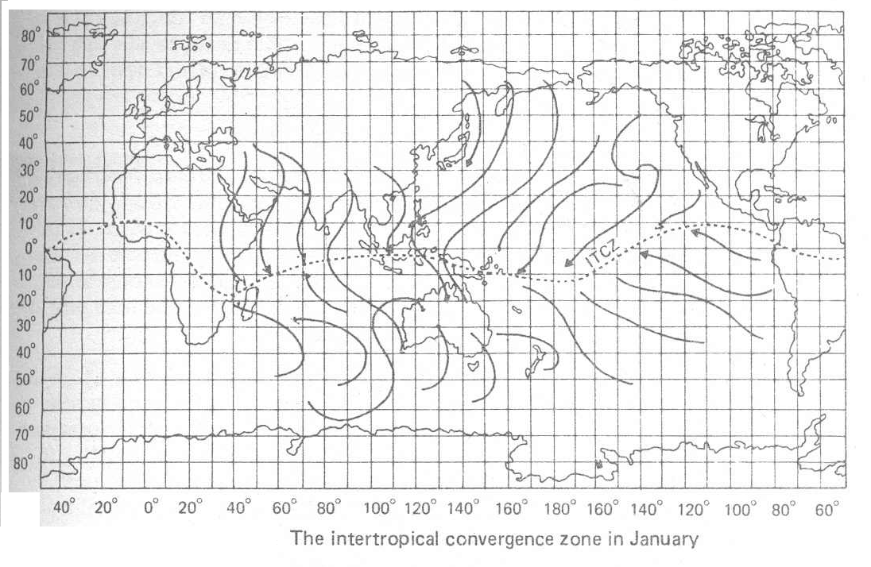

**Typhoon or Tropical cyclone** is an intense weather disturbance having more or less a circular shape and with an average size of about five hundred kilometers in diameter. The wind blows toward the center, called the eye, in a counter clockwise motion. Tropical cyclones are identified based on the speed of the circulating winds. If the speed of the wind is 60 km/h or less it is known as depression. If the speed becomes 60 to 118 it is known as storm and if the speed is more than 118 it is called a typhoon.

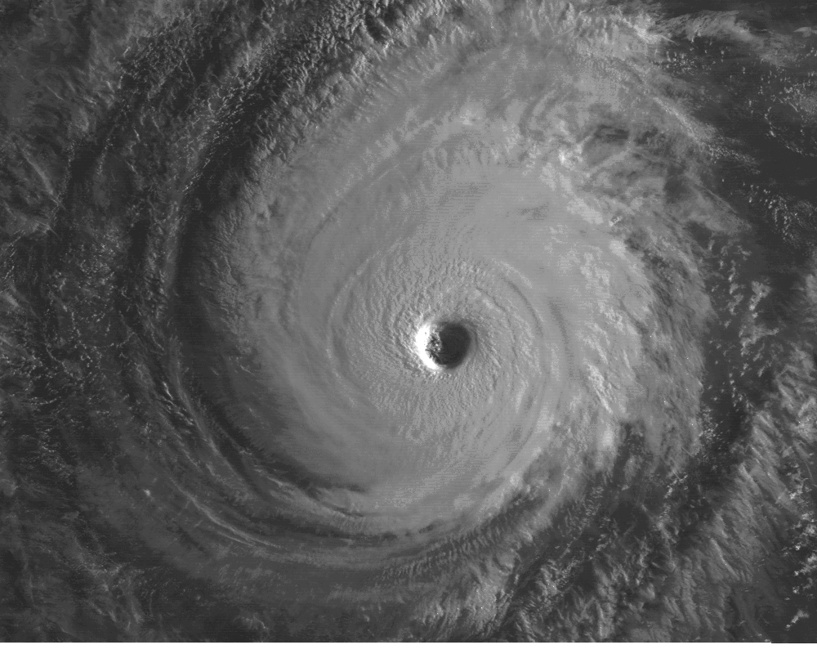

### Copy the table below in your notebook. Then complete it with information on the wind systems taken up in the module.

|  |  |
| --- | --- |
| Wind System | General Description |
| a. cold front |  |
| b. warm front |  |
| c. ITCZ |  |
| d. tropical cyclone |  |

### 

### Explain how does each of the following systems affect our weather. Write the answer in your notebook.

### Cold front

### Warm front

### Intertropical Convergence Zone

### Tropical cyclone

**I LEARNED THAT:**

* + - Some weather systems affect the climate of our country.
    - As **Front** is the boundary between two masses of different properties
* **Cold front** is the boundary of an advancing cold air mass and the

opposing warm air mass. The cold air mass being denser, moves

rapidly closer to the ground, thereby pushing the warm air mass

upward. The boundary between the cold an warm air mass is called

cold front.

* **Warm front** is formed when a warm air mass advances over the

edge of a mass of cold air mass. The boundary known as warm

front, has a very gentle slope extending as much as 1-6 km. Ahead

of the base of the front.

* + - **Intertropical Convergence Zone** (ITCZ) is a narrow zone or band of cloud moving from east to west. This is due to the meeting of trade winds from the tropical regions (30˚N and 30˚S) blowing towards the equator.
    - **Typhoon or Tropical Cyclone** is a weather disturbance that begins as a low pressure center over an ocean with strong circulating winds in counterclockwise direction.

## **Apply It**



What will you do when you hear a typhoon is coming?



## **Test Yourself**

**\***

Read each statement below carefully. In your notebook write a check (√) if the statement describes the weather systems. Write a cross (x) if does not.

1. The weather disturbance that begins from a low pressure area is called

*tropical cyclone.*

2. The ITCZ is a narrow band of clouds coming from the east to west, caused by the meeting of the north and south trade winds.

3. The boundary of an advancing cold air mass that sinks over a warm air mass, and pushes the warm air upward is called a cold front.

4. A warm front is the boundary formed when a warm air mass advances over the edge of a mass of cold air mass.

5. Typhoons or tropical cyclones do not affect the weather systems of the Philippines.

Key Answer

1. /
2. /
3. /
4. /
5. x