GRADE VI
BAD EFFECTS OF CHANGES IN THE ENVIRONMENT

THE ENVIRONMENT

At the end of the module, you should be able to:

- Describe how certain changes in materials have bad effect in the environment

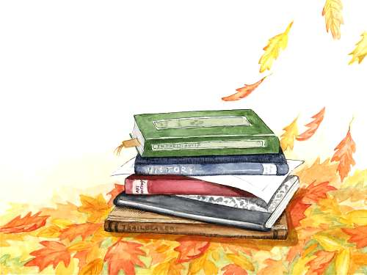

Try to Recall

Do you still remember the good effects of changes of materials to the environment? Answer the exercise that follows:

Write Yes if the change has good effect to the environment and No if it has no good effects.

1. making medicine

2. vehicles that produce black smoke

3. making hollow blocks out of sand and cement

4. cooking food

5. burning garbage

Study the picture. Identify the biodegradable materials and non biodegradable. Write them on the chart below.

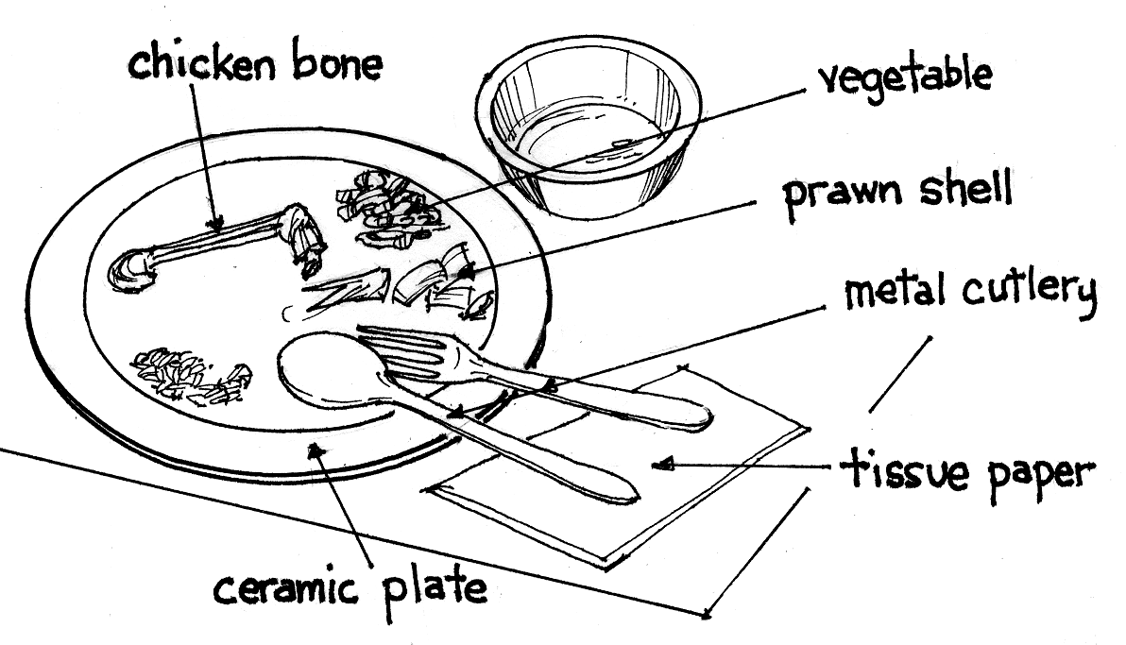

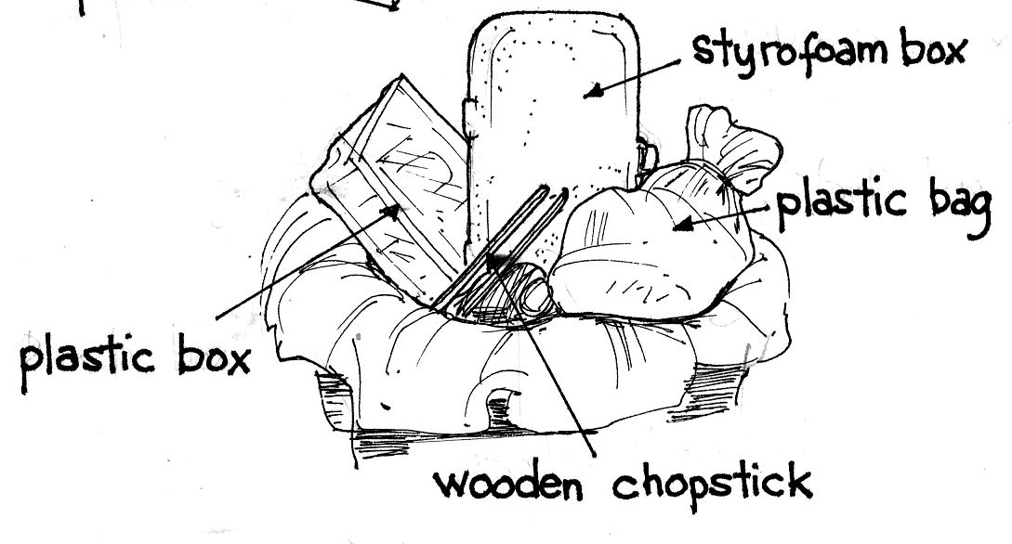

BIODEGRADABLE | NON-BIODEGRADABLE
1. | 1.
2. | 2.
3. | 3.
4. | 4.
5. | 5.

Explore

D e

Identify some materials around you. What effects do they bring to you? Are they all good? Is it good or bad effect?

Activity 1

What you need:

white cloth or handkerchief

What to do:

Leave a white cloth or handkerchief on a windowsill or clothesline for 3 days. Observe.

Answer these questions:

- Where did you put the white cloth or handkerchief?
- What happened to it after a few days?
- Did the color change? Why so?
- What does it show?

Activity 2

What you need:

Tablespoon of ash

What to do:

Put a tablespoon of ash in the clean water. Observe.

Answer these questions:

1. What happened to the water after you put the ash?
- What changes took place?

Activity 3

Look at the picture below. Then, answer the questions that follow:
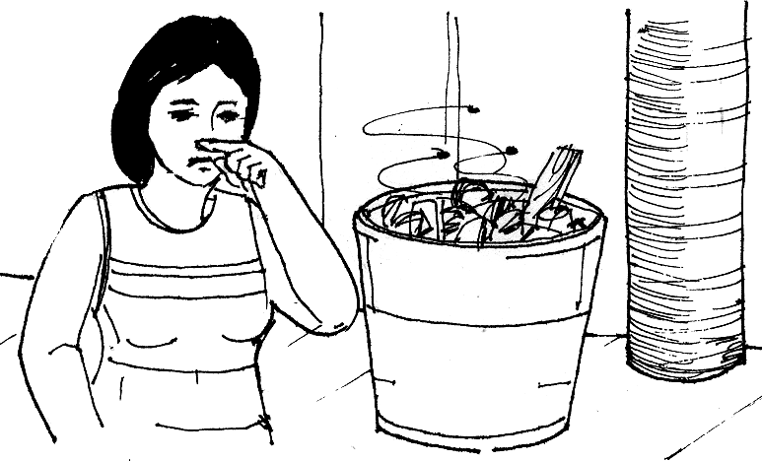

Answer these questions:

- What is found along the road?

- What do you see flying over the garbage?

- What can this picture not good to our health?

- What will happen to the soil if garbage is dumped on it?

Activity 4

Look at the picture below.
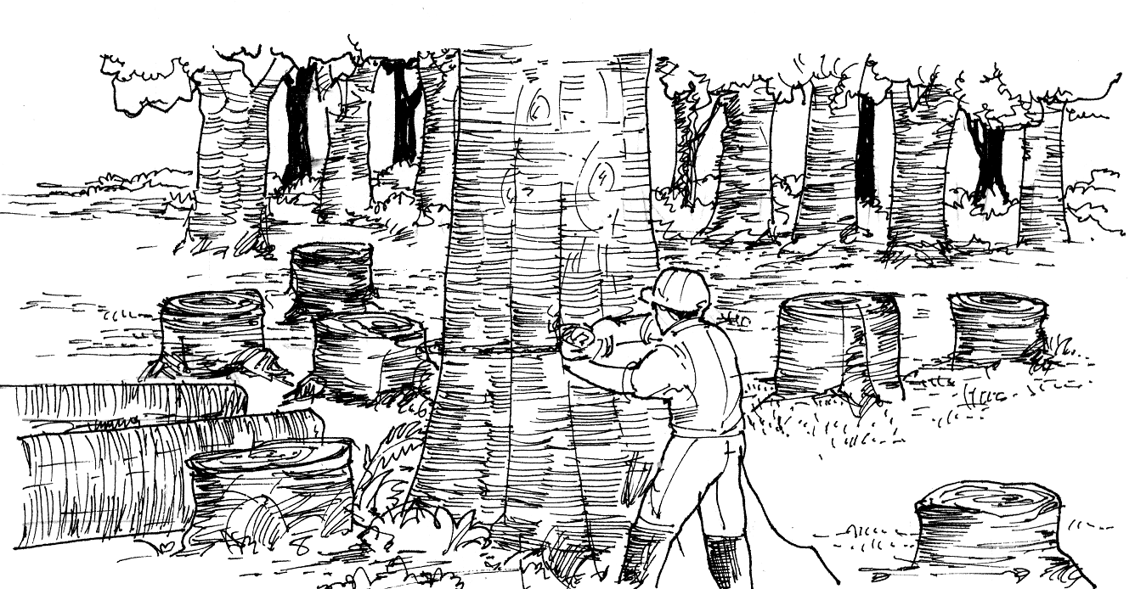

Answer these questions:

- What happened to the trees?

2. What will be the effect of this activity to the forest animals?

3. What will be the effect to people?

Read and learn more.
Good and bad effects result from certain changes of materials in the water cycle and photosynthesis are changes that have good effects.
Some changes have bad effect like pollution and destruction of habitat and lose of lives.
Improper disposal of garbage, harmful chemicals and human waste can cause changes. It can pollute air, land and water. Smoke from the burning of oil and coal and wood can also cause air pollution. Land pollution can also occur when farmers use too much weed killers and insecticides on their farms. Seas and oceans become polluted when oil from ships spills into the water. We also add to air pollution when we burn fuels. When fuels burn they give out smoke. Cigarette smoke also pollutes the air. Motor-cars, buses and other vehicles burn fuels such as petrol or diesel oil. The engines of these vehicle give out harmful gases which are invisible. The air becomes polluted when there are too many vehicles on the road. Smoke from factories and power stations can also cause air pollution.
Forests had been cleared to give way to housing projects. But this could lead to lose of habitat to animals and even lose of lives. It could also lead to soil erosion.
The loss of forests and air pollution have led to another threatening situation for our planet: GLOBAL WARMING. The cutting down of trees and the burning of fuels increases the amount of gases that cause greenhouse effect. Temperature all over the world rises resulting to global warming. With this, the ice at North and South Pole may melt. This will cause sea-levels to rise and so widespread flooding and destruction will occur. Plants and animals that are unable to adapt to the higher temperature will become extinct.

I LEARNED THAT:

- Some of changes in materials have bad effects to the environment.

- Improper disposal of garbage, harmful chemicals, human waste, smoke leads to
pollution.

- Pollution and deforestation causes loss of habitat lives, erosion and global
warming.

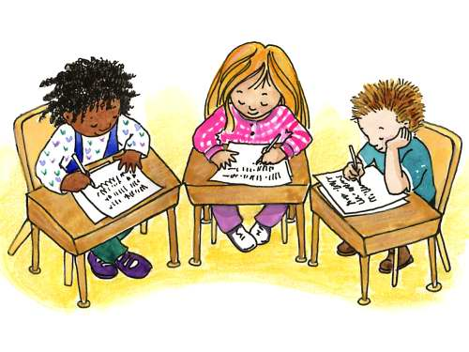

Apply It

- Some people prefer using styrofoam for food packing. Would you do the same? What would be the effect of this? What other alternatives can you suggest?

- Describe how you dispose your garbage in your house. Do you think this is proper or could it lead to pollution? Draw how you can correct your garbage disposal practices.

- Make a slogan on a bond paper on how we can prevent pollution.

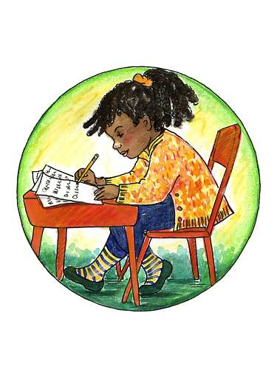

Test Yourself

*

- Write the Bad effect of these changes in the environment. Choose from the choices and write in your notebook.

1. cutting of trees
2. smoke from vehicles
3. using aerosols
4. throwing of garbage in rivers
- using harmful chemicals on land

air pollution soil pollution
deforestation water pollution

- Complete the outline in your notebook. Fill in the needed information from the choices in the box.

Bad Effects of Changes in the Environment

I. Pollution
Burning of Wood
Loss of Habitat
Cigarette Smoke
Global Warming
Garbage Thrown in Canals
Harmful Chemical on Soil
Human Waste in Drainage
Release of CFCs into the Air
Soil Erosion
Improper Disposal of Garbage
- Air Pollution
1.
2.
3.
- Water Pollution
1.
2.
- Land Pollution
1.

II. Deforestation
A.
B.
C.

III. Depletion of ozone layer
A.

BAD EFFECTS OF CHANGES IN THE ENVIRONMENT

Key to Correction

A.
- deforestation
- air pollution
- air pollution
- water pollution
- soil pollution

B.
I. Pollution
- Air Pollution
1. smoke
2. chlorofluorocarbons
3. acid rain
- Water Pollution
1. garbage thrown in canals
2. human waste in drainage
- Land Pollution
1. harmful chemical on soil
II. Deforestation
- Soil erosion
- Loss of living things
- Global warming

