GRADE V
INNER PLANETS

At the end of the lesson, you will be able to:

- describe the characteristics of the inner planets in the solar system including their orbit, distance from the sun, temperature and period of evolution



Try to Recall

Study the illustration of the solar system. Can you name each planet? Write your answers in your notebook. To help you, rearrange the letters at the left to form the names of the planets.

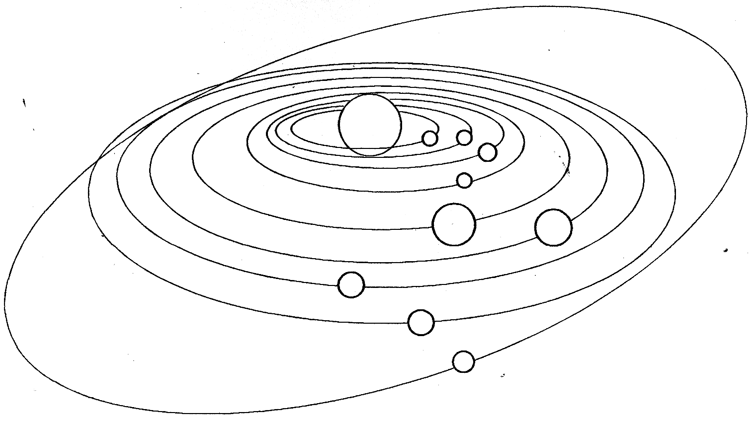

R U T N S A
R U S U N A
P U T E N E

R E M U C Y R
S U N E V
A T R H E

S R M A
T E R P I U J

If you answered (in correct order) Mercury, Venus, Earth, Mars, Jupiter, Saturn, Uranus, and Neptune and Pluto then you are doing well. Find out which of these planets are called the inner planets.

Explore

Activity 1

Study the information about the distance of inner planet from the sun.

Planets | Distance from Sun (km.)
Mercury | 58 million
Venus | 108 million
Earth | 150 million
Mars | 278 million

a. Draw an illustration like the one below in your notebook. Arrange the planets from their distance to the sun based on the given data.
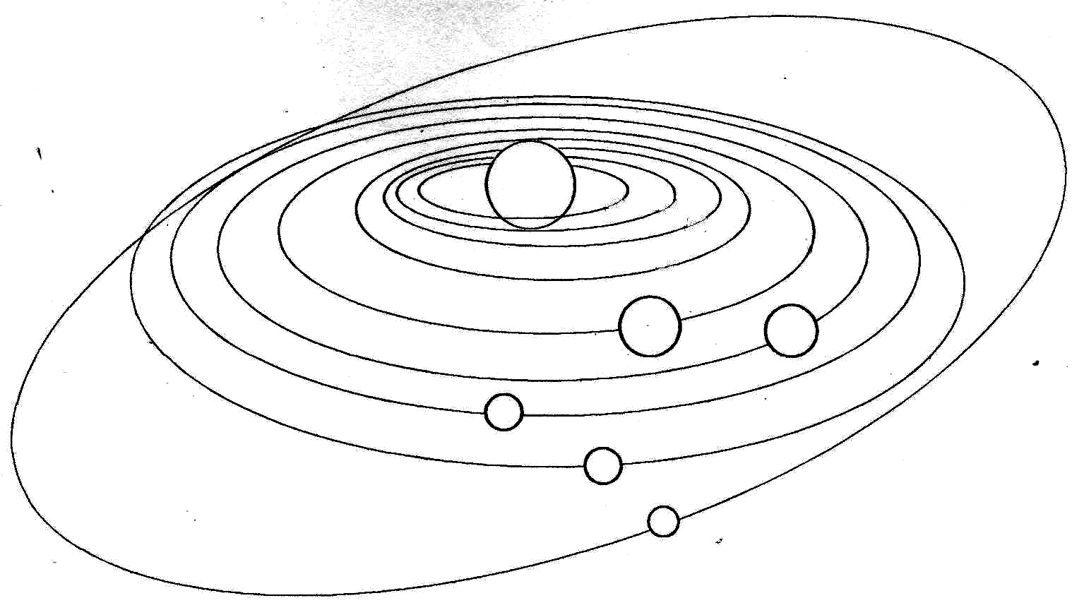

- Answer the following questions in your notebook.

1. Which inner plant is nearest to the sun?
2. Which planet is the third farthest from the sun?
3. Which planet is next to Mercury?
4. What is the distance of Mars from the sun?

Activity 2

Study the information on the inner planets. Answer the exercise that follows.
Planet | Period of Revolution | Diameter (km.) | Distance from the Sun (km.) | No. of Moons | Additional Characteristics
Mercury | 88 days | 4,880 | 58 million | 0 | It can be seen in the sky at sunrise and sunset.  Only one side of Mercury is facing the sun. This part is very hot.
Venus | 225 days | 12,100 | 108 million | 0 | The brightest planet with 96% CO₂.  The heat from the sun that reaches Venus cannot escape into space because it is trapped by the thick clouds that cover it. This thick clouds create a greenhouse effect making Venus the hottest planet in the solar system.
Earth | 365 ½ days | 12,756 | 150 million | 1 | The only planet to sustain life. It has an atmosphere.
Mars | 687 days | 6,787 | 228 million | 2 | It is reddish in color.  It is cold in Mars.  It has white caps on its poles which is ice.

Which are true about the inner planets? Copy these in your notebook.

1. Mercury is the fastest planet.
2. The earth has two moons.
3. If you live in Venus you can celebrate your birthday every after 225 days.
4. Venus is the most beautiful planet.
5. Mars has reddish color.
6. The nearer the planet to the sun, the fastest it moves around the sun.
7. Looking into the temperature of Mercury, life can exist there.
8. The presence of atmosphere can make life possible on Earth.
9. Mars has 2 moons.
10. The 4 inner planets move around the sun.
11. Planets have different distances from the sun.

Refer to the information given to check whether your answers are correct.
Read and learn more.
- The solar system is consists of the sun and the planets that orbit around it. These are nine planets, namely: Mercury, Venus, Earth, Mars, Jupiter, Saturn, Uranus, and Neptune and their moons.
- Mercury is the nearest planets to the sun. It is almost spherical in shape. It is covered with craters and huge basins.
- Venus is a beautiful white planet. Its temperature and pressure are extremely high. This is due to warm rays from the sun and trapped and making it hothouse. It is completely dry.
- The earth is not a perfect sphere. It’s an oblate spheroid or flattened sphere.
- Mars is the red planet. It is the only solid body in the solar system whose surface we can see. Mars shows as a small desk with red, dark and white markings.



Apply It

If you are given a chance to be an astronaut like
Neil Armstrong, what inner planet would you like to
visit? Why?




Test Yourself

*

Describe the four inner planets. Choose the phrase that can describe them on the box below. Write the answers in your notebook.

red planet
nearest planet to the sun
revolves 365 ¼ days
has a thin atmosphere
has a perfect sphere shape
has 1 moon
only planet to sustain life
has 96% carbon dioxide
has 2 moons
has living and non-living things

Mercury | Venus | Earth | Mars

To check your answers, refer to Read and Learn More.

Congratulations for a job well done! Keep up the good work. Now you’re ready to move on to the next module.

