GRADE VI
EARTHQUAKE INTENSITY AND MAGNITUDE

At the end of the module, you should be able to:

- Differentiate intensity from the magnitude of an earthquake



Try to Recall

In your notebook, answer the following questions.

- What is tsunami?
- What are some of the destructure effect of earthquakes? (give at least three)
- What are some precautionary measures to be undertaken before, during, and after an earthquake?

Explore

Try to investigate the difference between magnitude and intensity of an earthquake.

Activity 1

- Have an electric fan/fan, potted plants

- Switch the electric fan to No. 1, then No. 2 and No. 3. Fan with less force, then with a moderate force and then with greater force.
- Observe the rotation of the blade of the electric fan at each number/or the movement of the fan at each force.

The wind from the electric fan/fan represents the earthquake.

The strength/energy of the wind from the electric fan/fan
represents the magnitude.

Answer these:

1. When was the wind strongest? Why?
2. When was it fastest? Why?
3. When was the wind weakest? Why?
4. When was it slowest? Why?

Activity 2

1. Line up three potted plants in front of the electric fan at different distances. (Line up three potted plants in front of a person who will fan.)
2. Switch the electric fan to No. 3. (Fan with greater force.)
3. Observe the movement of the leaves of plants at different distances.

Answer these:

1. What did you observe on the movement of plants at the different distances?
2. Which plant has the strongest movement? Why?
3. Which plant has the weakest movement? Why?

The strength of the movement of the plants represents the intensity.

Activity 2

- Get

- mpty matchboxes, 3 stones of different sizes (small, medium, large)

2. Pile empty matchboxes one on top of the other in groups of five.
3. Place one pile near one end of the table and the other pile at the other end.
4. Using a stone, strike one pile under the table. Observe the movement of the matchboxes in each pile.
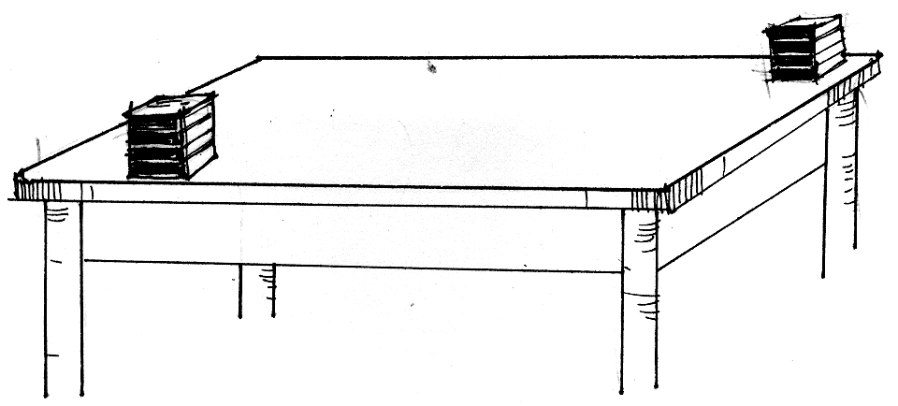

- Repeat using the two other stones one at a time.
- Observe the movement of the matchboxes each time you strike a stone on the pile.

Answer these:

1. What happened when you struck the table at one end?
- Which pile showed stronger movement? Why?
3. Which pile showed the least movement? Why?
4. Which stone caused the strongest movement?
5. Which stone caused the weakest movement?

The place where the stones struck the table represents the epicenter of an earthquake.

- Based on the different activities, which shows the magnitude of an earthquake? The intensity?

Read and learn more.
Earthquakes are vibrations or tremors produced in the earth’s outer layer or crust. An earthquake can be tectonic. It occurs when parts of the earth’s crust break and the rocks along a fault slide close to each other or away from each other. This is called faulting. An earthquake may also be volcanic. Tremors are often produced to signal an upcoming volcanic eruptions in that vicinity or region.

Focus is a break in the ground caused by the pressure of the moving rock. It is the place where the earthquake originates. Epicenter is the point or line on the earth’s surface directly above the focus of an earthquake. The study of earthquakes is called seismology. Scientists or experts in this field are called seismologists. There are two major scales in which earthquakes are measured. The magnitude of a particular earthquake is a single number which does not vary from place to place. Magnitude is the total energy released by an earthquake at its focus. Earthquakes of large magnitude are stronger and generally more destructive than those of small magnitude. The Ritcher Scale measures earthquake magnitude. The intensity of an earthquake is measured in term of its geological effects and the overall damage it brings. The intensity of an earthquake becomes weaker outward from the epicenter. The Mercalli Scale measures the intensity of shaking. Measures of intensity and magnitude corresponds to each other as shown by the table.

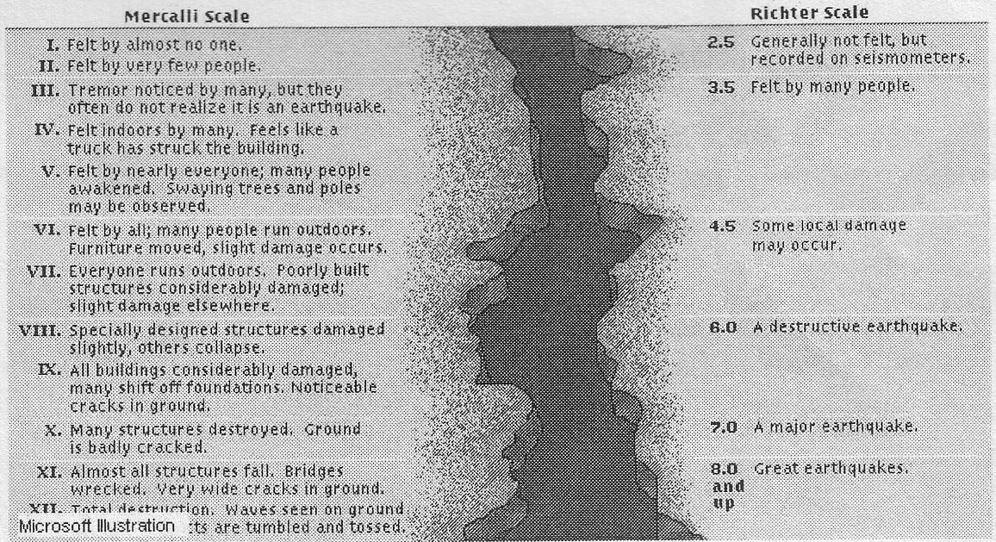

I LEARNED THAT:

- Magnitude and intensity are two different thing.
- Magnitude is the force that generate an earthquake while intensity is effect of the earthquake as perceived by an observer.



Apply It

- Read the situations below and answer the questions that follow.

Marikina was hit by an earthquake with a magnitude of 7. The epicenter was located at Concepcion.

- What is the total energy released by the earthquake?
- What is its corresponding intensity?
- What are the possible effects of the earthquake?
- What would be the intensity measures outside Concepcion?

- Some parts of Quezon City is located along a Major Fault line. Would buying house and lot in this area advisable? Why?



Test Yourself

*

Select the letter of the correct answers.

- What is the difference between intensity and magnitude of an earthquake?
A. There is no difference between intensity and magnitude.
B. Intensity measures energy while magnitude measures the strength of an earthquake.
C. Intensity refers to the strength while magnitude refers to the amount of energy released by an earthquake.
D. Intensity measures the thickness of an earthquake while magnitude measures the amount of its strength.
- Which of the following tells about the intensity of an earthquake?
A. lowest near epicenter
B. highest from epicenter
C. duration of the shaking
D. distance from epicenter
- Which statement tells about the magnitude of an earthquake?
A. strength of shaking
B. amount of energy released
C. cannot be determined if less than 7
D. cannot be determined if greater than 54
- Which of these statements are true?
A. Intensity and magnitude are the same.
B. Magnitude is expressed in Roman Numerals.
C. Magnitude can be measured by the seismograph.
D. Intensity can be measured with the use of phonograph.
5. Study the illustration below.

What is the place where an earthquake occurs called?
A. epicenter
B. focus
C. magnitude
D. intensity

