GRADE V
THE OTHER MEMBERS OF THE SOLAR SYSTEM

SOLAR SYSTEM

At the end of the module, you should be able to

- Describe the characteristics of the other members of the solar system.



Try to Recall

Copy the diagram below in your notebook. Draw the planets on their orbit around the sun then write their names.
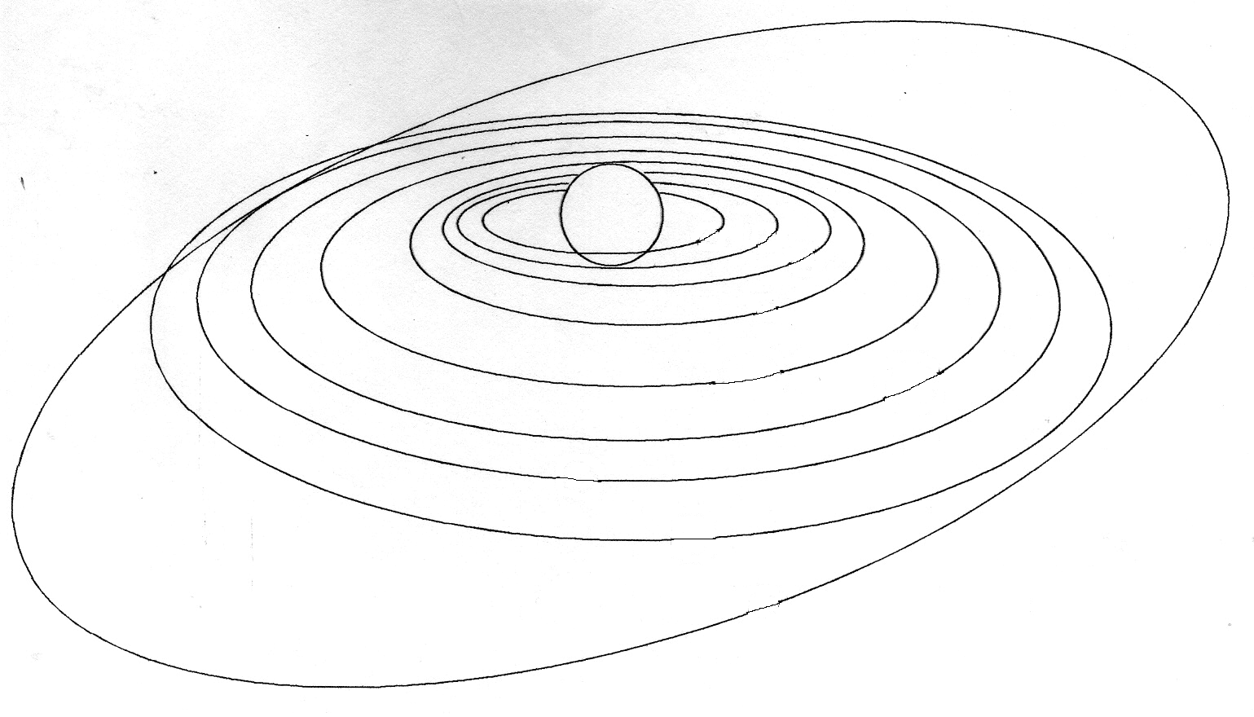

Explore

In the previous lesson, you have learned that there is a big space between Mars and Jupiter. This space is called the Asteroid Belt.

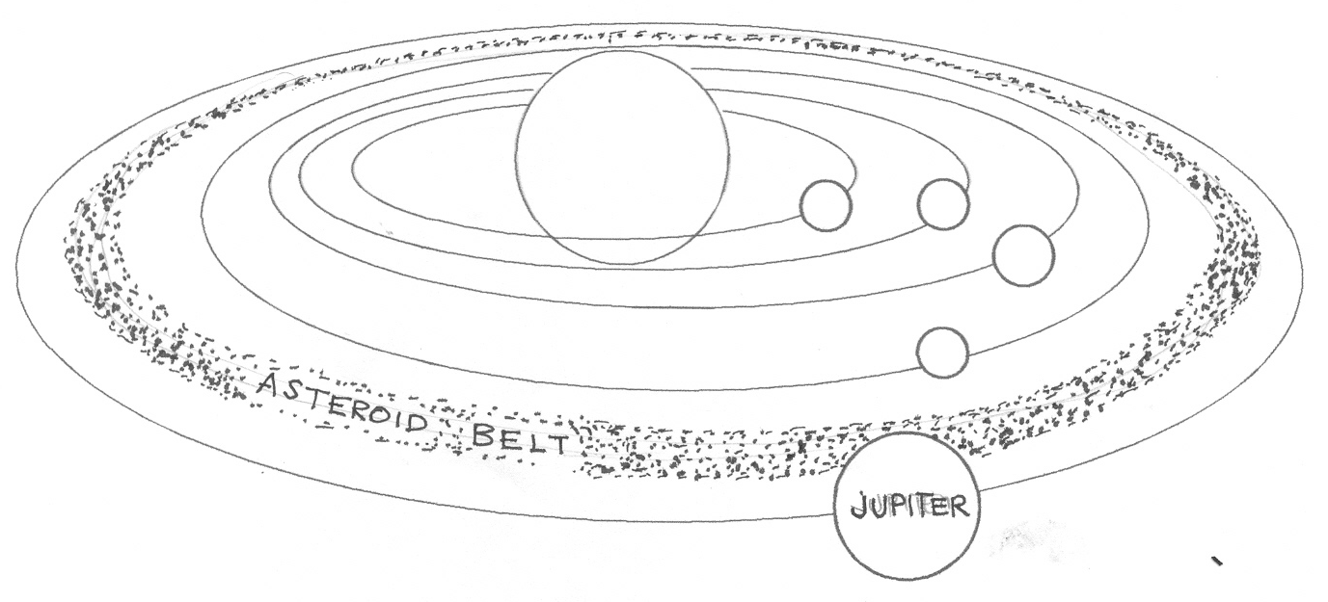
Mars orbit
Jupiter Orbit

Activity 1

- Asteroids are millions of small planet-like bodies. They are found between the great space between mars and Jupiter. Asteroids are not stars they are minor planets. Their sizes differ. The largest asteroids have diameters of about 1,000 kilometers. Most asteroids are a kilometer long or less
Like planets, asteroids revolve around the sun counterclockwise. Some asteroids may trace in space. They are called meteoroids when this meteoroids fall into the atmosphere of the earth they are called meteors. A meter that falls on the surface of the earth is a meteorite.

2. Underline the word/phrase in the parenthesis.

- Paragraph I tells us (where, when) asteroid belt can be found.
- Asteroids are (stars, minor planets).
- Asteroids (revolve, rotate) around the sun.
- Smaller particles caused by the breaking of asteroids are called (meteors, meteoroids).
- Sometimes we see shooting stars, these are (meteors, meteoroids).
- Meteors are meteoroids that enter the (Earth, Mars).
- When meteors fall on the surface of the earth they are called (meteorites, meteoroids).

Activity 2

Read the following paragraphs about comets.

I. A comet is a heavenly body. It is believed to originate in a dense comet cloud beyond Pluto. It has a glowing head and a long bright tail. The head seems to be only a few kilometers in diameter. However the tail maybe millions of kilometer long.

II. In far out space, a comet has no tail. But when it comes near the sun, some of its ice evaporate. A cloud of gas is then formed around the head. It is called the coma. Beyond the coma a long tail of gases and dust particles gradually stretches off into the space. The tail always points away from the sun. This is because the force of sunlight pushes the dust particles outward.

Do the following:

- Draw a comet based on the description found on the 3rd sentence of the 1st paragraph.

- What are the similarities and differences of asteroids and comets? Copy the VENN DIAGRAM on your notebook and fill it up.
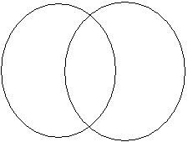

Read and learn more.

- Asteroids, Meteoroids and comets are members of the solar system
- Asteroids are rocky irregular materials which move in an area between Mars and Jupiter. This area is called the asteroid belt.
- When asteroids collide with each other they break and the broken pieces float in space.
- Meteorites are pieces of rocks traveling in space. They vary in size and composition.
- Meteoroids are glowing rock fragments from space moving across the Earth’s atmosphere.
- Some meteoroids burn completely in the atmosphere. Others are so huge, parts of them reach the Earth. Meteoroids that reach the Earth’s surface are called meteorites.
- Big meteors produce craters when they hit the ground.
- Halley’s Comet is a very famous comet that revolves around the sun in 76 years.

I LEARNED THAT:

- The other members of the solar system are the asteroids, meteoroids and comets.

- Asteroids are rocky materials found in the asteroid belt between Mars and Jupiter.

- Meteoroids are glowing rock fragments from space moving across Earth’s atmosphere.

- Meteoroids that reach the Earth’s surface are called meteorites.



Apply It

Answer this:

- Do you believe that wishes are granted if you see shooting stars? Why?


Test Yourself

- Read each statement below. In your notebook, write C if the sentence describes comets write A if it describes asteroids, M if it describes meteoroids, MT if it is meteorites.

1. Rocky and irregular in shape found between Mars and Jupiter
2. Reaches the earth’s surface
3. Sometimes called shooting stars
4. It has a glowing head and bright tail
5. Meteoroids that enters the earth’s atmosphere

B. Identify the pictures. Write your answer on your notebook.

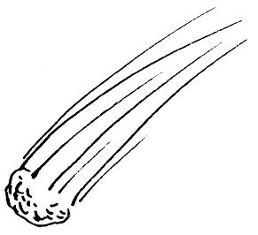
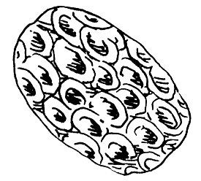
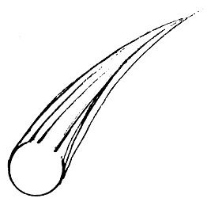

A
B
C

