Republic of the Philippines

Department of Education

Bureau of Elementary Education

Region IV– MIMAROPA

Division of Bulacan

San Jose East District

**SAN ROQUE II ELEMENTARY SCHOOL**

**TABLE OF SPECIFICATION**

**MAPEH 4**

|  |  |  |  |
| --- | --- | --- | --- |
| **OBJECTIVES** | **NO. OF ITEMS** | **ITEM PLACEMENT** | **PERCENTAGE** |
| Nakikilala ang iba’t ibang uri ng notes at rests | 5 | 1-5 | 17 |
| Naibibigay ang bilang ng kumpas ng note at rest | 5 | 6-10 | 17 |
| Nakaguguhit ng mga disenyong kultural | 10 | 11-20 | 33 |
| Nasusunod ang kahalagahan ng paggawa ng mga gawaing nakabubuti sa kalusugan | 10 | 21-30 | 33 |
| **TOTAL** | **30** | **30** | **100** |

Prepared by:

CHERRIE ANN A. DELA CRUZ

Teacher

**FIRST GRADING PERIOD**

**FIRST SUMMATIVE TEST**

**MAPEH 4**

Name: __________________________________________ Date: ______________

Gr./Sec: ____________________ Score: _____________

**I. A. Suriin ang awiting “Tayo Na!”**

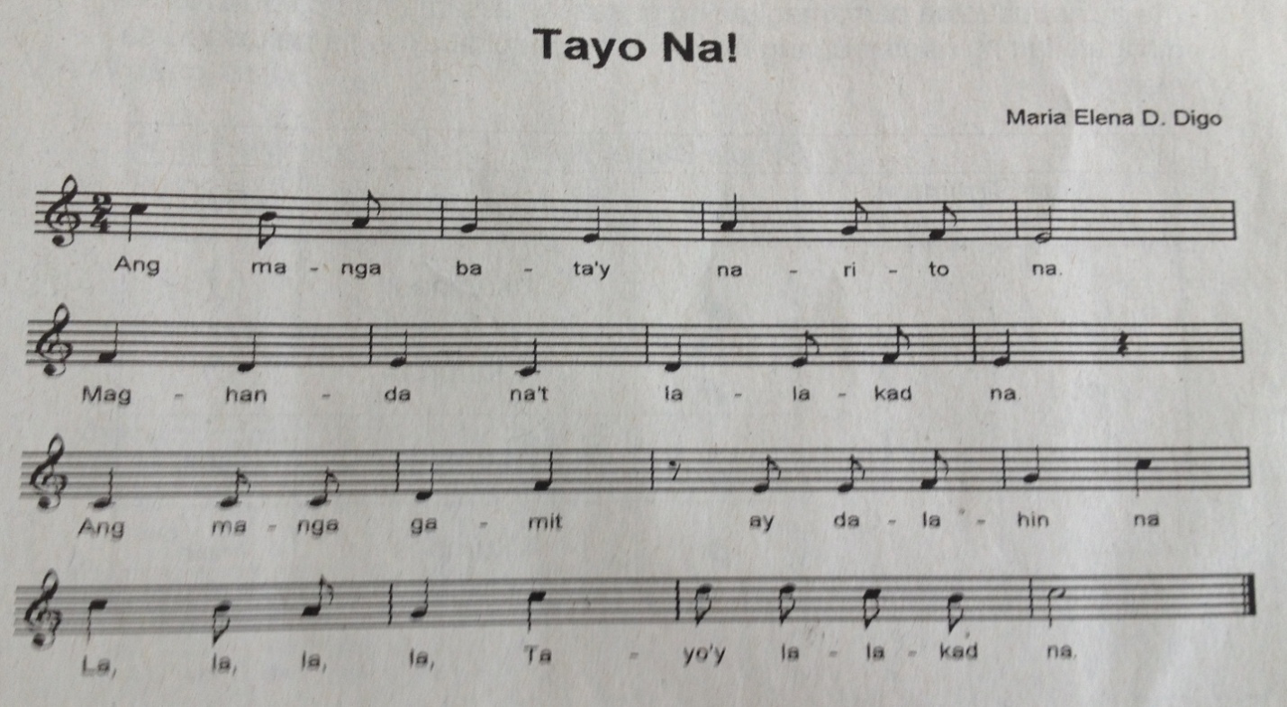

**Ano-anong uri ng note at rest ang ginamit sa awitin?**

1. _____________________

2. _____________________

3. _____________________

4. _____________________

5. _____________________

**B. Kumpletuhin ang nawawala sa tsart. (6-10)**

|  |  |  |  |  |
| --- | --- | --- | --- | --- |
| Mga Uri ng Note | Simbolo | Bilang ng Kumpas | Mga Uri ng Rest | Simbolo |
|  |  | 4 | Whole rest |  |
| Half note |  | 2 | Half rest |  |
| Quarter note |  |  | Quarter rest |  |
| Eighth note |  | ½ |  |  |
| Sixteenth note |  | ¼ | Sixteenth rest |  |

**II. A. Lumikha ng disenyong kultural mula sa pamayanan ng Luzon. (5 pts.)**



**B. Lumikha ng disenyong kultural mula sa pamayanan ng Visayas. (5 pts.)**



**III. Isulat sa patlang kung ilan beses dapat ginagawa ang mga sumusunod na gawain.**

**A** – 1 Beses  **B** – 2-3 Beses **C** – 3-5 Beses **D** – Araw-araw

____21. Paglaro sa labas ng bahay

____22. Pagbibisekleta

____23. Pagsasayaw ng Modern Dance o Ballroom

____24. Panonood ng TV

____25. Push-up/Pull-up

____26. Pagtakbo

____27. Pagtulong sa gawaing bahay

____28. Paglalaro ng computer

____29. Pag-upo/paghiga ng matagal

____30. Paglalaro ng basketbol/balibol

Republic of the Philippines

Department of Education

Bureau of Elementary Education

Region IV– MIMAROPA

Division of Bulacan

San Jose East District

**SAN ROQUE II ELEMENTARY SCHOOL**

**TABLE OF SPECIFICATION**

**ENGLISH 4**

|  |  |  |  |
| --- | --- | --- | --- |
| **OBJECTIVES** | **NO. OF ITEMS** | **ITEM PLACEMENT** | **PERCENTAGE** |
| Note details in a selection listened to | 5 | 1-5 | 17 |
| Read words, phrases, poems, and stories with the long a sound | 15 | 6-20 | 50 |
| Use plural form of regular nouns | 10 | 20-30 | 33 |
| **TOTAL** | **30** | **30** | **100** |

Prepared by:

CHERRIE ANN A. DELA CRUZ

Teacher

**FIRST GRADING PERIOD**

**FIRST SUMMATIVE TEST**

**ENGLISH 4**

Name: __________________________________________ Date: ______________

Gr./Sec: ____________________ Score: _____________

**I. What do you usually have when you celebrate your birthday? Do you also have a cake? How did Kate get a cake for her birthday? Find out as you listen to the story from your teacher. “A Cake for Kate”**

**Answer the following questions:**

1. What did Kate sell after her classes?

____________________________________________________________________________________________________________________________________

2. Why do you think did Kate sell rice cakes?

____________________________________________________________________________________________________________________________________

3. What did Kate see one afternoon?

____________________________________________________________________________________________________________________________________

4. What did she do with the box?

____________________________________________________________________________________________________________________________________

5. How did Mrs. Salas thank Kate for returning her box of *pasalubong*?

____________________________________________________________________________________________________________________________________

**II. A. Read the following words correctly. (10 pts.)**

date game bake cane male

cage tape vane lake name

**B. Read the sentences. Answer the questions.**

16. Jake takes the ape to the lake.

Where does Jake take the ape? _____________

17. Kate bakes a cake.

What does Kate bake? _____________

18. James is late for his game.

Who is late for the game? _____________

19. The lame man has a cane.

What does the lame man have? ____________

20. The cape is on sale.

What is on sale? ___________

**III. A. Complete the sentence with the correct form of the noun. The pictures will help you.**



21. We made _____________ in class.

22. The _____________ are in the field.



23. The boys brought their __________ to the camp.

24. Helen has ___________ on her hair.



25. During the Holy Week, our family visited different __________.

**B. Write the words for the following images.**



26. __________________



27. __________________



28. __________________



29. __________________



30. __________________

Republic of the Philippines

Department of Education

Bureau of Elementary Education

Region IV– MIMAROPA

Division of Bulacan

San Jose East District

**SAN ROQUE II ELEMENTARY SCHOOL**

**TABLE OF SPECIFICATION**

**FILIPINO 4**

|  |  |  |  |
| --- | --- | --- | --- |
| **OBJECTIVES** | **NO. OF ITEMS** | **ITEM PLACEMENT** | **PERCENTAGE** |
| Natutukoy ang pangngalan sa pangungusap | 10 | 1-10 | 33 |
| Natutukoy ang pangngalang pantangi at pambalana | 10 | 11-20 | 33 |
| Nasasagot ang mga tanong sa napakinggang tula | 5 | 21-25 | 17 |
| Nababasa ang maikling tula nang may tamang bilis, diin, ekspresyon, at intonasyon | 5 | 26-30 | 17 |
| **TOTAL** | **30** | **30** | **100** |

Prepared by:

REBECCA S. MAGA

Teacher

**FIRST GRADING PERIOD**

**FIRST SUMMATIVE TEST**

**FILIPINO 4**

Name: __________________________________________ Date: ______________

Gr./Sec: ____________________ Score: _____________

**I. A. Isulat sa patlang kung ang pangngalang may salungguhit ay ngalan ng tao, hayop, bagay, o pook.**

____________1. Mabilis tumakbo ang kabayo.

____________2. Nasa bukirin ang mga magsasaka.

____________3. Katulong nila sa trabaho ang mga kalabaw.

____________4. Tumawag sa telepono si Tatay kanina.

____________5. Darating bukas si Marlon mula sa Pampanga.

**B. Punan ng tamang pangngalan ang sumusunod na pangungusap. Piliin sa loob ng kahon.**

kabataan proyekto bansa Lea Salonga pamahalaan

6. Ang ________ ay pag-asa ng bayan.

7. Gagawa kami ng ________ para sa pangngangalaga sa sarili.

8. Tunay ngang katangi-tangi ang ating _________.

9. Katangi-tanging Pilipino si _________.

10. Malaki ang responsibilidad ng ________ sa taong-bayan.

**II. Piliin ang panggalang pantangi at pambalana sa loob ng kahon at isulat sa wastong hanay. (11-20)**

relo lapis Dove Mrs. Austria sapatos

pabango HBW Baguio damit Pasko

|  |  |
| --- | --- |
| PANTANGI | PAMBALANA |
|  |  |

**III. Sagutin ang mga tanong sa tulang “Ang Halaga ng Pamilya”.**

21. Ano ang pamagat ng tula?

________________________________________________________________

22. Tungkol saan ang tula?

________________________________________________________________

23. Bakit daw mahalaga ang pamilya?

________________________________________________________________

24. Bakit dapat alagaan ang pamilya?

________________________________________________________________

25. Ano ang hindi pinagsasawaan ng pamilya na ibigay sa atin?

________________________________________________________________

**III. Punan ang nawawalang salita sa tula. (26-30)**

Halaga ng Pamilya

*ni Arjohn V. Gime*

Pamilya’y dapat _________

Sila’y ating sandigan

Sa _________ at kalungkutan

Bawat kasapi’y maaasahan.

Mula _________ hanggang pagtanda

Di nagsawa sa pagkalinga

Ipinunlang pag-aaruga

Aning binhi ng pamilya’y masagana.

Pamilyang pinagmulan ay ating _________

Ama, ina, anak, laging magkaagapay

Ugnayang _________ na walang kapantay

Sama-sama sa pag-abot hangad na tagumpay.