GRADE V
MAKING WORK EASIER

At the end of the module, you should be able to

- describe what a machine does and how it can multiply force



Try to Recall

Some machines are so simple that we do not even realize that they are machines. Identify each simple machine described below. The shapes of the boxes have been provided to guide you. Write the answers in your notebook.

1. Machine for open cans

2. Machine for cutting paper

3. Machine used for move sand from
one place to another

4. Machine used for in pull nails

5. Machine used for catching fish

Explore

Activity 1

In this activity, you will discover the strength of a machine once there is an applied force. Applied force is the force acting upon an object like pushing the table.

- Prepare the following:

Paper and a pair of scissors

2. Tear the piece of paper using your hand.
3. After tearing, cut the remaining part of the paper using a scissor.
4. Answer the following questions:

- Which is easier to do: cutting a piece of paper using a pair of scissors or tearing the paper using your hand?
- When did you exert more?
- What happened to the amount of force you applied to do the activity?

Activity 2

This activity talks about the different kinds of simple machine that Mendoza family used to do in the household chores. Read what they did below.

Father is busy fixing the kitchen cabinets. He pulls out a nail using a hammer. The hammer is an example of a lever.
Mother is preparing lunch. She slices the beef meat a knife. The knife is an example of a wedge.

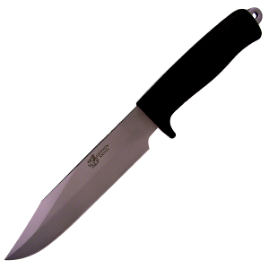
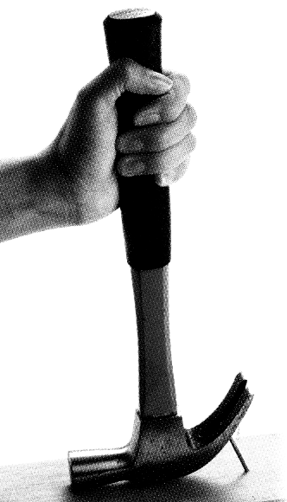

Brother is helping father. He turns a screw using a screw driver. The screw driver is and example of a wheel and axle.
Sister is gathering the toys. She carries them to the children’s room upstairs. The stairs are an example of an inclined plane.

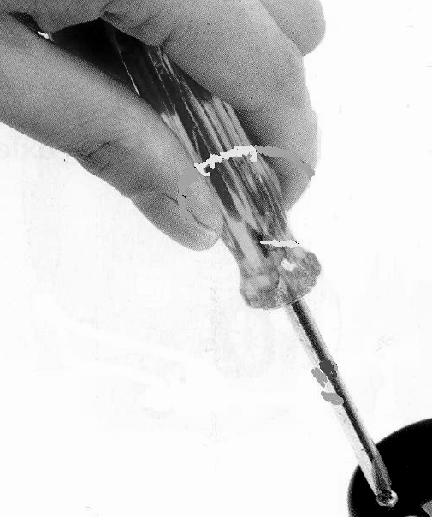
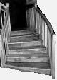

Answer the following questions. Write the answers in your notebook.

- What machines did the Mendoza family use?
- How did the machines make this household chores easier?
3. What other simple machines do you commonly use in your home?
4. How do these machines help you?

Activity 3

Study each illustration below. And identify the simple machine shown. Write your answers in your notebook. The first number has been done for you.

1.  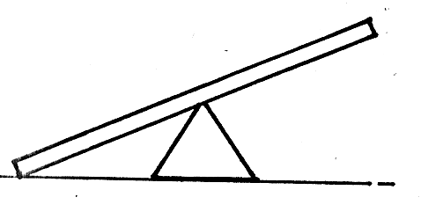  lever | 4.  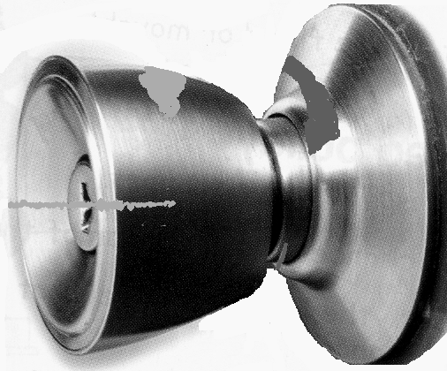
2.  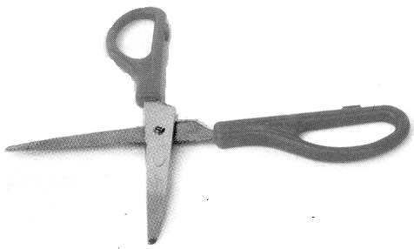 | 5.  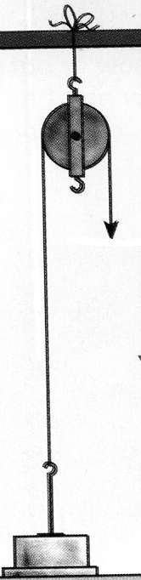
3.  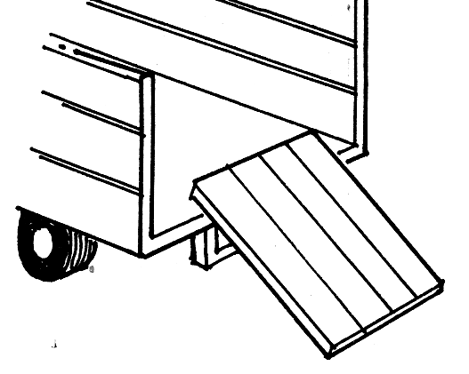 | 6.  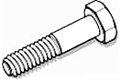

Read and Learn More.

A force is either push or a pull it can cause an object to move. It can make an object move faster or slower. It can stop a moving object. It can also cause an object to change direction.

There are six kinds of simple machines. When you use these simple machines you need force.

A lever is a simple machine that can be
used to lift objects easily. Can openers,
scissors, hammers, brooms, shovel, baseball
bat and spoon are examples of levers.

A lever has three parts.
fulcrum, load, and effort.
The fulcrum is the supporting point of a lever.
The effort is the force used to cause
movement. The load is the weight being
moved or lifted.

An inclined plane is a surface sloping or slanting from a lower place to a higher place load from the lower place with less effort. It can help you move heavy loads to higher level with lesser force.

A flight of stairs is considered a slope because it is an inclined plane that is folded.

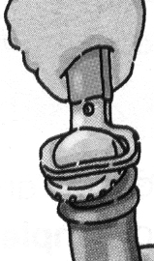
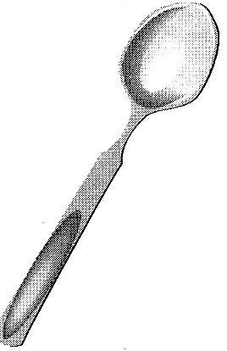

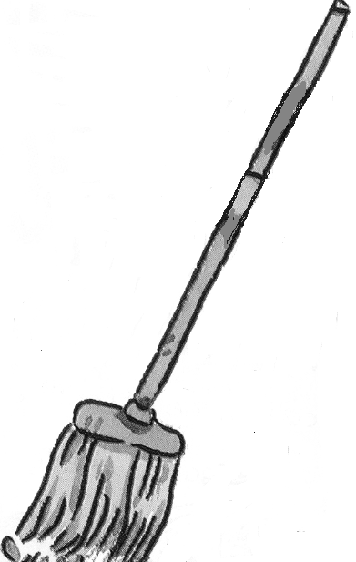
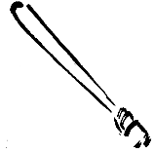

load
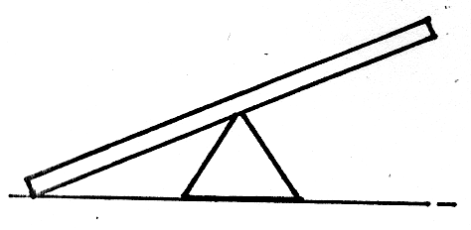

fulcrum

effort

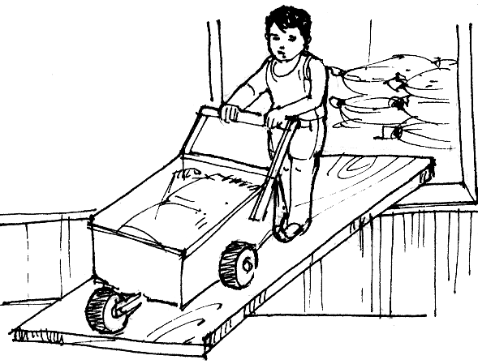
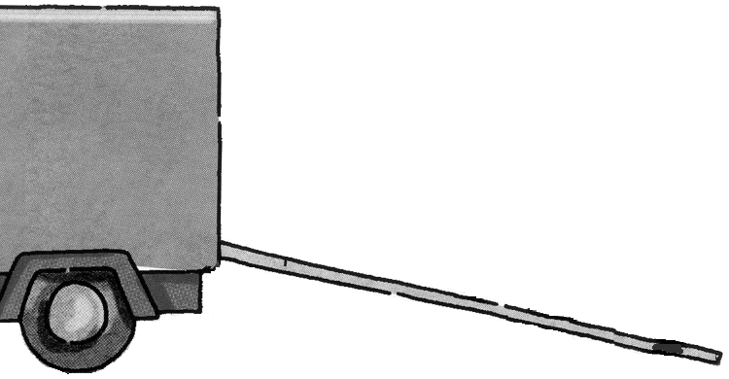

A pulley is a wheel that rotates freely, a rope is wound around the grove of the wheel. It can help you lift things. A Pulley may be fixed or movable.

A fixed pulley changes the direction of force because the force moves downward while the load moves upward. The movable pulley is one that is attached to a load and moves as the load moves. Both the force and load move upward.

The screw is a modified inclined plane. It is like a slope that is wrapped around a cylinder. It is wrapped things securely. It also helps move an object to a higher level.

The wheel and axle is made up of a
wheel fixed to a rod (axle). The wheel is bigger than the axle. Some examples are doorknob, hand drill, pencil sharpener.

The wedge is a modified inclined plane. It is made up of two inclined planes placed back to back and forming a sharp edge and a thick base. It is used to cut, split or pierce things. When you use a wedge you need less force.

Machines make work easier, increase/multiply the force used, and change the direction of the force.
pulley

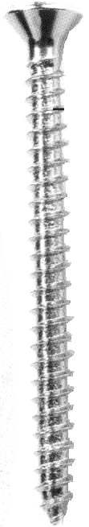
head
thread

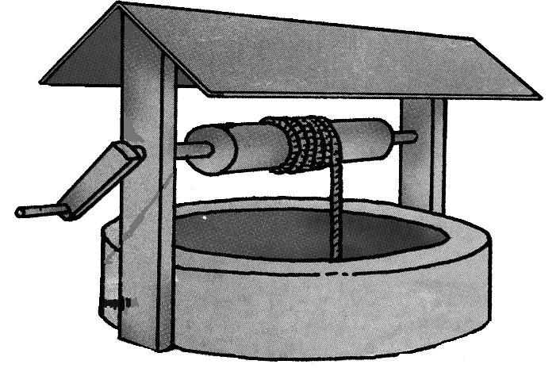
wheel
axle

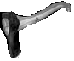

I LEARNED THAT:

- a force can cause things to start moving, move faster, move slower, stop moving, or change direction of movement.

- there are six kinds of simple machines: lever, pulley, wheel and axle, inclined plane, wedge, and screw.

- machines help to:

make work easier and faster to accomplish,
increase/multiply force used, and change the direction of force.

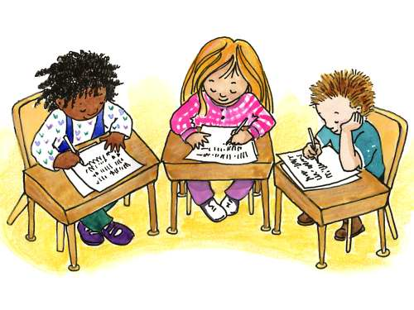

Apply It

Answer the following questions. Write the answers in your notebook.

- You want to hang up a picture on a wall. What kind of simple machine will you use? Why?

2. Which ramp would you prefer to use: long and low at one end or short and high at one end? Why?

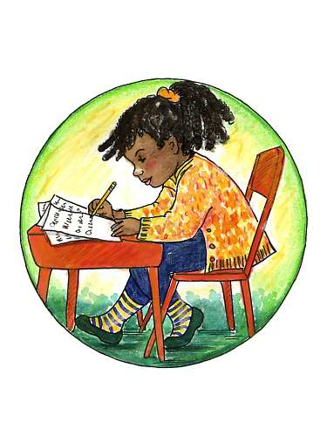

Test Yourself

- Draw each simple machine below in your notebook then label its parts.

faucet
1.
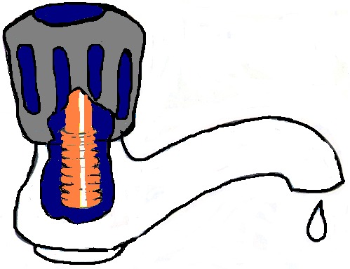

- wheelbarrow
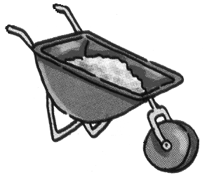

- screw
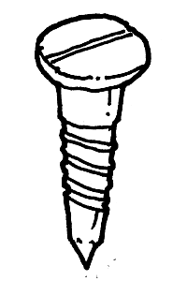

- Identify each simple machine below. Write the answer in your notebook.

1. 4.
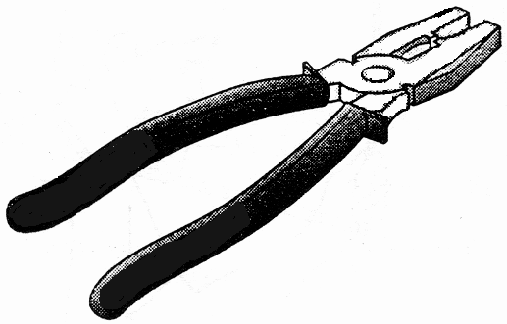
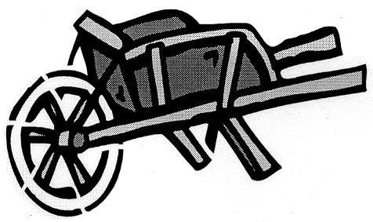

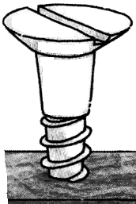
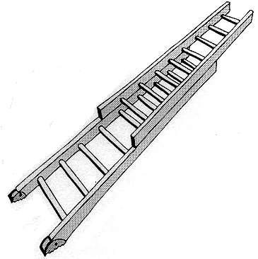
2. 5.

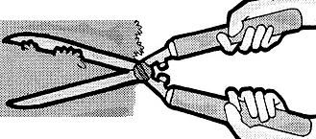
3.

