GRADE 1V
COMMON INJURIES ON THE MUSCULAR SYSTEM

At the end of this lesson, you will be able to:

- Identify common injuries of the muscular system

Try to Recall


- Answer the crossword puzzle about the muscular system. The clues below will help you. Write the answers in your notebook.

1
4

5

2
3

7
8

DOWN | ACROSS
1. Muscles that cannot be controlled. | 2. Help the bones move.
2. System of the body that gives the body shape and makes movement possible. | 4. Nutrient needed by the muscles to become healthy.
3. Movement of the muscle that makes it short and thick. | 5. We need to observe correct _____ when we stand, walk or sit.
 | 7. Muscles that can be controlled.
 | 8. Tough, white cords that connect muscles to the bones.

B. Below are some activities that our body does. Classify them whether they are controlled by voluntary muscles and involuntary muscles. Write the answers in your notebook.

Voluntary Muscles Involuntary Muscles

__________________ ____________________
__________________ ____________________
__________________ ____________________
__________________ ____________________
__________________ ____________________

digesting food drawing
yawning driving a car
shivering exercising
beating of the heart sneezing
walking playing basketball

Explore

Do you work or play for long hours? Do you feel your muscles ache afterwards? Our muscles can also be affected by injuries.

Activity

- Lay one arm on a table with the palm of your hand facing upward
- How many times can you “close and open” your palms in 30 seconds? Your hand must be opened completely and then form a tight fist each time.
- Do this, three or four times more. Can you make the same number of fists each time? When does your arm begin to feel tired? Which muscles are affected or gets fatigued?

Read:

When a muscle becomes tired, fatigue occurs. It may feel strained or it may not respond when you want it to.

Some injuries can happen to our muscles. The soreness of the muscles after a prolonged work or play is called strain. Since a strain is not a serious injury, it does not do any damage to our muscles. If you have strained muscles, take a hot bath and have a good rest.
A blow to the muscle can cause a muscle bruise. A muscle bruise usually occurs when we accidentally bump any part of our body against hard objects. After that, we usually notice black-and-blue spot on the part of the body that was hurt. This is caused by blood that leaked out of the blood vessel. To prevent swelling and to lessen the pain of the injured part, apply a cold compress.
Another injury that can harm our muscular system is torn muscles. This usually occurs when you lift heavy objects that cause tendons to break. Since this is a serious injury, surgery is necessary to repair the broken tendons.

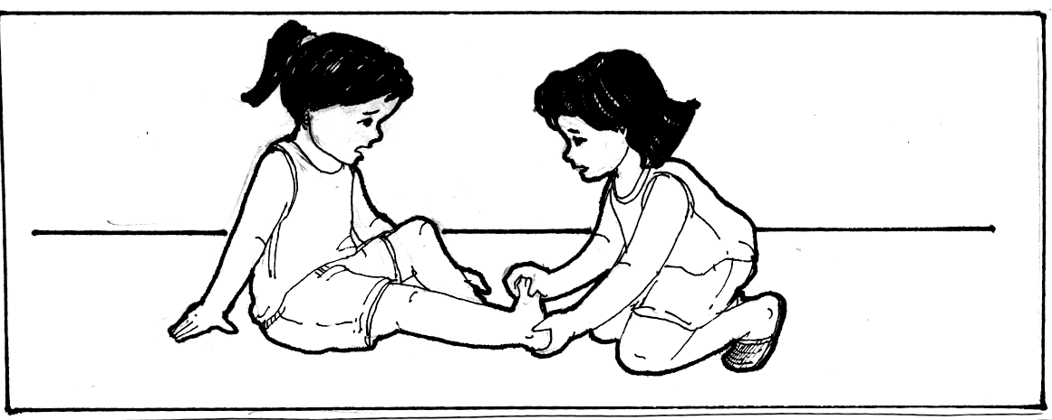

The most common muscle injury among athletes is muscle cramps. To relieve the pain, they rub the cramped parts to make them warm so that the blood can circulate normally. Sometimes, a cramp may be due to lack of salt in the diet, so its very helpful to add a little more salt in our diet.

* Answer the following

- What is a strain?
- How could you lessen the pain and prevent the swelling of the injured part of your body?
- What is the most common muscle injury among athletes? How could you relieve the pain?

I learned that….

- A strain is the soreness of the muscles caused by prolonged work and play.
- Muscle cramp is a contraction of the muscles.
- Torn muscle is a break in the tendon caused by a strong pull.
- Muscle bruise is a rupture in the muscle caused by a sudden blow.

Apply It
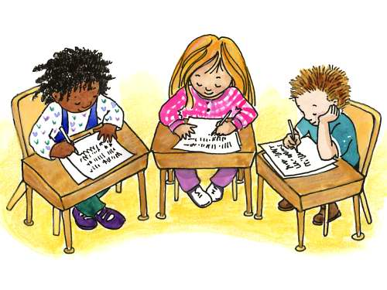

Read each situation carefully then answer the question that follow. Write the answers in your notebook.

- You mother is expecting visitors, so you decided to help her clean the house and fix the furnitures. After working, you felt that your muscles are aching. What will you do to relieve the pain?

- Your elder sister is about to start cooking when she found out that she does not have salt anymore. She sent you to buy from a nearby sari-sari store but because you were in a hurry you didn’t notice that your forehead bumped into a wall. What will you do to prevent further swelling?

- Mother sent you to fetch your younger sister from your neighbor’s house. On your way, you felt a sudden involuntary contraction of a muscle in your legs, which caused a shooting pain. You can’t walk so you decided to stop walking, what will you do?

- Your father, who works in a factory is on-leave for one month because he cannot move his arms after lifting heavy objects. What could have happened to the arm muscles of your father? How could you help him?

Test Yourself
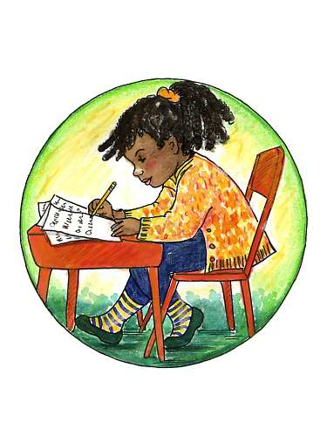

A. Unscramble the letters to form a list of common injuries associated with muscles. Write the answer in your notebook.

- (SPARCM) ________________ caused by muscles that are very tired.

- Viewing TV the whole day causes eye (RAINTS) ________________.

- (ESIUBR) ______________ is a rupture in the muscle caused by a sudden blow.

- (ORNT) ________________ muscle is a break in a tendon.

B. Read each item carefully. Choose and write the letter of the correct answer in your notebook.

- Cramps will happen most likely when _____.

  - you exercise regularly.
B. good posture is maintained.
C. the bones are broken.
D. the muscles become very tired and remain contracted.

- After jogging, Alyssa felt muscle cramps. The best first aid is _____.

A. consult a doctor
B. ignore the pain
C. continue doing the activity for a long time
D. relax and massage the muscles

- What can exercise do to our body?

A. It makes the muscle lose control
B. It increases the number of muscles
C. It makes the muscle weaker, flabby and smaller
D. It makes the muscle stronger, firmer and larger

- How can we make our muscles healthy?

A. Have enough sleep and exercise
B. Have enough rest and exercise
C. Eat food rich in protein like meat, milk and eggs
D. All of the above

- What is the best thing for you to do if you have strained muscles?

A. Apply cold compress
B. Apply hot compress
C. Take a cold bath and exercise
D. Take a hot bath and have a good rest

