GRADE V

**KINDS OF ANIMAL ACCORDING TO FOOD AND HABITAT**

*At the end of the module, you should be able to:*

* *Classify animals according to the food they eat*
* *Relate the mouth parts of the animals to the kind of food they eat*
* *Describe how animals get and eat their food*
* *Explain how some animals adapt to a particular environment*

## **Try to Recall**



The cow just had a meal and it is satisfied. Do you know why? If you think the cow is satisfied because of the meal it had, then you are right! Do you know that its favorite food is grass? Let us find out more about other animals. Identify where the animals live and the food they get from that place. Write the answer in your notebook.

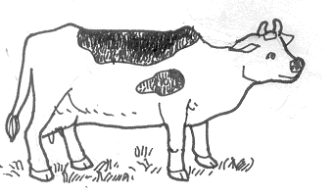

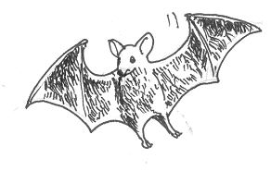

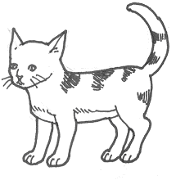

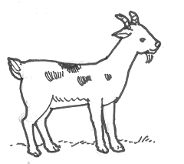

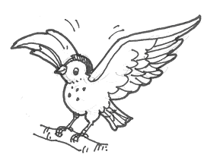

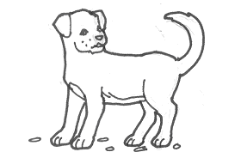

Here are some possible answers for the Try to Recall.

Animals Where the animals live The food they get from the place

1. Bat

2. Cat

1. Goat
2. Bird

5. Dog

Did you get the correct answers? You may now proceed with the Exploration Time.

## **Explore**



Do you have a pet at home? Most children like you love to feed their pets. What does your pet eat? Look at each animal below. Write its name and the food it eats in your notebook.

1 2 3

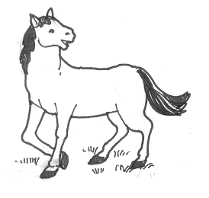

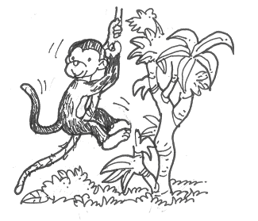

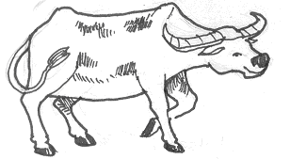

Which of the animals above eats plants? Animals that eat only plants are called ***herbivores***. Do you know other animals that eat only plants? Write their names in your notebook.

Look at each animal below. Write down its name and the food it eats in your notebook.

1 2 3

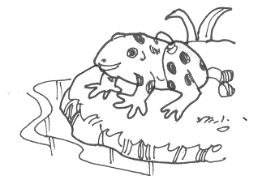

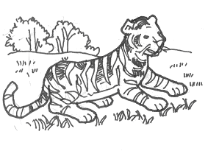

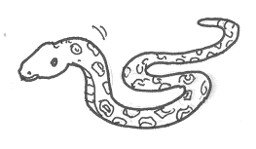

Go through your list above. What kind of food do the animals eat? Animals that eat only animals are called***carnivores***. Think of other carnivores. Write their in your notebook. See how many you can write.

Look at each animal below. Have you tried to feed this animal? What did you give it? In your notebook, make a list of the food each animal eat.

1 2 3

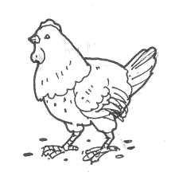

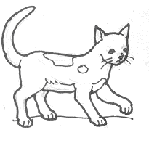

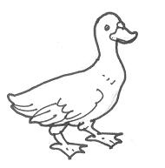

Go through your list above. What do you notice? Do these animals eat plants? Do they eat animals? Animals that eat both plants and animals are called ***omnivores***. Think of other omnivores. Make a list of them in your notebook. Try to write as many as you can!

Observe the animals in your community. Copy the table below in your notebook then list the animals in your community in the correct column.

|  |  |  |
| --- | --- | --- |
| Herbivores | Carnivores | Omnivores |
|  |  |  |
|  |  |  |
|  |  |  |
|  |  |  |
|  |  |  |
|  |  |  |

Take a closer look at the teeth of each animal below then guess the kind of each.

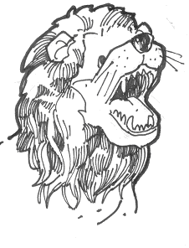

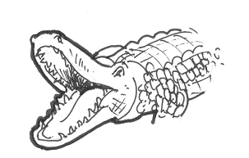

animal eats? If your answer is “Meat”, then you got it correctly! They eat meat. They use their sharp, pointed teeth or called the canine teeth to tear meat into small pieces. Can you think of more animals that eat meat? What do their teeth look like?

Observe the teeth of each animal below. How do they differ from the teeth of the crocodile and the lion? What do these animals eat?

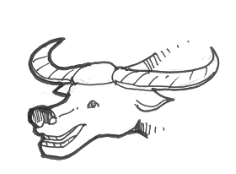

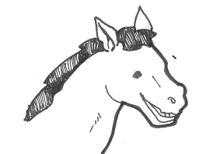

Animals such as carabaos and horses have flat teeth with no sharp points. They use their flat teeth in chewing grass and other plants. What other animals have flat teeth? What do they eat?

You have just studied the different kinds of animals according to the food they eat. Aside from this teeth, there are other kinds of animals use to get and eat food. Find out what these are.

Do you know I got this banana using my arms? Well, I have to use my body parts. How about the animals below do you know how they get their food? Identify the body parts they use to get and eat their food.

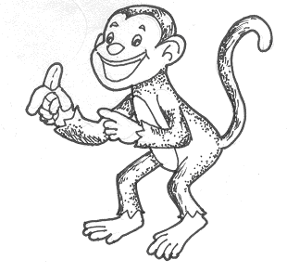

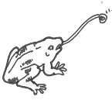

c.

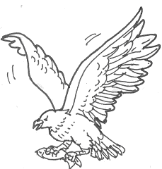

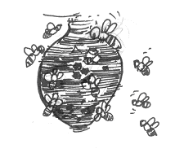

d.

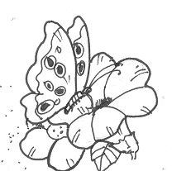

b.

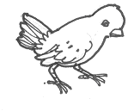

e.

Answer the questions below.

1. What does an eagle use to get and eat its food?
2. How does a frog used to catch insects?
3. How do butterflies and bee sip nectar from flowers?
4. How does a bird get and eat its food?

Other animals get and eat their food by using certain body structures other than their teeth. Birds use their beaks for getting food. Toads and frogs use their long tongues fastened at the front of their mouth. Frogs pop their tongue out to catch. This tongue is so sticky that few insects can escape it. The butterfly and bee have tiny tubes for sipping nectar from flower.

Birds have different kinds of beaks used in getting and eating food.

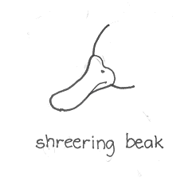

Birds that feed in the water have beaks suited for catching fish, probing in sand, or sieving food particles from the water. The beaks have a broad, flattened, and round tip with serrated edges.

Scooping beak

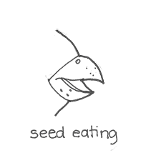

The beaks of seed-eating birds are stout, sharp-edged, and conical. These are used to obtain food other than seeds.

seed-eating beak

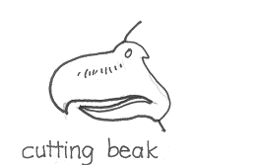

A cutting beak have sharp-edged in using for grasping and tearing of fruit eating birds.

cutting beak

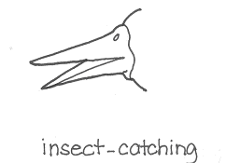

Most insect-eaters have long, pointed beaks which they use to extract insects from hiding places.

insect-catching beak

Do you love the place where you live in? Why? Animals live in particular habitat because it is where they belong. The get their food there and they can also hide from their enemies because they have successfully adapted to the environment. Animals may live in the forest, water or swamps. Do you know where the animals below live? Complete the sentences below. Write the answers in your notebook. The first is done for you.

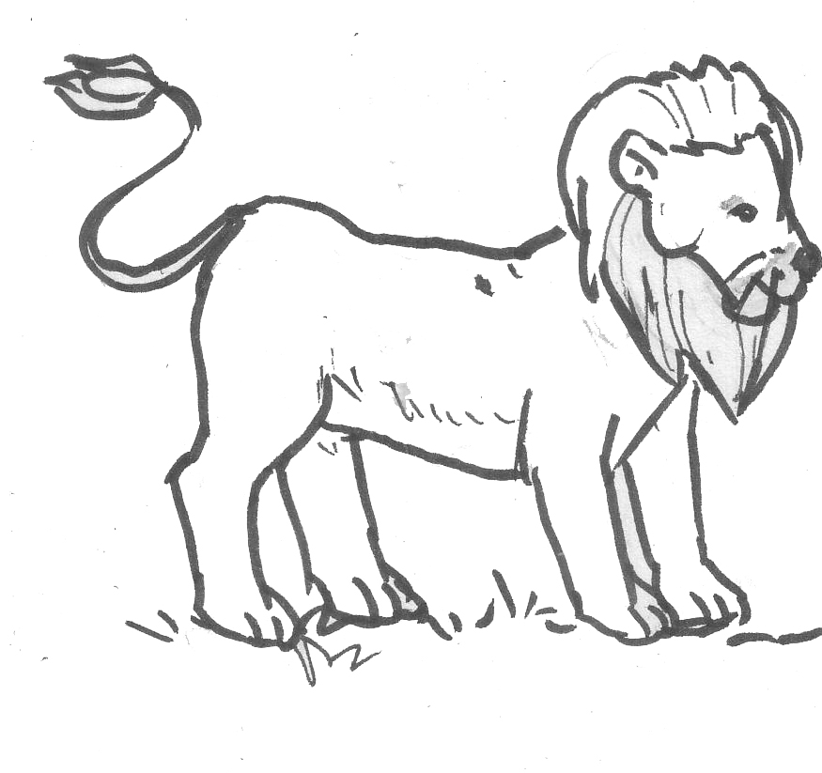

1. The lives in the forest where it gets its food there.

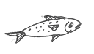

2. The lives in ____________ because _____________.

3. The 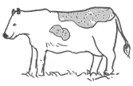 lives in ____________ because _____________.

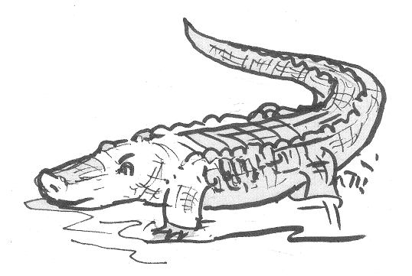

4. The lives in ____________ because _____________.

Answer the following questions. Write the answers in your notebook.

1. Can a horse and a seahorse live together? Why?
2. Can birds and caterpillars eat the same food? Why?
3. Owls, eagles, and vultures Can live together in a forest? Why?
4. Can a tadpole live both underwater and on land, Why?
5. Can rats live in a place where there are many cats Why?

Were your answers correct? Read this.

Animals have different habitat. They live only in places where they find enough food. When animals are taken out of their natural habitat, they might get sick and die.

Read and learn more.

Animals can be classified according to the food they eat. Animals that eat only plants are called ***herbivores*** like cow, goat, horse, and carabaos. Animals that eat only animals are called ***carnivores*** like lion, tiger, crocodile. If the animals eat both plants and animals, they are classified as ***omnivores*** like cat, ducks, chickens.

Animals with sharp, pointed canine teeth eat meat. They use their sharp teeth in tearing meat. Animals with flat teeth eat grass and other plants. They use their flat teeth in chewing grass or other animals. Birds eat meat with the help of their beaks.

The way animals get and eat their food in different ways. Some use mouth, teeth, beak, claws, paws. Other animals use their tongue to catch insects. Pythons and other snakes stretch their jaws to take in food larger than their mouth. Bees use their tiny tubes for sipping nectar.

Animals eat a variety of food. Some find their food may be found in their habitat but not in another place. Animals need food to survive so they live in place where they can get their food.

## **Apply It**



Read the following situations and answer the question after each

A.

1. Your friend left for a vacation at his grandmother’s place. He left his pet rabbit with you. He forgot to tell you what his pet eat. You noticed that its teeth are flat. What will you feed to the rabbit? Why?
2. Your classmate gave you a wild bird as a birthday present. After a few days, you noticed that the bird is getting weak even though you are taking good care of it. What do you think is the cause of the bird’s weakening?

B. Match the column A with column B. Write only the letter of the answer in your notebook.

A B

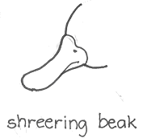

|  |  |
| --- | --- |
| 1.  scooping beak | a. |
| 2.  seed eating | b. |
| 3.  cutting beak | c. |
| 4.  insect catching | d. |

D. Classified according to the food they eat. Copy the flower below.

sheep

1.

vulture

2.

duck

3.

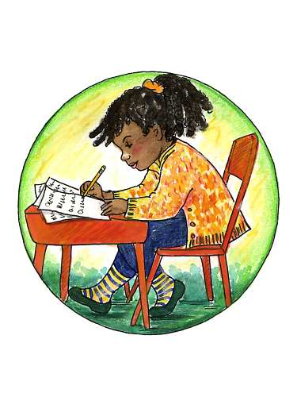

## **Test Yourself**

**\***

1. Complete each analogy below. Write the answers in your notebook.

1. grass : flat teeth; meat and _________

2. beak : birds; proboscis is for _________

1. horse : grass; lion eats _________
2. teeth : cow; beak is for _________
3. tongue : frog; claws and _________

B. Read each sentence below. In your notebook, write true if the sentence is correct. write false if it is incorrect.

1. Mudfish and carps hibernate during dry season.

2. A grasshopper may look like grass became of the animal adaptation called mimicry.

1. Ants, bees, and termites live in groups, with each member performing a special function for its group.
2. While in hibernation, an animal uses more energy.

5. Some animals are able to change their colors to match their surroundings.

C. What body parts of the animals that they use to get and eat their food? In the puzzle below. Find 5 body parts and write them in your notebook.

|  |  |  |  |  |  |  |  |  |  |  |  |  |  |  |
| --- | --- | --- | --- | --- | --- | --- | --- | --- | --- | --- | --- | --- | --- | --- |
| T | E | E | T | H | M | A | R | I | C | E | L | M | E | N |
| D | O | Z | O | A | D | W | V | E | R | A | J | U | D | E |
| M | E | L | N | M | I | S | L | A | N | J | S | H | A | N |
| J | U | L | G | I | A | N | M | A | L | A | S | O | Q | U |
| I | P | A | U | N | G | A | S | P | A | W | I | R | N | A |
| A | M | B | E | A | K | A | G | T | A | Q | U | N | I | N |
| B | U | G | A | L | L | O | N | P | A | N | G | S | S | I |
| N | A | A | S | A | C | B | F | V | M | Y | F | Q | W | A |
| T | Y | U | I | O | N | F | L | D | R | F | O | O | T | A |
| T | I | N | Y | T | U | B | E | D | S | A | F | G | H | B |
| K | L | O | P | T | E | W | G | Q | C | B | N | M | H | J |
| G | H | J | K | L | P | I | S | U | S | G | H | J | K | Y |
| Q | W | T | Y | U | I | O | P | C | L | A | W | C | V | N |
| R | T | Y | U | I | O | K | H | B | F | D | S | A | W | N |
| B | N | M | H | J | K | L | F | D | S | X | C | B | F | R |