GRADE VI
THE FOOD COURT IN AN ECOSYSTEM

At the end of the module, you should be able to:

- describe the interrelationship among living organisms in an ecosystem (food chain, food web, food-nutrient cycle)

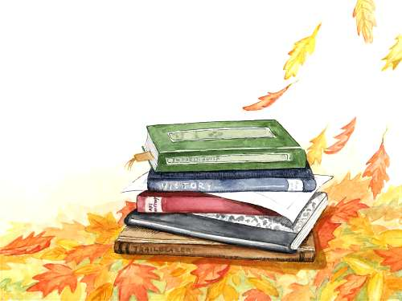

Try to Recall

Note both living and non living things. Classify them using the table below. Do this in your notebook.

A | B
Living things | Non living things

Now try to answer these:
- What are listed in column A? column B?
- Complete the map to find out where living things and non living things are found. Fill the blank with the correct letters.

Living Things

Non-Living Things

Are found in the
E _ O _ Y S _ E _

Explore

Do you know how living things are connected with one another? In the following activities you will learn how living things are related.

Activity 1

- Copy the table in your notebook.
- Think of your favorite foods.
3. Tell whether it comes from a plant or an animal.
4. List them in the table you copy in your notebook..

Food | Source of Food (Plants or Animals)

Activity 2

Study the diagrams in each letters below. Take note of the arrows which tells the direction of the energy it passed from one organism to another.

a.  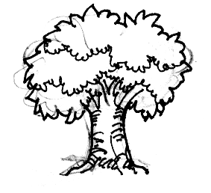  (a) | 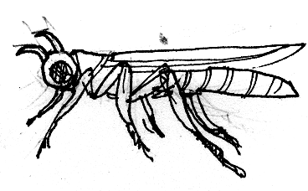  (b) | 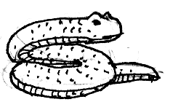  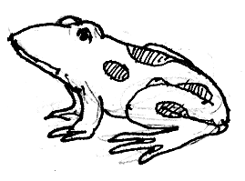  (c) | (d)

b.  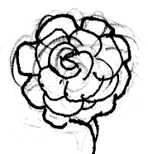  (a) | 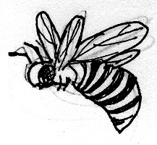  (b)
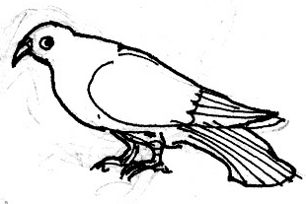  (c) | 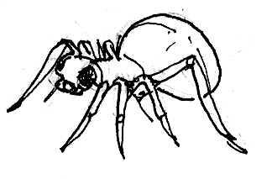  (d)

c.  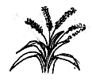  (a) | (d)  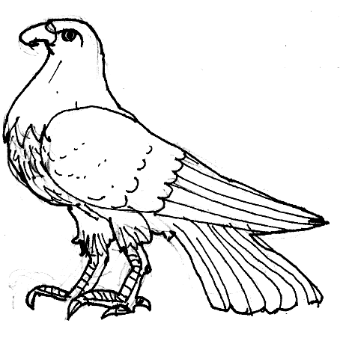
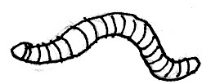  (b) | (c)  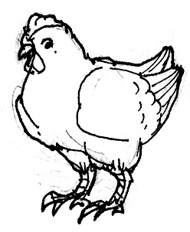

Answer these in your notebook.

- What do you notice about the organism in each labeled A and C?
- What do you notice in labeled B? Are they plants or animals?
- Why are the organisms in letter a all plants? How can are they be called?
- What happens to the organism in letter e if there are no organisms in letter b?
- What is a food chain? (based your answer from the illustrations).

Activity 3

Study the following:

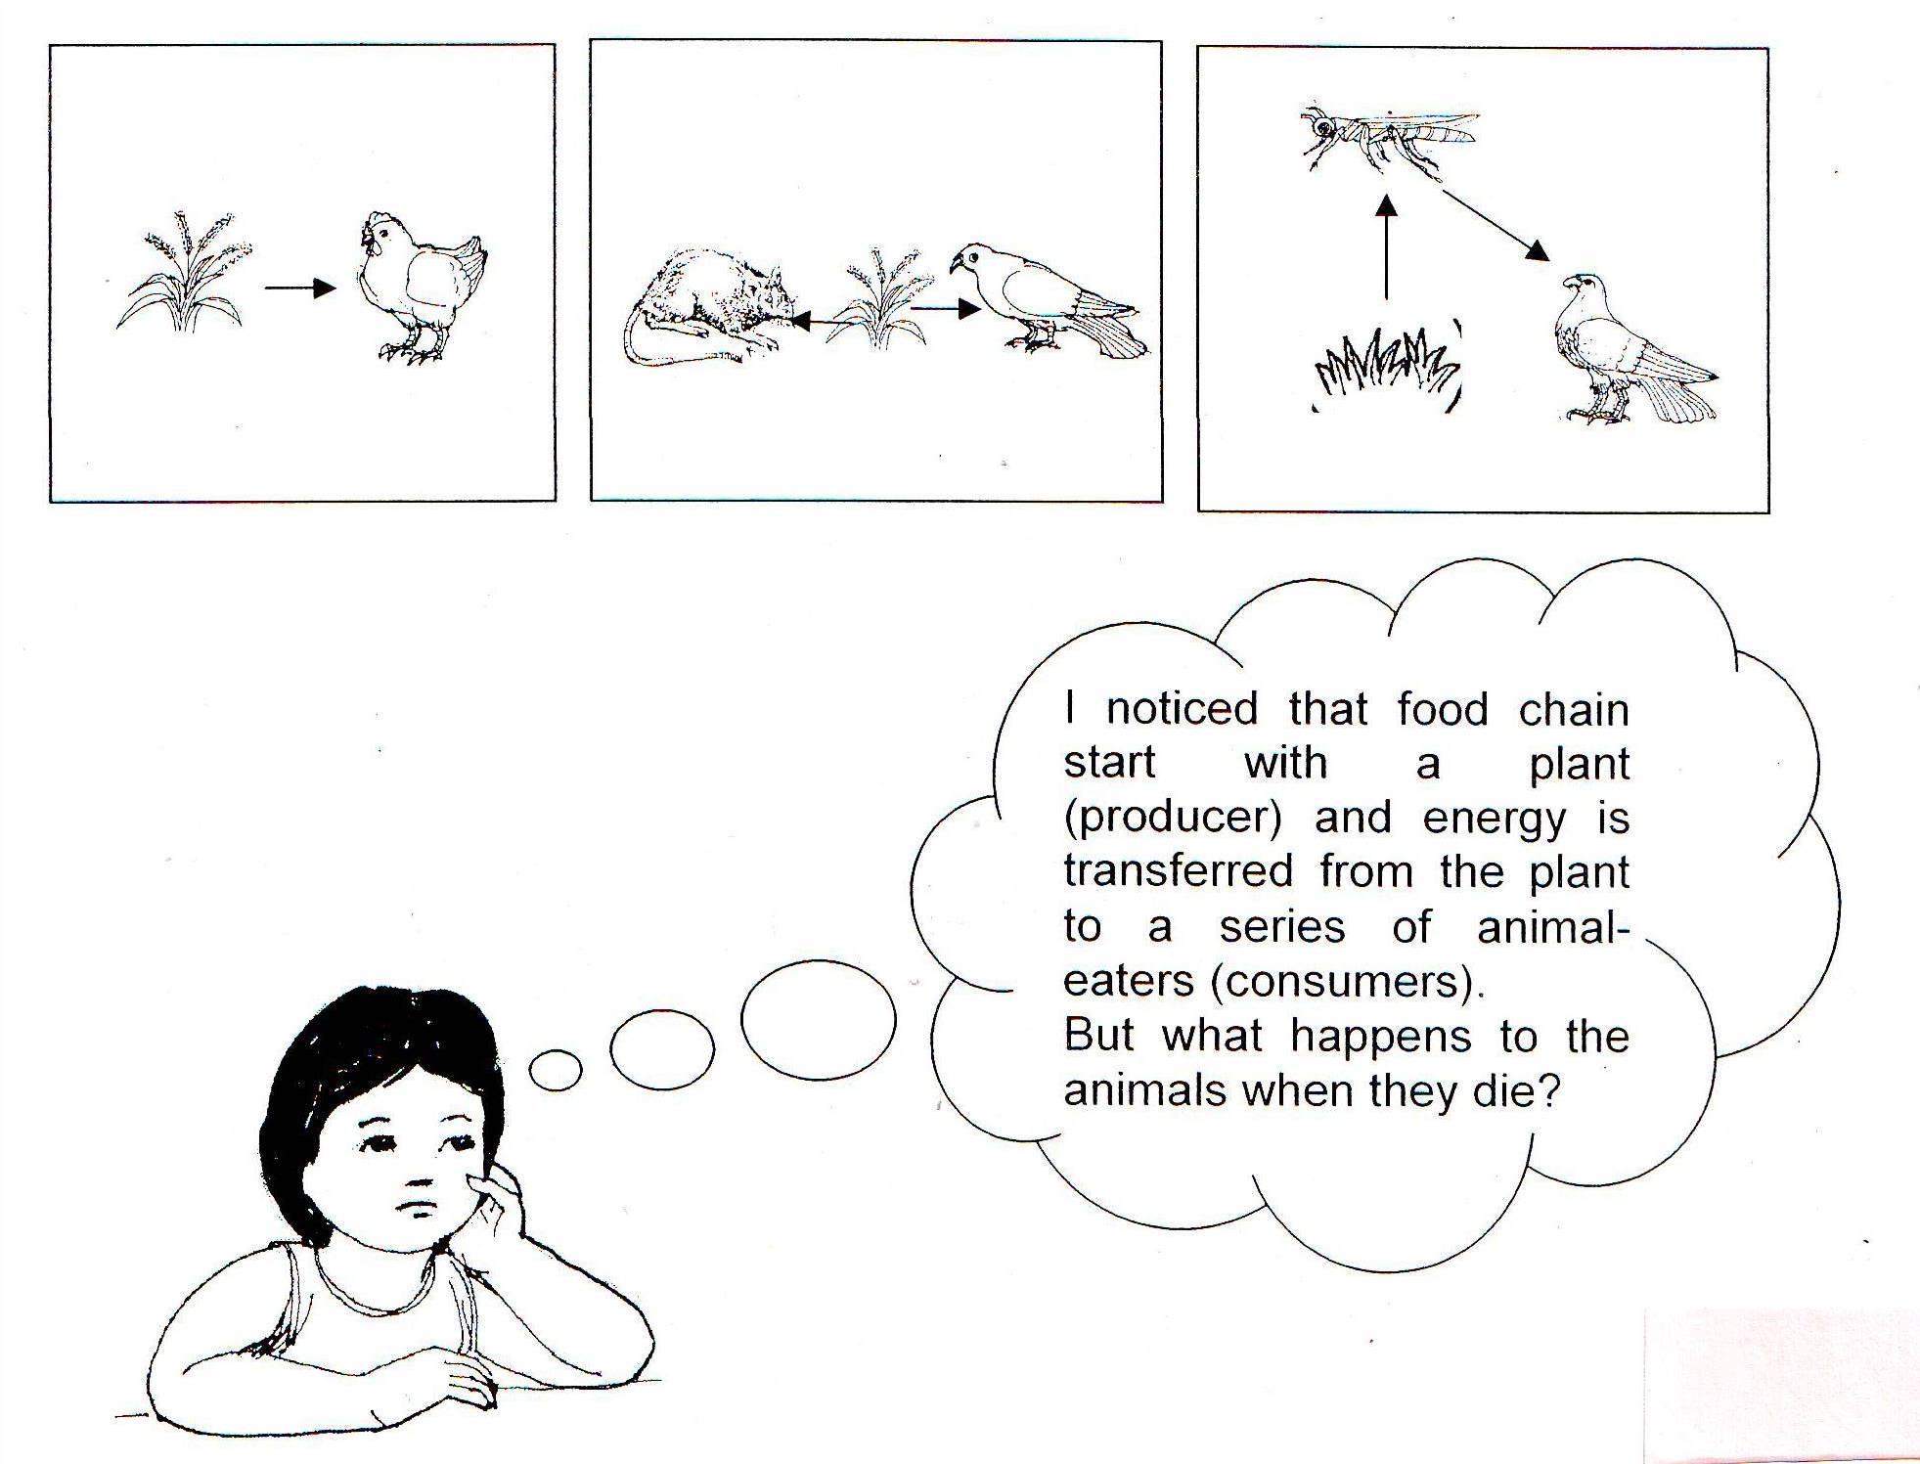

Help Lisa find the answer to her question by rearranging the jumbled letter underlined in the paragraph to form a word.

 | When plants and animals die, they become 1) dofo for other organisms. These organisms are called 2) compodesers. They break down dead matter and animal waste into simple substances and return the energy back to the 3) liso to be used again by 4) pltsna. | 1.________________  2.________________  3.________________  4.________________

Trace the energy pathways using the following terms

Consumers, producers, decomposers.

Activity 4

- Study the following food web below.
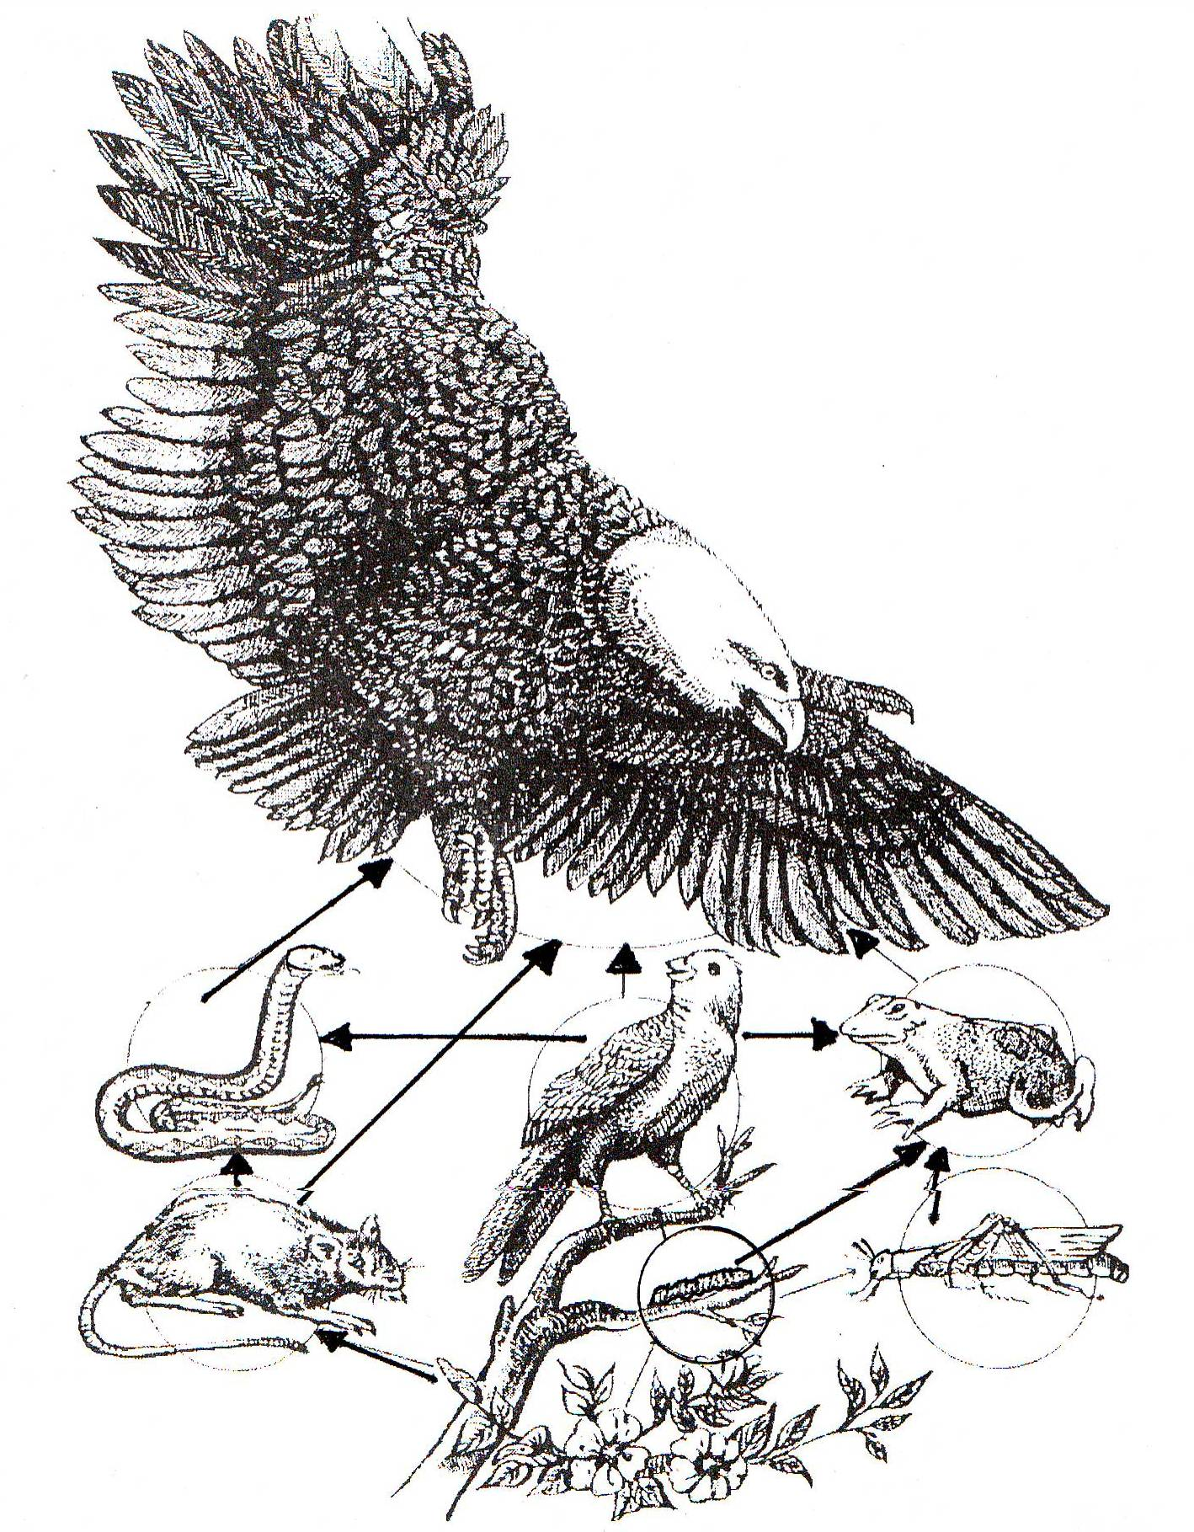

(Adapted: Exploring Science and Health 6, Reprint, 1996)

- Do these in your notebook.
a. Study the food web then pick out three food chains from the food web above. Show a diagram of each chain.

b. Make a food web (at least 3 food chains) of marine ecosystem (organisms in the sea or ocean).
Read and learn.

- Our environment or ecosystem is composed of living and non-living things.
- There is interaction between organisms and the environment for food and survival.
- A food chain shows the relationship of different organisms and the transfer of energy from the producer to one consumer to another.
- Plants produce their own food through the energy from the sun and are eaten by other animals. They are called producers.
- Animals that eat plants and other animals are called consumers.
- A food web is made up of many food chains that are linked together.
- Food chains are usually short with only up 4 to 5 levels. This is because the amount of energy passed on the next link becomes less. Each organism takes part of the energy available.
- Decomposers are organisms that break down dead matter and animal waste into simple substances such as mineral salts and CO₂. These are returned to the soil to be used again by plants.

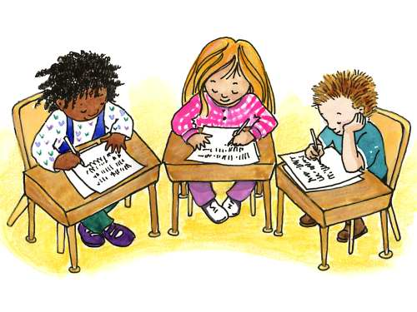

Apply It

A. Illegal logging is a serious environmental problem our country is facing today. Landslides, drought, global warming are some of the bad effects of this problem.

- How does illegal logging affect the food relationships (food chain and food web) among the different organisms? (the plants and animals in the forest ecosystem?)

B. Create a food chain with a human being and a cow.

C. If you are a vegetarian, is your food chain longer or shorter than the food chain of a person who is a meat eater? Why?

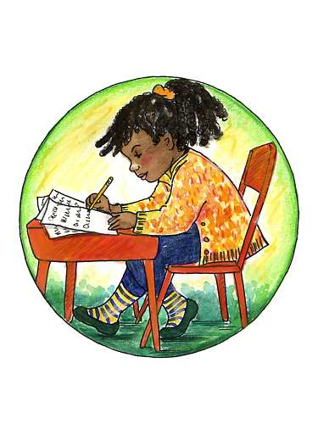

Test Yourself

*

1. Which shows a food chain?

A. corn → chicken → ducks
B leaves → worm → birds
C. pechay → carabao → hawk
D. earthworm → chicken → men

- Create a food chain by filling out each box with the name of an organism in a pond or river ecosystem

producer
primary consumer
tertiary
consumer
secondary consumer

- What happens in a food chain?

  - Energy is lost.
  - Energy is increased.
  - Energy is transferred from producer to consumer.
  - Energy is transferred from consumer to producer.

- Study carefully the food web below then pick out two food chains consisting of at least three consumers from the food web.

