GRADE VI
THE HEART

At the end of the module, you should be able to:

- identify the main parts of the (heart)
- describe the function of the heart


Try to Recall

Copy the chart in your notebook and fill it up.
A. What are the parts of the blood?
Blood
SOLID PARTS
LIQUID PART

- What are the kinds of the blood vessels?

BLOOD VESSELS

Explore

Activity 1

- Do the following

- Clench your fist.
- Locate your heart then place your clenched fist over it.
- Feel the beating of your heart.

- Answer these questions in your notebook

- Where is your heart located? ________________________
- What did you feel when you placed your clenched fist over your heart?
_______________________
- Why do you think is it beating? ________________________
4. How big do you think is your heart? _____________________________________________________

Activity 2

Directions: do this activity and answer questions in your notebook.

- Prepare the following materials.

clear tubings adhesive tape
plastic bottle rubber stopper
Y-tube red-colored liquid

What to do:

2. Attached the clear tubings to the Y-tube as shown below. Use the tape to hold the tubes in place.
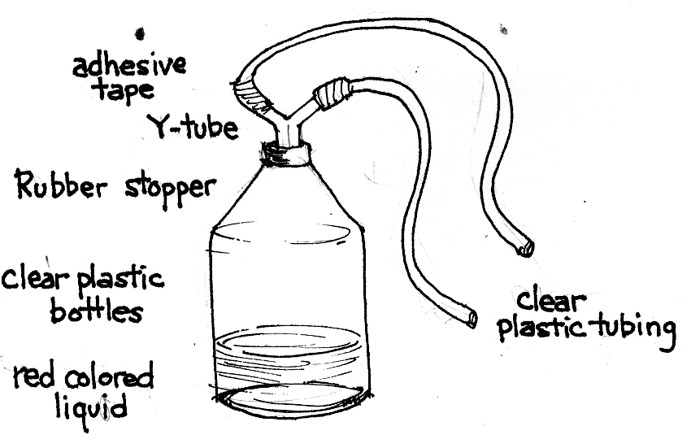

- Pour the red-colored liquid into the bottle.

- Insert the Y-tube into the rubber stopper of the small bottle filled with red-colored liquid.

- Now you have a made a model of a single-circuit circulatory system.
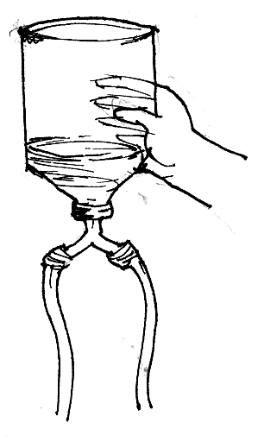

4. Squeeze the bottle and observe what happens to the red liquid.
  - What does the plastic bottle represent?
  - What was applied on the bottle to make the liquid move?

Activity 3

- Secure a poster or chart of the heart and a model.
- Compare the model with the chart.
- Examine the model of the heart.
- Label the chambers using the words below.
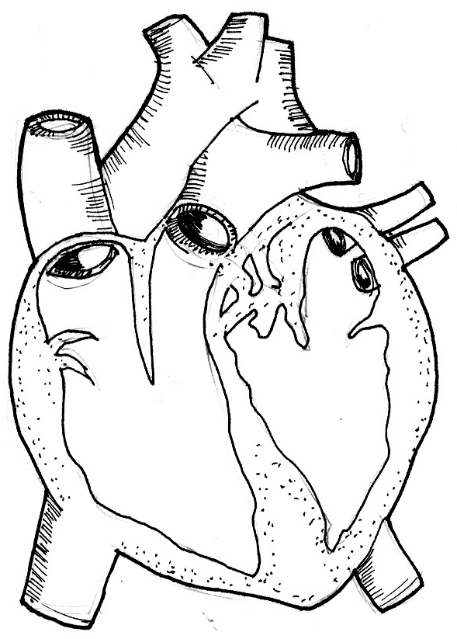

right atrium
left atrium
right ventricle
left ventricle

Your heart. Your heart is a cone shaped, muscular organ found in the middle of the chest cavity slightly tilted to the left. It is divided into chambers. The upper chambers are called atria (singular-atrium) and are sometimes called auricles. The atria are thin-walled. The two atria receive the blood entering the heart. When the heart beats, the atria contrast at the same time and forces the blood into the ventricles.

The ventricles (lower chambers of the heart), are thick-walled. When the ventricles contracts, blood is pushed/pumped into the arteries and flows into the different parts of the body.

- Read this information about the functions of the heart
- Answer these questions in your notebook.

- What are the upper chambers of the heart?
- What is their function?
- What are the lower of chambers of the heart?
- What is their function?

Read and learn more.

Have a Heart

Your heart is a muscular organ that pumps blood around your body more than 1,000 times a day; each trip takes less than one minute.

Your heart…
- starts beating 6 months before you were born.
- is about the same size as your closed fist.
- on its right side receives blood from the veins and pumps it into the lungs.
- on its left side receives blood from the lungs and pumps it around the body.
- is found in the middle of your chest; bottom tip actually touches your chest wall.
- contracts (pumps) and forces blood out into the arteries (tubes that carry blood from the heart to all parts of the body). The walls of the arteries stretch.
- relaxes – the artery walls contract to push the blood along.
- pulse beat - involves one expansion and contraction of the artery walls with each heart beat
- pulse beat equals rate of heart pump
- person’s resting pulse rate decreases with age:
- newborn – 130 – 150 beats/minute
- 11 years old – 70-100 beats/minute
- adult – 60-80 beats/minute
- the heart has four chambers: two small upper chambers called atria (right atrium and left atrium) and two large lower chambers called ventricles (right ventricle and left ventricle).
- the valve prevents the blood from flowing backward.
tricuspid valve – opens from the right atrium into the right ventricle
pulmonary valve – opens form the right ventricle into pulmonary arteries
mitral valve – opens from left atrium into the left ventricle
aortic valve – opens from the left ventricle into aorta.

- The heart is the powerful pump that moves blood through the body’s blood vessels.
- Heartbeat: each heart chamber relaxes as it fills (diastole) and contracts as it pumps blood (systole).

aorta
From upper body
Pulmonary artery

To the lungs

pulmonary veins

From the lungs

left atrium
right atrium

From lungs
valve

left ventricle
right ventricle

From lower body
To lower body

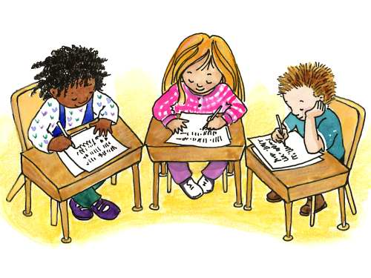

Apply It

A. Complete the paragraph below.

The heart is made up ______ chambers. It has also two sides, the right side and the ____ side. The right side pumps blood to the _______. The ______ side pumps blood to the cells of the body.

B. What happens when the heart stops pumping blood to the lungs and to the different part of the body?

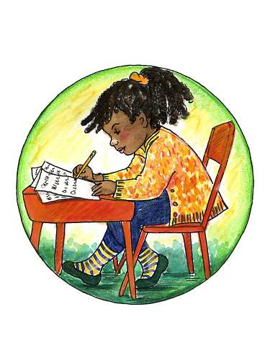

Test Yourself

*

A. Label the parts of the heart.
Refer to the box below for your answers.
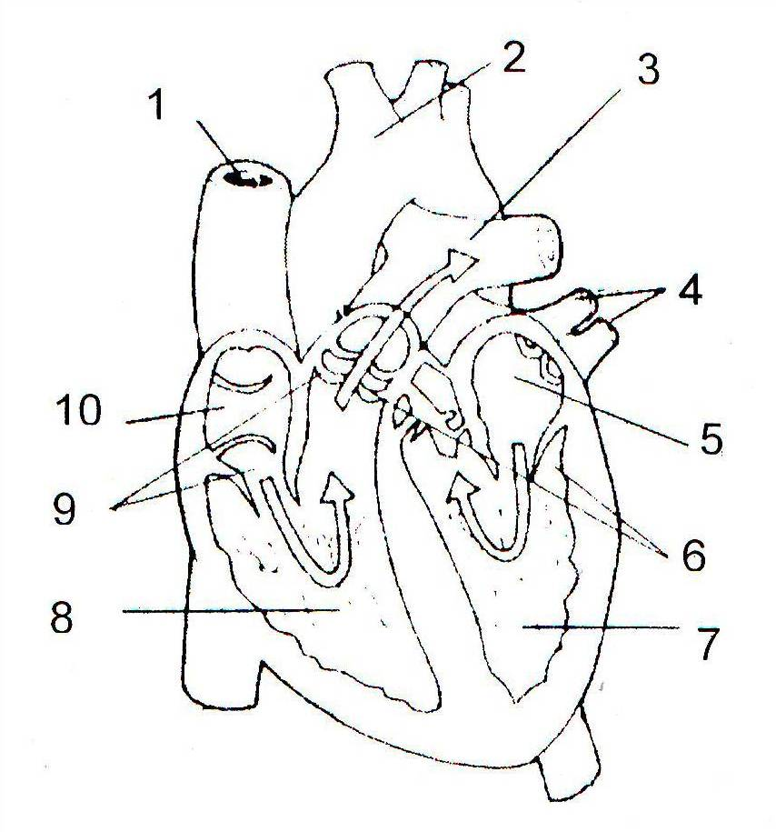

Vein
Pulmonary artery
Left auricle
Left ventricle
Pulmonary veins
Aorta
Vein
Right auricle
Right ventricle

B. Underline the correct answer. Write your answers in your notebook.

- The (right side, left side) of the heart pumps blood to the lungs.
- The (right side, left side) pumps oxygen-rich blood out to your body.
- (Valves, Arteries) prevent blood from flowing backward.
- The blood goes to the lungs through the (pulmonary artery, pulmonary vein, right auricle).
- The blood from the lungs enter the (left auricle, left ventricle, right ventricle) of the heart.
Key to Correction

Try to Recall

A.
Blood
SOLID PARTS
LIQUID PART
Red blood cells
White blood cells
Plasma
Platelets

B.

Artery
BLOOD VESSELS

Veins

Capillaries

Exploration Time

Activity 1

- In the middle of the chest
- About the size of the fist
- Beating of the heart; Lubdub sound
- The heart beats when the heart muscles contracts and relaxes as blood is forced out into the arteries.

Activity 2
- a. pressure or force
b. heart
- Cardiac muscles

Activity 3

- a. right atrium and left atrium
  - Receives blood from the body and the lungs into the heart
- a. right ventricle and left ventricle
  - Forces blood from the heart out into the lungs and the different parts of the body

Apply It

A. four chambers, left side, lungs, left side

B. When the heart stops to pump, the blood cannot circulate around the body. The blood from the heart cannot go to the lungs to get fresh oxygen and leave carbon dioxide in the lungs. It cannot move the blood to the different parts of the body along the arteries and cannot move the blood back to the heart through the veins. The body cells will be deprived of the needed oxygen and cannot remove carbon dioxide and other wastes from the body cells.

Test Yourself

A. Labels of the Parts of the Heart

- vein 6. left ventricle
- aorta 7. right ventricle
- pulmonary artery 8. vein
- pulmonary vein 9. right auricle
- left auricle

B.

- right side
- left side
- valves
- pulmonary artery
- left auricle

