GRADE VI
EFFECTS OF NATURAL CALAMITIES

At the end of the module, you should be able to:

- Explain how certain events and activities disturb the interrelationship in an ecosystem(natural calamities)



Try to Recall

Rearrange the jumbled letters to form words about man’s destructive practices.

- S E A W T A L S O P I D S I R O P P E R M

- I N K A I G N

- R U O M I A M

- M I D Y A N E T S H I F G I N

- G A L I L E L G N O G L G I

Explore

Do you want to know some natural calamities?
Try answering the guessing game.

Activity 1

“WHAT AM I”

- I can make the earth tremble. 2. I am a hill with a vent.
I can shake the trees. I expel hot molten magma.
I can make buildings fall. I can make the ground rumble.
I can make cracks on roads. What am I?
What am I? _____________________
_____________________

3. I bring strong wind and 4. I am a big wave on the sea.
too much rainfall. I can wash away
I can uproot trees and an entire shoreline.
destroy weak houses. My name
What am I? means “big wave”.
_____________________ What am I?
_____________________

Answer these:

- What natural calamities were mentioned in the activity?
- Which of these have you experienced? Write the effects based on you experience.

Activity 2

Read the following articles. Below each article, name 2-3 effects of natural calamity to the environment/ecosystem.

Article 1

“THE ROARING EARTH”

The July 16, 1990 earthquake produced a 125-km long ground rupture that stretches from Dingalan, Aurora to Kayapa, Nueva Viscaya as a result of strike-slip movements along the North-West segment of the Philippine Fault Zone and the Digdig Fault. The earthquake epicenter was near the town of Rizal, Nueva Ecija. Damage to buildings, infrastructures and properties amounted to at least 10B, a part of which was caused by ground rupturing.

Effects to the Environment/Ecosystem

1.
2.
3.

Article 2

“TSUNAMI”

In May 1960, a giant wave called tsunami from the Pacific Ocean hit the shores of Polio Islands of Quezon province. Hundreds of houses and people where swept to the sea. In August 1976, giant wave destroyed the coastal towns of Cotabato and Davao. Undersea earthquake was reported as the cause in both events.

Effects to the Environment/Ecosystem

1.
2.
3.

Article 3

“TYPHOON WINNIE”

Rescuers continue to search for more victims and fatalities of floods and landslides that hit several areas of Luzon at the height of tropical depression Winnie. Rescue and recovery operations went on in flooded areas in the provinces of Nueva Ecija, Aurora, Quezon, Bulacan and Rizal. Although media reports said more than 300 people are dead, the official tally of the National Disaster Coordinating Council (NDCC) showed 182 people were killed in floods and landslides. Damage to property and agriculture was estimated at 40 million.

Effects to the Environment/Ecosystem

1.
2.
3.

Article 4

“VOLCANIC ERUPTION”

The first recorded accounts of Mayon’s eruption were made by the Franciscan priests during the 18th century. Its most destructive explosion occurred in February 1814, when clouds of volcanic gas and waves of mud and lava destroyed the town of Cagsawa, about 16 kilometers away. More than 1, 200 lives were lost. What remained was the church’s bell tower and a few stone roofs, visible to this day and nearly as postcard-famous as volcano itself.

Effects to the Environment/Ecosystem

1.
2.
3.

Read and learn more.

Volcanic Eruptions
- When a volcano erupts, gas, liquid and solid materials are spewed out.
- Steam or water vapor makes up 50% of the gas materials. The rest are carbon monoxide, carbon dioxide, hydrogen sulfate, sulfur dioxide, hydrocholoric acid, methane and ammonium chloride. Most of these gases are poisonous when present in large amounts and can affect our air which can cause air pollution.
- Solid products are rocks of hardened lava and ashes. When rain accompanies eruption, the poisonous gases in the air are carried by water down to the soil.
Earthquakes
- Strong quakes, and shaking ground can loosen the soil and rocks and can cause disastrous landslide.
- Earthquake and sudden upward movement of the seafloor during faulting (crack) along a plate boundary cause the water to rush upward then huge surface waves are created and can reach a nearby coast. This is known as TSUNAMI – (a Japanese word for “bay or harbor wave”) a gigantic wave sometimes 150 km. long traveling at about 180 km/h and increases in height wile traveling, rising as high as 30m as it approach shore.
- When a tsunami is about to come, water is first observed to move out to sea uncovering long stretches of coastal bottom. In a few minutes giant waves rush and carrying everything within reach back to the sea.
Tropical cyclones
- 40% or 8 tropical cyclones (bagyo) passed through Casiguran, Quezon with the highest number of typhoons, foll the owed by Nueva Ecija, Nueva Viscaya, Samar, Leyte, Bicol region, Southern Mindanao, and Southern Visayas Islands.

I LEARNED THAT:

- Volcanic eruption, earthquake, tropical cyclones, tornadoes, and tsunami are natural calamities that can disturb interrelationship in a eruption.



Apply It

- If you are living near a body of water, what will you do to help lessen the effects of typhoon to your place?

- Interview your parents on the effects of earthquake that they have experienced. Ask them what should be done when earthquake happens.

- Make a short report on how volcanic eruptions affect the atmosphere.

- If your are given a chance to have powers, which calamity would you prevent? Why?



Test Yourself

*

1. Name the natural calamities shown in each picture.

2. Recall how each affects the environment. Write 2 effects and 2 safety measures you should observe to minimize effects of each calamity.

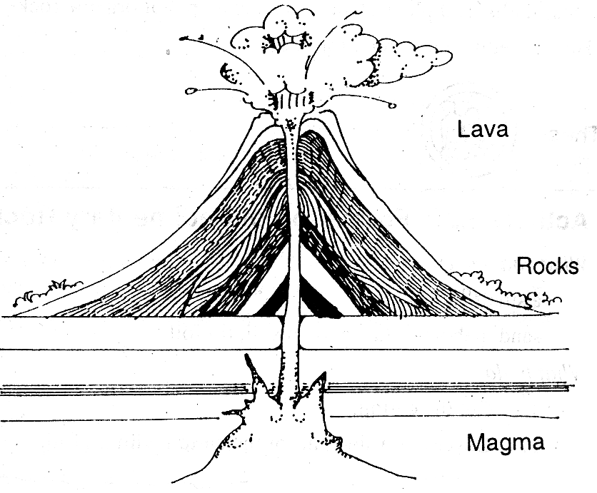
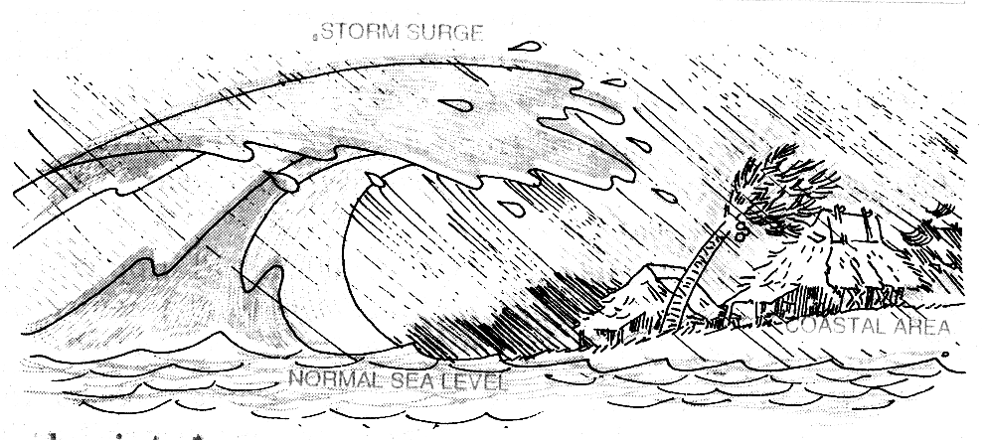

tsunami

volcanic eruptions

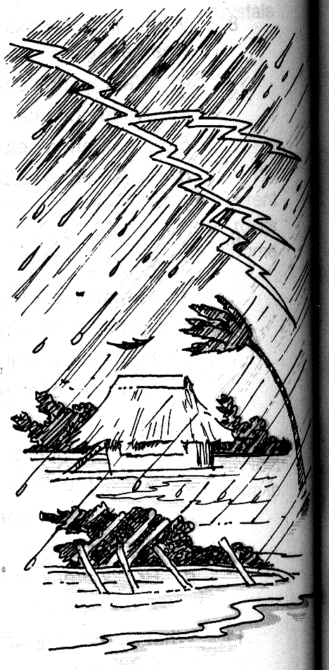

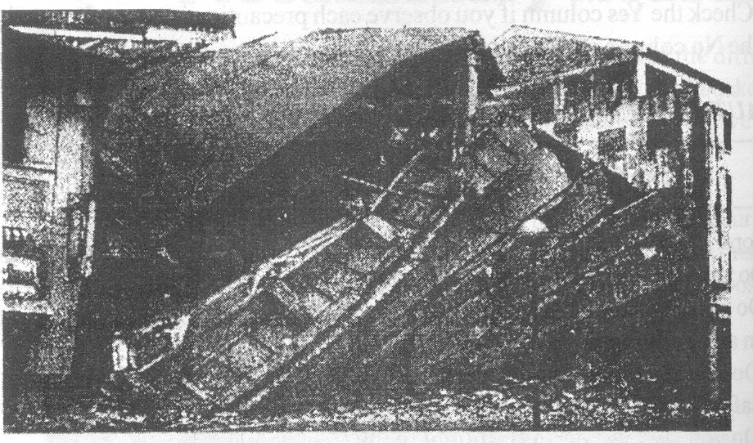

earthquake
typhoon

