ENVIRONMENTAL PROBLEMS
GRADE VI
ENVIRONMENTAL PROBLEMS

At the end of the module, you should be able to

- Explain how certain events and activities disturb the interrelationship in an ecosystem (destructive practice)


Try to Recall

- Study the picture below. Identify the source of living in each place. Write your answers in your notebook.
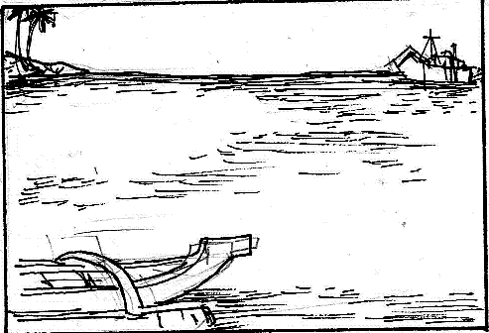
1)

________________
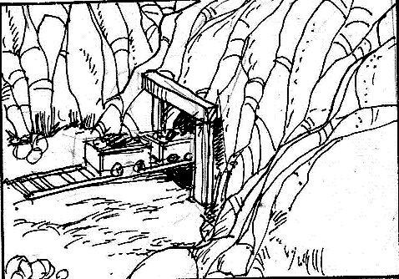

2)

________________

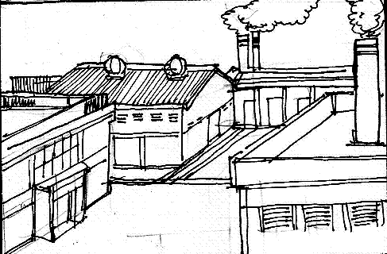

3)
________________

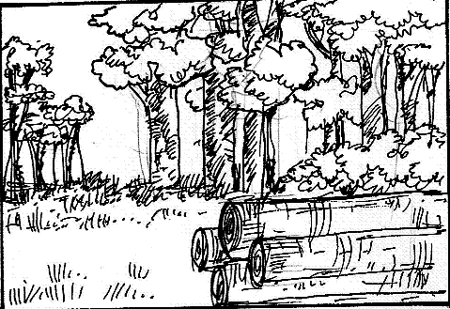

4)
________________

- If people continue to use the environment, will the natural resources last long?

Explore

Look around you. Are the things you see now still the same as they were before? What changes have you observed? How do you feel about the changes that happened now? What do you think cause these changes?

In this lesson, you will learn the different practices of man which created changes in the ecosystems and disturb its balance.

Activity 1

Elmark, Kyz, and their friends are packing for a picnic at the river.

I’m so glad we’ve got disposable utensils. We don’t have to wash or carry all these things back after our picnic.
I’m going to bring this insect repellant on the beach.

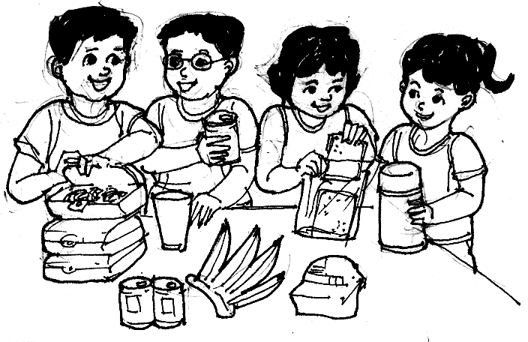
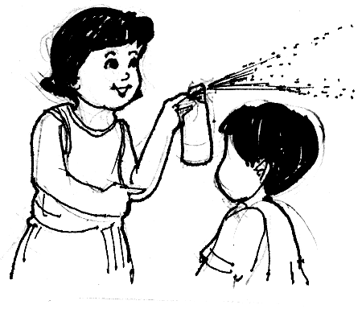

It’s so convenient, isn’t it?

What happened? This beach was nice and clean when we were here last year!
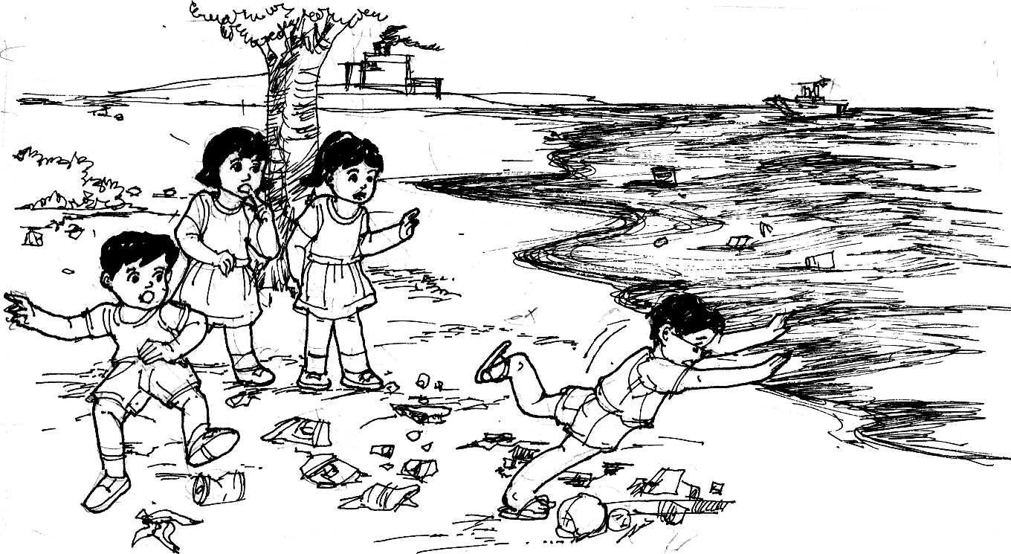

- What practices caused the beach to become polluted?

  - ___________________________________
  - ___________________________________
  - ___________________________________

- What will be the effects to the ocean and the organisms living in it if these
practices continue?

- What practices should people practice to prevent water pollution?

Activity 2

Make a research on Solid Waste Management?
Is solid waste management program in school important?
How do you dispose your rubbish at home and in school?

Activity 3

Study the illustrations below.

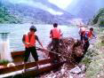
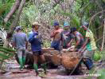

A
B

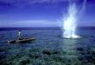
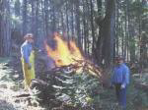

D
C

Answer these:

- What are human activities shown in each picture?
A - C -
B - D -
- How do these activities affect that ecosystem?
- Of the four human activities, which one is occurring in your community? What changes happened because of these? What are the possible solutions?

Tabulate your answer in a table similar to the one below.

Human Activities | Environmental Problems/Changes | Solutions

Read and learn more.

- One way of disturbing the balance of ecosystem is through the destructive practices of people.
- Destructive practices include all the things people do that can harm the environment like illegal logging, kaingin, dynamite fishing and improper waste disposal.
- Illegal logging and kaingin lead to deforestation or loss of trees. This results to soil erosion, flash flood, destruction of homes of the animals, disturbance in the cycles in nature and rise in surface temperatures.
- Soil erosion happens when soil with no more plants is washed by running water. The absence of roots can wash away soil especially in a sloping area. Soil erosion can lessen the fertility of the soil.
- Forest plants absorbs rain water to prevent flash floods..
- 80 % of the world’s plants and animal species live in the forest. When deforestation happens, there will be no homes and food for the plants and animals.
- Deforestation affects the climate of a place. It lessens the supply of oxygen which people and animals need. It increases the supply of carbon dioxide which makes the temperature rise causing the polar ice to melt and eventually may result to flood.
- Muro Ami is a way of catching fish by pounding the coral reefs to let the fishes come out. This can damage/destroy the coral reefs which takes a whole lifetime to form which serve as food, shelter and spawning area of marine organisms.
- The use of cyanide and dynamite can kill small fishes.
- Improper waste disposal causes pollution of land, water and air. It can clog drainage systems which can cause flashfloods during heavy rains.

I LEAREND THAT:

- Illegal logging, kaingin, dynamite fising, and improper waste disposal are some of the destructive practices of man.
- This destructive practices disturb the interrelationship in an ecosystem.

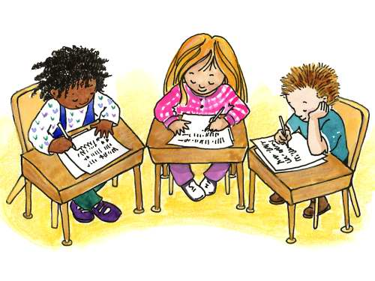

Apply It

Find out what happened in Quezon Province.

Read the comic strip below.
Yes, people are helpless and some homes and livelihood are gone already.
I’ve heard
what happened in Quezon! It’s so devastating!

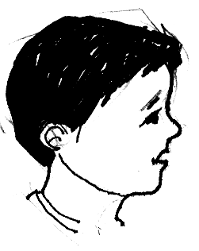
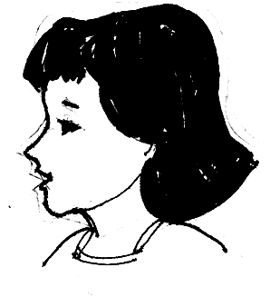

What causes flash flood there!
Well, according to the news illegal loggers caused that to happen.

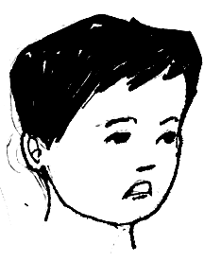

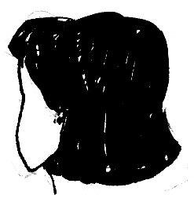

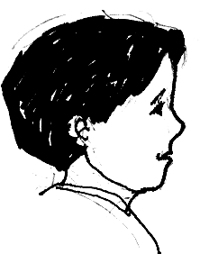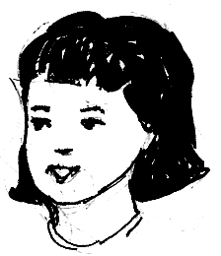
Well, when the trees are gone, excess water cannot be held back and flash flood occurs.
Why? What did they do?
They cut down trees until the forest becomes barren?
But what is bad about cutting trees? After all they can grow again.

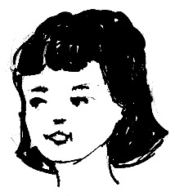
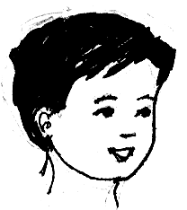

- If you are living in that place, what will you do to help to lessen flash flood problem?

- Write a letter to your barangay captain informing him/her the effects of deforestation to the environment.



Test Yourself

*

- Copy the following in your notebook. Draw line from each activity on the left to its effect on the right.

Activities Effect

- No homes and food for animals and animals will be endangered.

- Plants will not grow well.

- Water will be polluted and fishes will be affected and eventually die.

- Flash floods and soil erosion happen.

1. Dumping garbage, dead animals
and chemical wastes to the river.

2. Throwing leftover pesticide to the soil.

3. Cutting of trees without replacing them.

4. Clearing forest areas for commercial purposes.

- Read the situation below and answer the questions that follow.

The ocean air act has been passed into law. What can you suggest to your parents/family so they keep reduce air pollution?

