GRADE V

**ANIMALS WITHOUT BACKBONES: THE INVERTEBRATES**

At the end of the module, you should be able to:

* *Identify observable characteristics of invertebrates.*

## **Try to Recall**



Recall what you have learned about vertebrates. Identify sub group belongs. Write the answer in your notebook.

|  |  |
| --- | --- |
| 1. | 6. |
| 2. | 7. |
| 3. | 8. |

|  |  |
| --- | --- |
| 4. | 9. |
| 5. | 10. |

Have you identified the lion and the elephant as mammals; the bangus and tilapia as fish; the rooster and hawk as birds; the frog and salamander as amphibian, and the crocodile and snake as reptile? Very Good!

You have learned about the animals with backbones. Let’s look at animals that do not have backbones on the next page.

## **Explore**

tELESCPE

Tell what animal is being described. Choose from the animals in Column B.

Match Column A with Column B. Write your answer in your notebook.

**A B**

|  |  |
| --- | --- |
| 1. I can fly.  I am colorful.  I have no backbone.  Who am I? |  |

|  |  |
| --- | --- |
| 2. I am soft.  I live in the sea.  I have no backbone.  What am I? |  |
| 3. I move slowly.  I have a shell.  I have no backbone.  What am I? |  |
| 4. I look like a star.  I live in the sea.  I have no backbone.  What am I? |  |
| 5. I am soft.  I burrow in the earth.  I have no backbone.  What am I? |  |
| 6. Water can pass through me.  I lie on rocks in the ocean.  I have no backbone.  What am I? |  |

You can find the animals described in the exercise in the pictures that follow.

Can you find them?

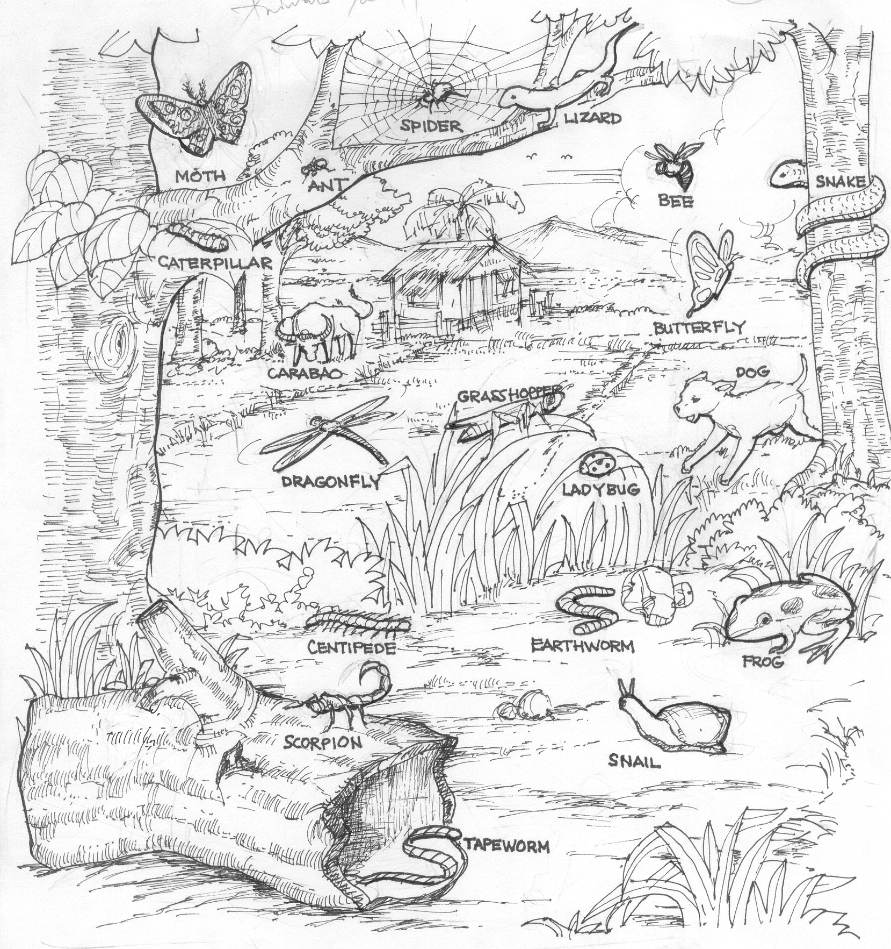

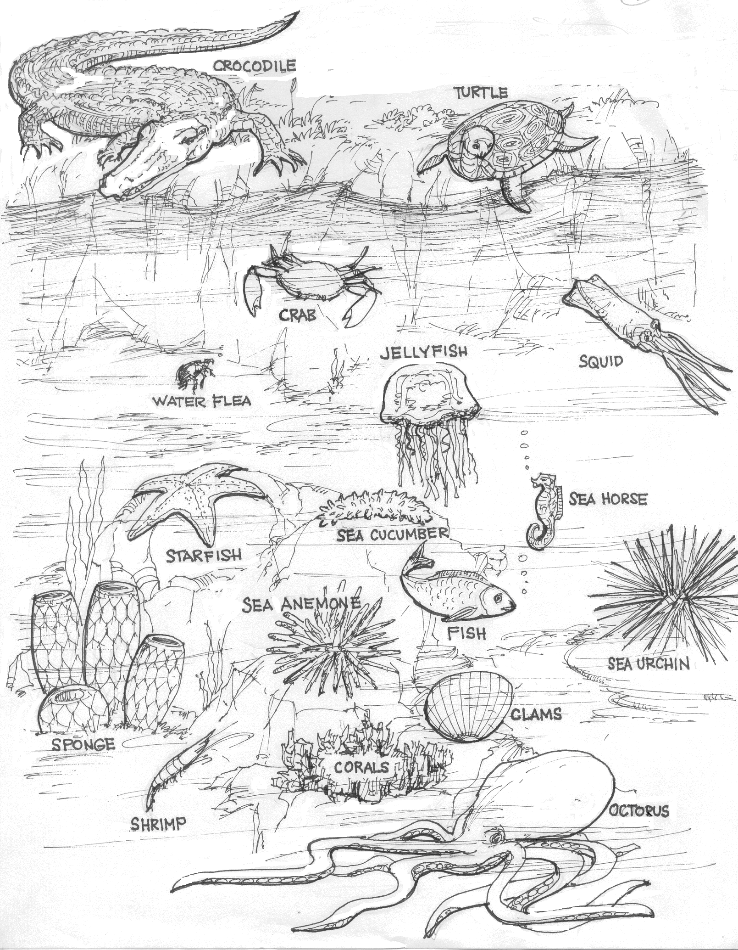

Copy the table in your notebook. In the left column, write the names of the vertebrates that you can find in the pictures on pages 4 and 5 and list them in the appropriate column.

**Animals**

|  |  |
| --- | --- |
| **Vertebrates** |  |
|  |  |
|  |  |
|  |  |
|  |  |
|  |  |
|  |  |
|  |  |
|  |  |
|  |  |
|  |  |
|  |  |

What characteristic is common among the animals in the first column? All the **vertebrates** have backbones. The other animals in the pictures do not have backbones. These are called **invertebrates**.

Write the appropriate heading in the right column and list the animals shown in the pictures that belong to the sub-group.

The heading at the other column should be “Invertebrates: Animals without Backbone”.

Read and learn more.

An invertebrate is an animal that does not have a spine or backbone.

Arthropodsare joint legged invertebratescan be grouped according to the number of legs they have. Insects are arthropods that have six legs. Arachnids are arthropods that have eight legs. Crustaceans are arthropods that have ten legs. Myriapods are arthropods that have more than ten legs. Among the arthropods are

A **coelenterates** is a hallow–intestined invertebrate that lives in water. Its body is shaped like a hollow sac that is open at one end. This opening is used for taking in food and getting rid of wastes. Among the example coelenterates are

Crustacean

Arachnid

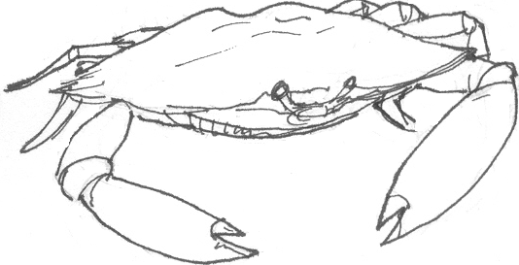

crab

Insect

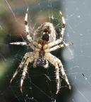

spider

Myriapod

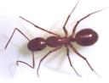

Ant

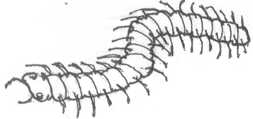

centipede

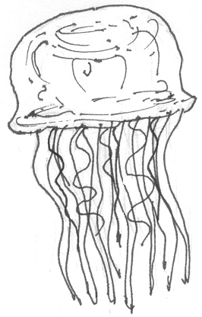

jellyfish

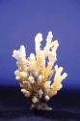

coral

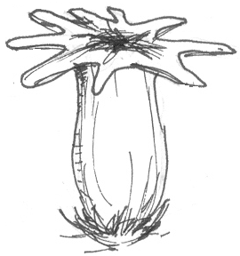

hydra

a **Mollusks** are invertebrate with soft bodies. Some mollusks have hard shell to protect their bodies while others do not have this protective shell. Among the mollusks are snails, mussels, squids, octopus.

**Echinoderms** are invertebrate that are found only in the sea. They are covered with rough and spiny skin. Most echinoderms have thousands of tubed feet on the underside of their bodies these allow them to catch prey and cling to rocks. Most echinoderms have a great number of suckers. Among the echinoderms are starfishes, sea urchins, and sea cucumbers.

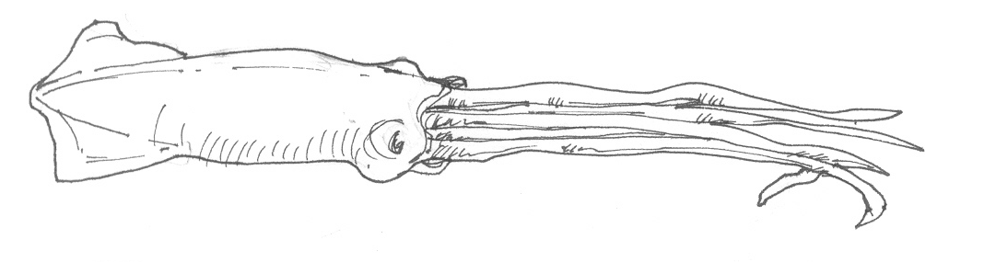

squid

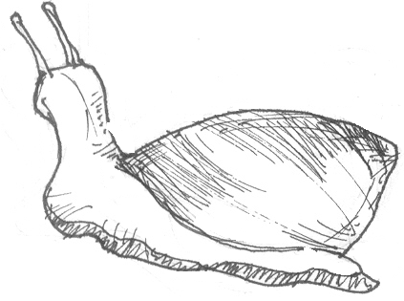

snail

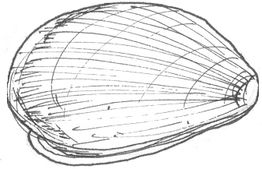

mussels

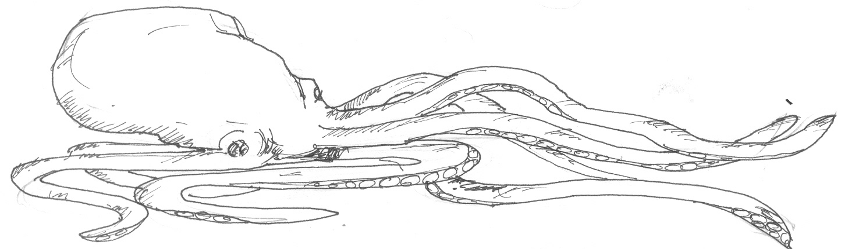

octopus

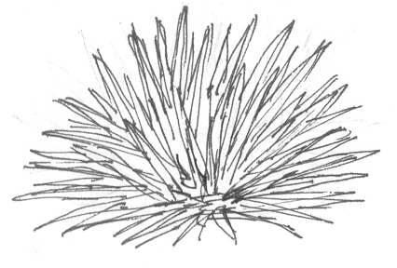

sea urchin

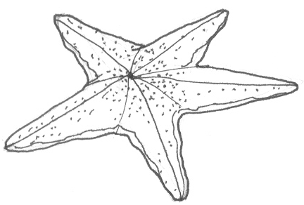

starfish

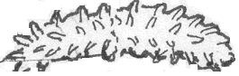

sea cucumber

**Worms** are long, slender and limbless invertebrate. They are classified into three main groups: segmented, flat, and round. Flat bodied worms are called flat worms like

**Sponges** are many celled invertebrates. The body of a sponge is full of small holes called pores. A narrow canal connects the pores to one another. The shape of a sponge depends on its skeleton; however, some sponges do not have a skeleton.

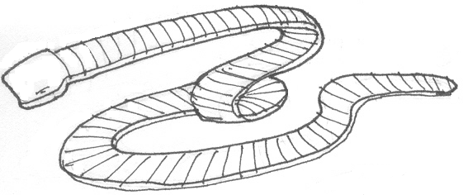

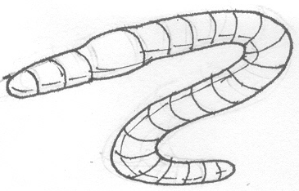

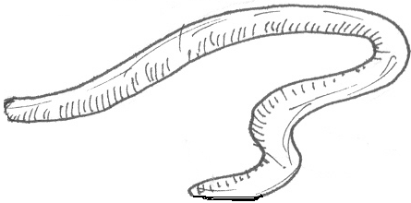

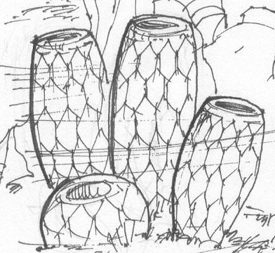

Think examples of invertebrates for each group below. Write the answers in your notebook.

**A. Arthropods**

1. Insects 3. Crustacean

2. Arachnids 4. Myriapods

**B. Coelenterates C. Mollusks**

**D. Echinoderms E. Worms**

**F. Sponges**

*Check your work against the examples given in the Read and Learn More section.*

Answer the following questions.

1. What are invertebrates?

1. What are the different groups of invertebrates?
2. What is the largest group of invertebrates?
3. What is the hard outer covering that protects the soft part of the body of some invertebrates?
4. To what group of invertebrates does the coral belong?

I LEARNED THAT:

* Animals without backbones are called *invertebrates*.
* There are six subgroups of invertebrates: arthropods, coelenterates, mollusks, echinoderms, worms, and sponges.
* All arthropods have a hard outer covering called exoskeleton that protects the soft part of the body.
* Coelenterates are hollow– intestined invertebrates that live in water.
* Mollusks are invertebrates with soft bodies. Some mollusks have hard shells to protect their bodies. Some mollusks live in land while others live in water.
* Echinoderms are found only in the sea. They are covered with rough and spiny skin.
* Worms are long, slender and limbless invertebrates.
* Sponges have many cells and its body is full of small holes called pores. These are found in the sea or ocean.

## **Apply It**



**A. Answer the following questions. Write only the letter of the answer in your notebook.**

|  |  |  |
| --- | --- | --- |
| 1. Which of the following is not an arthropod? | | |
|  |  |  |

|  |  |  |
| --- | --- | --- |
| 2. Which of the following animals is a coelenterate? | | |
|  |  |  |
| 3. Which of the following is not a worm? | | |
|  |  |  |
| 4. Which of the following is not an example of a mollusk? | | |
|  |  |  |
| 5. Which of the following is an echinoderm? | | |
|  |  |  |

**B. Answer the following questions. Write the answers in your**

**notebook.**

1. Farmers need fertile land for their crops to grow. How does An earthworm help the farmers?

1. Plants have to be pollinated in order to reproduce. What is the importance of butterflies in pollination?
2. Corals serve as habitats to some aquatic animals. What do you think will happen if coral reefs are not be protected?



## **Test Yourself**

1. **Match the invertebrate in Column A with its description in column B. Write only the letter of answer in your notebook.**

|  |  |
| --- | --- |
| **A** | **B** |
| worm  mollusk  echinoderm  arthropod  sponge  coelenterate  insect  arachnid  myriapod  crustacean | 1. It is a hollow-bodied invertebrate 2. It is a long, slender, and limbless invertebrate 3. It has a soft body and usually has a shell. 4. It has segmented body, jointed legs, and an exoskeleton 5. A classification of arthropods with six legs. 6. It is an arthropod with eight legs. 7. It is an arthropod with ten legs. 8. It is an arthropod with more than ten legs. 9. Its body is full of small holes called pores. 10. It is spiny-skinned and lives in the ocean. |

**B. Copy the hierarchical map below in your notebook. Then complete the maps with…**

**invertebrates**