GRADE VI
PHYSICAL CHANGE

At the end of the module, you should be able to:

- Show that materials may change in size, shape, volume or phase
- Observe that no new material is formed when physical change took place



Try to Recall

Activity 1

Study the following pictures. Tell whether each object is SOLID, LIQUID or GAS write your answer in your notebook.

1. 4.

2. 5.

3.

Activity 2

Write the unit of measurement use to measure these materials. Do it in your notebook.
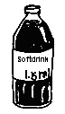

1. 2. 3.

Activity 3

What changes happened to materials? Write the answer in your notebook.
1.

2.

3.

4.

5.

Explore

Do you see the changes that happen to materials?
How do these materials change?
Is it possible to change a material and return to its original form?

Find out the answers by doing these activities.

Activity 1

What you need:

A piece of paper popsicle sticks
fruit (any) yarn, any string, nito or rattan strips
knife ½ yard of soft wire

What to do:

- Construct a paper boat or airplane using a piece of paper.
- Slice the fruit in half.
- Make a vase or any object out of sticks. Tie the edges together with yarn, string, nito or rattan strips.
- Form the soft wire into a interesting object or shape.

Answer these:

A. What changes take place in the

paper sticks
fruit wire

B. Are there new materials formed? Did the materials remain the same?
C. Can the materials be returned to their original form?

If materials returned to their original form, physical change took place.

Activity 2

What you need:

2 drinking glasses
ice cubes
kettle or small pot with water
marker or crayon
bar or detergent soap
bowl or basin of water

What to do:

- Put some ice cubes in a glass. Observe.
- In another glass, with water. Pour water in a kettle or pot. Measure the amount of water with a marker. Boil it for 10 minutes. (Ask the help of an adult). Cool then before pour back to the glass. Then, measure with a marker.
- Dissolve the powdered soap in a basin of water.

Answer these:

A. What are the materials used?
- What became of the ice cubes? water? soap? Are there new materials
formed?
C. How these materials changed?
D. Can these materials return to their original form? How?
E. What do you call this kind of change?

Read and learn more.

In physical change, only the physical properties or characteristics of the substance changed and it is still the same substance and no new material is formed. It takes place when a substance is heated and expands, or is cooled and contracts. The substance can be changed back into its original size shape, volume or phase. There are different ways of showing physical change like folding, cutting, mixing, freezing, melting, bending, pasting, sewing, sawing or stretching.

I LEARNED THAT:

- Materials may change in size, shape, volume or phase

- No new material is formed when physical change takes place

- Physical change is shown by folding, slicing, tying, stretching, melting, heating, etc.

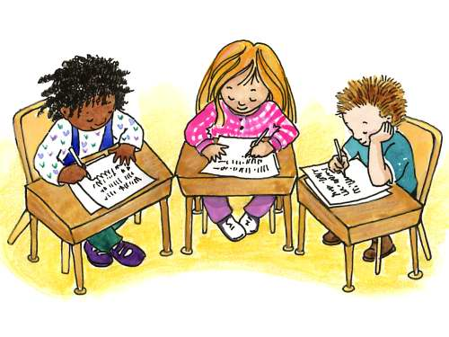

Apply It

Answer the following:

- Instead of throwing scratch paper, what can you do to make them useful?

- Plastic and canned containers must be recycled / reused.
What materials/projects can you think of to make them usable?

- Write PHYSICAL if the situation shows physical change and NOT PHYSICAL CHANGE if the situation does not show a physical change.

  - broken glass
  - cross-stitching
  - making a paper mache of animals
  - designing a paper bag puppet
  - burning paper

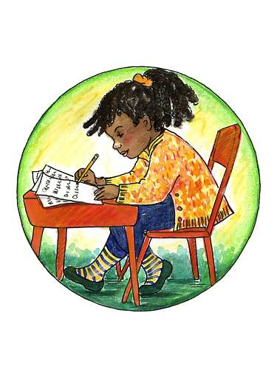

Test Yourself

*

A. Put a check mark (√) if the illustration shows a physical change and a cross mark (x) if not. Do it in your notebook.

1. 4.

2. 5.

3. 6.

B. Prepare a table like one below in your notebook.
On the left columns are materials. Fill in the next column with the way the materials undergo physical change. Do it in your notebook.

Material | How it undergoes physical change
1. paper | cutting, folding, rolling, tearing
2. candy wrapper
3. piece of wood
4. beads
5. string or rope
6. bread

Key to Correction

Try to Recall

Activity 1. What Matters Most!
- SOLID
- GAS
3. LIQUID
4. SOLID
5. GAS

Activity 2: Take Note of the Size
- LITER
- MILLIMETER
3. GALLON

Activity 3
- YES
- YES
3. NO
4. YES
5. YES

TEST YOURSELF
- √
- √
- √
- √
- X
- √

B.

Material | How it undergoes physical change
1. paper | cutting, folding, rolling, tearing
2. candy wrapper | cutting, folding, tearing
3. piece of wood | sawing, carving
4. beads | stringing, grinding
5. string or rope | cutting, tying
6. bread | cutting, slicing

