List of Stories

1. At the beach
2. Having a Picnic
3. Jessica can cook well
4. My Family
5. Bestfriends
6. My house
7. Bob the Frog
8. A Big Cake
9. A Great Big Fox
10. Underground Town
11. Picnic Time
12. Little blue Bird
13. Halloween Fun
14. My Camping Trip
15. Bedtime
16. A Hike with Spike
17. I Can Zip
18. Jack Loves Adventure
19. Painting
20. Eva and Pat

# At the Beach

Jane went on vacation to the beach. She likes to play in the sand. Her brother likes to jump over waves. Her favorite thing to do is find sea shells.

**Questions:**

1. Where did Jane go on vacation?
   1. to the mountains
   2. to the beach

1. What does her brother like to do?
   1. jump over waves
   2. play in the sand

1. What is Jane’s favorite thing to do?

# Having a Picnic

Franklin went on a picnic with his family. They packed lots of food to eat. They sat on a blanket. It was a nice day. Franklin had a great time.

**Questions:**

1. What did Franklin do with his family?
   1. have a picnic
   2. write a letter

1. What did they bring?
   1. toys
   2. food
2. What did they sit on?
   1. blanket
   2. chairs

# Jessica can cook well

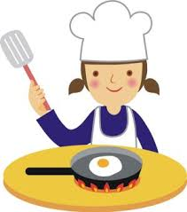

Jessica can cook well. Every Sunday she makes breakfast for everyone. She cooks eggs, bacon, and pancakes. Everyone in her family thinks she makes the best pancakes.

**Questions:**

1. On what day does she make breakfast for everyone?
   1. Sunday
   2. Monday
   3. Saturday
2. What does she cook for breakfast?
   1. Bacon
   2. Pancakes
   3. All of the above
3. What does she make really well?
   1. Bacon b. pancakes c. egg

# My Family

I love my family. There are five people in mmy family. I have one brother and one sister. My brother is seven and my sister is two. My mom and dad make the rules for my family. My little sister gets in trouble sometimes. Our favorite thing to do as a family is to play games together.

**Questions:**

1. How many people are in the family?
2. How old is the sister?
3. Who gets in trouble sometimes?
4. Who makes the rules?
5. What does the family like to do best?

# BESTFRIENDS

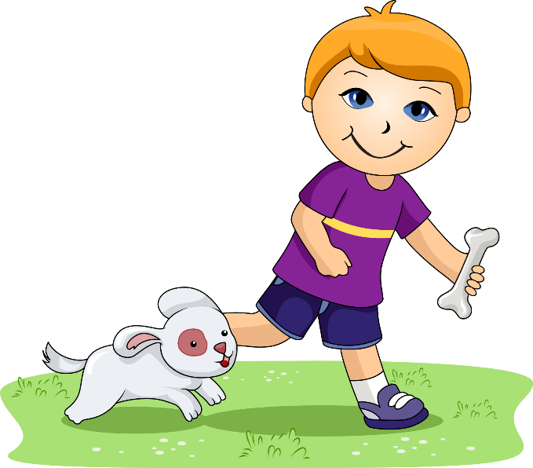

Jack is a seven year old boy who loves adventure. He likes to climb trees and find interesting bugs and leaves in his backyard. He also likes to play with his dog, Daisy. Daisy is a two year old yellow lab mix. Jack and Daisy are best friends.

**Questions:**

1. How old is Jack. He is _________________.
2. What does Jack loves to do in his backyard? He likes to ________________________________________.
3. What kind of dog is Daisy? She is a _____________________

# My House

My house is where my family lives. It is blue. There are four bedrooms. We have a kitchen and three bathrooms. Our family room is where we like to watch television together. When people come over, we eat in the dining room. We have a playroom in the basement. We have a swing in the backyard. I love my house.

**Questions:**

1. What is the color of the house?
2. Who lives in the house?
3. How many bedrooms are there in the house?
4. What is in the backyard?
5. What happens in the family room?

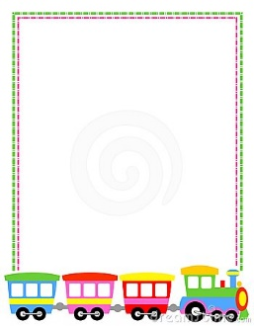BOB THE FROG



Bob is a frog. He hops on a log. Hop, hop. The log is hot! Bob hops off the log. He plops in the pond. Plop, plop. Bob flops back on the log. Flop!

**Questions:**

1. Who is Bob?
   1. Dog
   2. Fox
   3. Frog
2. Where did Bob hop?
   1. Pond
   2. Fog
   3. Box
3. Where did Bob flops back?
   1. Bug
   2. Log
   3. Tad

# A BIG CAKE

My house is where my family lives. It is blue. There are four bedrooms. We have a kitchen and three bathrooms. Our family room is where we like to watch television together. When people come over, we eat in the dining room. We have a playroom in the basement. We have a swing in the backyard. I love my house.

**Questions:**

1. What is the color of the house?
2. Who lives in the house?
3. How many bedrooms are there in the house?
4. What is in the backyard?
5. What happens in the family room?

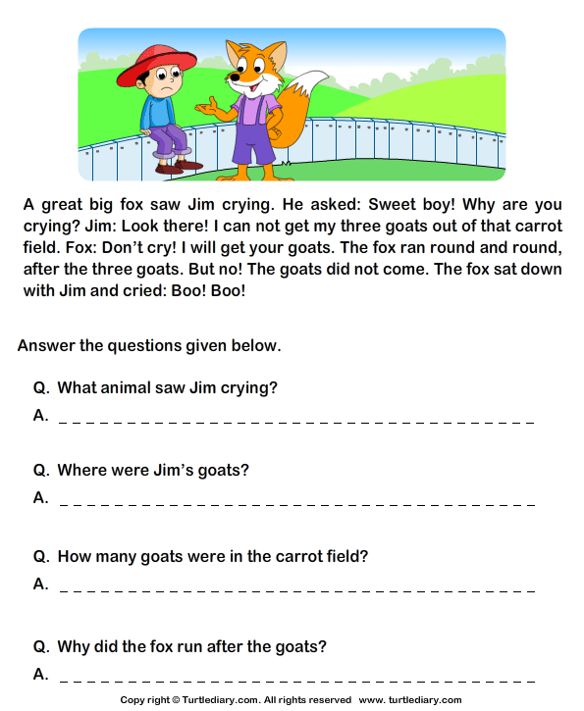A GREAT BIG FOX

Bob is a frog. He hops on a log. Hop, hop. The log is hot! Bob hops off the log. He plops in the pond. Plop, plop. Bob flops back on the log. Flop!

**Questions:**

1. Who is Bob?
   1. Dog
   2. Fox
   3. Frog
2. Where did Bob hop?
   1. Pond
   2. Fog
   3. Box
3. Where did Bob flops back?
   1. Bug
   2. Log
   3. Tad

# UNDERGROUND TOWN

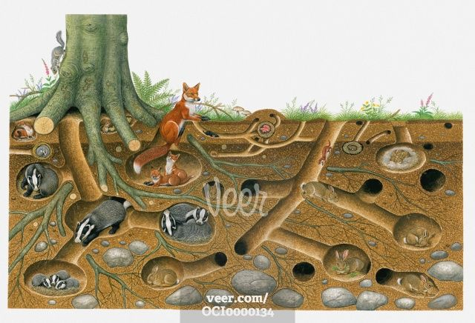Have you ever seen a prairie dog town? That is where prairie dogs live. But this town has no buildings or houses. Prairie dogs live underground. They dig deep into the earth to make tunnels. Along the tunnels are rooms for sleeping or storing food. One room is lined with grass for the babies.

**Questions:**

1. What is a prairie dog town?
   1. Underground town
   2. Bee hive
2. What did they do to make a prairie dog town?
   1. Build b. Dig
3. What can you see along the tunnels?
   1. Rooms b. classrooms

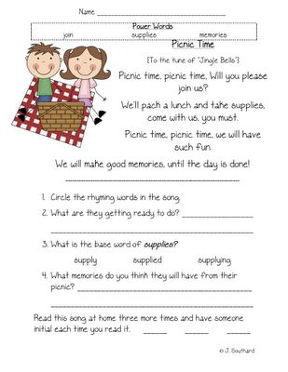**PICNIC TIME**

Picnic time, picnic time will you please join us?

We’ll pack a lunch and take supplies

Come with us you must.

Picnic time, picnic time

We will have such fun

We will make good memories

until the day is done.

1. Circle the rhyming words in the song.
2. What are they getting ready to do? ___________________________________
3. What is the base word of supplies? Supply supplied supplying
4. What memories do you think they will have from their picnic? ____________________________________
5. Read each song at home three more times and have someone initial each time you read it. _______ _______ _______

**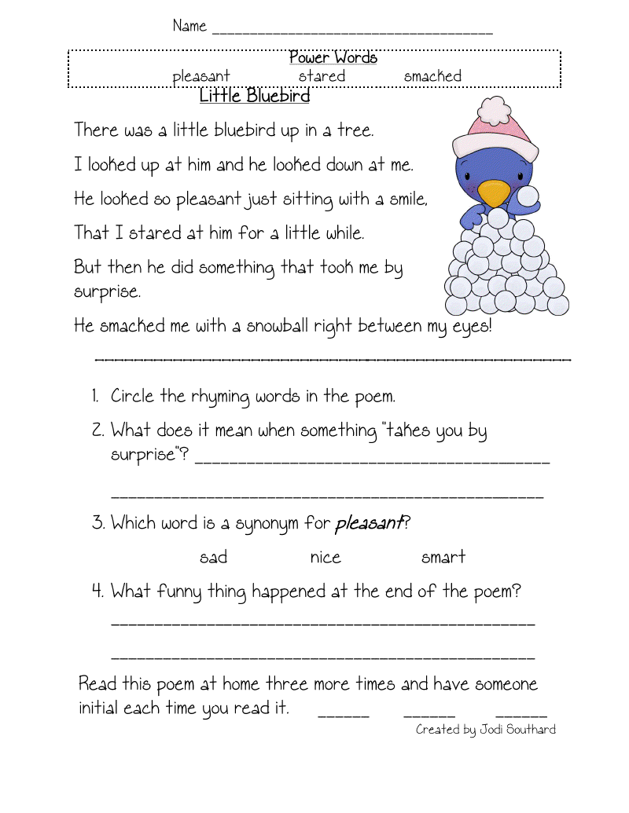****LITTLE BLUE BIRD**

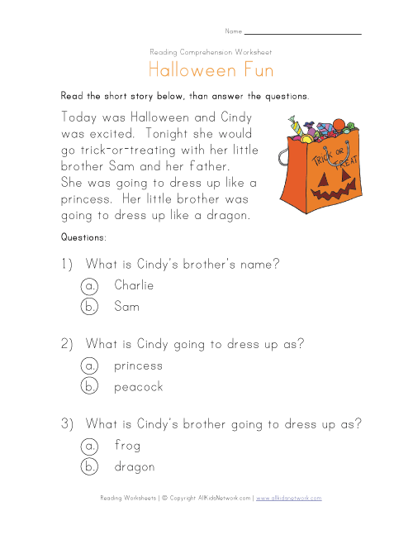**HALLOWEEN FUN**

Today was Halloween and Cindy was excited. Tonight she will go trick-or-treating with her little brother Sam and her Father. She was going to dress up like a princess. Her little brother was going to dress up like a dragon.

**Questions:**

1. What is Cindy’s brother’s name?
   1. Charlie
   2. Sam
2. What is Cindy going to dress up as?
   1. Princess
   2. Peacock
3. What is Cindy’s brother going to dress up as?
   1. Frog
   2. dragon

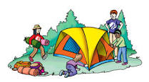**MY CAMPING TRIP**

I am going to camp with my family. We are going to sleep in a tent. We will swim in the lake. I can’t wait!

1. Where am I going? _________________________
2. Where will I sleep? _________________________
3. What will we do? ________________________

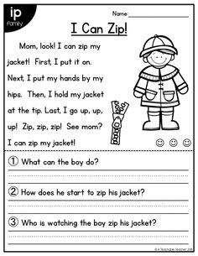

**BEDTIME**

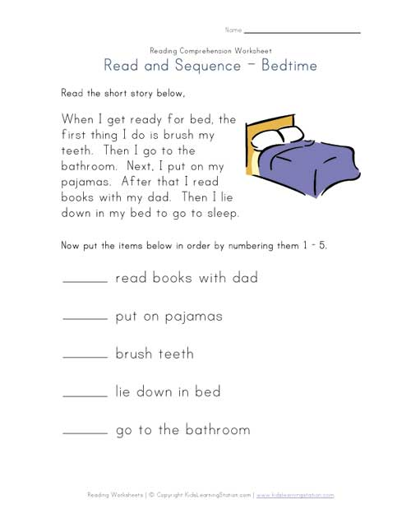When I get ready for bed, the first thing I do is brush my teeth. Then I go to the bathroom. Next, I put on my pajamas. After that I read books with my dad. Then I lie down in my bed to go to sleep.

Put the items below in order by numbering them 1-5

_____ read books with dad

_____ put on pajamas

_____ brush teeth

_____ lie down in bed

_____ go to the bathroom

