GRADE VI
OXYGEN-CARBON DIOXIDE CYCLE

At the end of the module, you should be able to:

- Describe the interrelationships among living organism in an ecosystem for gas (oxygen-carbon dioxide cycle)



Try to Recall

A. Write the answers in your notebook.
1. Complete the diagram below with words, to show what plants needs in manufacturing their food during the process of photosynthesis in order to grow.

A
B

C
D

2. Complete this:

H₂O + Minerals + Sunlight + CO₂ → ______ and ______
B.
1. Study the diagram below. Fill in the blank below with the gas that you exhale and inhale.
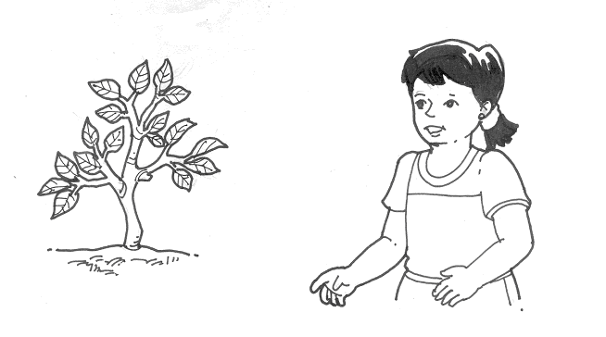

_______?

_______?

2. Answer the questions below.

a. What gas do humans exhale?
b. What gas do humans inhale?
c. What happens to the gas that we exhale?
d. Where does the gas that we inhale come from?
e. What gas do we take from plants?
f. What can you call the cycle shown in the diagram? Why?
g. What would happen if there were no plants or animals?
h. Is it important to maintain a supply of these gases? Why?

.

Explore

Activity 1

1. Copy the phrases below in your notebook and match each of the following sentences with the number indicated in the diagram it best describes. (Write the number in the box.)

 the by-product of photosynthesis

 the gas needed by plants in making food

 the process by which plants manufacture food

 the organisms that need oxygen in order to survive

 the process of taking in oxygen and giving off carbon dioxide

 releases oxygen during photosynthesis

Read and learn more.
- Plants and animals depend on each other in many ways.
- The continuous exchange of oxygen and carbon dioxide by plants and animals including man is called oxygen-carbon dioxide cycle.
- Plants need carbon dioxide in the process of photosynthesis.
- Carbon dioxide is a waste product produced when man and animals respire.
- One of the by-products during photosynthesis is oxygen which is needed by animals and humans in order to live.
- The oxygen-carbon dioxide cycle is very important to keep both plants and animals alive.

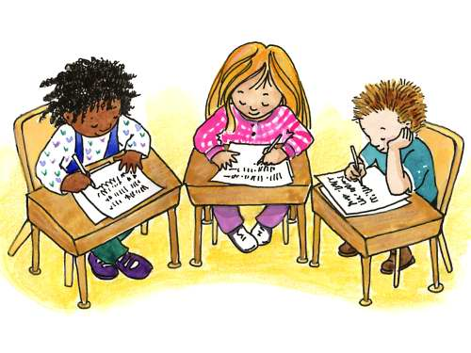

Apply It

- Construct your own oxygen-carbon dioxide cycle using the following organisms:

rice plant – bird

- If you are given a chance to choose, what kind of place would you like to live in? Why?

a) A place with many trees
b) A place with wide space but lesser trees

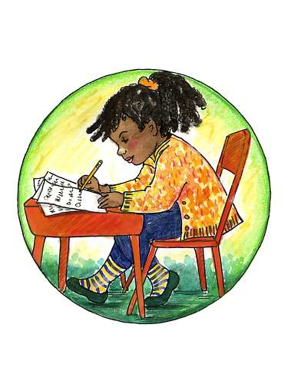

Test Yourself

*

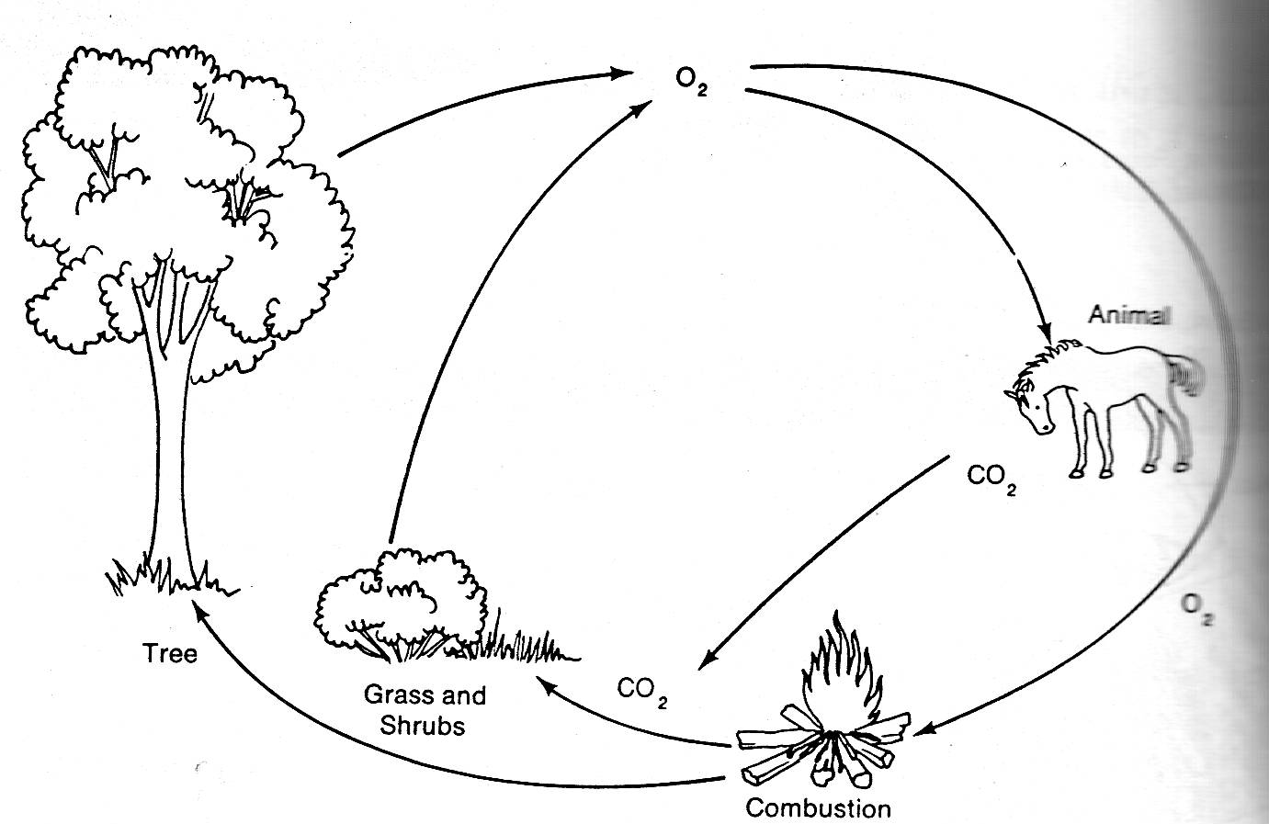

Write a 4-5 sentence paragraph about oxygen-carbon dioxide cycle using the illustration above.

