GRADE VI
INSTRUMENTS IN STUDYING STARS

At the end of the module, you should be able to:

- Identify stars with naked eye
- Describe the instruments used by astronomers to gather information about stars



Try to Recall

- In your notebook list down five constellation that belongs to the zodiac sign
- Give two reasons why the north star is important.

Explore

In this lesson you will learn more about the jewel of the night sky, the stars.

Activity 1

- Go out when the sky is clear and observe.
- List the objects you see in the sky.
- This is a picture of sky at night. Is it the same as what you have actually observed?

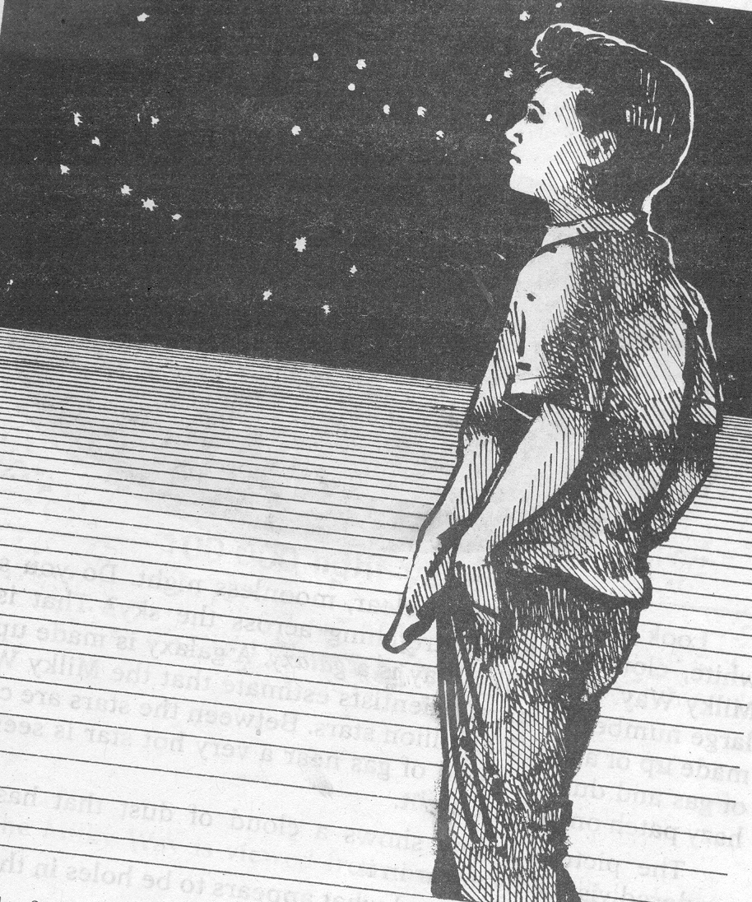

Write your answers in your notebook.

- What are the objects you saw?
- How do you know that they are stars?
- Differentiate the stars and the planets.
- Aside from stars and planets, what else do you see?

Activity 2
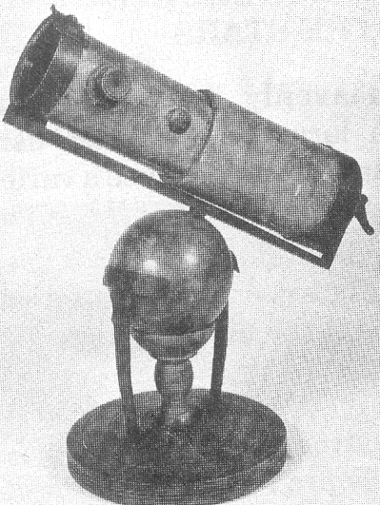

What to do:

- Complete the words below by identifying the missing letters using the position or order of the letters in the alphabet. Each word has meaning or description on the opposite side. Write your answer on your notebook.

- It is used to see distant/far objects. It is
used to gather information about stars.

- T 5 12 5 1 9 3 15 16 E

- It is used to take a photographs.
- 3 A 13 5 R 1

- It is used to determine the movement
of stars based on its color pattern.
3. S P 5 3 20 R O 19 C 15 P 5

- A special telescope which can see
images of objects with the help of
radiation.
- 18 A 4 9 15 T 5 L 5 19 3 0 16 5

- It is the largest space telescope.
- H U 2 B 12 5 S16 A 3 5
T E 12 E 19 3 15 16 E

- Has a light-gathering mirror consisting
of thirty-six segmented mirrors mounted
close to each other.
- K 5 3 K T E 12 5 S C 15 16 5

- Telescope that uses lens.
- R E 6 18 A 3 T 9 14 7
20 E 12 5 19 C 15 16 5

- 18 E 6 L E 3 20 9 14 G
- Telescope that uses mirror.
20 E 12 E 19 C O 16 E

- A place were astronomers work to
study the stars and other heavenly
bodies. It is usually located in the
mountains.
9. O 2 19 E R 22 A 20 O 18 9 5 S

10. A 19 20 R 15 N O 13 E 18 S
- Scientists that study about stars and other heavenly bodies.

Read and learn more.

- Stars are ball of hot burning gases.
- Galileo Galilie is the astronomer that invented the first telescope followed by Isaac Newton.
- Reflecting and refracting telescopes are the two kinds of telescope.
- Observatories’ roof are dome-shape because on top of it the large telescope is placed.
- Observatories are located high up in the mountain to have a clear view of the sky.
- THE NIGHT SKY (by Marian Lockwood)

The pageant of the night skies aroused the curiosity of men from the very earliest times. As observation piled up and astronomical instruments were perfected, the pattern of the sky became clearer. Though there is still a great deal that we do not know about our universe, we now have a tolerably accurate idea of the face of the sky as it is viewed from our planet, the earth.

Of the countless thousands of millions of celestial bodies, we can see either with the naked eye or the optical telescope only those bodies that shine. Some of the heavenly bodies – the stars, for instance, which are suns like our sun – shine by their own light. Others, like the planets and their moons, shine because they reflect the light that shines upon it. The earth, because it reflects the sun’s light, would also appear as a shining body to a nearby observer.

The stars make up by far the largest part of the individual objects that we observe in the sky. The average person looking at the sky can see perhaps 4,000 stars at one time. Other naked -eye stars, numbering perhaps 5,000 more, would not be visible to him. For one thing, we see only one-half of the sky at any one time. Besides, some of the stars that are close to the horizon are lost in the haze that so often obscures the sky just above the horizon line. The astronomer with a powerful array of telescopes can see or photograph countless individual stars and star groups that are not visible to the naked eye.

Different Instruments Used to Gather Information About the Stars and Heavenly Bodies
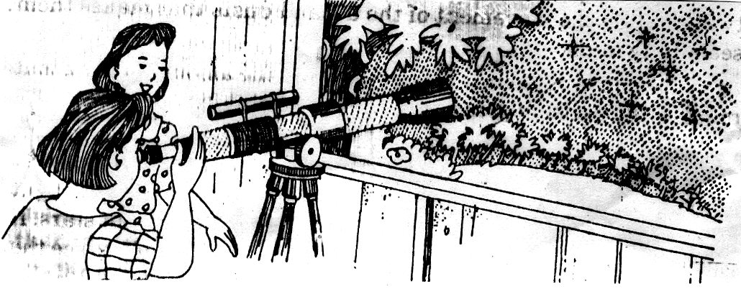

Telescope

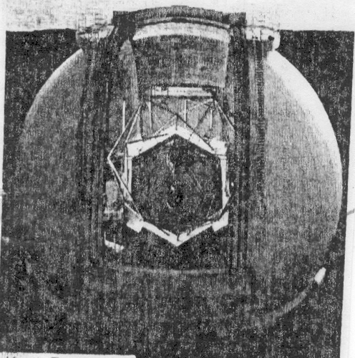

Keck Telescope

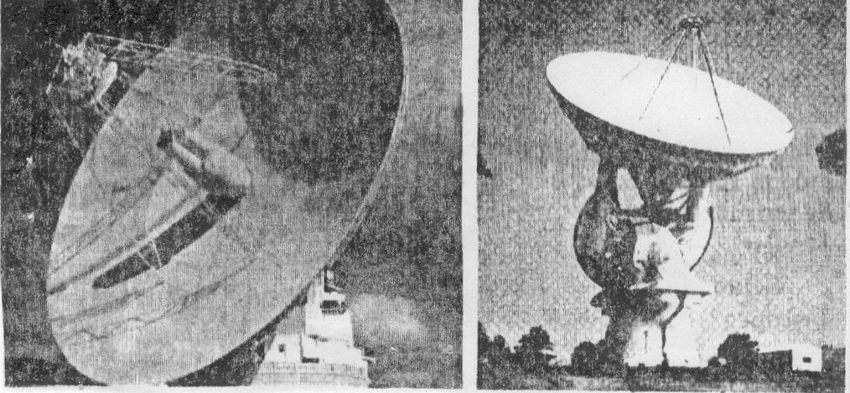

Reflecting Telescope

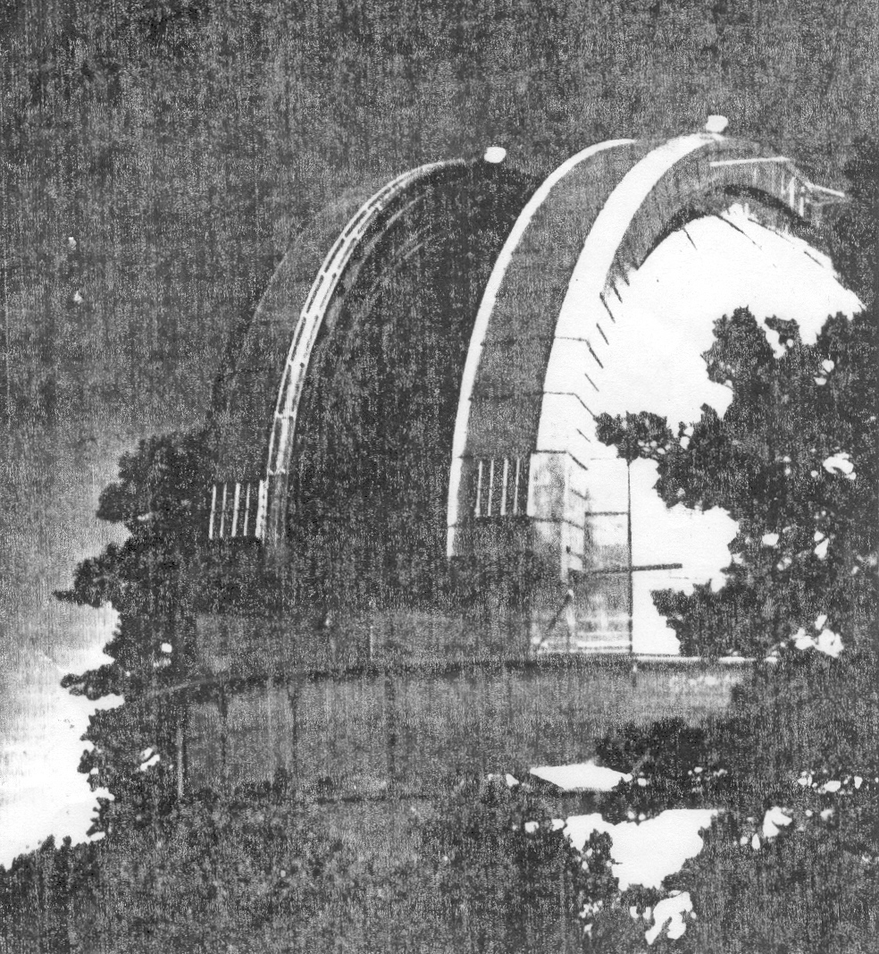

Observatories

I LEARNED THAT:

- Some stars can be seen with the naked-eye like the north star
- Astronomers use different instruments to study the stars.



Apply It

A. Answer the following questions.

- What is a telescope? How is it used?
- What is the other alternative instrument for telescope if you dont have any?
- Where do astronomers work to study the stars and other heavenly bodies? Why is it situated on top of the mountains?
- What are the latest telescopes that are used by the astronomers?



Test Yourself

*

Match column A with the proper description in column B.

A B

1. Telescope A. It can be used to collect information about
stars like its movement through its color
pattern.

2. Reflecting telescope B. It makes the object appear bigger and
clearer.

3. Refracting telescope C. It is a sauce-like dish structure that used
radiation to gather information in space.

4. Radio telescope D. Optical telescope that used mirror.

5. Spectroscope E. It uses lens instead of mirror

- It uses both mirror and lens.

Key to Correction

Exploration Time

Activity 1

Activity 2

Apply it

A
1.

2.

3.

4.

5.

B

Test Yourself

- B
- D
- E
- C
- A

