Name: _____________________________________________ Teacher: **_____________________**

**Aa Bb Cc Dd Ee Ff Gg Hh Ii Jj Kk Ll Mm**

**Nn Ňň Ngng Oo Pp Qq Rr Ss Tt Uu Vv Ww Xx**

**Yy Zz**

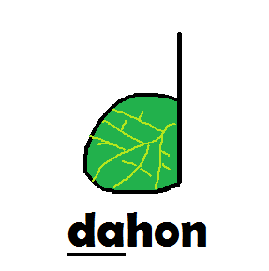

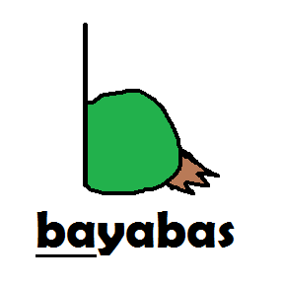

**a** **ba** **ka** **da** **e**

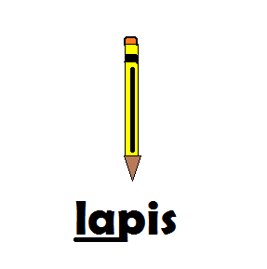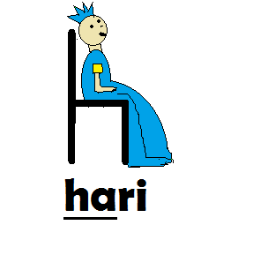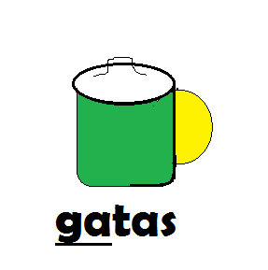

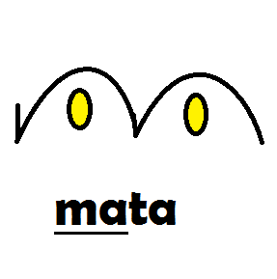

**ga** **ha** **i** **la** **ma**

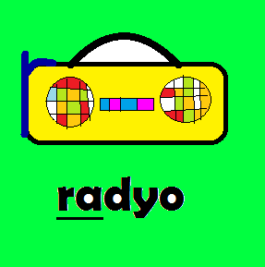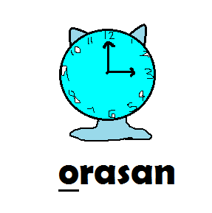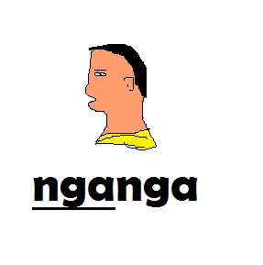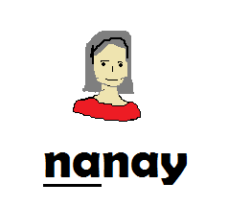

**na**  **nga** **o** **pa** **ra**

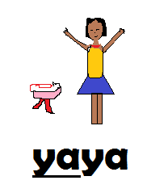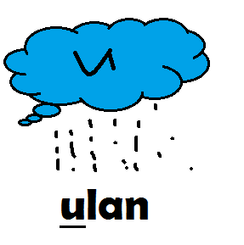

**sa** **ta** **u** **wa** **ya**