**SECOND GRADING**

**ENGLISH II**

**Table of Specification**

|  |  |  |  |
| --- | --- | --- | --- |
| **Objectives** | **No. of Item/s** | **%** | **Test Placement** |
| I. Identify mass and count nouns. | 5 | 16.66% | 1-5 |
| II. Answer the questions with:  Yes it is. / No it isn’t.  Yes, they are. / No, they aren’t. | 5 | 16.66% | 6-10 |
| III. Identify words with similar meaning. | 5 | 16.66% | 11-15 |
| IV. Identidy adjectives/describing words | 5 | 16.66% | 16-20 |
| V. Identify the –ing verb. | 5 | 16.66% | 21-25 |
| VI. Answer the why questions | 5 | 16.66% | 26-30 |
| **Total** | **30** | **100%** |  |

**Second Periodic Test in ENGLISH II**

NAME:___________________________________ DATE:_____________________

GRADE/SECTION:___________________________ TEACHER:__________________

**I. Identify mass and count nouns**

1. Count noun.

O rice O crayons O leaves of acacia tree

2. Hair is a _____ .

O mass noun O count noun O none of the above

3. Raindrops are _____ .

O mass noun O count noun O none of the above

4. Books are _____ .

O mass noun O count noun O none of the above

5. Boy Scouts are _____ .

O mass noun O count noun O none of the above

**II. Answer the questions with:**

**Yes it is. / No it isn’t. Yes, they are. / No, they aren’t.**

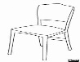6. Is this a chair?

O Yes, it is. O No, it isn’t O Yes, they are

7. Is this a pencil?

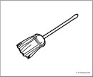O Yes, it is. O No, it isn’t O No, they aren’t

8. Is this a broom?

O Yes, it is. O No, it isn’t O No, they aren’t

9. Are these flowers?

O Yes, it is. O No, they aren’t O Yes, they are

10. Is this a bag?

O Yes, it is. O No, it isn’t O Yes, they are

**III. Identify words with similar meaning.**

11. What is the synonym of the word *neat*?

O dirty O untidy O clean

12. What is the synonym of the word *beautiful*?

O ugly O unbecoming O pretty

13. *Full* is the synonym of ______.

O empty O loaded O light

14. *Stop* means _____.

O continue O go on O halt

15. *Up* means _____.

O down O below O above

**IV. Identify the correct adjective.**

16. one

O size O shape O number

17. small

O size O color O shape

18. square

O number O quality O shape

19. yellow

O size O quality O color

20. pretty

O size O color O quality

**V. Study the picture and blacken the correct action word for it.**

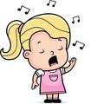21. O dancing

O singing

O playing

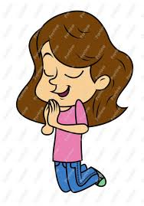22. O praying

O playing

O cleaning

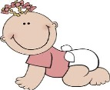23. O swimming

O crawling

O flying

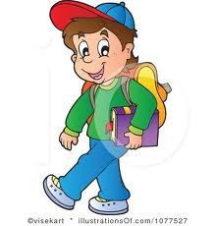24. O walking

O crawling

O cleaning

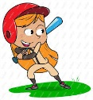25. O cleaning

O playing

O cooking

**VI. Blacken the circle that answers the question correctly.**

26. Why are the children sad?

O Because they are hungry.

O Because they’re sick.

O Because they can’t play outdoors.

27. Why is the boy happy?

O Because it is holiday.

O Because he won in a raffle draw.

O Because many people are watching him.

28. Why did the trees fall down?

O Because the wind blew hard.

O Because the trees are very tall.

O Because the trees are very weak.

29. Why did the police scold the girl?

O Because she disobeyed traffic rules.

O Because she did not listen to the whistle.

O Because she played on the street.

30. Why did the boy slide on the floor?

O Because the floor is shinny.

O Because the floor is slippery.

O Because the banana skin scattered on the floor.