GRADE V

**KINDS OF ROCK**

*At the end of the module, you should be able to describe how igneous, sedimentary, and metamorphic rocks are formed.*

## **Try to Recall**



**A. Unscramble each of jumbled letters below to form the word denoting a property of a rock. Write the answers in your notebook.**

1. ARSNHEDS
2. HAEPS
3. TGEIWH
4. EZSI
5. OCRLO

**B. Read each statement below. If the statement is true, write T in your notebook. If not, write False. Write the answer in your notebook.**

1. Rocks differ from one another because they are made up of different minerals.
2. Rocks are hard to classify because they do not have distinct minerals.
3. Rocks can be classified according to hardness, through the scratch test.
4. All rocks have almost the same shape.

5. Rocks can be identified by their physical characteristics such as color, hardness, weight, shape, and texture.

## **Explore**



**Activity 1**

Look at the pictures below. Which rocks are familiar with to you? Which rocks do you know? Identify them. Write their names in your notebook.

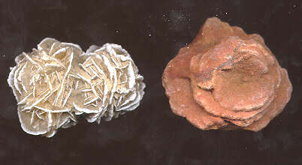

1.

2.

3.

4.

5.

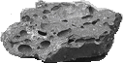

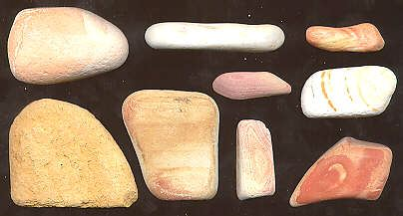

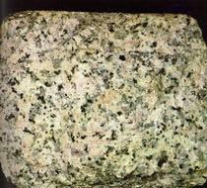

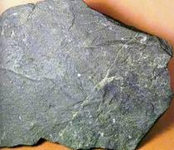

Below the earth’s surface at depth of 60-20 km the temperature is about 1400o C. At this depth is the presence of molten rock or magma. *Magma* is formed near the bottom of the crust or within the upper mantle. Then the *magma* then moves upward into the crust or rises to the surface of the earth and flows out during volcanic eruptions. This molten rock coils and harden. This kind of rock is called *igneous rock,* taken from the Latin word “*ignes”* which means “fire.” This is also called fire-formed rock. Some examples of igneous rocks are granite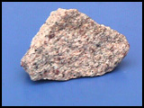, diorite, filsite, basalt,  and obsidian 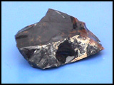



Another kind of rock is the sedimentary rock. Sedimentary rock is very common rock in nearly every community. They are softer than the igneous rock. Its name is taken from the Latin word *sedimentum* which means “setting” or “ driften down.” The sediments are sand, gravel, sea shells, plant matter, mud, and other materials that settle down at the bottom of any body of water. It is formed from the accumulation and setting of sediments. Examples of these kind of rock are sandstone, 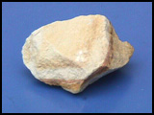 mudstone, and conglomerate. 



Are you familiar with this stone? This is marble. This is an example of another group of rocks known as metamorphic rock. The word metamorphic is taken from a Greek word which means “the process of being transformed or changed”

Metamorphic rocks start either as igneous rocks or sedimentary rock. High temperature and pressure change the rocks into new form, the metamorphic rock. These rocks are harder and smoother than the original igneous or sedimentary rock. Some examples are slate, gneiss,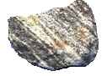and quartzile.









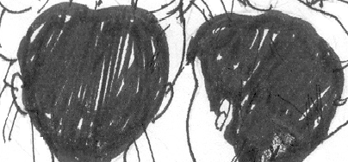

Yesterday, we learned from Dr. Ocampo about the three types of rocks. Do you remember them? Let’s see how much you have learned.



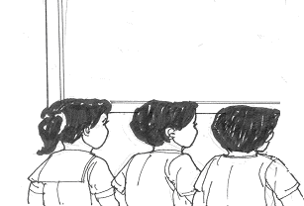

Answer the following questions

1. What are the three kinds of rocks?
2. Which kind is the hardest rock?

Read and learn more.

Rocks tell us something about the history of earth. The three kinds of rocks namely igneous, sedimentary, and metamorphic are formed in different ways.

Igneous rocks are said to be formed from molten materials that moves upward. These are two types of igneous rocks. These are the *intrusive* and the *extrusive*. Intrusive igneous rock is one the solidity within the earth’s crust and appear at the surface after the rocks above them have eroded. Extrusive igneous rock are formed when the magma flows out of a volcano as lava and then cools at the earth’s surface.

Sedimentary rocks are often softer and less resistant to erosion than igneous rock or metamorphic rock. Limestone on example can easily be dissolved by the action of carbonic acid in ground water. However, sandstones are frequently resistant to the forces of nature.

Metamorphic rocks the hardest rocks. Igneous rock a sedimentary rock carried become metamorphic rock. The change is brought about by extreme heat and pressure.

**Metamorphic rocks** are formed by metamorphism. Igneous rock or sedimentary rock could become a metamorphic rock. This happens when igneous or metamorphic rock is exposed to extreme heat and pressure.

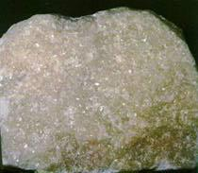

Marble



Gneiss

**I LEARNED THAT:**

* Rocks may be classified as igneous, sedimentary, and metamorphic
* Igneous rocks are formed from hot magma.
* Sedimentary rocks are formed out of sediments cemented together.
* Metamorphic rocks are formed due to extreme heat and pressure.

## **Apply It**



**A. Copy the diagram below in your notebook. Then complete it with information on the classification of rocks.**

Rocks

may be classified

as

**B. Sheila loves to collect rocks. If she was at a beach, what kind of rock do you think will she find and bring home? Why?**



## **Test Yourself**

**\***

A**.** Copy the following puzzle in your notebook. Complete it based on the clues given below.

4

2

1

6

9

3

7

10

8

Down

1. a rock that is formed from layers of compressed shale and clay.
2. a rock that is formed from sediments
3. fire-formed rocks
4. a sedimentary rock that turns into marble

Across

6. a very hard stone that comes from a limestone

7. a rock that is formed due to extreme heat and pressure

1. a form of limestone
2. a rock formed from grains of sand cemented together.

10. a type of igneous rock

B. In 5 to 6 sentences, differentiate the three kinds of rocks by discussing how they were formed. Write the explanation in your notebook.