GRADE VI
THE HUMAN CIRCULARORY SYSTEM

At the end of the module, you should be able to:

- Identify the major parts of the circulatory system.



Try to Recall

Why do I need food?
How does food reach my toes?
Why do I need oxygen?
How does oxygen go to the different parts of my body?

Directions: Study the illustrations.
Answer the question/questions
In your notebook.

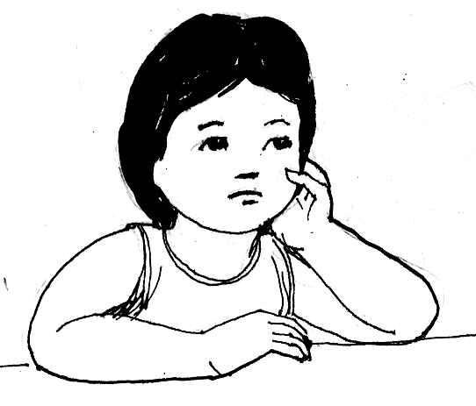

What materials does your body need shown by the arrow?

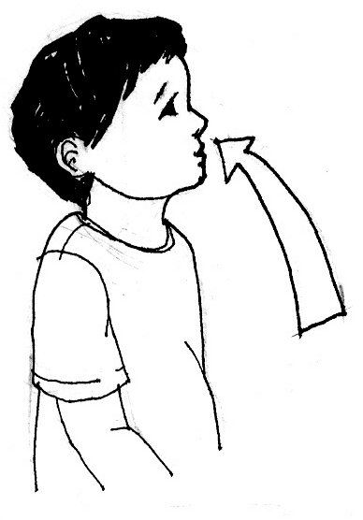

What waste materials does your body give off?

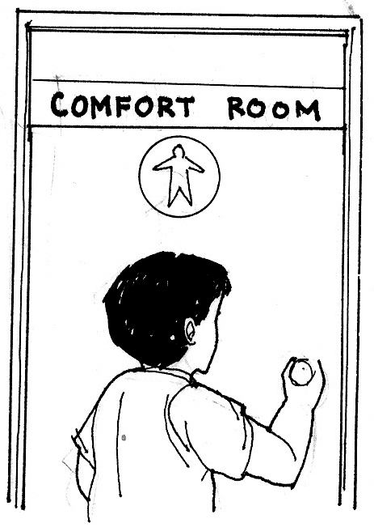

Explore

In this lesson, you will learn how different materials are transported to the different parts of your body. Write all your answers in your notebook.

Activity 1

1. Study the diagram very carefully.
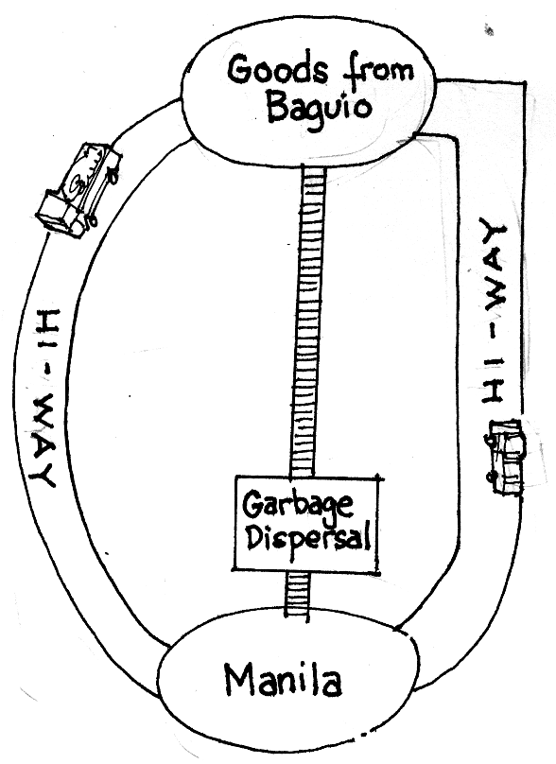

How do goods (vegetables) from Baguio reach Manila?
How are wastes from different houses brought to the Garbage Disposal Area?

Activity 2

Your body also has a transport system. This brings digested food and oxygen to different parts of your body. This also picks up waste materials like carbon dioxide from the different parts of your body and brings these to the kidneys and lungs.

Study the illustrations below.

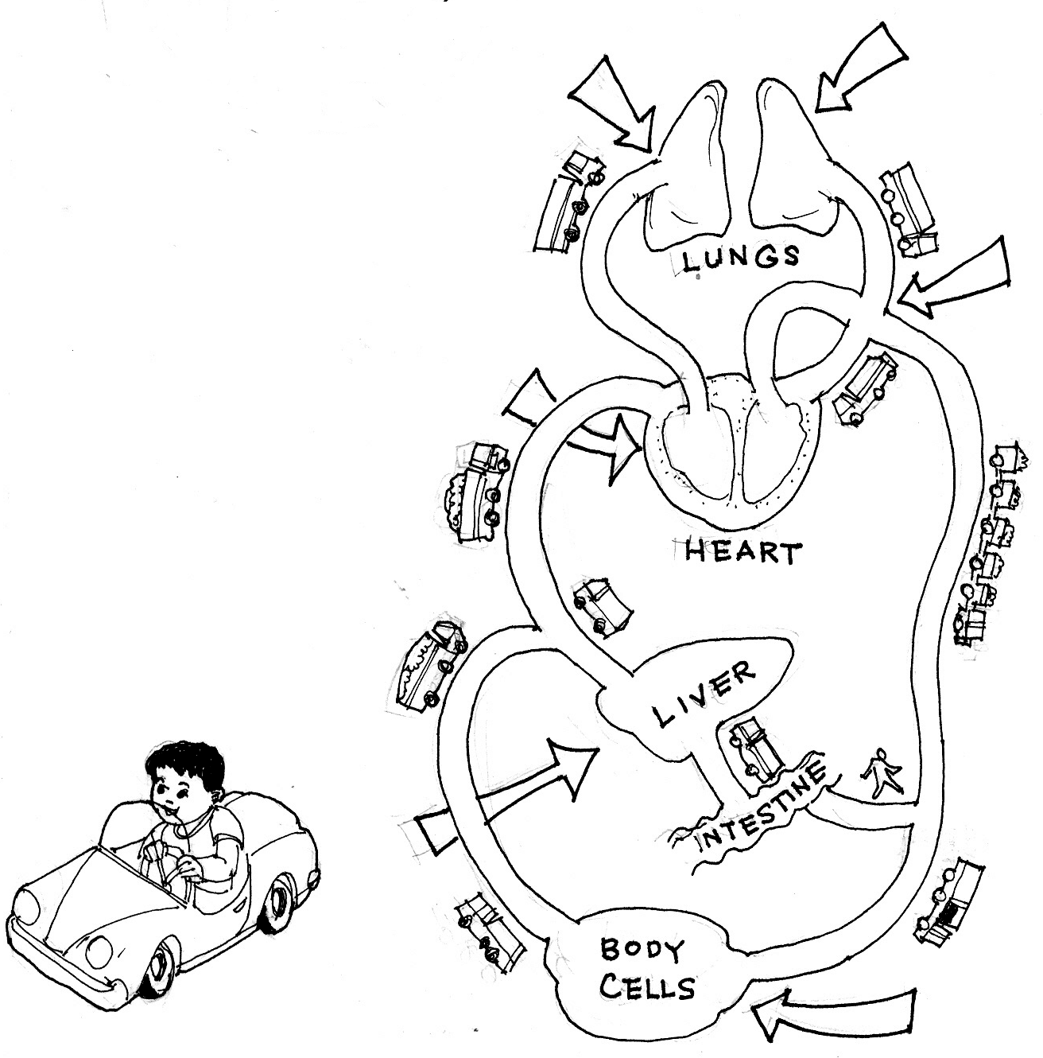
Blood loses carbon dioxide, red cells pick up oxygen
Little oxygen in blood, lots of carbon dioxide

Blood rich in oxygen

Heart pump blood

Extra food is stored ready for blood use needed

Food and oxygen is removed from the blood, carbon dioxide goes into the blood

Adapted from Science for Life 1991 by Jesuitas P., et. al.
Anvil Publishing, Inc. Pasig City, Philippines

Activity 3

This is your transport system. It is also called the circulatory system.
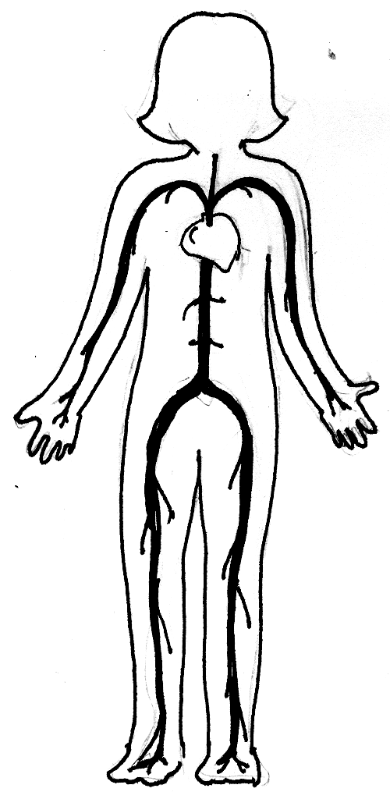

Heart

Blood (inside
the blood vessels)

Blood vessels

What are the major parts of your circulatory system?

1.
2.
3.

Read and learn more.

The human circulatory system is the transportation system of the body.

It performs many important function such as the following:

- carries food and oxygen to each of the billions of the body cells.
- removes waste products that each of the body cells produces.
- contains special chemicals that fight disease.
- contains special cells that migrate among the body cells and engulf foreign matter such as bacteria.
- contains other cells that promote clotting where a blood vessel is broken or cut.
- helps regulate body temperature by distributing heat generated in the body cells.
- blood plasma provides a ready supply of water for maintaining proper cell function and removes excess water that accumulates among the cells.
- the blood transports nutrients, and enzyme, and other materials throughout the body. And collects body waste from cell.

I LEARNED THAT:

- The major parts of the circulatory system are heart and blood vessels.
- The heart is located at the center of the chest cavity.
- The human circulatory system transports nutrients and enzyme throughout the body.



Apply It

What do you think will happen if one of the organs of the human circulatory system is removed?



Test Yourself

*

- Complete the concept map on circulatory system.

Circulatory System
i
s

ma
de

up

o
f
works
as/by
works
as/by
works
as/by

Key to Correction

Try to Recall

Q - What materials does your body need?

A - Your body needs food and air (or oxygen).

Q - What materials does your body give off?

A - Carbon dioxide and urine

Q - What are the major parts of your circulatory system?

A - 1. heart
2. blood
- blood vessels

Apply It

When one of the organs of the circulatory system is removed, the body will not function normally and would lead to the death of human being.
If the blood is removed, no food and oxygen can reach the body cells.
If the blood vessels are removed, there are no passageways for the blood
to travel into the body cells.
If the heart is removed, nothing will pump the blood causing it to flow from the heart to the different parts of the body and back.

Test Yourself
Circulatory System
Blood vessels
heart
blood
i
s

ma
de

up

o
f
works
as/by
works
as/by
works
as/by
transporting nutrients, oxygen, and waste materials from the cells of the body
serve as pathways for the blood to travel around the body
pumps blood so that it can circulate around the body

