GRADE VI
THE BLOOD

At the end of the lesson, you will be able to:

- Identify the components of the blood
- Describe the functions of each part



Try to Recall

Name of the parts of the circulatory system as indicated by each number. Write the answers in your notebook.
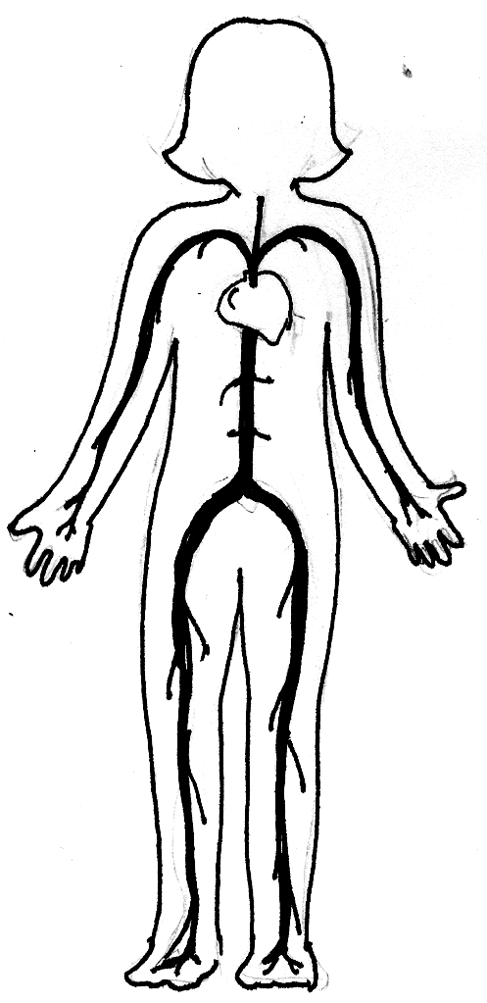

(1) ___________

(2) ___________

(3) ___________

Explore

What happens when you accidentally cut yourself? Blood comes out. Sometimes blood keeps on flowing because it continuously flows in your body. You need to stop the flow of blood.

Activity 1

Study the illustration below:

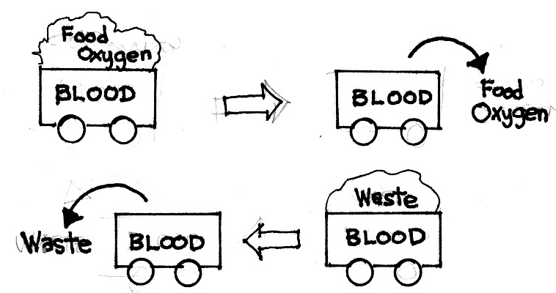
A

B

What does the blood carry with it in section A?
What does the blood pick up in section B?
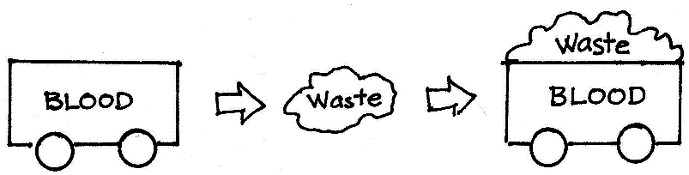

What body waste do you think is picked up by blood?

Activity 2

- The solid Parts of the blood

- Study the illustration of the solid parts of the blood.
- Read and learn more about them.

Red blood cells (Erythrocytes)
- are the most numerous and make up almost half of the blood’s volume.
- are filled with hemoglobin which gives the red blood cells its red color and enables them to carry oxygen from the lungs and deliver it to all body tissues.
- carry away carbon dioxide from the tissues and back to the lungs.
- are produced in the red marrow of the bones.
- are shaped like flat disk with two concave surface.

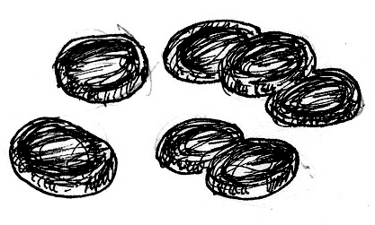

Red Blood Cells (RBCs)

White blood cells (Leukocytes)
- are fewer in number with a ratio of about 1 WBC to every 660 RBC.
- larger than the red blood cells.
- protect the body against infections by changing their shapes so that they can move through capillary walls and surround foreign organisms entering the body.
- produce antibodies to protect the body against diseases.
- are produced in the red bone marrow, and in the lymph nodes, tonsils, and spleen.

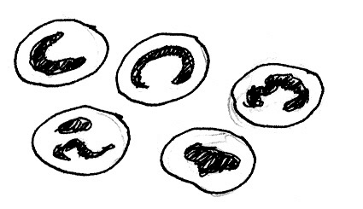

White Blood Cells (WBCs)

Platelets (Thrombocytes)
- are cell - like particles smaller than red or white blood cells.
- help seal the blood vessel and stop bleeding.
- release substances that help promote blood clotting with the help of vitamin K and calcium.
- are not really whole cells but are piece of larger cells formed in the bone marrow.
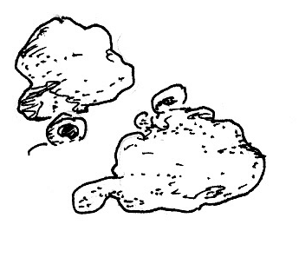

Platelets

- The liquid part of the blood

Plasma
- consists of mostly water containing dissolved salts and protein (mostly albumin and antibodies).
- sticky and straw colored.
- carries hormones, electrolytes, fats, sugar, minerals and vitamins to the body tissues.
- carries antibodies to fight disease -carrying germs.
- Carries cell wastes to the organ of excretion.

Directions: Copy this table in your notebook and fill up using the information from the reading above.

Parts/Components of the Blood | Function
1.
2.
3.
4.

I LEARNED THAT:

- The blood is a combination of liquid, cells and cell-like particles that travels through the blood vessels.
- The blood is made up of plasma, red blood cells, white blood cells and platelets.
- Blood delivers oxygen and essential nutrients to tissues/cells and carries away carbon dioxide and other waste products.
- Each part of the blood has its own function
- Plasma carries hormone, electrolytes, fats, sugar, minerals, and vitamins to body tissues antibodies to fight disease carrying germs; cell wastes to the organ of excretion.
- Red blood cells carry oxygen and digested food to all parts of the body; carry away carbon dioxide from tissue.
- White blood cells protects body against infection by producing antibodies.

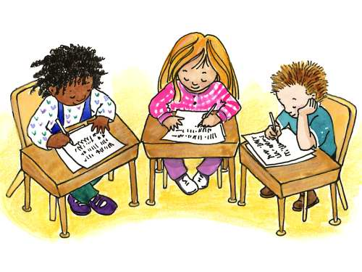

Apply It

Directions: Answer the following questions briefly in your notebook.

- Lina has a big wound. After a few seconds, it stopped bleeding. Can you tell why?
- What do you think will happen if your body lacks red blood cells?
- Why will people die if they lose too much blood?



Test Yourself

*

I. Match column A with column B. Write the letter of the correct answer in your notebook.

A B

_____ 1. Red blood cells a. fight germs that cause infections
_____ 2. White blood cells b. liquid part of the blood
_____ 3. Platelets c. provides the cells of the body with
oxygen and food nutrients
_____ 4. Plasma d. a red fluid within the blood vessel
_____ 5. Blood e. forms blood clot to stop bleeding
_____ 6. Hemoglobin f. red pigment of the blood containing
iron

II. Give three reasons why blood is vital to humans?

Key to Correction

Try to Recall

Answer (1 – heart; 2- blood vessels; 3 – blood)

Activity 1

The blood is like a truck. It brings food and oxygen to different parts of the body. It also picks up wastes on its way back.

Answer these

Parts/Components of the Blood | Function
1. Red blood cells | - contain hemoglobin which carry oxygen from the lungs and deliver it to body tissues  - bring oxygen to the cells and carry away carbon dioxide from the tissues
2. White blood cells | - protect the body against infections by changing their shape as they surround foreign bodies entering the body  - produce antibodies to protect the body against diseases
3. Platelets | - help seal the blood vessel and stop bleeding  - produces blood clot
4. Plasma | - carries hormones, electrolytes, minerals, vitamins, sugars, fats to body tissues  - carries antibodies that fight disease - causing germs

Answer in Apply It:

- Lina’s wound stopped bleeding because of the action of platelets present in the blood. Platelets help seal the injured blood vessel by producing a substance that helps blood to clot.
- If the body lacks red blood cells, the body cells will receive insufficient supply of oxygen and food nutrients.
- People will die if they lose too much blood because nothing will bring oxygen and food nutrients to the body cells. Wastes will accumulate in the body that could poison the cells.

Answer to Test Yourself

- c
- a
- e
- b
- d
- f

