GRADE V

**PROTECTING THE ENDANGERED SPECIE**

At the end of the module, you should be able to

* *Identify animals that are considered endangered*
* *State ways to protect endangered animals*



Recall the three classifications of animals according to the food they eat. Write the answer in your notebook.



|  |  |
| --- | --- |
| 1. | 6. |
| 2. | 7. |
| 3. | 8. |
| 4. | 9. |
| 5. | 10. |

**Explore**

## **Try to Recall**



There are different kinds of animals. Animals are grouped together according to closely similar in appearance and structure. Each group of animals that are genetically similar is called species

A specific becomes extinct when it last member dies. Species made up of only a few small population living in restricted areas (e.g. calauit island in Palawan) and may possibly become become extinct is called endangered species. In the Philippine certain animals are included in the list of endangered species.

**Activity 1**

Read each short paragraph carefully. Copy this table/grid in your notebook. Then fill it up based on your reading.

|  |  |  |
| --- | --- | --- |
| Name of Endangered Animal | Description | Other names |
|  |  |  |

The ***Philippine Eagle*** is one of the largest birds in the world. It lives in the rainforests of Isabela, Leyte and Mindanao. With an estimated population of 100 to 300 today, the Philippine eagle is in danger of extinction. It is one of the 400 exotic bird species in the Philippines, which if not protected, will become extinct.

[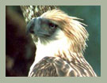](javascript:;)

**Philippine Eagle**

[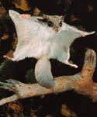](http://www.isidore-of-seville.com/viewer/viewer.html?http://wonderclub.com/Wildlife/mammals/flyingsquirrel.htmlluxfiathttp://wonderclub.com/Wildlife/mammals/images/flying-squirrel.jpgluxfiat200luxfiat271)

The ***flying lemur*** is a mammal that does not have wings but it can glide acoss 100 meters of space in a single leap. In Mindanao, people call it **“*kagwang”****.* Around the world it is known as colugo or the flying lemur. Zoologists, however, claim that it does not fly and it is not a *lemur*. The continuous denudation of the tropical forests in the country threatens the remaining population of “kagwang”, which used to abound in the wilderness of Basilan, Leyte, Samar, Bohol, and Mindanao.

**Flying Lemur**

Scientists refer to ***sea turtles*** as the only living remnants of the dinosaur age, but maybe not for long. Unless sincere efforts are undertaken, sea turtles might follow the dinosaurs into extinction. Sea turtles, popularly known as ***pawikan*** are found in Palawan.



**pawikan**

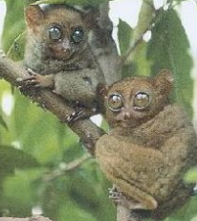

The ***tarsier*** is considered as the world’s smallest primate. It measures about twelve centimeters in length. Its two big eyes cannot move so it has to turn its head 180 degrees to look at objects elsewhere. It is found Samar, Leyte, Bohol, and Mindanao got its name from its elongated tarsus bone.

**tarsier**

People used to call Mindoro as the “Land of the Tamaraws.” Today, the ***tamaraws*** in the province are in danger of extinction, and Mindoro might lose the symbol that it once proudly introduced to the world. While it shares many similarities with the carabao, the Tamaraw is most known for its horns, with a “V” form, unlike the horns of a carabao, which take a curved shape.

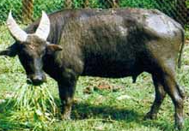

**butanding**

The locally known “***butanding***” is considered as the largest fish in the world. A group of 40 whale that visit the waters of Donsol, Sorsogon from November to May annually.

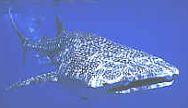

**tamaraw**

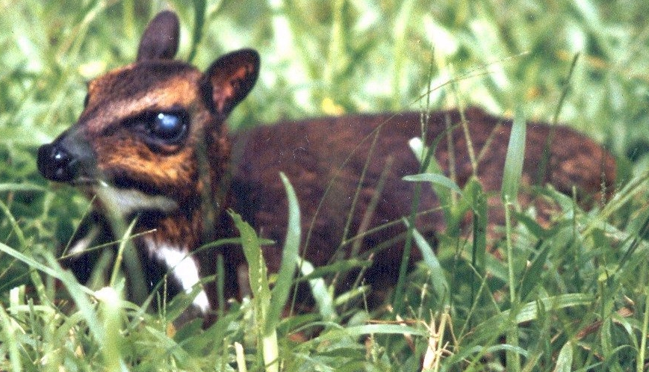

South of Palawan lies the Balabac Island, home of the world’s smallest hoofed mammal, the **Philippine mouse deer**. Locally known as **pilandok**, it stands only about 40 centimeters at its shoulder level.

**Philippine Mouse Deer**

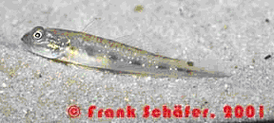

The world’s freshwater fish was discovered in lake buhi Camarines Sur. The ***dwarf goby*** (Pandaka pygmea) measures 1.2 centimeters or less than half of an inch. This tiniest known vertebrate is also called “*sinarapan*”.

**Dwarf Goby**

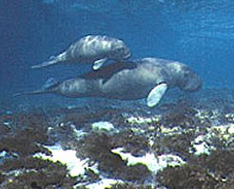

***Dugong*** or ***sea cow***, is the only herbivorous marine mammal. It is often sighted near Palawan province and southern Mindanano. It feeds on sea grass so it is often found at the sea bottom.

**Sea cow**

Endangered species need our help. We have to do something in order to protect them. Study the list of practices in the box. Choose the practices that will help in protecting our endangered animals. Copy the topic map in your notebook. Write your answer in the box.

a) Throw trash in the rivers.

b) Do not hunt animals for fun.

c) Stop cutting trees in forest.

d) Abide with laws that protect animals.

e) Sell animals to animal collectors.

f) Do not take animals away from their natural habitats.

g) Stop making bags, shoes, and other articles out from animal skin.

h) Do not sell animals to restaurants that serve exotic food.

Ways to protect endangered species

Answer the following questions in your notebook.

1. What animals in the Philippines are considered endangered?
2. Where are these animals found in the philippines?
   1. tamaraw
   2. dugong
   3. tarsier
   4. pawikan
   5. monkey eating eagle
3. Why are these animals considered endangered?
4. What do you think will happen if endangered animals are not protected?

5. What are some ways to protect endangered animals?

Read and learn more.

Animals that are in immediate danger of extinction are called **endangered animals**.

Other endangered animals are:

**Philippine Bamboo bat**. It is considered as the world’s smallest bats. This bat measures about 4 centimeters in length and has a wingspan of 15 cm. and weighs 1.5 grams.

**Giant flying fox** and the **Golden brown flying fox**. They live in the virgin forests of Subic Bay and Bataan.

**Calamian deer**. It is found in Calamian, Palawan and said to have longer and darker legs, compared with other hog deer.

**Palawan bearcat**. This is neither a bear or a cat. Known in the Southeast Asia as **binturong** it is found in the forests of Palawan, Borneo, Burma and Vietnam. It has thick and black fur which hunters use for making clothes and caps.

**Philippine cockatoo**. It is one of the most endangered species of birds. It is exotic and it also called **Kalangay**. They are known for mimicking human voices.

Most species become extinct because people destroy their natural habitat by converting it into farmlands, highways or subdivisions. Wildlife should be saved. The proper protection given to them will ensure the survival and growth of most of them.

The following are ways of protecting the endangered animals:

* preserving the wildlife habitat
* allotting lands to be made into parks or animal habitat
* following the laws that regulate hunting and fishing
* building habitats closely similar to the natural habitat of the animals

**I LEARN THAT:**

* Species is a group of animals closely similar in appearance and structure
* Some animals in our country belongs to endangered species.
* Some Philippine animals that belong to endangered species are Philippine Eagle, flying lemur, pawikan, tarsier, tamaraw, butanding, pilandok, dwarf goby, dugong.
* Endangered species must be protected to avoid their extinction.
* There are different ways of protecting endangered species.

## **Apply It**



A. Do you know the different endangered animals in the Philippines? Find out by answering the crossword puzzle below. Copy this in your notebook.

2

**T**

1

**B**

4

**D**

3

**P**

5

**T**

6

**P**

Across:

1. local name of whale shark found in Donsol, Sorsogon
2. P _ _ _ _ _ _ _ pygmea; locally known as “sinarapan” which is found in Camarines Sur is the world’s smallest fish.

5. smallest primate with big eyes.

6. said to be the only living remnants of the dinosaur age.

Down:

2. endangered animal found in Mindoro that shares many similarities with the carabao.

4. seacow found in Palawan and southern Mindanao

1. Complete the topic map below by writing the different ways of protecting the endangered animals.
2. Read each situation and answer the question briefly

1. Your mother would like to buy you a bag made of Palawan bearcat’s fur. What will you say to your mother? Why?

2. As a grade five pupil, how can you help in protecting the endangered animals?



## **Test Yourself**

A.Write the letter of the correct answer in your notebook.

1. What is one of the worlds largest bird?

A. chick-eating eagle B. monkey-eating eagle C. bear-eating eagle

D. falcon

1. What is the local name of the flying lemur?

A. kagwang B. tamaraw C. dugong D. pilandok

1. What is the smallest bat in the world?

A. giant flying fox B. golden brown flying fox C. Philippine bamboo rat

D. kalangay

1. What is the largest endangered land animal in the Philippines?

A. dugong B. pawikan C. tamaraw D.spotted deer

1. What is the world’s smallest freshwater fish?

A. bangus B. pandaka pygmea C. gloriamaris D. biya

B. Study each set of pictures below. Which of the pictures show how to protect endangered animals? Why? Write the answers in your notebook.

B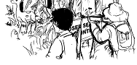

A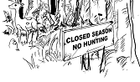

1.

B

A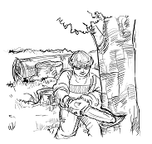

2.