DISSOLVING A SOLUTE IN A SOLVENT
GRADE V
ANIMALS WITH BACKBONES: THE VERTEBRATES

At the end of this module, you should be able to:

- describe the effect of stirring materials that are mixed,
- describe the effect of temperature on materials that are mixed,
- describe the effect of size of solid particles when mixed with and other materials.



Try to Recall

A. Study each mixture below. Identify the mixture in each set. Write the answer in your notebook.

Mixture | Solute | Solvent
1. sugar + water
2. cement + water
3. 10 ml water + 20 ml alcohol
4. vinegar + salt
5. calamansi juice + sugar

- Match the materials in column A with the description in column B. Write only the letter of the answer in your notebook.

A | B
1. sand and alcohol | a. The particles of the two materials cannot be distinguished from each other.
2. water and baking soda | b. The mixtures is cloudy.
3. face powder and flour | c. The solute settles at the bottom of the mixture.

Explore

Activity 1

- Prepare two drinking glasses half-filled with water.
- Put one teaspoon of salt into each glass.
- Stir the water in one glass. Do not stir the water in the other glass.
- Observe what happens.
- Answer the following questions. Write the answers in your notebook.

- In which glass of water did the salt dissolve faster?
- What do you think will happen if you did not stir the water in the other glass?
- What made the salt particles dissolve faster? Why do you think this happened?

Activity 2

  - Fill half of a drinking glass with cold water.
  - With the help of an adult, fill half of another glass with hot water.
  - Place one teaspoon of sugar in each glass.
  - Observe what happens.
  - Answer the following questions in your notebook.

- In which glass did the sugar dissolve faster?
- What made the sugar in one glass dissolves faster than sugar in the other glass?
- What factor affects the sugar to dissolve faster in one glass?

Activity 3

1. Prepare two drinking glasses, a teaspoon of powdered soap, and a small piece from a detergent bar.
- Place equal amounts of water in the glasses.
- Put the powdered soap in one of the glasses and the piece of detergent bar in the other glass.
- Observe which solid dissolves faster.
- Answer the following questions. Write the answers in your notebook.

Read and learn more.

Substances have different reactions when mixed in water. Some substances like sugar, coffee, milk, and salt spread evenly when mixed with water.

Several factors affect the way solute dissolves in a solvent. These are stirring, crushing, and heat energy.

Stirring or shaking a substance with solutes makes its solid particles dissolve faster. Stirring causes the surface of each tiny particle of such substances as sugar, and coffee to be pulled away by the water. Substances dissolve faster when the surface of each tiny particle comes in contact with water.

Crushing a solid solute into smaller pieces makes it dissolve faster. Materials in powder form such as powdered soap and rocky salt dissolve faster than the same materials that are in solid or compact form.

Heat energy affects how a solute dissolves in a solvent. Heat increases the temperature of the solvent and the solute (such as hot water), caused the particles of such substances as sugar to move faster. As the motion of the solute and solvent increases, there is also a greater chance for the solvent and solute to come into contact with each other.

I LEARN THAT:

stirring or shaking causes solid particles to move faster resulting in greater contact or even collision of the particles of the solute and solvent. When this happens, the solute dissolves faster in given solute.

- crushing, cutting or grinding reduces a solute into smaller pieces. When a solute’s the surface area is small, it is easier for the solute to make contact with the solvent, making dissolution faster.

- an increase in temperature (heat energy) will result in faster movement of particles. When this happens, the possibility of contact between the solute and the solvent increases, resulting in faster dissolution of the solute in a given solvent.

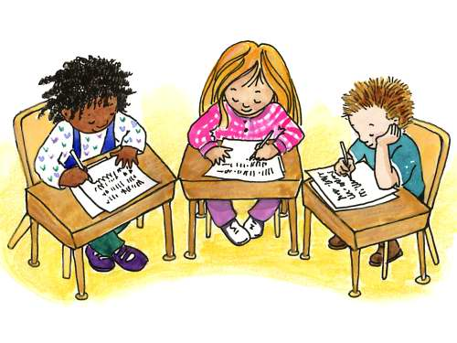

Apply It

A. Identify the condition that will make the solute in each mixture below dissolve faster. Write stirring, crushing, or using heat energy in your notebook.

  - Cube seasoning and water
  - powdered milk and water
  - salt and water
  - instant coffee and water
  - sugar and buko juice

B. Read each situation below. Then Answer the questions. Write the answers in your notebook.

- Mother asked you to prepare a glass of milk for your younger brother. After putting a teaspoon of sugar into the glass, you noticed that the sugar particles are still there. What should you do to make the sugar dissolve faster?

- In your EPP class, your group was assigned to cook fish sinigang. Your teacher asked you to use rock salt instead of salt. What should you do to the rock salt so that it would dissolve faster in your sinigang?

- Mario was asked to dissolve some of flour in water. What kind of water should he use to make the flour dissolve faster? Why?

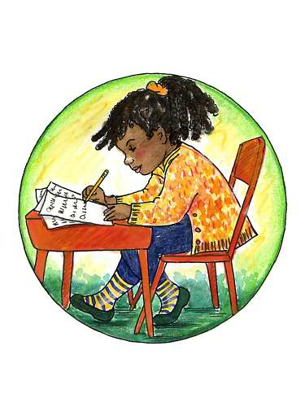

Test Yourself

A. Identify which mixture below needs stirring, crushing, and heat energy to dissolve solutes faster. Write the answer in your notebook.

- solid sugar and water
- rock salt and water
- sugar and calamansi juice
- powdered milk and water
- flour and water
- salt and water
- instant coffee and sugar
- powdered soap and water
- solid chalk and water
- solid alum (tawas) and water

B. Read each situations below then answer the given questions. Write the answer in your notebook.

1. Aling Nora sells cold buko juice in the school canteen. Everyday, she prepares jugs of buko juice for the pupils. For each jug, she mixes sugar, buko meat, milk, and water. What do you think should Aling Nora do so that the sugar she uses would dissolve faster?

- Ramon would like to soak his white uniform in water with powdered detergent. He found out that he no longer had powdered detergent. All he had was a detergent bar. What should he do so that the bar would dissolve faster?

