GRADE IV
ANIMALS WITH BACKBONES: THE VERTEBRATES

At the end of the module, you should be able to:

- identify the animals in each group of vertebrates; and
- classify animals into different groups of vertebrates.



Try to Recall

Find out the different characteristics of animals around you. Answer each riddle below. Choose the answer from the pictures. Write your answer in your notebook.

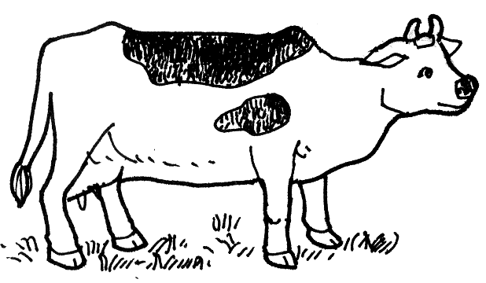

- I live in water and I have gills for breathing. My body is covered with scales.
I have fins that help me move and keep my balance. What am I?

- I spend part of my life in water and part of my life on land. I have gills for breathing but they will soon be replaced by a pair of lungs as I grow older. What am I?

- I have lungs as the main organ of respiration and I have dry scaly skin.

- I have wings for flying. My skeleton is made up of strong but light bones. I have legs for walking or running.

5. I eat grass. I feed my young with milk. I have lungs for respiration and four legs for walking or running.

Explore

Did you guess the riddles correctly? What do you think the five animals have in common?

Each of them have a backbone. All animals with backbones are called VERTEBRATES. Find out more about the different subgroups of vertebrates and their characteristics.

Activity 1. Read each short paragraph. After reading each paragraph answer these questions

- What covers their body?
- How do they move?
- How do they breathe?

Hello kids! I am Mr. Kangaroo. I belong to the sub-group called mammals. Mammals have fur or hair and mammary glands. Actually, our group’s name originated from the word mammary although only the females produce milk and feed their young. Most of us mammals are developed inside our mothers’ womb.

Hi there, boys and girls! I am Henny, a hen. I belong to the sub-group known as birds. A birds body is covered with feathers. You think of birds as fliers, don’t you? However, I seldom fly. I usually walk or run. A bird uses its feet for scratching the ground, perching on trees, or swimming.

I can also live in water because of body structure. I have raised nostrils and eyes. I also have fleshy value at the back of my mouth that prevents water from entering the lungs when my mouth is open.
My thick dry scale body covering can protect me against harm and prevents loss of water.

Do you know me? I am Nemo. I belong to the fish group. Among the vertebrates, only fishes breathe through gills so we can live in water. Our bodies are covered with scales, which are suited to our aquatic environment, and our eyes are always open.

What’s up kids? I’m Mr. Froggy, a frog. I belong to the sub-group of amphibians. I usually spend part of my life in water and part on land. I hibernate in cold weather by burrowing in the ground or in mud. When young amphibians breathe through our gills but adult amphibians develop lungs in order to live on land.

Activity 2
- Copy the following figures in your notebook. Fill in each empty box with the different characteristics of the indicated subgroups of vertebrates.

Birds

Reptiles

Fishes

Fishes

Mammals

- Classify the following animals into 5 subgroups of vertebrates based on the information given about the out subgroups.

crocodile maya tiger monkey
pig frog tilapia monitor lizard
horse alligator woodpecker goat

- Read and learn more.
Animals with backbones are called vertebrates. There are five subgroups of vertebrates namely, amphibians, reptiles, birds and mammals.

Fishes live in water and take air and food from their surroundings. They have gills for breathing. They reproduce is either by internal or external fertilization of the egg. Internal fertilization occurs in a female reproductive tract. The sperm cell enters the female body to meet the egg cell to produce living organisms. External fertilization occurs when the sperm cell and egg cell unite without physical contact with the mate. The union of the egg cell and sperm sell occurs outside the body of the animal. Their body temperature changes with the environment. Therefore, they called cold blooded. Some examples of animals under this group are milkfish (bangus) mudfish (dalag), tuna and galunggong.

Amphibians have moist, smooth skin that must remain moist in order to survive. Their moist skin allows exchange of gases. They have strong legs for walking, leaping, and swimming. The male amphibians fertilize the eggs laid by the female amphibians; thus, fertilization is external. When young they breathe trough gills and as adults they breathe through their lungs. They are also cold blooded animals. Some examples of this group are frog, lizard and salamander.

Reptiles are terrestrial animals that lay eggs. Their bodies are covered with horny scales or plates which are waterproof. Reptiles have lungs for breathing. Their body temperature changes with that of their surrounding and are therefore cold-blooded animals. Examples of reptiles are crocodile, alligator, sea turtle (pawikan) monitor lizard (bayawak) and snakes.

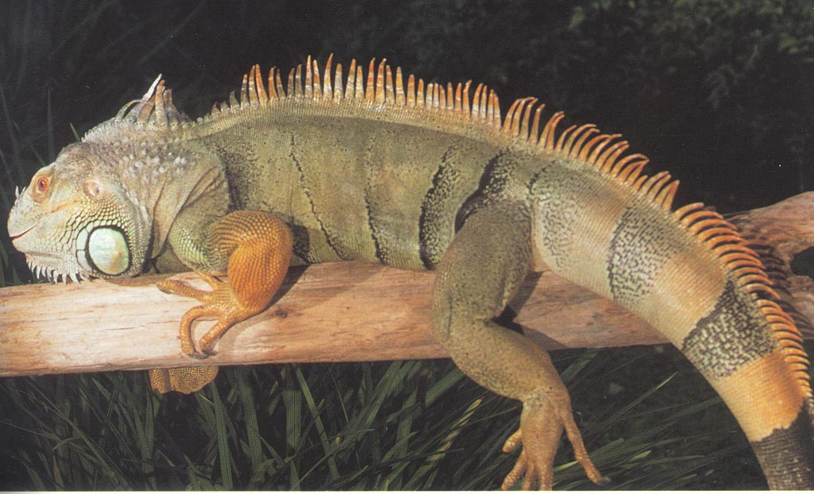

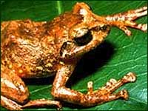
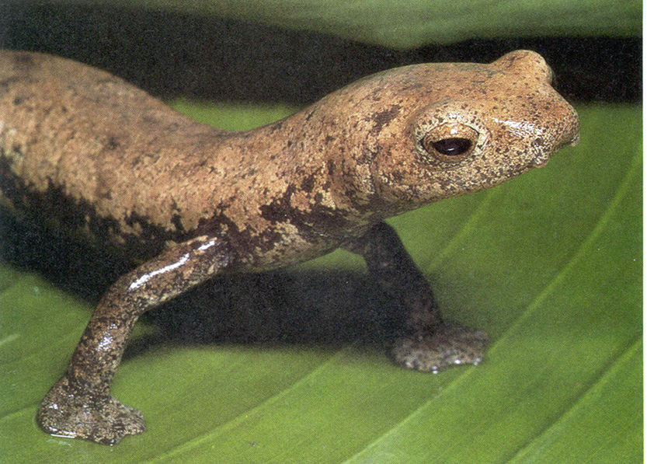

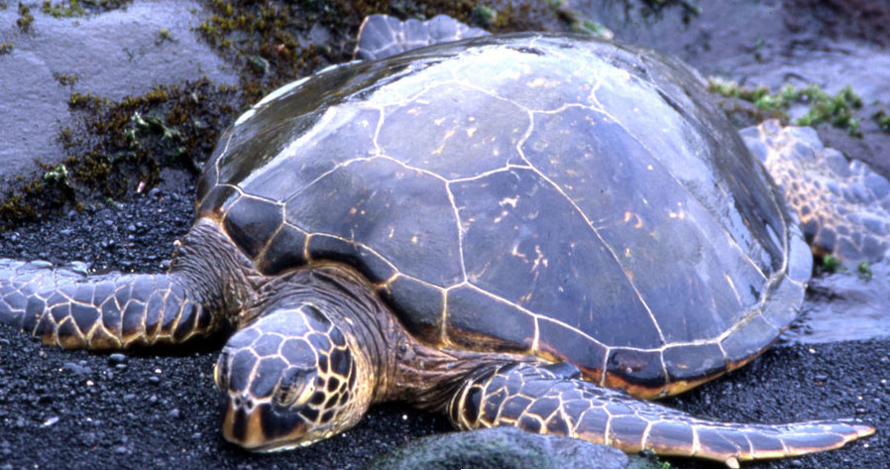

Mammals represent the most advanced group. They all have fur or hair and mammary glands. Mammary are usually born wholly formed. They develop inside the mother’s womb.

Mammals is the vertebrate groups to which men belong. Their skin are covered with fur or hair and have sweat glands. They breathe with their lungs. Young are born alive and are feed with secreted by mammary glands of the mother. This is the characteristic for where this subgroup is named. Mammals manage to live almost everywhere. Some examples of this subgroups are dogs, cats, rabbits, dolphins, whales and bats.

Birds are usually fliers, however, bird like chickens seldom fly. Some, ostriches, and penguin, cannot fly at all. The body of a bird is covered with feathers. Their bodies are suited for flight and they have hallowed bones that keep them light.

Mammals and birds are warm-blooded animals or animals whose body temperature remains the same even if the temperature of this environment changes. Reptiles, amphibians, and fishes are cold-blooded animals which mean their blood temperature changes as the temperature of this environment changes.

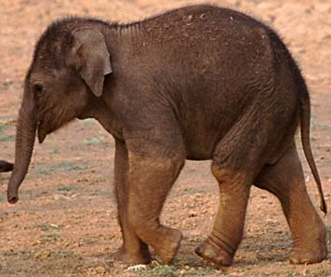
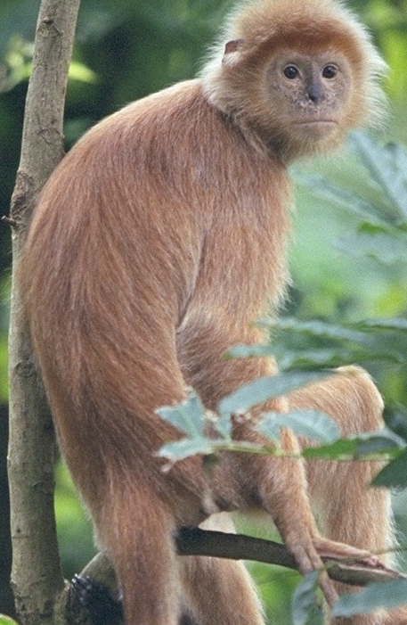

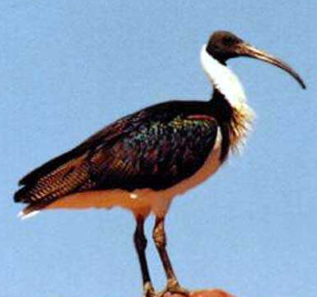
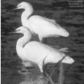

I LEARNED THAT:
- Animals with backbones are called vertebrates.
- Vertebrates are divided into five subgroups mammals, fishes, amphibians, reptiles, and birds.
- Fishes are cold-blooded animals. Among the vertebrates, only fishes breathe through gills instead of lungs.
- Reptiles are cold blooded animals with dry, scaly skin. They usually creep or crawl.
- Amphibians are cold blooded animals. Young amphibians breathe through their gills but adult amphibians develop lungs that allow them to live on land.
- Birds are warm-blooded animals. Most birds have horny beaks. Others have beaks of various shapes that are adapted to the kind of food they eat.
- Mammals and animals feed their young milk secreted by the mammary glands.


Apply It

- Identify if an animal below is a mammal, a fish, a reptile, an amphibian, or bird. Write the answer in your notebook.

1. | 6.
2. | 7.
3. | 8.
4. | 9.
5. | 10.
- Copy the flow chart like the one below in your notebook. Complete the first column of boxes with the five subgroups of vertebrates and the third column with their characteristics.

VERTEBRATES
1
5
4
3
2
Characteristics



Test Yourself

*
- Read each statement below. In your notebook, write true if the statement is correct. Write false if it is incorrect.

_____1. Mammals have dry and scaly skin.
_____2. Reptiles breathe by means of gills.
_____3. Female amphibians lay their eggs in water or in very moist places on land.
_____4. Fishes are cold blooded animals.
_____5. Mammals have fur or hair and mammary glands .
_____6. The eyes of most birds are located at the sides of their head.
_____7. Birds are cold-blooded animals.
_____8. The blood temperature of cold blooded animals stays at relatively the
same level.
_____9. Amphibians have gills but they develop lungs as they grow old.
_____10. Reproduction among fishes is done either by internal or external
fertilization of the egg.

- Classify each animal below according to its subgroup. Copy the table on page 12 in your notebook. Then write the names the animals in the corresponding columns. You may also draw the animals.

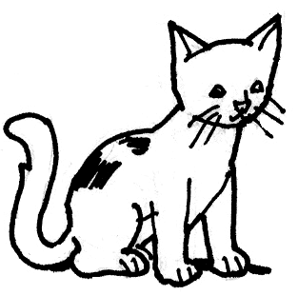

Mammals | Reptiles | Birds | Amphibians | Fishes

