GRADE VI
SOUND ENERGY

At the end of the module, you should be able to:

- Identify energy uses and sound



Try to Recall

Study the type of energy shown in each picture.
Identify whether it is electrical energy, light energy, chemical energy. There may be one or more answers.

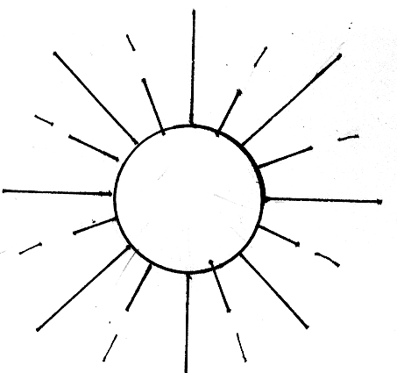
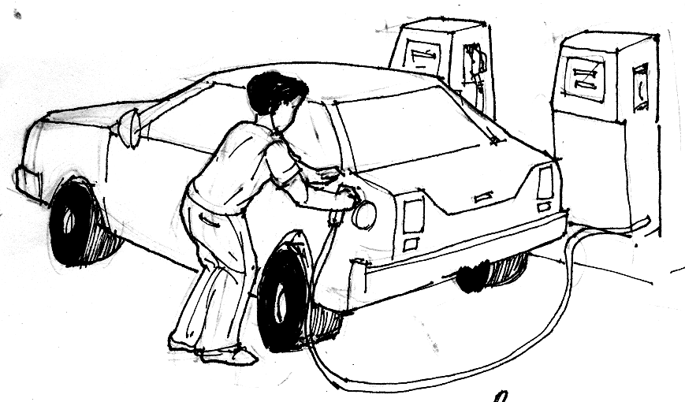

__________________ __________________
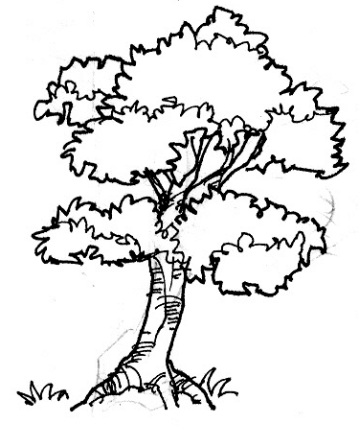
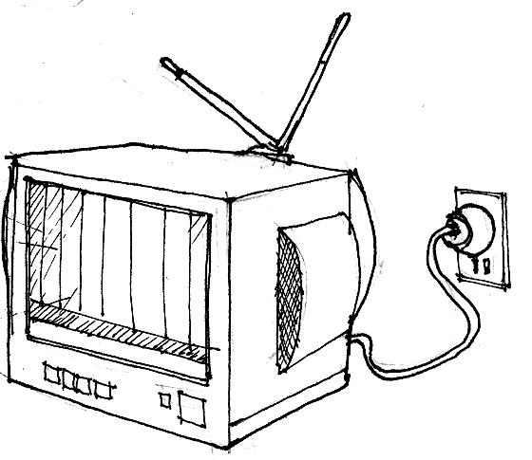

__________________ __________________

Explore

Close your eyes and listen. Name the sounds you hear. How many did you hear?

In this lesson you will learn more about sounds.

Activity 1

What you need:
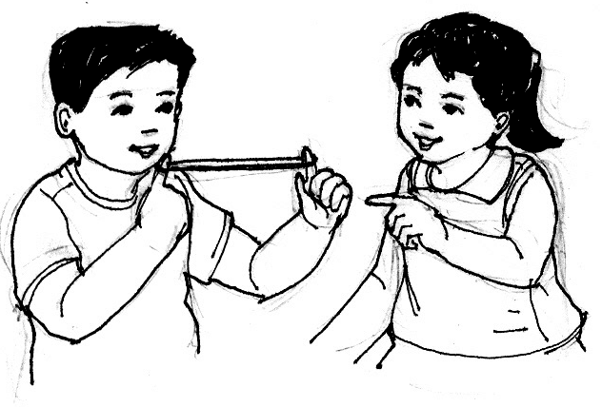
rubber band
fork and spoon

What to do:

- Get a rubber band. Stretch the rubber band tight with your fingers. Let your partner pluck the rubber band.
- Was sound produced?

- What movement was produced by the rubber band?

- Use shorter rubber band. Was the sound produced louder? softer? If you use longer rubber bands, what kind of sound is produced?

Did you know that…

sound is a form of energy that causes molecules of a medium to vibrate back and forth.

vibration is the back and forth, up and down motion of an object.

Activity 2

What you need:

cloth or balloon small pieces of paper
grains of sand can or bowl
rubber band stick

What to do:

- Wrap the mouth of the can or bowl with a cloth or balloon.
- Secure it with a rubber band.
- Sprinkle small pieces of paper or grains of sand on top of the cloth or balloon.
- With a stick, slowly tap the cloth. Then tap it with a stronger force.
5. Observe.

Answer these:

- What happened to the pieces of paper/grains of sand?
- What caused the pieces of paper/grains of sand to move?
- When did the pieces of paper/grains of sand move faster?
- When the pieces of paper/grains of sand moved fast, what was the kind of sound produced?
5. How can you relate force, vibration and sound produced in this activity?

Activity 3

What you need:

8 identical pep bottles
drinking straw (Waxed paper straws work better than plastic)

What to do:

- Fill eight identical bottles with different amounts of water as shown. Number the bottles 1 to 8.
- Which bottle has the longest length of air (more air inside).
- Blow across the lips of the bottles.
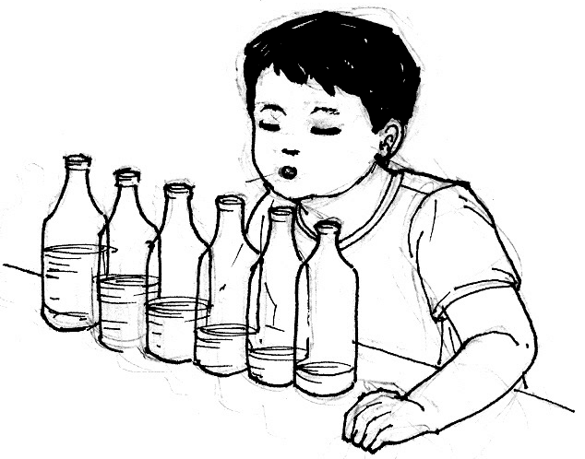

- Do all bottles give off the same sound?
- Which bottle produced the highest note? The lowest note?

- Arrange the bottles to make a musical scale from the lowest to the highest note.
- What can you say about the length of air space and the sound produced?
- Show the relationships.
longest space of air = ______ sound is produced
shortest space of air = ______ sound is produced

Activity 4

What you need:

a meterstick a big pail or can of water
a pencil 2 rocks

What to do:

- Get a meterstick and a pencil.
- Hold the meterstick close to your ear. Have a partner scratch the other end of the meterstick with a pencil.
  - What happens?
- Hold the meterstick away from your ear and repeat the activity.
- Did you hear a lesser sound?
- Where does sound travel faster?
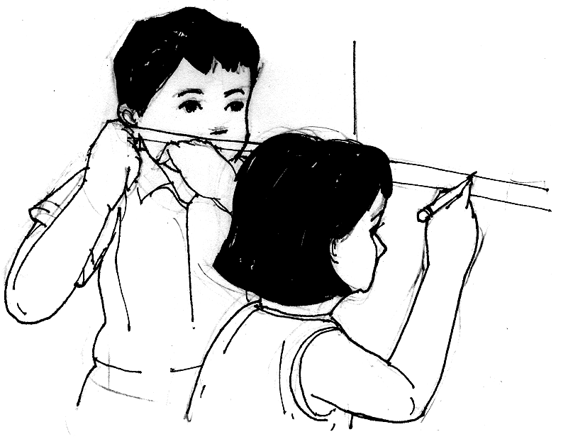

- Get a big pail of water. Get 2 pieces of rocks and hit them together under water. Now, hit them together out of water.
- Did you hear sounds when you hit the objects together? Why?
- Which sound was louder, in air or water?

Did you know that…

Solid is a better transmitter of sound than liquid. Liquid is a better transmitter of sound than gas.

Activity 5

List down different sources of sound. Identify some uses of these sound.

An example has been done for you.

- radio – listen to music

I LEARNED THAT:

- Sound is a form of energy that causes molecules of a medium to vibrate back and forth. It is used for communication and entertainment.

- Sound is produced by things that are moving or vibrating. When an object moves, it makes the air surrounding it vibrate. The vibrations are called sound waves. We hear sound when sound waves that are travelling through the air or another material reach our ears.

- Sound is transmitted through a medium.
- speed of sound in steel – 5,200 m/sec
- speed of sound in water – 1,500 m/sec
- speed of sound in air – 340 m/sec

- Some sounds are loud, soft, pleasant or unpleasant.

- Music is made up of sounds that are produced when people sing or when musical instruments are played. Music is used for entertainment and communication.

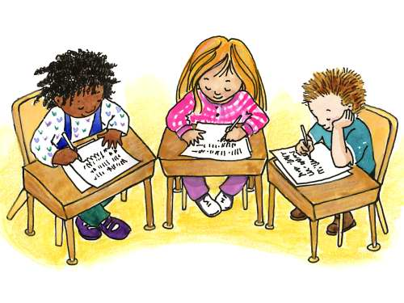

Apply It

What should a motorist do when he hears the sirens of an ambulance or a fire truck engine behind him?

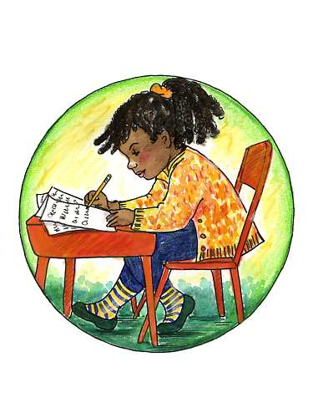

Test Yourself

*

Identify 5 sounds and describe the use of 3 of these sounds. An example is given below.

Key to Correction

Try to Recall

Exploration Time

Activity 1

Activity 2

Activity 3

Apply it

1.

2.

Test Yourself

- solid
- gas
- water
- fastest
- slowest

