GRADE VI
EFFECTS OF RAPID POPULATION GROWTH

At the end of the module, you should be able to:

- Explain how rapid population growth affects ecosystem



Try to Recall

- What kind of ecosystem is shown in each picture?
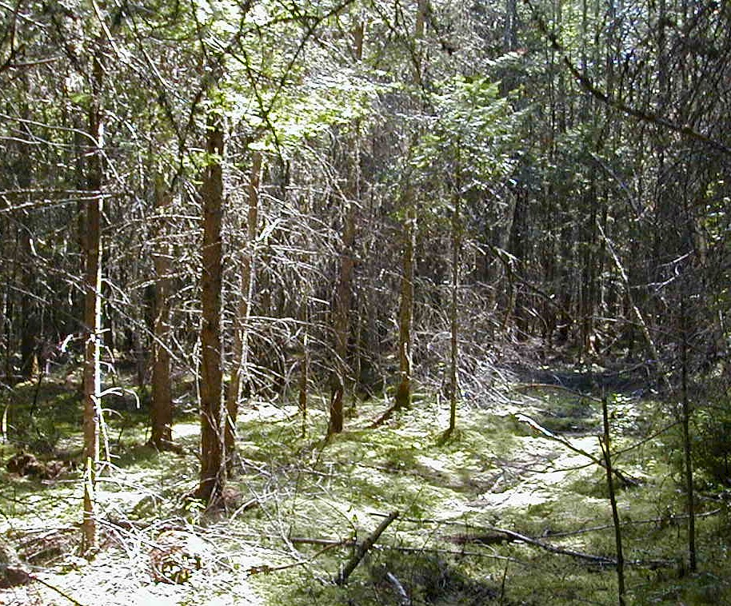
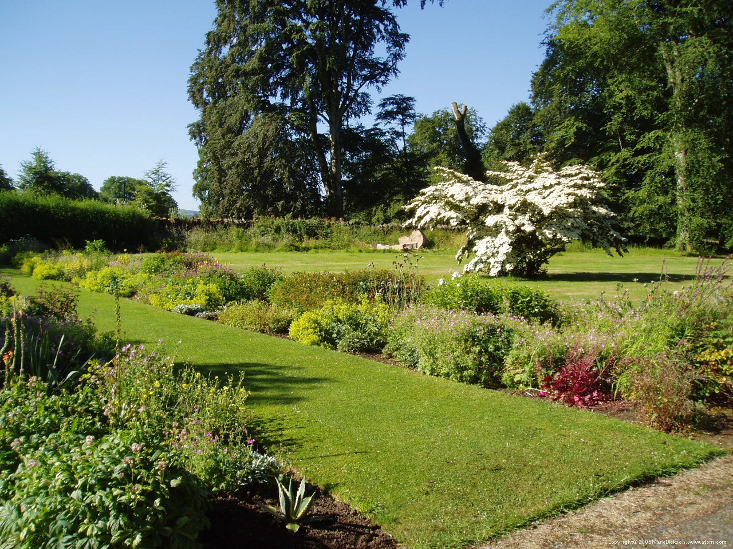

F__________T G__________N
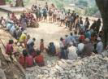
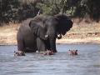

P_________D C_____________Y

2. What are the things interacting in each ecosystem?
3. What is common to all of the ecosystems?
- What is the term used to describe the number of organisms living in a place or ecosystem?

Explore

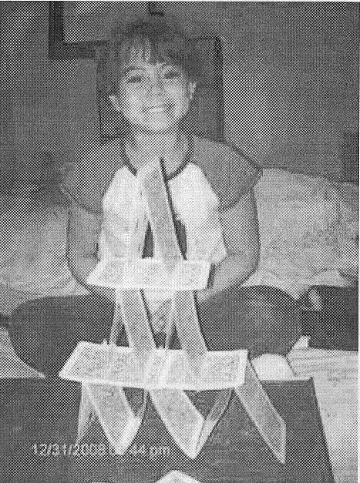

Activity 1: Card Pyramid

Prepare these Materials: deck of playing cards, paper, pencils

Procedure:

- Write names of plant or animal on slips of paper.
- Get a playing card to represent the plant and animal written on the slip of paper.
- Build a card tower using the playing cards. Plants should be at the bottom of the tower. Herbivores and carnivores the second and third levels of the tower.

Answer these:

Are there enough plants for the card tower?

- Reassign cards plants and animals names in order to build a stable structure?

Answer these:

Why many plants are needed?
What will happen if the plant population decreases and animal population grows rapidly?
How would this affects an ecosystem?

You learned what may happen to the ecosystem if these rapid population growth in certain organisms rapidly grows. Now let’s see what may happen to our bigger ecosystem if human population grows rapidly.

Activity 2

- Find out how fast the Philippine population is growing.
- Study the graph below to find the answer.
100

90

80

70

60

50

40

30

20

10

0



1980
1990
1995
2000
2005

Answer these:

1. What was the population in the Philippines in 1990?
2. Did the population from 1980 to 2000 increase? Describe how much is the increase.
3. If the population continues to grow, What would be the impact of rapid population growth to the environment?

Activity 3

Study the following pictures.

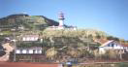 | 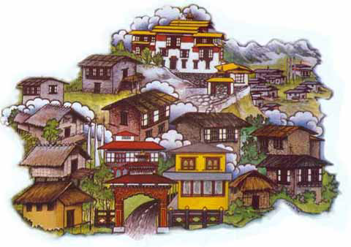

Barangay Maginhawa Barangay Masikip

Answer these:

- Compare the number of people in Barangay Maginhawa and Barangay
Masikip.

- What do you think will happen to the forest, river and land of the two barangays?

- Describe the space, food and water in each barangay.

- How does big population affect the environment?

- Which barangay would you prefer to live in? Why

Read and learn more.

- Population - is the total number of a group or groups of organisms belonging to the same species living in a place or given area.
- RPG or Rapid Population Growth - is a serious problem in our country today.
- Birth - refers to the number of babies born in a year.
- Death - number of people who die in a year.
- Migration - movement of people from one place to another.
- Immigrant - person who is a native of a certain country who comes to live in another country.
- Emigrant - person who leaves his country to settle in another place.
- When more babies are born each year and less people die, it leads to rapid population growth.
- Rapid Population Growth calls for an increased demand for food, water, air and space which leads to the imbalance of the environment.
- The increase in the number of people harms the living and non living things in the community. Food and space will become limited. The environment will become dirty because of too much waste dumped. There will be lack of oxygen because trees are already limited.
- The demand for basic necessities results in the generation of more waste and scarcity of food supply resulting to ecological imbalance.

I LEARNED THAT:

- Shortage of food, water and space may occur due to a rapid growth of population.
- Food, water, and air may become limited and eventually polluted due to overpopulation.
- Rapid growth of population has led to an increasing rate of using and spoiling of natural resources.

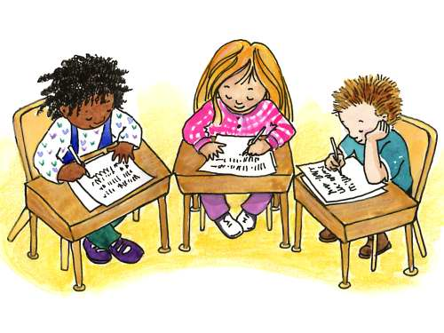

Apply It

- Philippines has a population of more than 100 million as of 2011. Population is projected to grow by 1.6% million per year. What possible effects will it bring to the environment?

- Read the story below.

In 1859, twenty-four rabbits were released near Geelong, Victoria, Australia. They multiplied rapidly. In Australia there were few numbers of predators and soon the rabbit became a big problem. The rabbits also built extensive underground warrens and stripped most of the vegetation in their area.

(Source adapted from Lofts and Marett, M, 1997)

Answer these:

How would this situation disrupt the ecosystem?
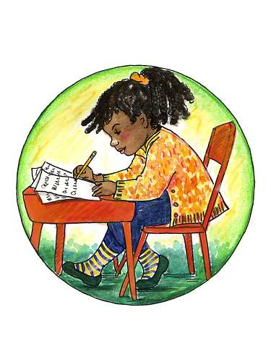

Test Yourself

*

- Read this story from India.

There were many snakes in the rice fields. The snakes fed on the mice which fed on the rice crops.
Many people killed the snakes, either out of fear or for their skin. As a result, the population of snakes decreased very fast.
With fewer snakes around, the population of mice increased greatly. Soon the population of rice plants decreased.

What do you think will happen next?
How does the increase/decrease in population affect the ecosystem?

- Study each picture. Write the effect of over population inside the corresponding box.

 |  |  | Effects to the environment
MORE | 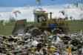
MORE  More people means | 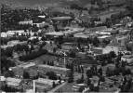
LESS | 
LESS | 