GRADE VI
GOOD EFFECTS OF CHANGES IN MATERIALS TO THE ENVIRONMENT

TO THE ENVIRONMENT

At the end of the module, you should be able to:

- Describe how certain changes in materials have good effects in the environment



Try to Recall

Materials undergo physical or chemical changes. Do you remember what physical and chemical changes are?

- PHYSICAL CHANGES

What happens when you perform each questions?

cutting of
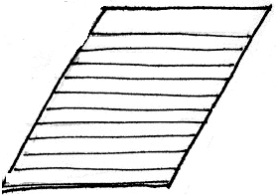

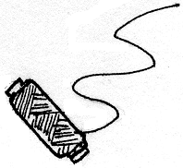

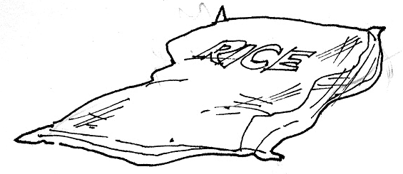

folding
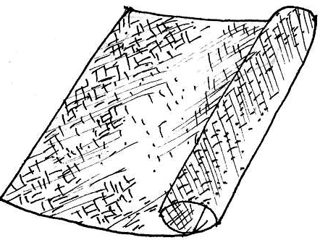

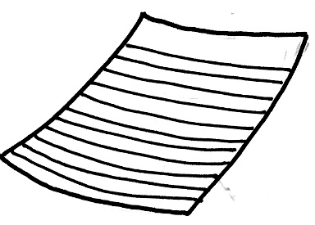

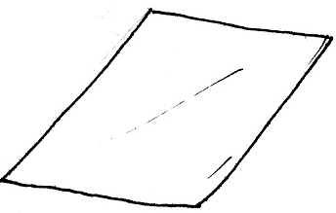

How do the materials change?

- CHEMICAL CHANGES

The following are ways of how chemical change happens.
  - Heating
  - Burning
  - Decaying
  - Cooking

Study the pictures below. You may choose which of the given ways above will cause change to these materials. Write the answers in your notebook.

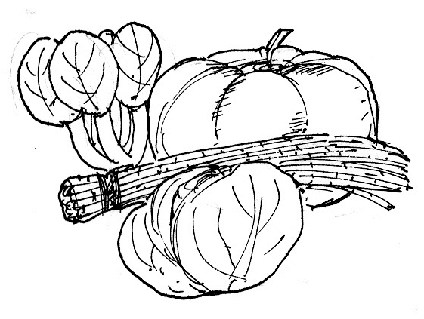

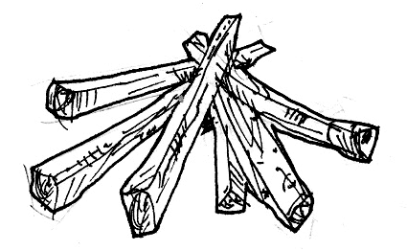

1. 3.

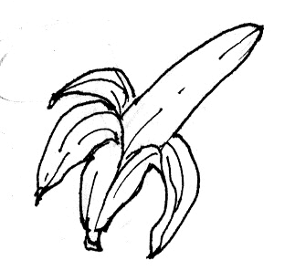

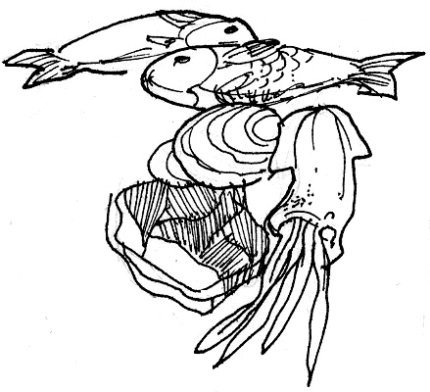

4.
2.

You have just finished answering the exercises about physical and chemical changes. Were you able to answer the questions correctly?

Whenever we cut materials such as a piece of paper, string or empty sack of rice, their appearance changes. The whole piece of paper will be divided into smaller pieces or sizes. The same thing will happen with string and empty sack of rice.

When you fold a piece of paper, a hankie or a mat, their size also changed from bigger to smaller. The change of these materials in their appearance is called physical change.

Explore

There are ways in which physical and chemical change may bring good effect to the environment. Considering our problem on too much garbage, recycling and composting could help to lessen this. Recycling is a way of reusing non-biodegradable materials instead of throwing them away and composting is also a way to recycle non-biodegradable materials.

Non-biodegradable materials are those which will not decay like glass, plastics, papers, cans, etc. while biodegradable materials are those which decay. Examples of these are fruit peelings, left over food, dried leaves and many more.

Are you ready now to recycle materials? Perform the activity below.

Activity 1

Do the following:

- Get four (4) small or medium-sized boxes or carton.

- Label each box with PAPER, GLASS, CANS and PLASTICS (see sample below).

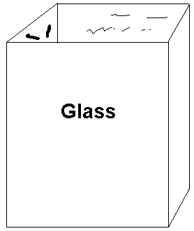

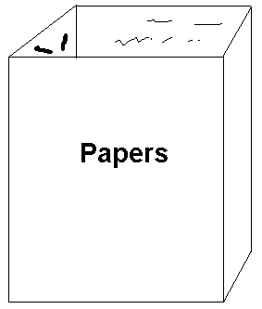

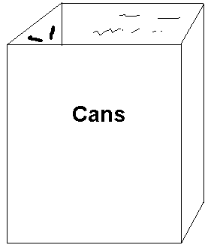

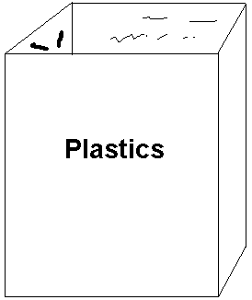

- Collect the trash that you can find in your house or in school and put them in the boxes that your have prepared.

How did you feel while collecting the garbage?
I know you’re happy to see a free garbage environment. You may now answer the following questions in your notebook.

- Why do you think it is good to separate materials like the way you did?
- What do you think will happen to the physical appearance of the following after recycling?
  - glass
  - papers
  - cans
  - plastics

- What kind of change will take place when the sized and shape of glass, paper, cans, and plastics will also change?
- Is recycling really bring good effect to materials in the environment?
_____________Why do you think so?

You have just finished activity 1 about “Recycling”. Were you able to answer the questions correctly? Read the paragraph below to verify if your answers are accepted.

A clean environment is a good place to live. A pile of garbage can be avoided if we know how to recycle glass including bottles of soy sauce, softdrinks, milk, etc.; papers such as old newspaper, magazines, etc.; cans of different goods; plastics; and many more. Instead of throwing all these in one garbage can or sack, we can help our garbage collector separate these materials for easy work. Glasses, papers, cans and plastics when recycled may change their shape, size or their physical appearance. This change is what we call physical change.

Recycling has really a good effect to materials in the environment. Through this, we can lessen the amount of garbage that pollute the air, and water.

You may proceed now to the 2nd activity.

Activity 2

In this activity, you will learn how composting may bring good effects in the environment.

Do you have any idea about composting? If you don’t have any, read the information below and look at the illustration of a compost pit to familiarize yourself.

Biodegradable materials such as leaves, food scraps, fruits and vegetables peeling can be placed in a compost pit as shown in the illustration. This process of change in the materials is called composting. Composting involves the breakdown of left-over food, leaves and other decaying materials with the presence of fungi, bacteria, earthworms and insects. The compost material now produces nutrients that are needed by plants to grow well. This chemical change in the biodegradable materials brings good effect in the environment. So you may practice composting at home instead of throwing biodegradable materials elsewhere.

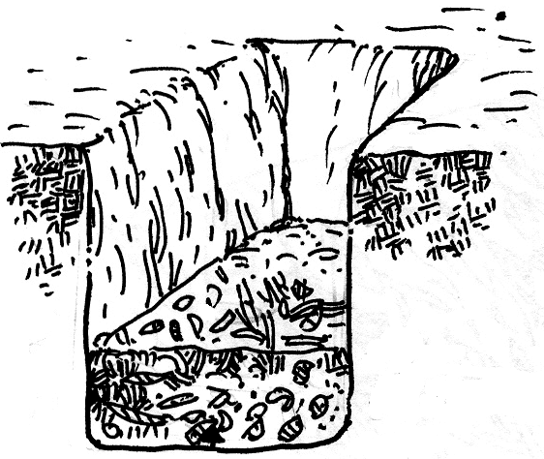

Answer the following questions:

- What garbage materials are good for composting?
- What makes composting important to the environment?

Activity 3

- Gather some clothes and study the materials which they are made from. What kind of changes has been these clothes undergo before they are made as such.

- Get some empty bottles of medicines. Find out from what materials are they from? What kind of changes has these materials undergo before they are made into useful medicines.

- Name other changes in materials that have been useful to effects humans.

Read and learn more.
- Changes in materials have good effects in the environment.
- Composting, recycling and the use of technology are some examples of the good effects of the changes in materials.
- Composting is a way of decomposing plant or animal matter into fertilizer. Recycling helps lessen garbage by reusing them like plastic, styrofoam and paper. Segregate or separate the biodegradable materials (objects that can decompose like left-over food, leaves, dead plants and animals and paper) from the non-biodegradable like plastic, styrofoam and metal. In the use of technology, man has benefited from it by having man-made materials and developments in farming and breeding. We have clothes, shelter, transportation and medicine because of changes in materials. Farmers now have better harvest and animals are healthier because of technology.
- Some changes in materials result to good effects in the environment.
- Composting produces fertilizer.
- Recycling lessens garbage.
- Technology gives us man-made materials like clothes, shelter, toys and transportation.

Read and learn more.
- Chemistry is the study of the way one substance can be changed into another – how it happens and why it happens.
- Much of our modern world is dependent upon the conversion of raw materials into useful products.
- Whether the products are processed food in the market, clothing, cars or medicines, all exist because we have learn how to change less useful substances into more useful ones.

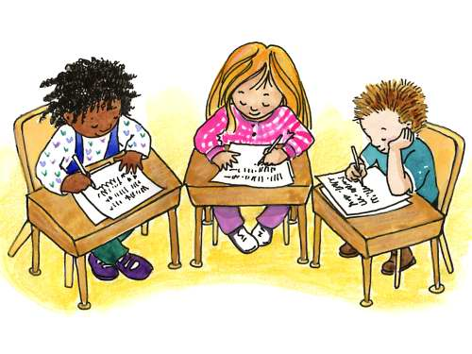

Apply It

- Look at the materials in the box. Think how the materials can be recycled. Write the answer in your notebook.
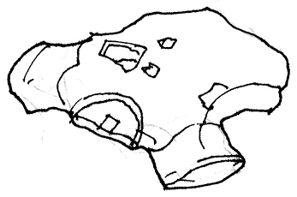
OLD SHIRT


CANDY WRAPPER

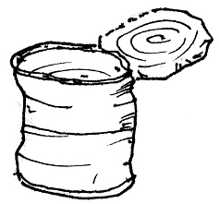
CAN
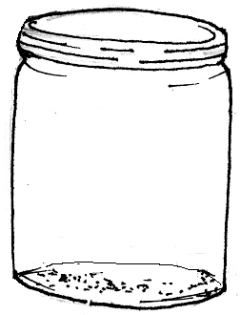
GLASS JAR

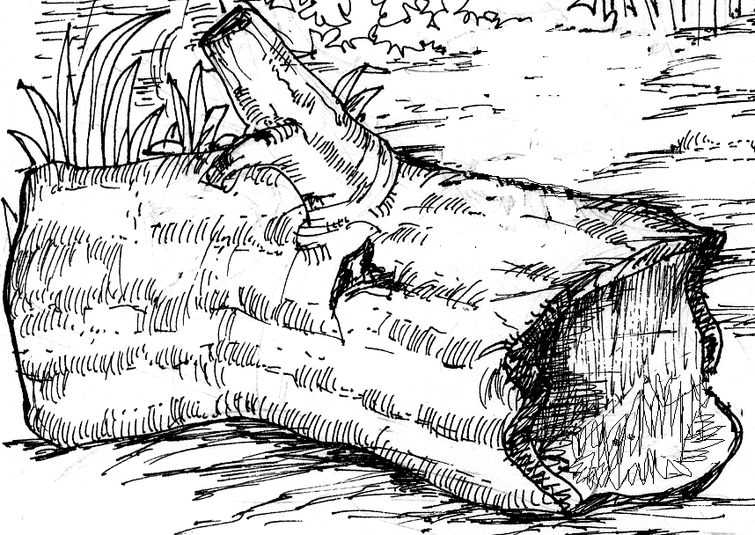
LOG

- Instead of throwing your left-over food, what can you do to make it
useful?

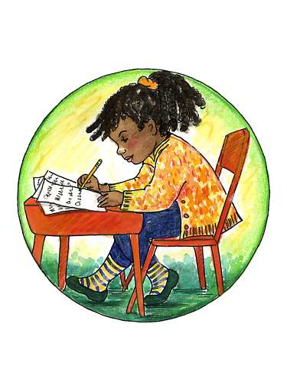

Test Yourself

*

- Write YES if the situation has a GOOD EFFECT in the environment and NO if it does not have good effect. Write the answers in your notebook.

  - Sewing clothes
  - Building houses
  - Making toys
  - Burning garbage
  - Cutting of trees
6. Throwing plastic bags in the rivers
7. Selling the empty bottles of patis.
- Collecting old newspapers and magazines then sell
- Placing left-over food in trash can.
10. Making doormats using old sacks and strips of cloth

- Write the good effect when these materials change.

1. bottle vase __________________
2. juice pack bag __________________
3. banana peeling fertilizer __________________
4. rock paper weight __________________
5. beads necklace __________________
6. herbs alternative medicines __________________
7. pina jusi barong tagalong __________________

