GRADE VI
SPEED, VELOCITY, ACCELERATION AND FRICTION

At the end of the module, you should be able to:

- Identify factors affecting movement
- Show that external conditions affect the movement of bodies (friction)



Try to Recall

In a “Tug of War” game between Team A and B, Team A was the winner. What made team A win? Put a check (√) on the blank before each number that explains the answer.

___ 1. Team A had greater force than Team B.
___ 2. There was an unbalanced force.
___ 3. Team B moved to the direction of Team A.
___ 4. Team A had lesser force.

Explore

Have you ever ridden a car or a tricycle with closed eyes?
- Closed eyes, can you feel if your car is moving slow or fast?
- Closed eyes, can you feel if the car is changing direction?

Find out the exact movement of moving objects in these activities.

Activity 1
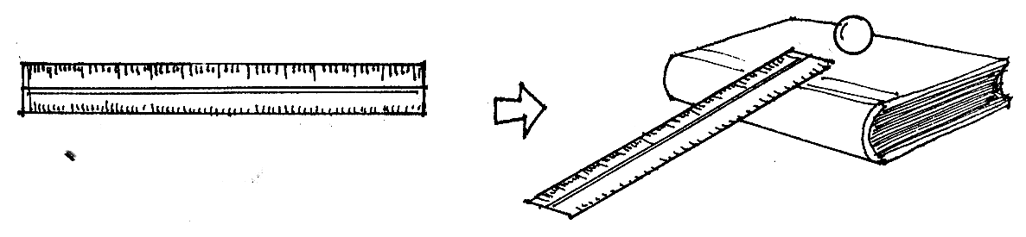
What you need:

two ruler
a book
a marble
stopwatch or watch with second hand

What to do:

- Get 2 rulers. Tape together the end of the two ruler. Set one end of the ruler on the edge of a book as shown. Roll the marble on the groove of the ruler. Do this 5 times.
- Using a stopwatch, take note of the time it takes for the marble to travel the length of the 60 cm ruler.
- Record it in a table similar to the one below.

Trial | Distance | Time in seconds | Speed
1 | 60 cm
2 | 60 cm
3 | 60 cm
4 | 60 cm
5 | 60 cm

- Compute the speed of the marble in cm per second by using this formula. If the marble travels 60 cm in 5 seconds.

distance traveled
speed =
time

speed = 60 cm
5 seconds

speed = 12 m/s

- Study the graph of the speed of a runner .
Distance (km)
30
20
10
0  1 | 2 | 3 | 4

Time (hr)

- What is the speed of the runner after the 1st hour?
- What is the speed of the runner on the 2nd hour?
- Is the speed the same? Is there an additional distance covered? Speed that remain the same is called constant speed.
- At the end of the 4th hour, what is the speed?
- Compute the average speed of the runner?
- What data are needed to find the average speed of a running object?
- Based on the activity how would you define speed?

Activity 2

Study the table below.

Give the velocity of each bus. The first one is done for you.

Car Speed Direction Velocity

A 50km/hr North 50km/hr, North

B 50km/hr South _____________

C 50km/hr West _____________

D 50km/hr Northeast _____________

E 50km/hr West _____________

- Which cars have the same speed? Why?
- Which cars are traveling in the same direction?
- Which cars have the same velocity? Why?
- What factors are considered in finding velocity?
- Based on the activity how would you define velocity?

Did you know that…

velocity is the speed of a moving object in a specified direction.

velocity changes when there is change in any of the following:

change in speed
change in direction
change in both speed and direction

when an object moves with the same speed and direction, it has constant velocity.

Activity 3

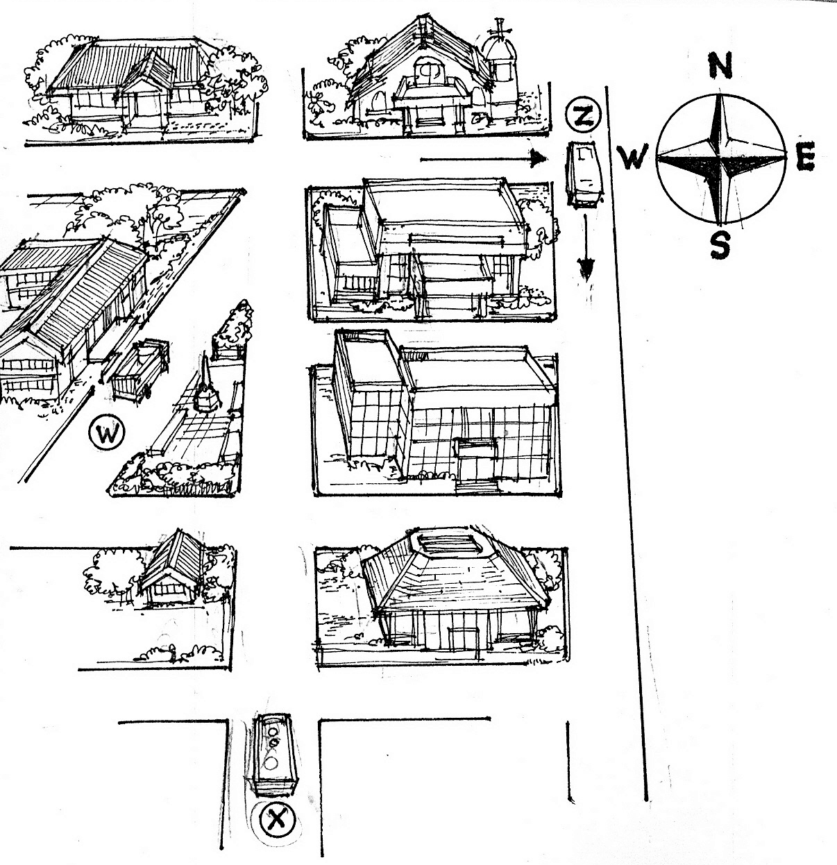

What to do:

- Trace with your finger the path taken by the bus.
a. Bus X is traveling with a speed of 20km/hr, North.
b. In the first corner, it turned left with the same speed.
c. Then it turned right, moving at 25 km/hr, North.
- What changes took place as the bus traveled?
- Was there change in speed? Change in direction?
- Was there change in velocity?

Did you know that…

- change in velocity over time is called acceleration.
- negative acceleration is deceleration.

Activity 4

What to do:

- Make 2 similar push carts using cardboard boxes with wheels as shown in the figure.

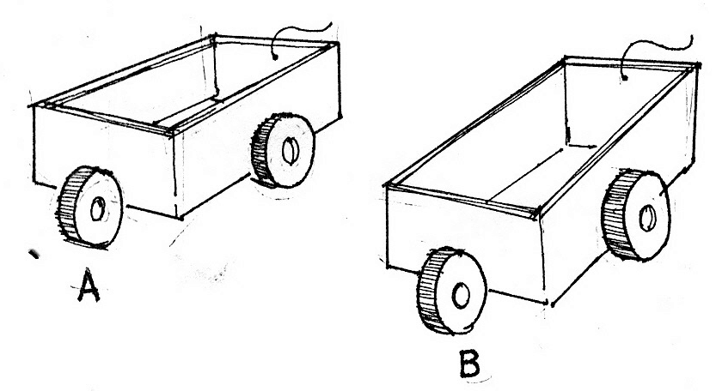

- Place these carts side by side.
- Put some stones in push cart A. Leave push cart B empty.
- Push the two carts with the same force with your left and right fore finger to different directions.
  - Which cart moved faster? Why?
  - Which cart can change direction easily? Why?
  - Which cart can accelerate or change velocity easily? Why?
- What factors affect acceleration?
- Study these illustrations. One truck is loaded while the other is empty.

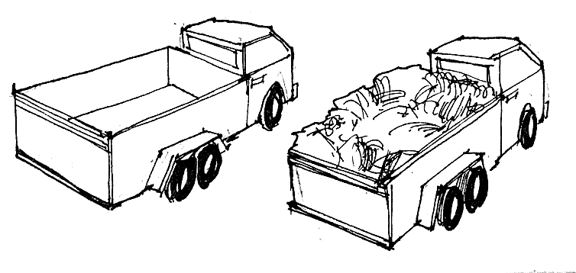

- Which truck moves faster? Why?
- Which truck moves slowly? Why?
- Which truck can change speed slowly? Change direction slowly?
- Which will accelerate more slowly?
- What factors affect acceleration?
- How can the problem of acceleration be solved in loaded trucks?
- What will you do to make a smaller bike win over a bigger bike?

more mass – less acceleration
less mass – more acceleration

truck – less acceleration
bicycle – more acceleration

more mass + more force – more acceleration
more force - more acceleration

Activity 5

What you need:

2 similar marbles
2 30 - cm piece of cardboard
6 books
some sand
a plastic cover

What to do:

- Pile 6 books on top of each other.
- Cover one board with a plastic cover or any smooth cover.
- Scatter a glass of sand over the other board.
- Place side by side one end of the 2 boards on the edge of the books.
- Roll the marbles on each of the board at the same time?
- In which board did the marble roll faster?
- What outside force helped the marble to roll faster?
- What was lessened because of the smooth surface?
- Which board did the marble roll slowly?
- What outside force helped the marble roll slowly?
- Describe the outside force that caused the marble to roll slowly?
- A force made the marble rolled down. An opposing or opposite force is also acting on the marble.
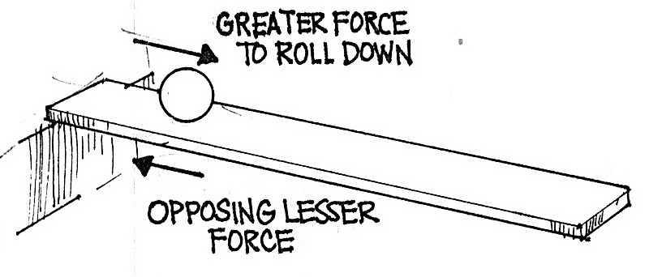

Did you know that…

- friction is an external force that affects the movement of bodies.
- friction can be lessened by using wheels, lubricants and smooth surfaces.
- friction can be increased by making surfaces rough, like the grooves of a tire.

I LEARNED THAT:

- Speed is the distance traveled over a certain period of time.

- Velocity is the speed of a moving object in specified direction.

- Velocity changes when there is change in speed, change in direction or change in both speed and direction.

- Acceleration is the change in velocity over time. Deceleration is negative acceleration.

- Acceleration is affected by the mass of a body and the amount of force applied to it.

- Friction is the force that opposes the motion of an object.

- Friction is the force that brings an object to rest.

- When objects are in contact with each other, friction acts in the direction opposite to the motion of the moving body. The moving body slows down and finally stops.

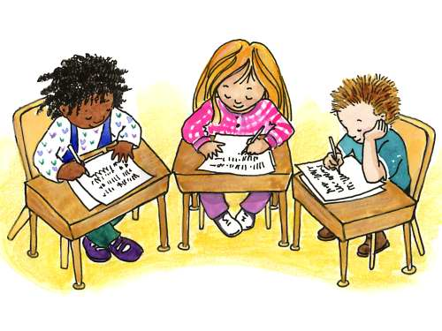

Apply It

- Find out how speed and velocity are related.
- Describe moving bodies with constant velocity.
- How can friction be of help to you?
- Why are wheels round?

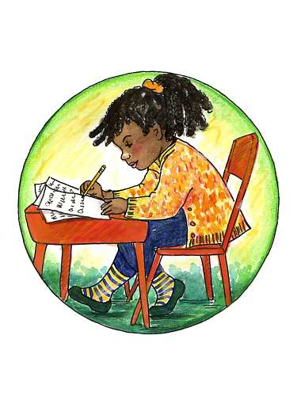

Test Yourself

*

- Match column A with the description in column B. Write the letter of the correct answer on your test notebook.

A B

1. speed A. brings an object to rest

2. friction B. speed of a moving objects towards a
direction

3. acceleration C. less mass

4. greater acceleration D. change in velocity

5. velocity E. tells how fast you run

- Explain why is it easy and fast to move in an ice rink.

Key to Correction

Try to Recall

Exploration Time

Activity 1

Activity 2

Activity 3

Activity 4

Activity 5

Apply it

Test Yourself

1. E
2. A
3. D
4. C
5. B

