GRADE VI
MECHANICAL ENERGY

At the end of the module, you should be able to:

- Describe mechanical energy and its uses
- Investigate changes in mechanical energy



Try to Recall

Observe the picture carefully. Identify the persons showing potential energy and those showing kinetic energy. Support your answer.

Explore

Things around you move because of mechanical energy. In the following activities you will learn what produce mechanical energy.

Activity 1. Can water produce mechanical energy?

What you need:

pencil
paper plate with ridges along the edges or improvised pinwheel
water faucet

What to do:

- Push a pencil through the center of the paper plate, wriggling the pencil bank and forth to make the hole loose

- Turn on the tap water to produce a slow stream. Hold the pencil so that one edge of the plate touches the water. What happens to the plate?

- Turn on the tap water to produce a steady fast stream. Place the paper plate as in number 1.

  - Describe the movement of the paper plate.
  - How did you increase the movement of the paper plate?
  - Can you guess what energy is formed when the paper plate moves?
  - If the paper plate represents a turbine or waterwheel, what are some of its uses?

- Trace the energy transformation

Mechanical energy
flowing of water turning paper plate

- Look outside the window

  - What makes the leaves sway?
  - What energy is performed when the leaves sway? When the wind blows? Why?
  - Why is mechanical energy important to our daily activities?

Did you know that…

energy possess by moving object is called mechanical energy.

Activity 2. Mechanical Energy as to Ability to do Work

Materials: hammer
nail
wood block
dart gun
dart target

- Nail the wood using the hammer.
- Hit the dart into the dart target.

Answer these:

- Were you able to do the actions above?
- What energy did you perform?

Read and Learn More.

Mechanical energy is the energy produced by moving bodies. It is a kind of kinetic energy. Any object that moves produces mechanical energy. A running car, the wind flowing water, waves in the ocean and falling leaves produce mechanical energy.

Activity 3

What to do:

- Stand up. Clap your hands.
  - Are you moving?
  - What energy is formed when you move?
  - How can we use the mechanical energy of our body?

I LEARNED THAT:

- A moving object has movement/mechanical energy.

- Some things in the environment, such as wind, water, running water have mechanical energy.

- Mechanical energy enables us to do many things.

- Mechanical energy can be changed to other forms.

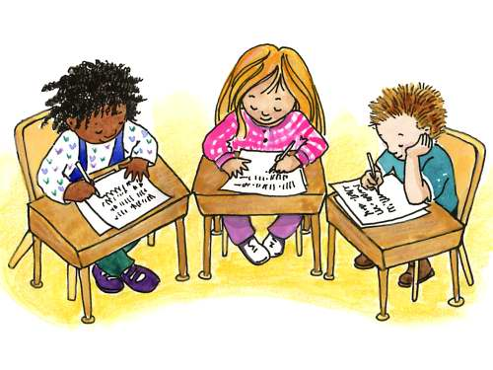

Apply It

1. Your classmate is thin, sluggish and tires easily.
- How would you describe her energy?
- What must she do to increase energy into mechanical energy?
- Would she able to convert it to mechanical energy?
3. Can you think of other sources of mechanical energy?

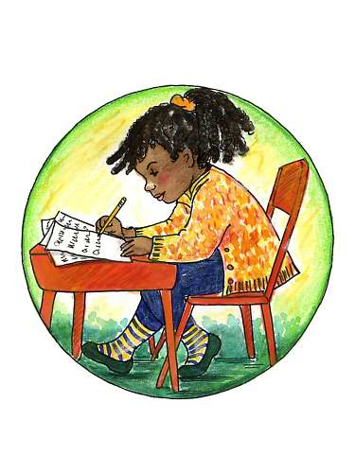

Test Yourself

*

Fill up the table with the correct word from the list.

MECHANICAL E NERGY
Movement of the Following

Key to Correction

Try to Recall

Exploration Time

Activity 1

Activity 2

Activity 3

Apply it

Test Yourself
in any order
MECHANICAL E NERGY
Movement of the Following
wind
water
human
animal
rock

